XXX Activity or Task Based Lesson ☐ Language Based or Presentation, Practice, Production PPP Based Lesson
☐ Storytelling Lesson Plan ☐ Puppet Play Presentation

Topic, Story Title, or Puppet Play Name:
World Travel With My Dream Transportation
Instructor:  Seul | Students Competency Level and Student ages  7-8 years old, Elementary | Number of Students:  12 | Lesson Length:  60 minutes
Materials:(List the Names of all materials used in the lesson. Materials must be shown at the end of this document)
- Whiteboard and Markers
- A Whole New World Video Clip
- Computer
- Transportation Materials
- Transportation Picture Book
- I Like Cars Book
- Helicopter Toys
- Hot Air Balloon Photo
- Elephant Photo
- Camels Photo
- Carriage Photo
- World Map with Countries
- World Map Worksheet
- Transportation Card
- Around the World in 80 Days Map
- My Dream Transportation Worksheet
- Cell Phone as Speaker
- Background Music About Travel
  - Weesing In the Car “Oh Me! Oh My!”
  - Weesing In the Car “Riding Along”
  - Weesing In the Car “The Upward Trail”
  - Weesing In the Car “My Aunt Came Back”

Lesson Objectives(What do you want the students to know (new skill or knowledge that you want them to gain)? and What do you want them to be able to do?
- Ss will be comfortable talking about transportation, where they want to go and how they would go by participating in activities of this lesson.
Aims:(What students will be able to achieve by participating in the activities of the lesson. (Ss gain or get by doing…)
- Improve speaking skills by participating in the activities and answering teacher.
- Improve listening skills by participating in an activity, responding to teacher.
- Improve reading skills by reading the worksheet instructions.
- Improve writing skills, interaction and communication skills by doing the presentation.
- Activate, increase interest, and participate with fun in an English communication activity by presenting themselves to teacher and students.
Language Skills:(Lists what activities language skills students will be using by participating in the activities of the lesson.)
- Reading: (Where did reading occur in the lesson?)
Worksheet instructions
- Listening:(Where did listening occur in the lesson?)
Presentation, activity, teacher talk
- Speaking: (Where did speaking occur in the lesson?)
Presentation, activity, answering teacher
- Writing: (Where did writing occur in the lesson?)
Planning presentation and activity
Assumptions:(What students must already be able to do and what concepts must already be mastered before the lesson in order to achieve the aims of the lesson.)
- All Ss probably enjoy planing on world travel with several transportation.
- All Ss have basic knowledge on world map and geography.
- All Ss enjoy creative drawing and explaining about their work.
Anticipated Errors and Solutions:(What things might go wrong in the lesson and what the solution will be. An SOS activity should also be included)
- Ss don’t know some transportation. -> T give hint and explain what it’s like.
- Ss don’t know country or place name. -> T give some ideas and facilitate other option.
References:
World Map with Countries https://geology.com/world/world-map.gif
World Map Worksheet https://img.auctiva.com/imgdata/1/7/3/7/5/8/7/webimg/611466172_tp.gif

Lead-Inor Pre-Task Part (Warm-Up Part to activate and create interest in the lesson.)
Materials: (List the Names of all materials used in the Lead-In or Pre-Task Part of the lesson. Materials must be shown at the end of this document)
- Whiteboard and Markers
- ‘A Whole New World’ Video Clip
- Computer
Time: | Classroom Set Up: | Student Activity and Goals: | Teacher Procedure & Instructions:
1  2  1  1  2 | Whole  Whole  Ss  Whole  Whole | Ss respond to T  Ss watch the clip  Ss respond to T  Ss listen to T  Ss respond to T | Introduce the movie ‘Aladdin’.  Show Ss the Video Clip of ‘A Whole New World’.  Ask Ss what they’ve seen on the movie, talk about the magic carpet.  Introduce ‘Around the World in 80 days’.  T elicits Ss ideas brainstorm on ‘transportation’ on the board.

Pre-Activity or Task Familiarization Part (Presentation Partfor Presenting the language structure to be covered in the lesson. Prepares students for the communication activity.)
Materials: (List the Names of all materials used in the Pre-Activity or Task Familiarization Part of the lesson. Materials must be shown at the end of this document)
- Whiteboard and Markers
- Transportation Pictures or Toys
  - Transportation Picture Book
  - I Like Cars Book
  - Helicopter Toys
  - Hot Air Balloon Photo
  - Elephant Photo
  - Camels Photo
  - Carriage Photo
Time: | Classroom Set Up: | Student Activity and Goals: | Teacher Procedure & Instructions:
8 | Whole | Ss respond to T | T show Ss pictures/toys of transportation. Facilitate small talks on each of them.

Main Activity or Task Realization Part(Practice to Production Part Teacher lead practice of the language presented and move to communication based more student centered activity)
Materials: (List the Names of all materials used in the Main Activity or Task Realization Part of the lesson. Materials must be shown at the end of this document)
- World Map with Countries
- World Map Worksheet
- Transportation Card
- Around the World in 80 Days Map
Time: | Classroom Set Up: | Student Activity and Goals: | Teacher Procedure & Instructions:
1  1  2  6  4X  3 | Whole  Group  Group  Group  Group | Ss listen to T  Ss move into groups  Ss respond to T  Each team color and put round sticker, post-it on their World Map.  Everything below happens for four times.  Team come up and present their World Map. | Introduce team activity of making their own plan  of ‘Around the world in 80 days’ with transportation.  Ss can use same transportation for several times, but need to use all transportation at least once.  Group Ss in four team, give each team a World Map.  Each person roll two dices and pick Transportation cards as many as the bigger number of dice.  If the same number appears like 2*2, the team gets a Magic Carpet.  T facilitate each team plan and do the activity. Give help if needed.  Everything below happens for four times.  T approvingly listen to the presentation and facilitate questions and feedback from class.

Post Activity or Post Task Part (Wrap-Up Part to Close the Lesson on a high note to and consolidate language learned in a communication based activity new situation.)
Materials: (List the Names of all materials used in the Post Activity or Post Task Part of the lesson. Materials must be shown at the end of this document)
- My Dream Transportation Worksheet
- Cell Phone as Speaker
- Background Music About Travel
  - Weesing In the Car “Oh Me! Oh My!”
  - Weesing In the Car “Riding Along”
  - Weesing In the Car “The Upward Trail”
  - Weesing In the Car “My Aunt Came Back”
Time: | Classroom Set Up: | Student Activity and Goals: | Teacher Procedure & Instructions:
2  1  5  12  3 | Whole  Whole  Whole  Ss  Whole | Ss respond to T  Ss listen to T  Ss draw and fill out the worksheet.  Ss take turns to present their work, others listen.  Ss respond to T | T facilitate feedbacks for S-S about team activity.  T hand out a Worksheet on drawing My Dream Transportation and explain instructions. T plays Background Music About Travel.  T move around Ss and facilitate activity. Give help if needed.  T listen and give feedback.  T facilitate feedbacks for S-S about drawing activity. Clap hands to celebrate.

Materials:
- Transportation Pictures or Toys

  - Transportation Picture Book ㅇHelicopter Toys
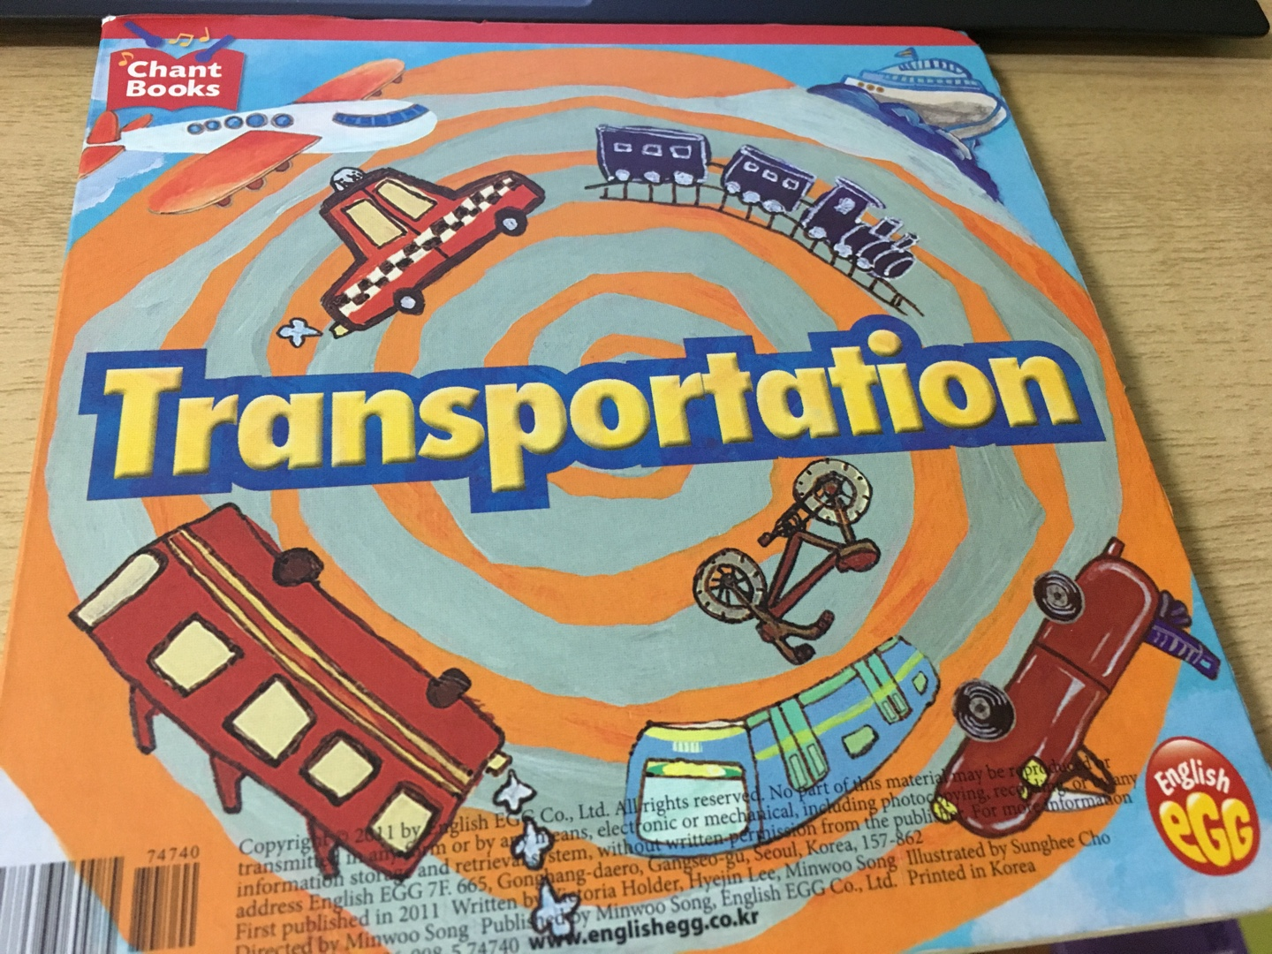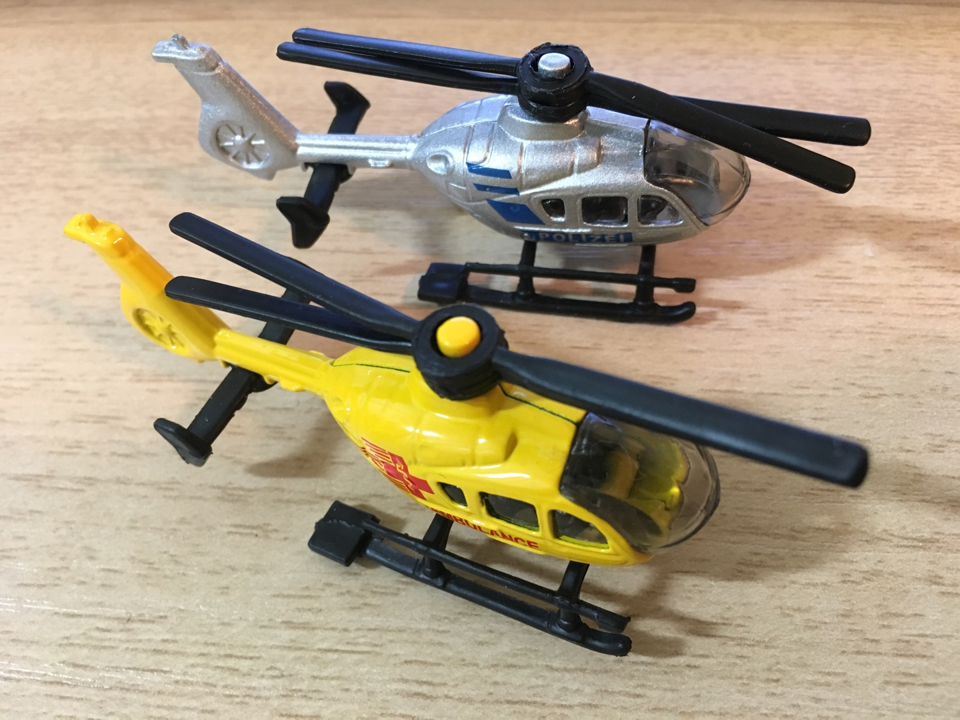

  - I Like Cars Book
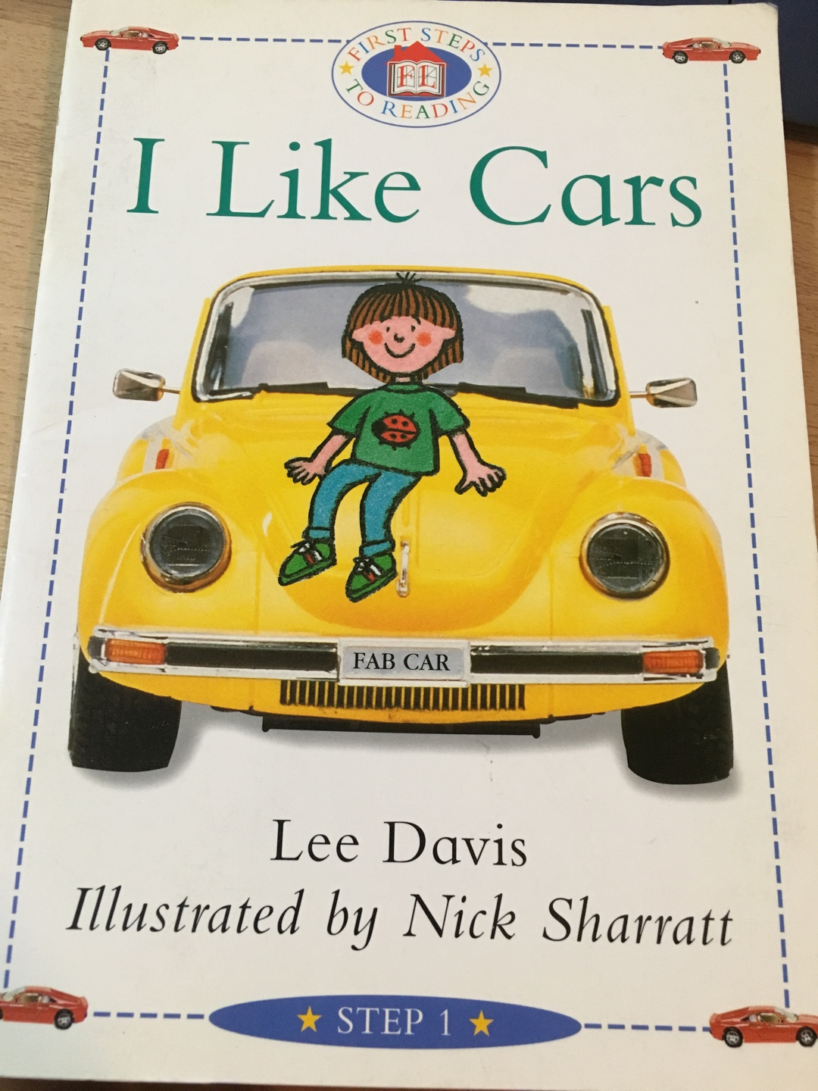

  - Hot Air Balloon Photo

  - Elephant Photo
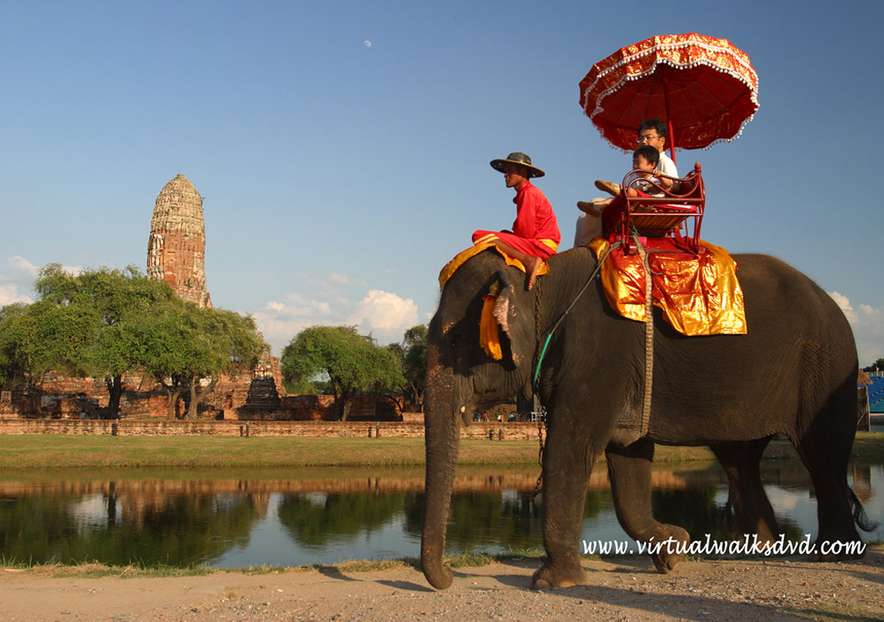

  - Camels Photo
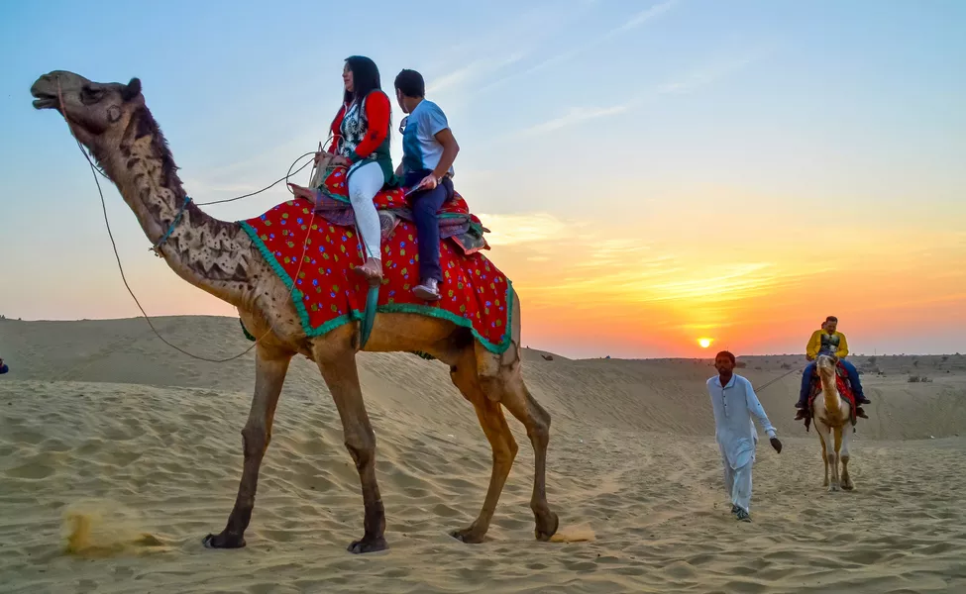

  - Carriage Photo
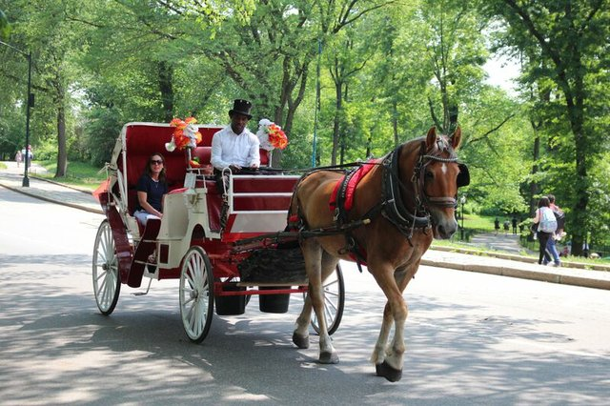

- World Map with Countries
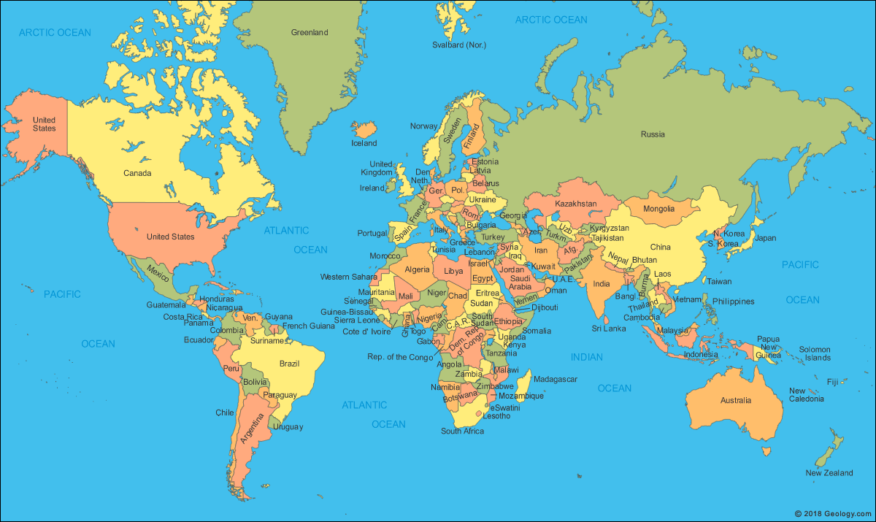

- World Map Worksheet
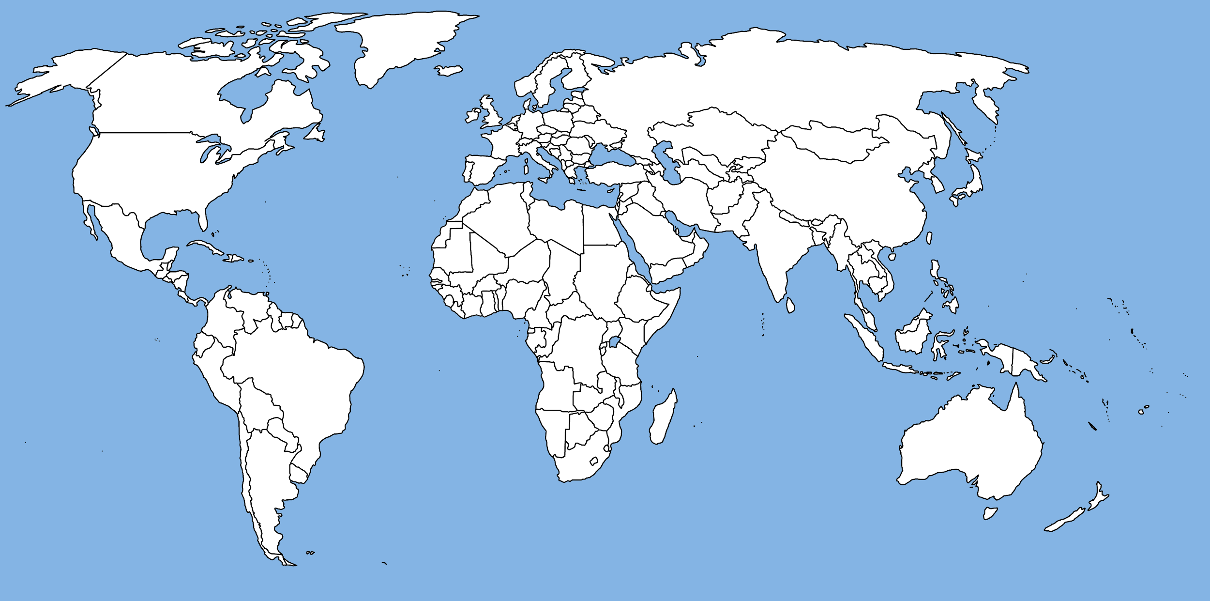

- Around the World in 80 Days Map
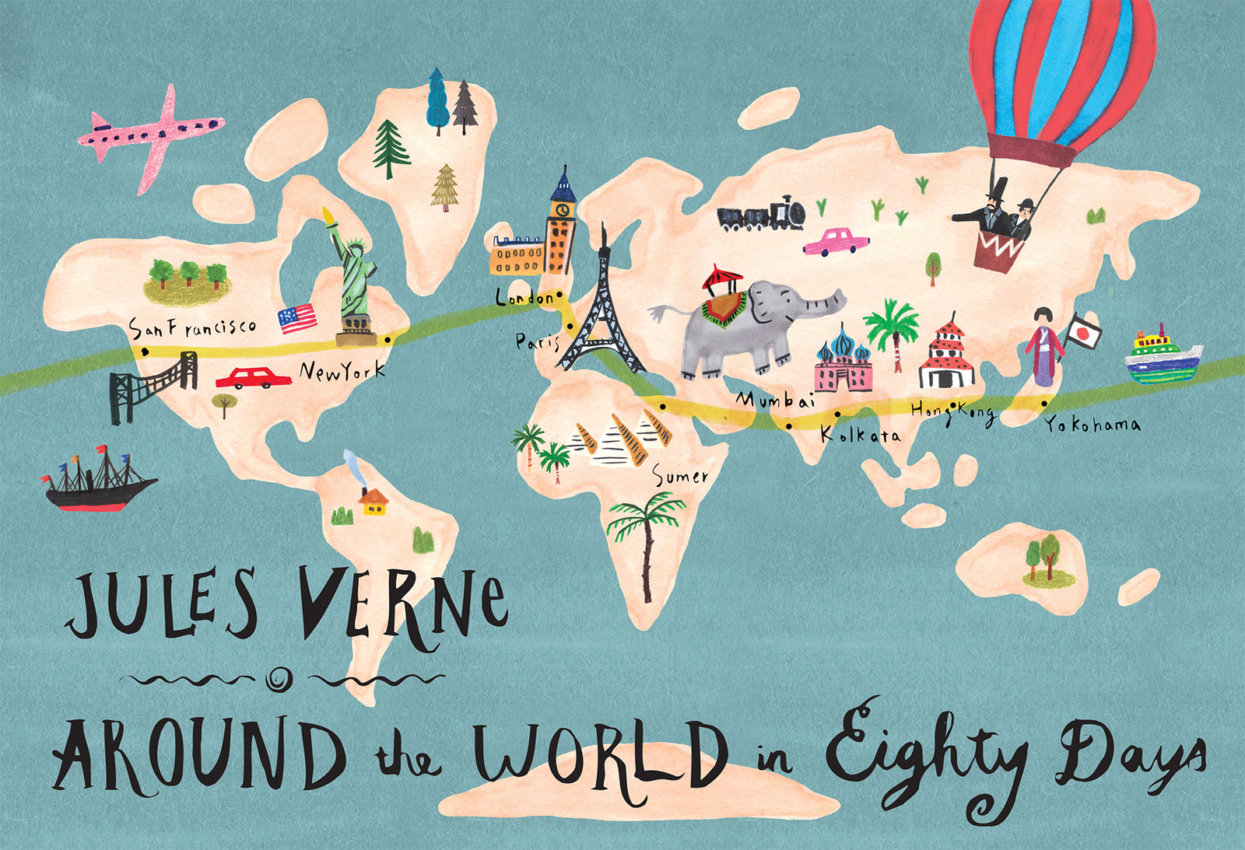
- Transportation Card
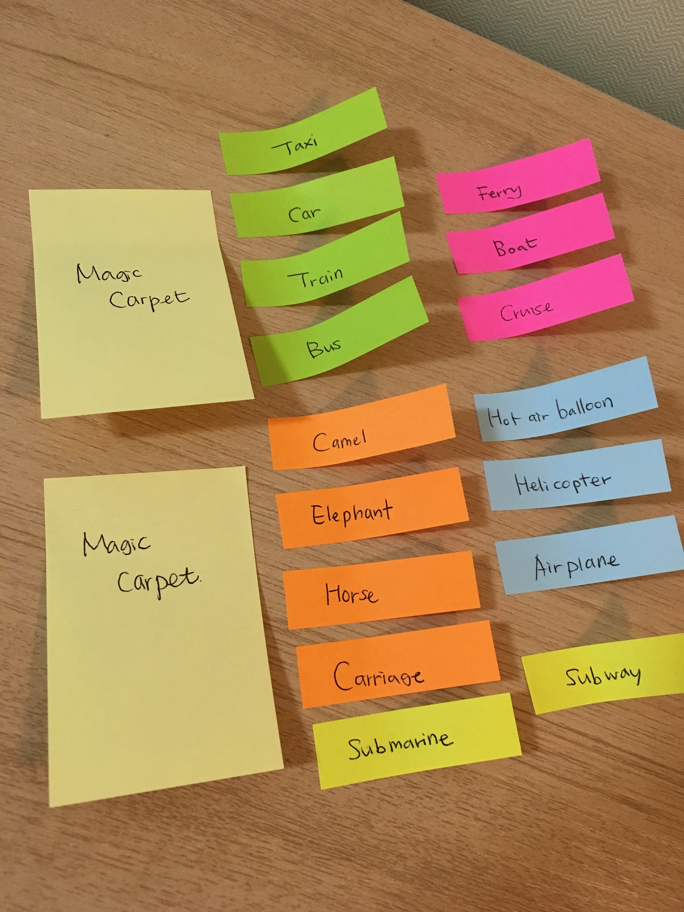

- My Dream Transportation Worksheet
My Dream Transportation!

- What’s the name of it?

- What does it look like?

- How does it work?

- What would you like to do?

- Who do you want to ride with?

