☐ Activity or Task Based Lesson XXX Language Based or Presentation, Practice, Production PPP Based Lesson
☐ Storytelling Lesson Plan ☐ Puppet Play Presentation

Topic: Making Sandwiches

Instructor:  Elin | Students Competency Level and Student ages  7-8 years old, Elementary | Number of Students:  10 | Lesson Length:  50 min
Materials:(List the Names of all materials used in the lesson. Materials must be shown at the end of this document)
- Pictures
Sandwiches
Sandwich & Coffee
- Hello song
- Let’s make a sandwich song
- Ingredients of Sandwich
Bread
Strawberry jam
Mayonnaise
Cheese
Ham
Lettuce
Tomato
Apple
Onion
Pickle
- Creative Sandwich Pictures
- Making Sandwich Worksheet
- Plate
- Knife
- Recipe Sample
- Recipe Book Worksheet
- Computer or Blue tooth speaker

Lesson Objectives(What do you want the students to know (new skill or knowledge that you want them to gain)? and What do you want them to be able to do?
Ss can understand and practice using English by expressing detailed descriptions of how to make their own sandwiches.

Aims:(What students will be able to achieve by participating in the activities of the lesson. (Ss gain or get by doing…)
Ss will get interested in lesson by the conversation with Bakki.
Ss improve listening skills by responding to teacher, Bakki and sharing opinions in class.
Ss improve speaking skills by sharing opinions about the order of making sandwich in class.
Ss improve writing skills by making a sandwich list.
Ss improve interaction and communication skills by having discussion in a group and make sandwiches.
Ss will practice the expression of detailed behavior by participating in activities of the lesson.

Language Skills:(Lists what activities language skills students will be using by participating in the activities of the lesson.)

- Reading: (Where did reading occur in the lesson?)
worksheet

- Listening:(Where did listening occur in the lesson?)
Teachers talk, discussion, presentation of other students

- Speaking: (Where did speaking occur in the lesson?)
Group discussion, answering teacher, presentation

- Writing: (Where did writing occur in the lesson?)
create a sandwich making order list

Assumptions:(What students must already be able to do and what concepts must already be mastered before the lesson in order to achieve the aims of the lesson.)
Ss will enjoy and also have fun
Ss will become more comfortable and friendly with each other
Ss can make descriptive behavior verbs
Ss will learn how to think and speak more specifically

Anticipated Errors and Solutions:(What things might go wrong in the lesson and what the solution will be. An SOS activity should also be included)
If Ss may not understand > T shows demonstration
If activity finished too soon > make another recipe sandwich
If Ss try one’s own way what is not written in the list > T make only the actions mentioned

References:

Lead-Inor Pre-Task Part (Warm-Up Part to activate and create interest in the lesson.)
Materials: (List the Names of all materials used in the Lead-Inor Pre-Task Partof the lesson. Materials must be shown at the end of this document)
- Hello song
- Computer or Blue tooth speaker
- Pictures
Sandwiches
Sandwich & Coffee

Time: | Classroom Set Up: | Student Activity and Goals: | Teacher Procedure &Instructions:
3  2  1  2 | W  W  W  Ss | Sing and dance together to greet T and each other  Respond  Listen to T  Share their thoughts about making sandwiches | Greeting and dancing with Hello song  Show a sandwich pictures and ask Ss if they like sandwich and have ever eaten  T tells Ss about the experience of making sandwich  Ask Ss if they have ever made sandwiches and what kind of sandwich do you want to make

Pre-Activity or Task Familiarization Part (Presentation Partfor Presenting the language structure to be covered in the lesson. Prepares students for the communication activity.)
Materials: (List the Names of all materials used in the Pre-Activity or Task Familiarization Part of the lesson. Materials must be shown at the end of this document)
- Ingredients of Sandwich
Bread
Strawberry jam
Mayonnaise
Cheese
Ham
Lettuce
Tomato
Apple
Onion
Pickle
- Making Sandwich Worksheet

Time: | Classroom Set Up: | Student Activity and Goals: | Teacher Procedure &Instructions:
2  1  3  4 | W  G  G  G | Listen and see  Move into groups  Discuss and decide which sandwich to make, choose the ingredients  Discuss and write down in order on worksheet | Show each of ingredients for a sandwich  Divide Ss into 2 groups  Ask Ss to discuss what kind of sandwich want to make and choose the ingredients  Ask Ss to write down the order you make on the worksheet

Main Activity or Task Realization Part(Practice to Production PartTeacher lead practice of the language presented and move to communication based more student centered activity)
Materials: (List the Names of all materials used in the Main Activity or Task Realization Partof the lesson. Materials must be shown at the end of this document)
- Ingredients of Sandwich
Bread
Strawberry jam
Mayonnaise
Cheese
Ham
Lettuce
Tomato
Onion
Pickle
- Making Sandwich Worksheet
- Recipe Sample
- Plate
- Knife

Time: | Classroom Set Up: | Student Activity and Goals: | Teacher Procedure &Instructions:
1  2X  3  2  5  1  8  1 | W  G  G  G  G  G  G  W | Listen what T says  Everything below happens two times  Ss read the list of sandwich recipes.  Ss see the T’s sample recipe (detail describe)  Modify the list of ways to make it more detailed  Choose one cook  The cook makes sandwiches as the group members say  Listen what T says | Explain the rules that we should act only just follow the contents listed  Everything below happens two times  T act just follow they speak and start making sandwiches  T show T’s detail recipe sample  Give Ss some time to fix and add missing parts  Ask Ss to decide who is cook  One more time, ask cook act just follow they speak and start making sandwiches  Gives Ss positive feedback and comments

Post Activity or Post Task Part (Wrap-Up Part to Close the Lesson on a high note to and consolidate language learned in a communication based activity new situation.)
Materials: (List the Names of all materials used in the Post Activity or Post Task Part of the lesson. Materials must be shown at the end of this document)
- Creative Sandwich Pictures
- Recipe Book Worksheet
- Let’s make a sandwich song
- Computer or Blue tooth speaker

Time: | Classroom Set Up: | Student Activity and Goals: | Teacher Procedure &Instructions:
2  1  5  2  1 | W  Ss  Ss  W  Ss | Look at the pictures while listening to song  Respond and think about how to decorate the book  Draw and write an sandwich recipe book  Shows and presents their own special sandwich  Take pictures with their own cookbook and sandwiches. | T plays ‘Let’s make a sandwich’ song, and  Shows pictures of creative sandwiches  Asks Ss to make an mini recipe book of their new creative sandwich  T plays ‘Let’s make a sandwich’ song (background song), and monitors and encourage  Gives Ss positive feedback and comments  The teacher takes pictures with the recipe book and sandwiches that the students have completed

Sandwiches Picture

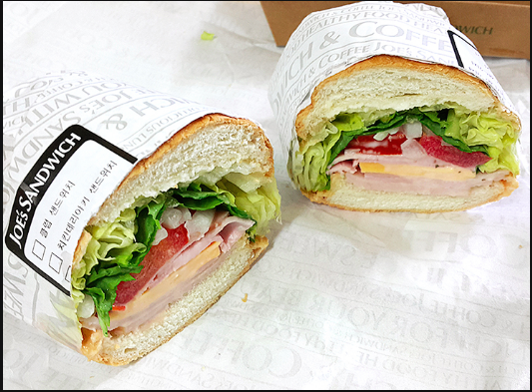

Sandwich & Coffee
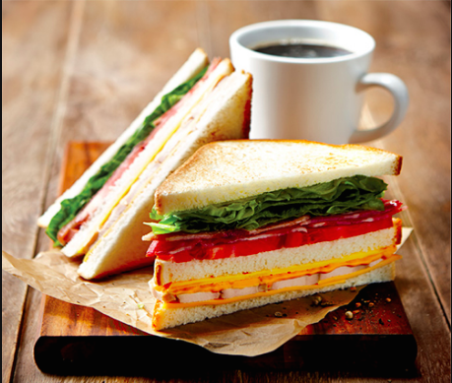

Creative Sandwich Pictures1
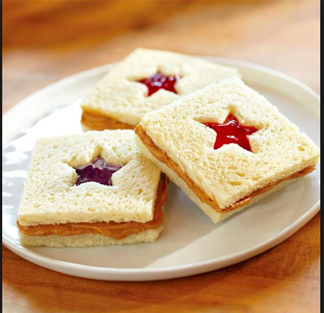

- Creative Sandwich Picture 2
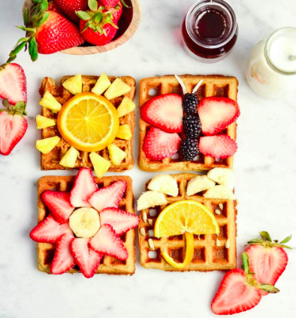
- Creative Sandwich Picture 3

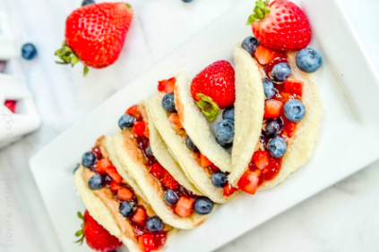

- Creative Sandwich Picture 4

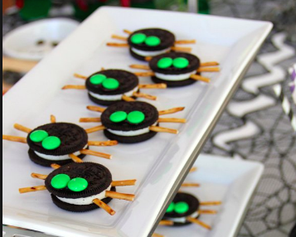

- Creative Sandwich Picture 5
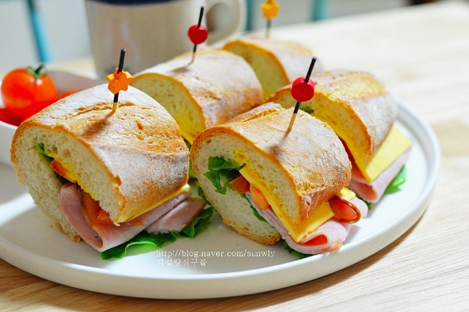

Creative Sandwich Picture 6
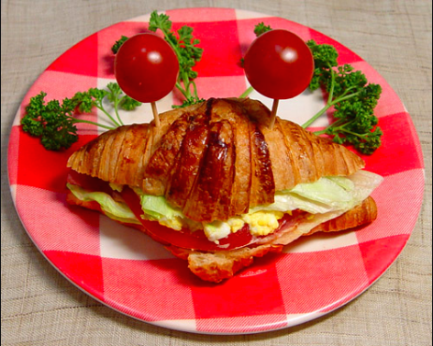
Creative Sandwich Picture 7
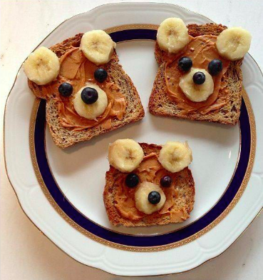
Making Sandwich Worksheet
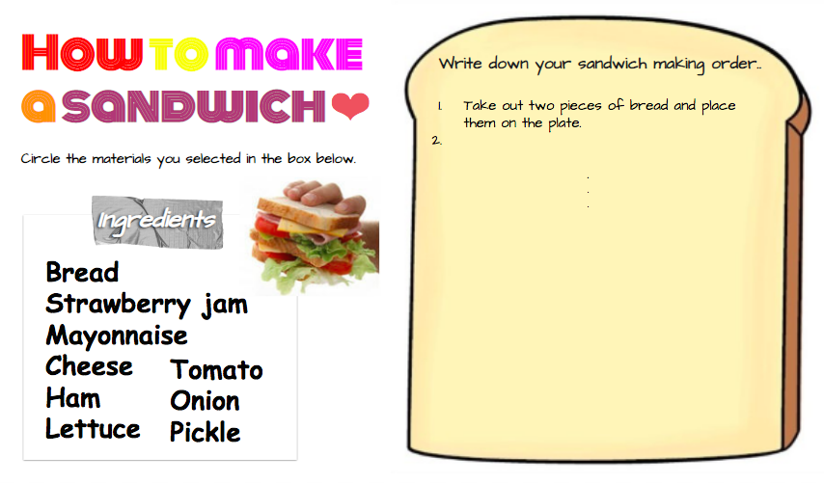
Recipe Book Sample
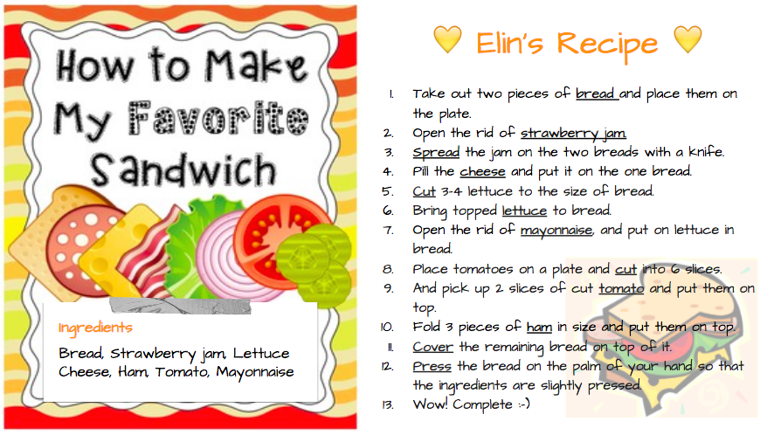
Recipe Book Worksheet
