Activity or Task Based Lesson Language Based or Presentation, Practice, Production PPP Based Lesson
XXX Storytelling Lesson Plan Puppet Play Presentation

Topic: A Blue Elephant

Instructor:  Julia | Students Competency Level and Student ages  Elementary 7-8 years old | Number of Students:  6 | Lesson Length:  45min
Materials:(List the Names of all materials used in the lesson. Materials must be shown at the end of this document)
- Winnie Harlow Picture
- Blue Elephant Doll
- A Blue Elephant Book
- Computer
- Phone
- Bluetooth Speaker
- We All Sing with the Same Voice Video Clip
- We All Sing with the Same Voice Song MP3
- Pictures of Lyrics
- We All Sing with
- the Same Song
- the Same Voice
- and We Sing in Harmony
- White Board and a Marker
- Board Chart

Lesson Objectives (What do you want the students to know (new skill or knowledge that you want them to gain)? And What do you want them to be able to do?
Ss will enjoy being able to understand story in English by listening to teacher’s storytelling and have time to think of living together with different people

Aims:(What students will be able to achieve by participating in the activities of the lesson. (Ss gain or get by doing…)
Ss will get interested in lesson by listening to the story of Winne Harlow and touching the main character ‘Blue Elephant’ doll
Ss will improve vocabulary by listening the story and playing the activity
Ss will improve listening skills by listening to the story
Ss will practice singing and dancing with fun by participating the activity
Ss will gain writing skills by creating new verse in activity

Language Skills:(Lists what activities language skills students will be using by participating in the activities of the lesson.)
- Reading: (Where did reading occur in the lesson?)
Teacher’s writing on the board
- Listening:(Where did listening occur in the lesson?)
Teacher’s storytelling, Listening to the song, Teacher talk
- Speaking: (Where did speaking occur in the lesson?)
Answering, Singing a song
- Writing: (Where did writing occur in the lesson?)
Board writing
Assumptions:(What students must already be able to do and what concepts must already be mastered before the lesson in order to achieve the aims of the lesson.)
Ss have interest in listening to story with pictures
Some of the students may think that they are different with others
Some of the students may think that some other people are different with them
Ss think learning a new song and singing a song is fun
Ss know general vocabulary and basic grammar of the lesson

Anticipated Errors and Solutions:(What things might go wrong in the lesson and what the solution will be. An SOS activity should also be included)
If a computer or a phone does not work, sing the song by teacher herself
If all the lesson is finished too soon, sing the song together one more time

References:
Maria Rius, 파란 코끼리(A Blue Elephant), Kyowon, 2017
https://blackdoctor.org/500526/winne-harlow-from-cow-to-covergirl/
https://www.youtube.com/watch?v=Y8t1vQnVU90&t=38s
https://www.youtube.com/watch?v=fCMO7Oluloo

Lead-In or Pre-Task Part (Warm-Up Part to activate and create interest in the lesson.)
Materials: (List the Names of all materials used in the Lead-In or Pre-Task Part of the lesson. Materials must be shown at the end of this document)
- Computer
- Winnie Harlow Picture

Time: | Classroom Set Up: | Student Activity and Goals: | Teacher Procedure &Instructions:
1  3  2 | Whole  Whole  Ss | Greet T  Look at the picture and listen to T  Answer what they think they are different with others | Greet Ss  Show Winnie Harlow Picture and tell about her story  Ask Ss if they think they are different with others

Pre-Activity or Task Familiarization Part (Presentation Part for Presenting the language structure to be covered in the lesson. Prepares students for the communication activity.)
Materials: (List the Names of all materials used in the Pre-Activity or Task Familiarization Part of the lesson. Materials must be shown at the end of this document)
- Blue Elephant Doll

Time: | Classroom Set Up: | Student Activity and Goals: | Teacher Procedure &Instructions:
1  2  2 | Whole  Ss  Whole | Listen to T  Greet Blue Elephant Doll and touch it  Listen to T | Introduce Blue Elephant Doll  Let students to say hello to Blue Elephant Doll and touch it  Tell students what the story is about briefly

Main Activity or Task Realization Part (Practice to Production Part Teacher lead practice of the language presented and move to communication based more student-centered activity)
Materials: (List the Names of all materials used in the Main Activity or Task Realization Part of the lesson. Materials must be shown at the end of this document)
- A Blue Elephant Book

Time: | Classroom Set Up: | Student Activity and Goals: | Teacher Procedure &Instructions:
1  10  3  2 | Whole  Whole  Ss  Ss | Listen to T  Look at the pictures and listen to T  Answer T what they think  Tell what they feel about the story | Introduce a book ‘A Blue Elephant’  Tell the story with pictures on the book  Ask some questions while telling a story  Ask student what they think about the story

Post Activity or Post Task Part (Wrap-Up Part to Close the Lesson on a high note to and consolidate language learned in a communication-based activity new situation.)
Materials: (List the Names of all materials used in the Post Activity or Post Task Part of the lesson. Materials must be shown at the end of this document)
- Computer
- Phone
- Bluetooth Speaker
- We All Sing with the Same Voice Video Clip
- We All Sing with the Same Voice Song MP3
- Pictures of Lyrics
- We All Sing with
- the Same Song
- the Same Voice
- and We Sing in Harmony
- White Board and a Maker
- Board Chart

Time: | Classroom Set Up: | Student Activity and Goals: | Teacher Procedure &Instructions:
1  3  1  1  1  2  3  3  2  1 | Whole  Whole  Ss  Ss  Ss  Ss  Ss  Ss  Ss  Whole | Listen to T  Watch the video clip  Tell what they have heard  Look at the pictures and sing  Practice the chorus putting arms around each other's shoulders  Look at the board and listen to T  Come out to the board and write what teacher asks  Practice to sing with new version separately  Sing the new version song  Applaud | Introduce the song that blue elephant and children from the story sang when they played  Play the We All Sing with The Same Voice Song Video Clip with computer  Ask Ss what they have heard from a song  Introduce the lyrics of chorus with pictures and sing the part together  Ask Ss to practice the chorus putting arms around each other's shoulders  Write the chart for new lyrics on the board and give instructions for making new lyrics  (Example of the board writing is below)  Ask Ss to come out and write down their name, where they come from, and what they like to do on the board individually  Ask Ss to practice the song with new version separately  Play the song MP3 and sing the song with new version  Congratulate and thank Ss for accomplishment

-Board Chart

- Winnie Harlow Picture

- Blue Elephant Doll - A Blue Elephant Book
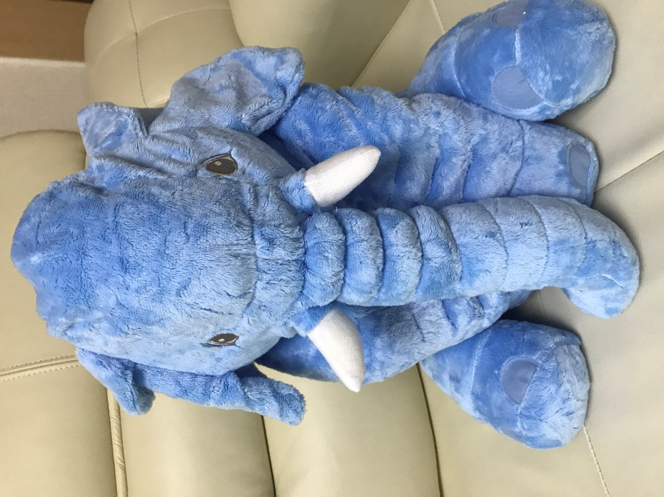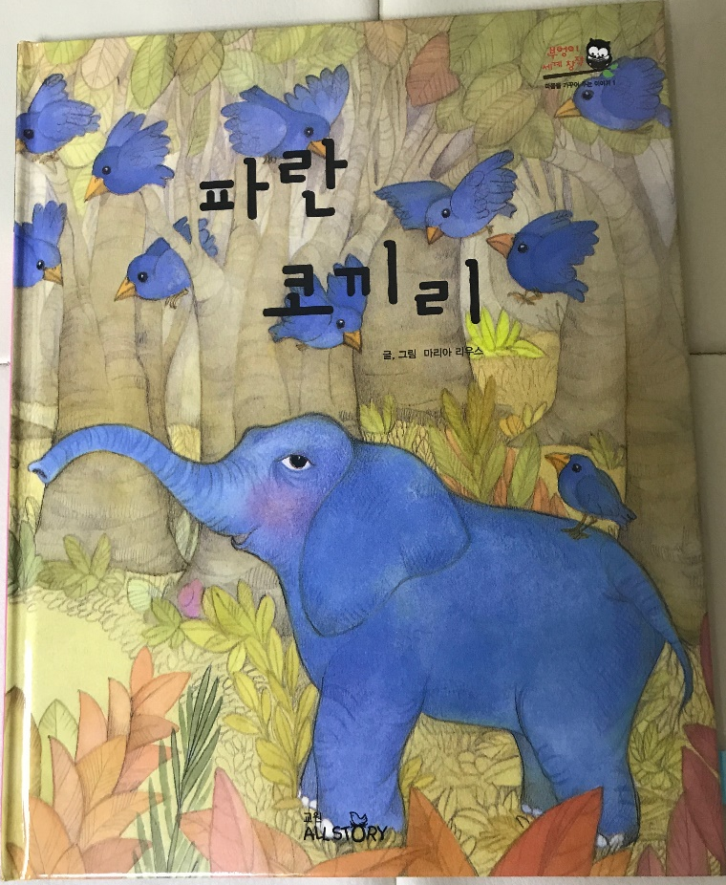

- Pictures of Lyrics

- We All Sing with
- the Same Song
- the Same Voice
- and We Sing in Harmony

