☐ Activity or Task Based Lesson ☐ Language Based or Presentation, Practice, Production PPP Based Lesson
XXX Storytelling Lesson Plan ☐ Puppet Play Presentation

Topic, Story Title, or Puppet Play Name:
Swim the Silver Sea, Joshie Otter
Instructor:  Seul | Students Competency Level and Student ages  7-8 years old, Elementary | Number of Students:  12 | Lesson Length:  60 minutes
Materials:(List the Names of all materials used in the lesson. Materials must be shown at the end of this document)
- Swim the Silver Sea, Joshie Otter Book
- Swim the Silver Sea MP3
- Cellphone as Speaker
- Egypt Photos
  - Family Photo
  - Safari Car
  - Camping Site
  - Sister and I
- Arctic Animals Photos
  - Otters
  - Seal Pup
  - Walrus Calf
  - Puffin
  - Kittiwake
  - Murres
  - Arctic Fox
- Arctic Animal Book Images Memory Card Set
  - Otters
  - Seal Pup
  - Walrus Calf
  - Puffin
  - Kittiwake
  - Murres
  - Arctic Fox
- Phrase Sticks and Memos
  - Oh no, not today
  - Stop right now
  - Please
  - Please
  - Let’s play together
- Lyric Puzzle
  - Verse 1
  - Verse 2
Lesson Objectives(What do you want the students to know (new skill or knowledge that you want them to gain)? and What do you want them to be able to do?
- Ss will comprehend the story and get familiar with sea animals by listening to storytelling and participating in the activities.
Aims:(What students will be able to achieve by participating in the activities of the lesson. (Ss gain or get by doing…)
- Improve speaking skills by participating in the activities and answering teacher.
- Improve listening skills by participating in an activity, responding to teacher.
- Improve reading skills by reading the worksheet instructions.
- Improve writing skills, interaction and communication skills by doing the presentation.
- Activate, increase interest, and participate with fun in an English communication activity by presenting themselves to teacher and students.
Language Skills:(Lists what activities language skills students will be using by participating in the activities of the lesson.)
- Reading: (Where did reading occur in the lesson?)
Worksheet instructions
- Listening:(Where did listening occur in the lesson?)
Presentation, activity, teacher talk
- Speaking: (Where did speaking occur in the lesson?)
Presentation, activity, answering teacher
- Writing: (Where did writing occur in the lesson?)
Planning presentation and activity
Assumptions:(What students must already be able to do and what concepts must already be mastered before the lesson in order to achieve the aims of the lesson.)
- All Ss probably enjoy memory game with Arctic animals.
- All Ss probably have an experience of being lost, been lonely, or got afraid of something.
- All Ss enjoy writing and drawing about their own story.
Anticipated Errors and Solutions:(What things might go wrong in the lesson and what the solution will be. An SOS activity should also be included)
- Ss don’t know some words. -> T give hint and explain what it is.
- Ss give up on memory games. -> T provide more chance and give some help.
- Ss have difficulty with role playing. -> T facilitates ideas and help conduct sentence.
References:

Lead-Inor Pre-Task Part (Warm-Up Part to activate and create interest in the lesson.)
Materials: (List the Names of all materials used in the Lead-Inor Pre-Task Partof the lesson. Materials must be shown at the end of this document)
- Egypt Photos
  - Family Photo
  - Safari Car
  - Camping Site
  - Sister and I
Time: | Classroom Set Up: | Student Activity and Goals: | Teacher Procedure & Instructions:
2  2  2  1 | Whole  Whole  Whole  Whole | S respond to T  S listen to T  S listen to T  S listen to T | T introduce herself briefly and ask Ss “Have you ever been lost by yourself?”  T talks about her family trip to Egypt. T explains the White Desert Safari and show photos.  T describes how she nearly got lost in desert with her sister, and what she has seen and felt. (music, fox, light) T explains how she got back and relieved.  T introduce today’s Storytelling book, Joshie Otter who nearly got lost in the sea.

Pre-Activity or Task Familiarization Part (Presentation Partfor Presenting the language structure to be covered in the lesson. Prepares students for the communication activity.)
Materials: (List the Names of all materials used in the Pre-Activity or Task Familiarization Part of the lesson. Materials must be shown at the end of this document)
- Arctic Animal Book Images
  - Otters
  - Seal Pup
  - Walrus Calf
  - Puffin
  - Kittiwake
  - Murres
  - Arctic Fox
- Arctic Animals Photos
  - Otters
  - Seal Pup
  - Walrus Calf
  - Puffin
  - Kittiwake
  - Murres
  - Arctic Fox
Time: | Classroom Set Up: | Student Activity and Goals: | Teacher Procedure & Instructions:
5  1  2  5 | Whole  Group  Group  Group | Student respond to T  Students sit in groups  Student respond to T  Student do activity. | T take turns to show and introduce the Arctic Animal Photo as Otter’s friend.  T group students in two teams, give them a pair of mixed Arctic Animal Book Image and place them upside down so that the pictures are not shown.  T give instruction of memory activity. The team take turn to flip two cards at a time, and who first collects all the matching animal pair wins.  T move around and facilitate process.

Main Activity or Task Realization Part(Practice to Production Part Teacher lead practice of the language presented and move to communication based more student centered activity)
Materials: (List the Names of all materials used in the Main Activity or Task Realization Part of the lesson. Materials must be shown at the end of this document)
- Swim the Silver Sea, Joshie Otter Book
- Swim the Silver Sea MP3
- Cellphone as Speaker
- Phrase Sticks and Memos
  - Oh no, not today
  - Stop right now
  - Please
  - Please
  - Let’s play together
- Lyric Puzzle
  - Verse 1
  - Verse 2
Time: | Classroom Set Up: | Student Activity and Goals: | Teacher Procedure & Instructions:
4  3  4  2  2X  5 | Whole  Whole  Whole  Group | Ss respond to T  Ss watch T and follow the movement.  Ss respond to T  Ss sit in group and respond to T.  Everything below happens twice.  Each team sing with the lyric puzzle. | T reads the story with book, ask Ss to read Phrase Memo out loud when teacher holds out the Phrase stick.  T play MP3 music during the page of mama singing. T performs movements during the song.  T read the story to the end in same way.  T group Ss in two teams, and hand out the Lyric Puzzle one verse per team. T turn on the music so that the Ss can put the lyrics in right order.  Everything below happens twice.  T sing together with Ss.

Post Activity or Post Task Part (Wrap-Up Part to Close the Lesson on a high note to and consolidate language learned in a communication based activity new situation.)
Materials: (List the Names of all materials used in the Post Activity or Post Task Part of the lesson. Materials must be shown at the end of this document)
- Swim the Silver Sea MP3
- Cellphone as speaker
Time: | Classroom Set Up: | Student Activity and Goals: | Teacher Procedure &Instructions:
5  5  1 | Whole  Whole  Whole | Ss do activity.  Ss present their work.  Ss respond to T | T hand out paper and ask Ss to draw and write about what Joshie Otter had for his dream that day. Turn on the background music during activity.  T ask each S show their work, give feedback and facilitate in-class communication.  End the class with clapping hands.

Materials:
Swim the Silver Sea, Joshie Otter Book
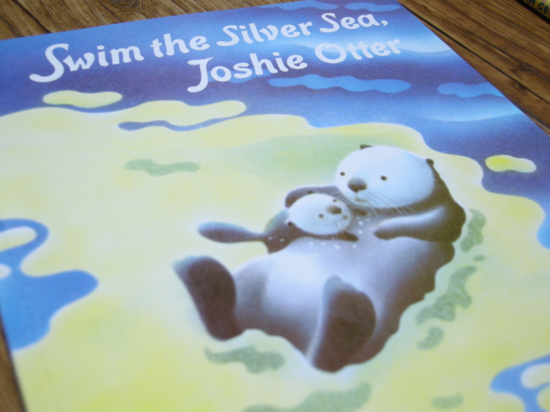

T’s Egypt Photos
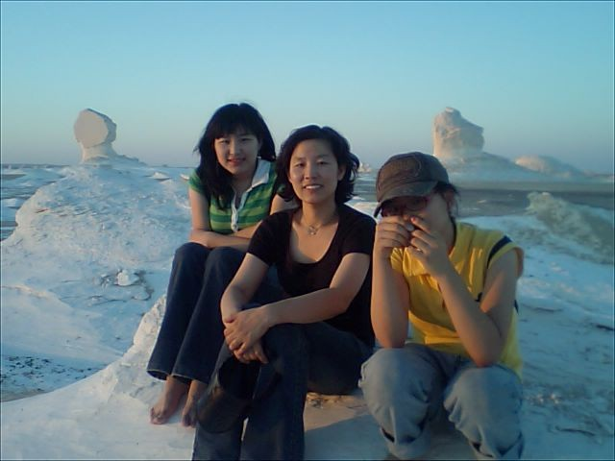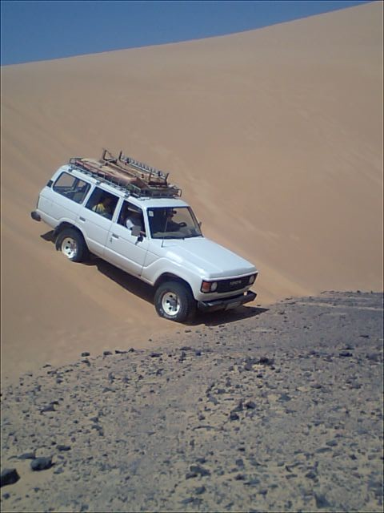
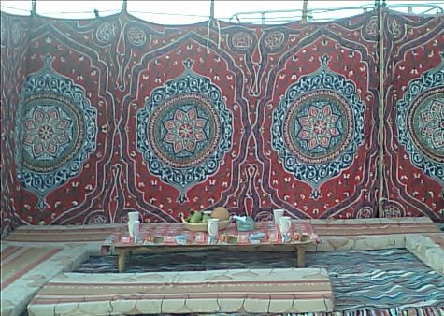

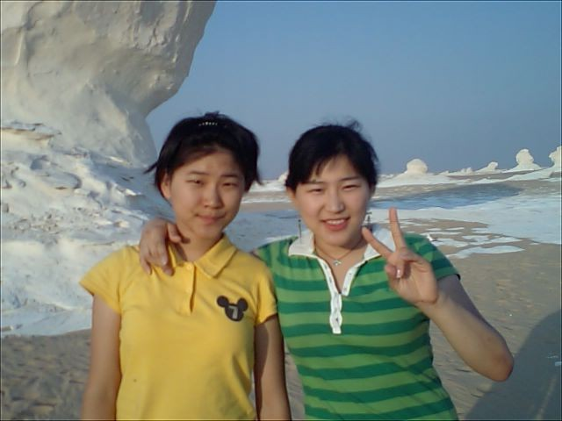

Arctic Animals Photos

Otters
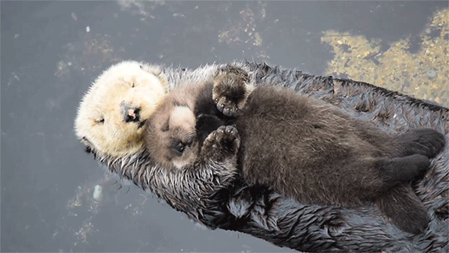

Seal Pup
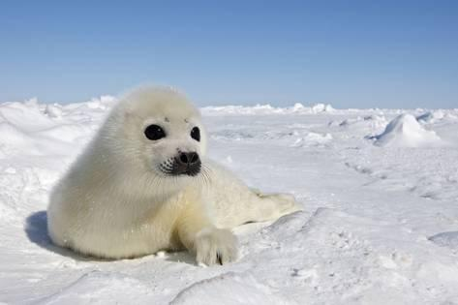

Walrus Calf
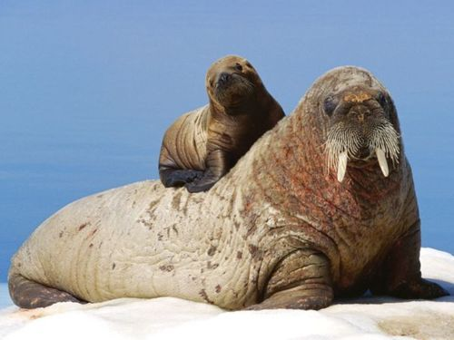

Puffin
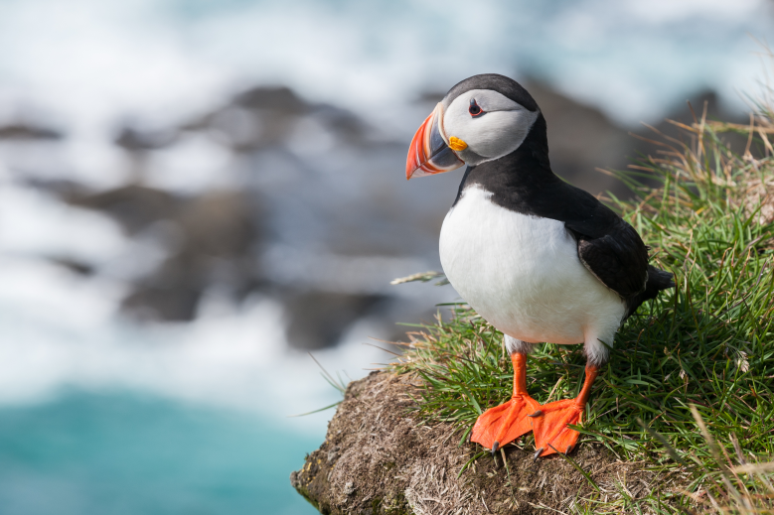

Kittiwake
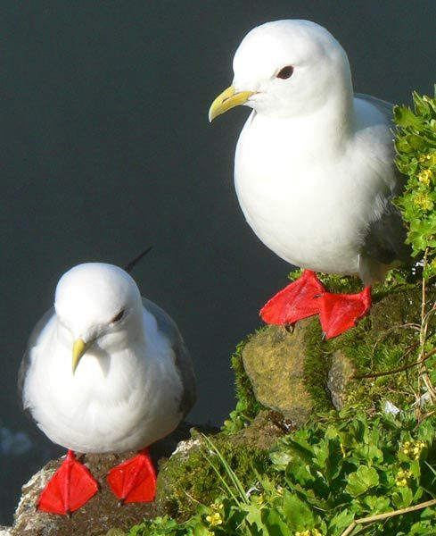

Murre
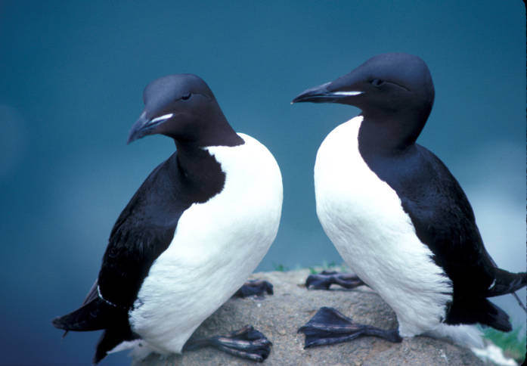

Arctic Fox
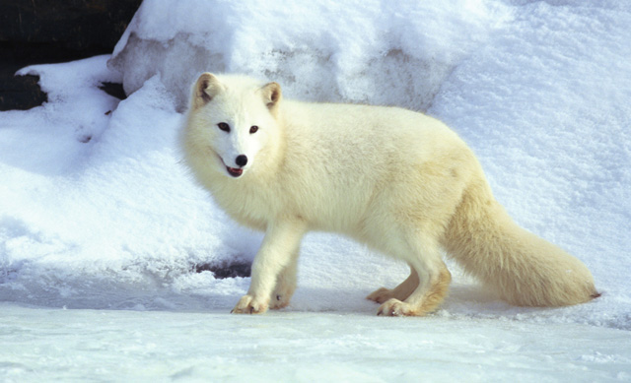

Arctic Animal Book Images (Original Image)
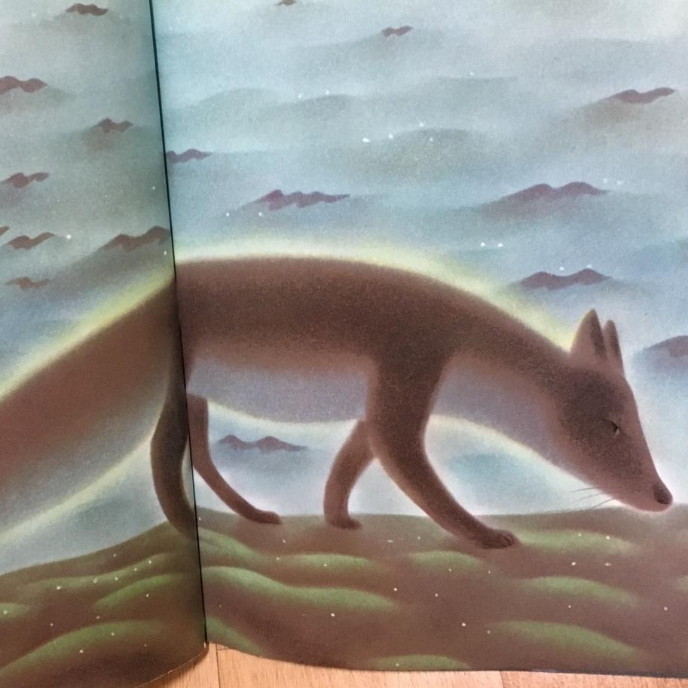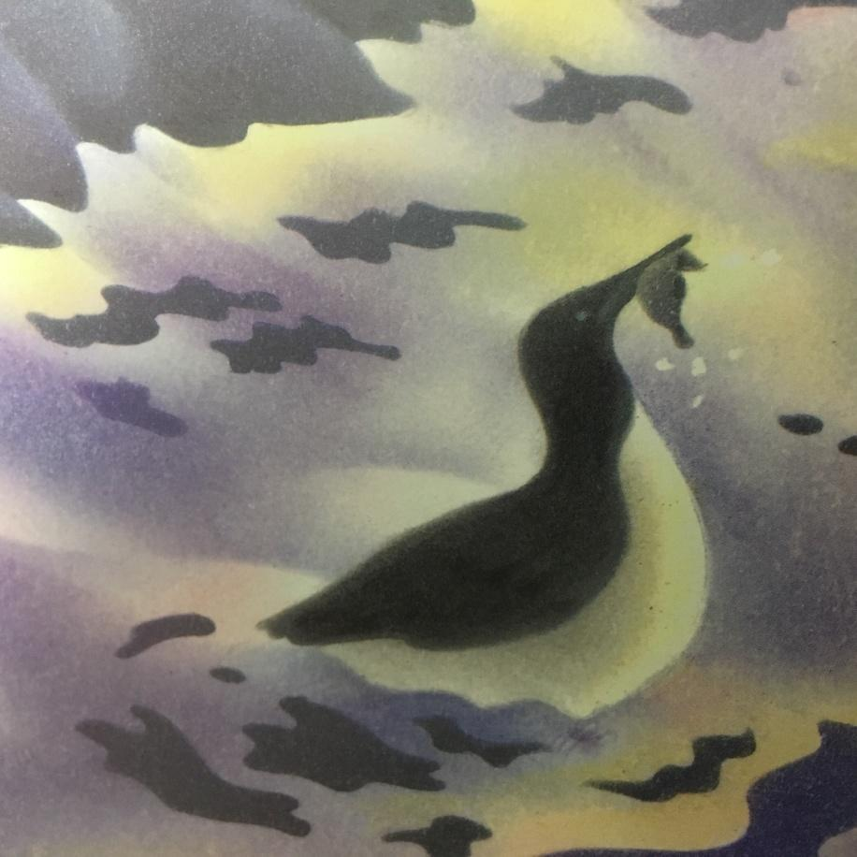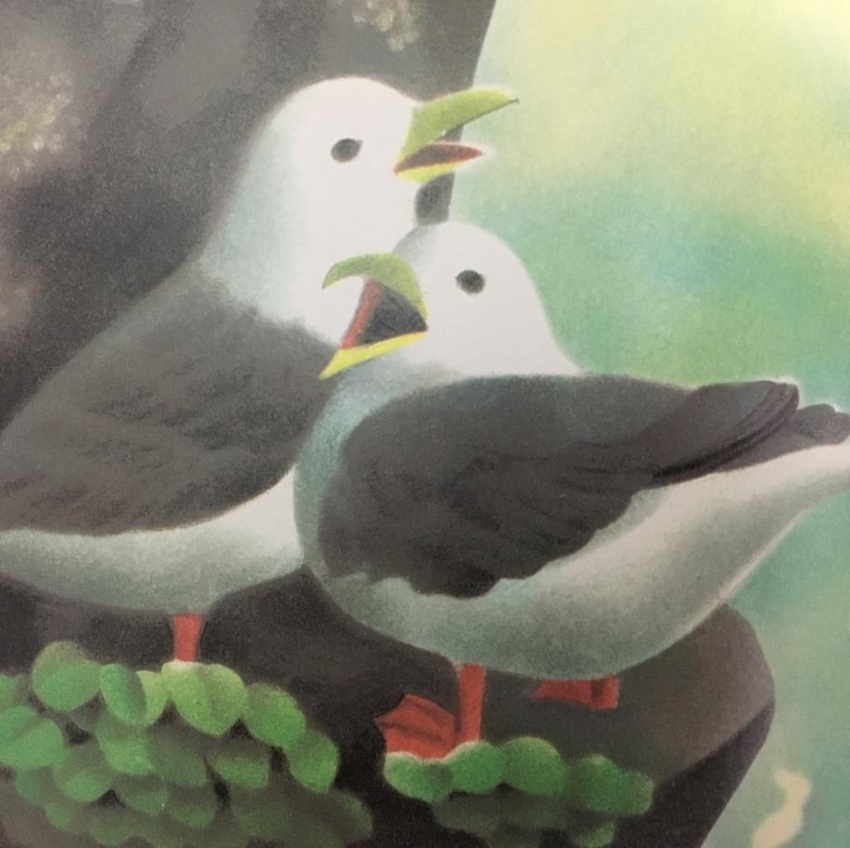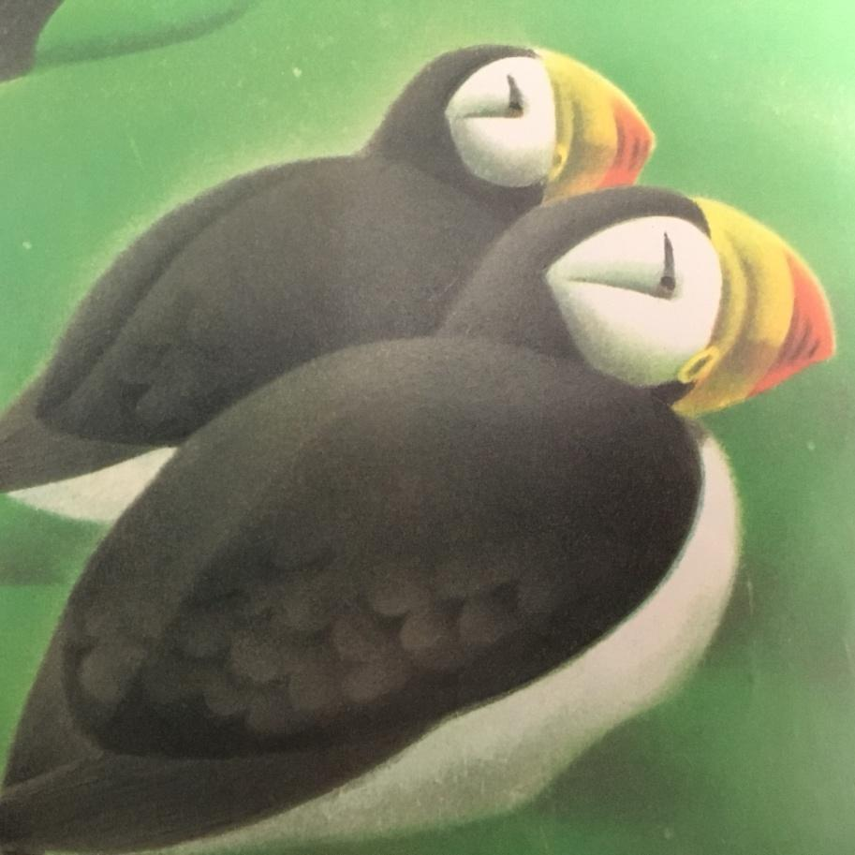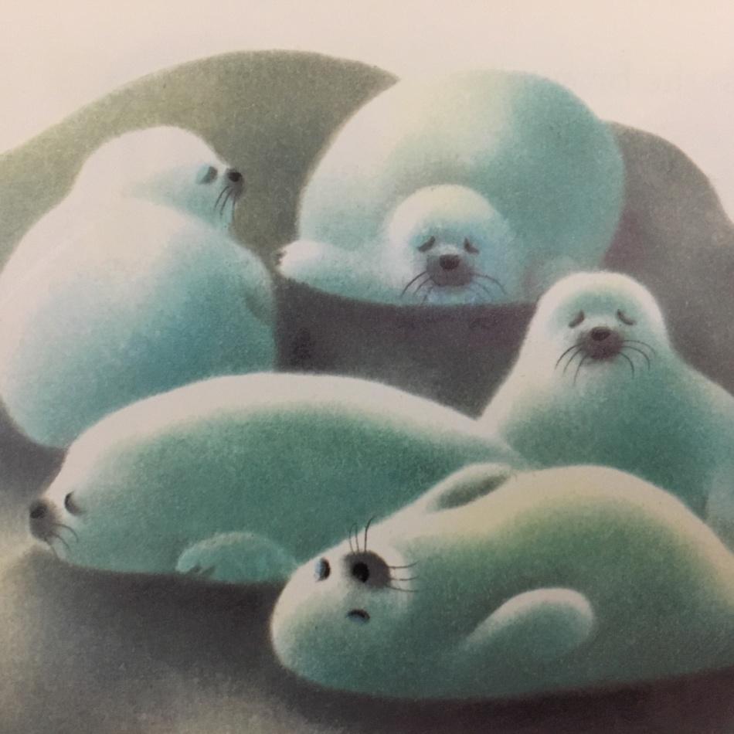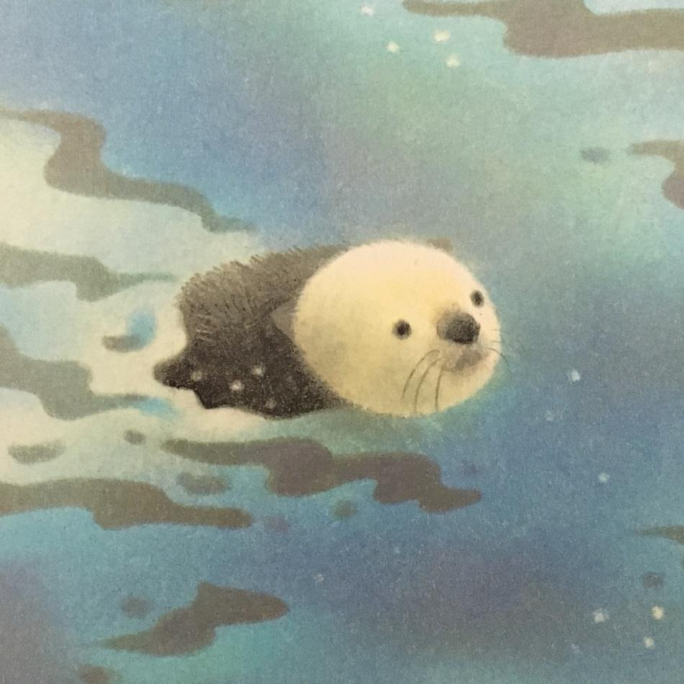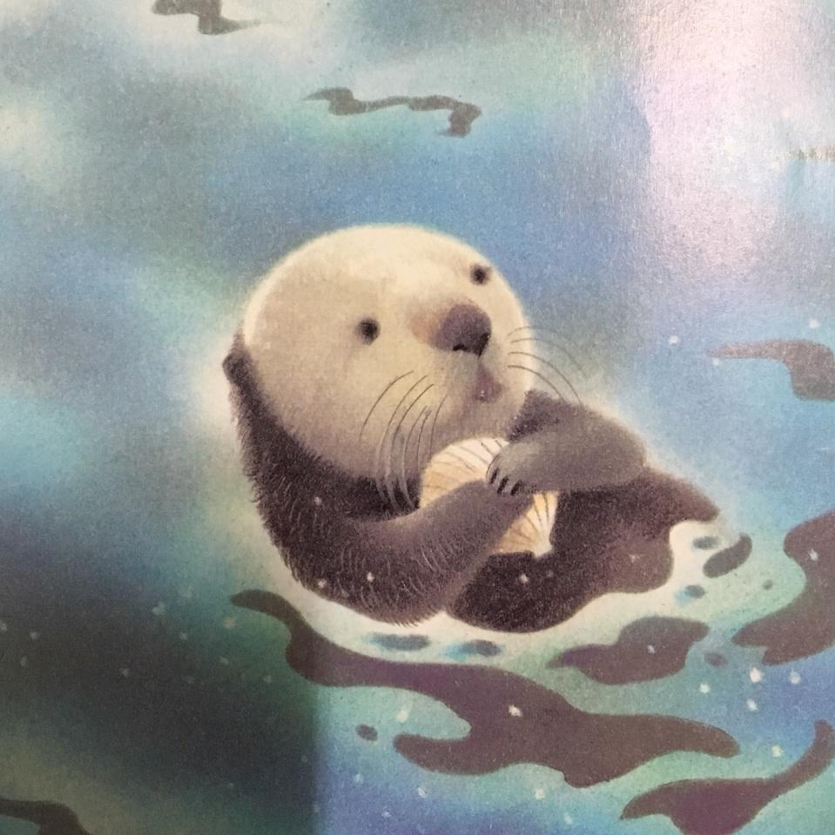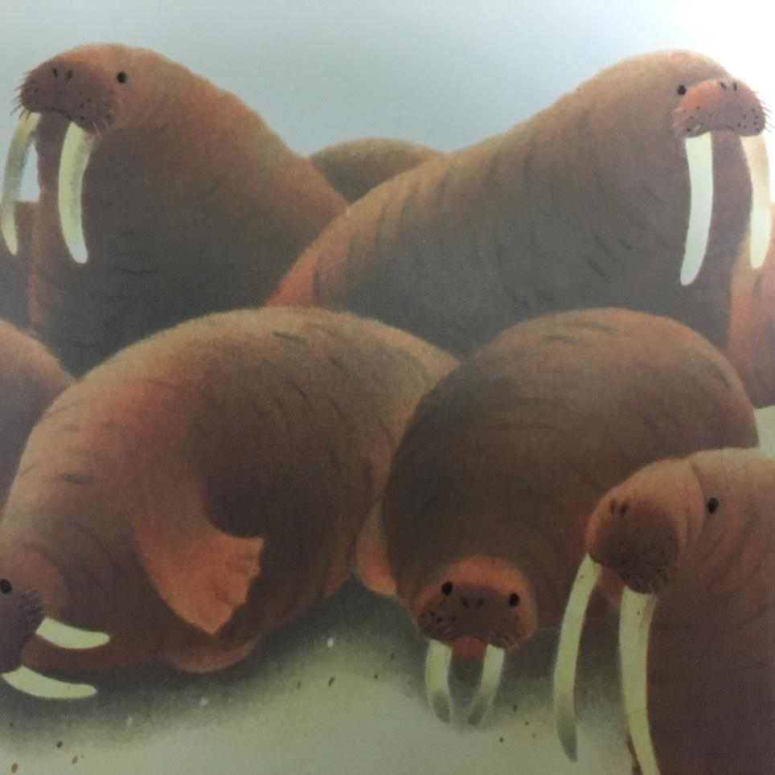

Arctic Animal Book Images Memory Card Set
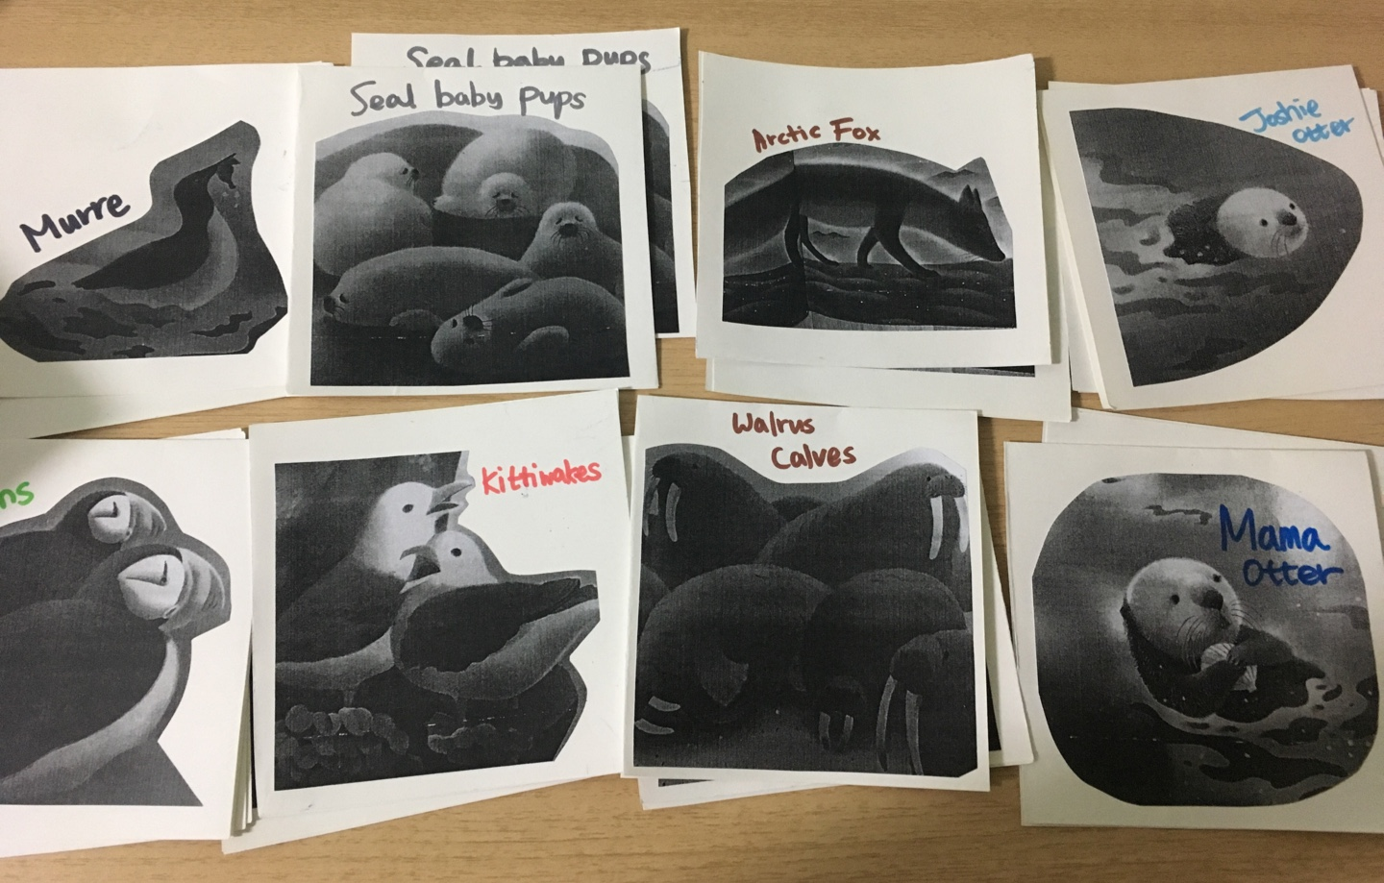

Lyrics Puzzle
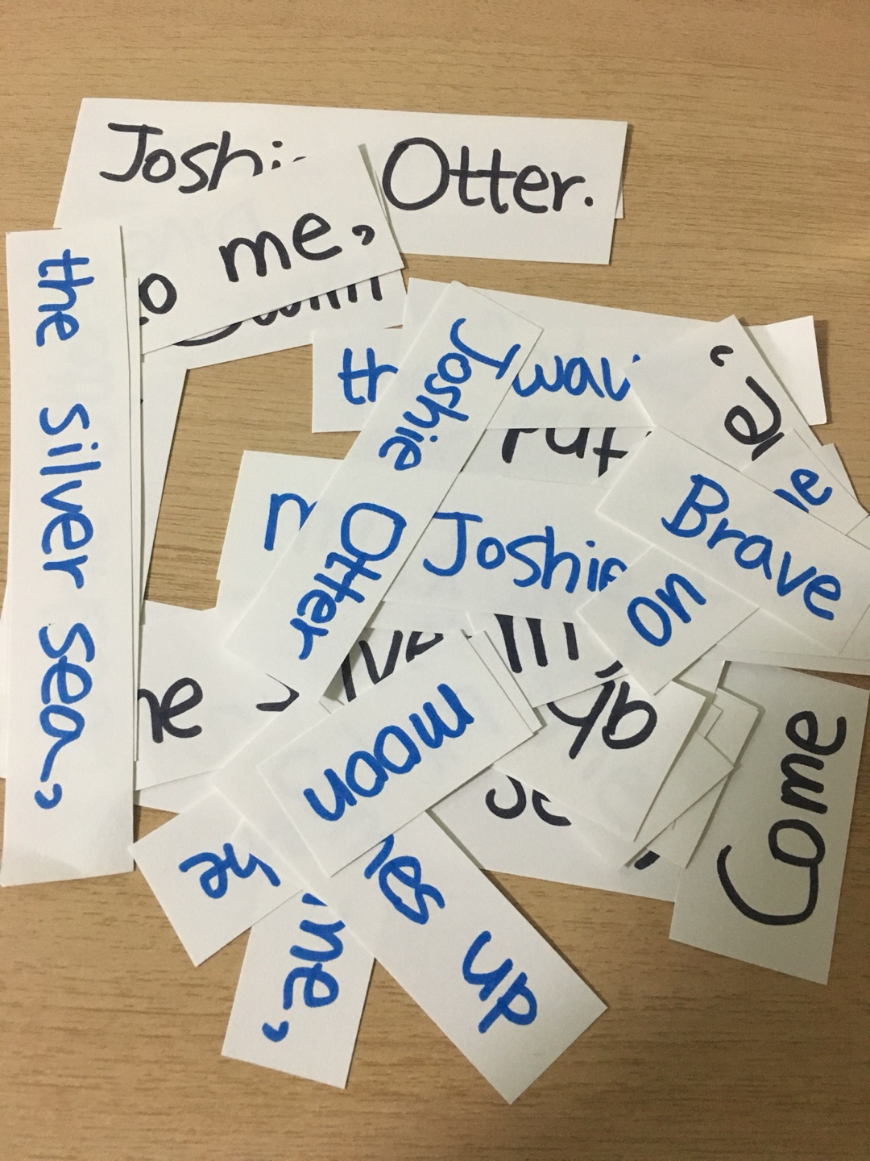

Phrase Sticks and Memos

