XXX Activity or Task Based Lesson Language Based or Presentation, Practice, Production PPP Based Lesson
Storytelling Lesson Plan Puppet Play Presentation

Topic: How To Design Your Dream Robot

Instructor:  Sujin | Students Competency Level and Student ages  Elementary, 7-9 years old | Number of Students:  10 students | Lesson Length:  50 minutes
Materials: (List the Names of all materials used in the lesson. Materials must be shown at the end of this document)
- Whiteboard and Markers.
- Cell Phone
- Bluetooth Speaker
- Body Song MP3
- Picture Flash Cards:
- “Body Part”
- “Bone Structure”
- Big Hero Video Clip
- “Design Your Dream Robot” Worksheet.
- Movable Paper Robot Parts.

Lesson Objectives: The main objective of the lesson is to learn about the names and functions and improve the ability discuss each body parts and bone structures of people.

Aims: (What students will be able to achieve by participating in the activities of the lesson. (Ss gain or get by doing…)
- Practice speaking skills by explaining the roles of each body parts.
- Improve writing skills by writing down your “Design Your Dream Robot” worksheet.
- Improve speaking skills by sharing your ideas with your partners.
- Improve listening skills by listening to other students’ robot functions.

Language Skills: (Lists what activities language skills students will be using by participating in the activities of the lesson.)
- Reading: (Where did reading occur in the lesson?)
- When Ss reads other Ss “Design Your Dream Robot” worksheet.
- Listening: (Where did listening occur in the lesson?)
When Ss listen to other Ss “Design Your Dream Robot” presentation.
When teacher talks about magic stories.
- Speaking: (Where did speaking occur in the lesson?)
When T asks students questions about body parts, bone structures, robots.
When Ss do presentation on “Design Your Dream Robot” Worksheet.
- Writing: (Where did writing occur in the lesson?)
When Ss fill out “Design Your Dream Robot” Worksheet.

Assumptions: (What students must already be able to do and what concepts must already be mastered before the lesson in order to achieve the aims of the lesson.)
- All Ss are aware of the names of body parts, humanoid robots, the movie.
- All Ss probably have their own thought of how your body parts and bones function.
- All Ss can think of their dream robot.
- All Ss will enjoy and also have fun.
- Ss are able to create future tense sentences to describe their dream robot in the future.

Anticipated Errors and Solutions: (What things might go wrong in the lesson and what the solution will be. An SOS activity should also be included)
- If Ss may not have enough ideas. Inspire them by showing the example of the teacher.
- If the activity lasts too long Ss divide the class into group, and do group presentation.
- If the activity finished too soon Teacher suggests to read the vocabularies used in the class.
- If Ss may not understand the instruction: T helps them to explain more of examples.
- If certain Ss are shyT encourages them, give positive feedback, and change roles for them.

References:
www.google.com
www.naver.com
www.youtube.com

Lead-In or Pre-Task Part (Warm-Up Part to activate and create interest in the lesson.)
Materials: (List the Names of all materials used in the Lead-In or Pre-Task Part of the lesson. Materials must be shown at the end of this document)
- “Body Parts” Song
- Cell Phone
- Bluetooth Speaker
- Picture Flash Cards:
- “Body Parts”
- “Bone Structure”

Time: | Classroom Set Up: | Student Activity and Goals: | Teacher Procedure &Instructions:
1min  3min  1min  5min  5min.  10min. | Whole  Whole  Whole  Group  Group  Group | Greeting from teacher  Ss listen and become curious.  Ss listen to the music.  Ss sing along.  Ss look at the picture of two students.  Ss write down the body parts name on the board. | Greeting.  T asks Ss how they come to the class.  T tells which body parts she used from the morning time to come to the class.  T plays “Body Song” with gestures.  T tells Ss to sing the song with the gesture together.  T draws body shapes on the board and asks Ss to write down the names of body parts they already know.  T checks and reads the Ss’ writing on the board and encourages Ss of their great work.  T introduces briefly on the “Bone Structure” and introduces the names of the bones to Ss.  T tells students how human bones and robot structures are similar.

Pre-Activity or Task Familiarization Part (Presentation Part for Presenting the language structure to be covered in the lesson. Prepares students for the communication activity.)
Materials: (List the Names of all materials used in the Pre-Activity or Task Familiarization Part of the lesson. Materials must be shown at the end of this document)
- “Big Hero” Movie Clip
- Cell Phone
- Bluetooth Speaker

Time: | Classroom Set Up: | Student Activity and Goals: | Teacher Procedure &Instructions:
5min.  5min. | Whole  Whole | Ss watch the movie clip.  Ss look at the worksheet. | T introduces and plays movie clip. T asks Ss to find out what the movie is about and who is Bay Max.  T introduces sample worksheet on “Design Your Dream Robot”

Main Activity or Task Realization Part(Practice to Production Part Teacher lead practice of the language presented and move to communication based more student centered activity)
Materials: (List the Names of all materials used in the Main Activity or Task Realization Part of the lesson. Materials must be shown at the end of this document)
- “Design Your Dream Robot” Worksheet.

Time: | Classroom Set Up: | Student Activity and Goals: | Teacher Procedure &Instructions:
2min.  10min.  10min. | Groups  Individual | Ss choose one paper.  Ss sit down with the group.  Ss look at the worksheet and fill out.  Ss give presentations. | T asks Ss to choose one paper.  (5 body part names are written on the paper: Head, Left arm, Right arm, Left Leg, Right Leg)  T tells student to sit down with the group.  T hands in “Design Your Dream robot” Worksheet.  T hands in each body parts (Head, Left arm, Right arm, Left Leg, Right Leg) of the robot.  T directs students to present their robot.  T listens and responds to individual presentation.  T facilitates class feedbacks.

Post Activity or Post Task Part (Wrap-Up Part to Close the Lesson on a high note to and consolidate language learned in a communication based activity new situation.)
Materials: (List the Names of all materials used in the Post Activity or Post Task Part of the lesson. Materials must be shown at the end of this document)
- Joints

Time: | Classroom Set Up: | Student Activity and Goals: | Teacher Procedure &Instructions:
2min.  3min. | Whole  Whole | Ss look at the board.  Ss listen to T’s wrap-up.  Clap hands together. | T gathers the worksheet together and put them together on the board.  T gathers the each paper robot body parts and connects them together with joints.  T tells students how they enjoyed designing the robot and put them together.  Congratulate and T appreciates Ss participation.

Picture Flash Cards
- Body Part
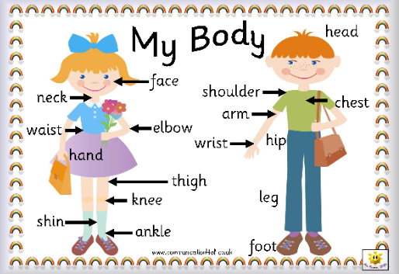

- Bone Structure
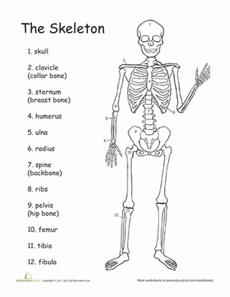

- “Your Dream Robot Design” Worksheet
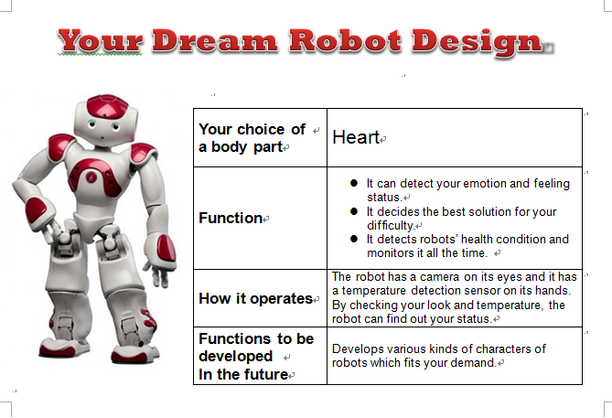

- Movable Paper Robot Shape Example
