Topic: Grocery Shopping
Instructor: | Level: | Age: | Number of Students: | Length:
Yeram Lee | Intermediate | Adults | 15 | 20 mins
Materials:
- PPT (Pictures for Pre-Task/ eliciting)
- 17 Worksheets (Task Preparation/Realization)
- White board (Correction if used)
- Relia (Wasabi for CCQ)
Aims:
- SWBAT use the proper container words for specific vocabularies by completing worksheet.
- SWBAT make a situation with the proper container words by role-playing.
Language Skills:
- Listening: Students will listen to other student’s ideas.
- Reading: Students will read the worksheets with the container words.
- Speaking: Students will do a roleplay with other students.
- Writing: Students will write on the worksheet paper.
Language Systems:
- Lexis: new container words (carton, packet etc)
- Grammar: making sentences for role-play
- Function: making role-play script
- Discourse: doing role-play
Assumptions:
- Ss know the basic word of grocery shopping items (e.g chocolate, cigarettes)
- Ss can make a creative short conversation for the role-play.
Anticipated Errors and Solutions
- If Ss have wrong answer for the blanks, correct them with the right answer key.
- If Ss don’t talk during the activity, motivate them to talk more with their partners.
- If Ss need more time to finish worksheet, give them more time and cut off the time of post-task.
References:
Containers (n.d). In Teach This ESL/EFL Resources, Retrieved February 6, 2019, from https://www.teach-this.com/functional-activities-worksheets/shopping
Notes:

Pre-Task:
Aims: Students will be interested in today’s topic. |  |  | Materials: Pictures(PPT)
Time | Set Up | Student |  | Teacher
3 mins | Whole Class | Answering T’s questions |  | - Greeting  Hello, everyone. Good morning. Did you guys have a great holidays?  - Eliciting  What can you see in this picture?  What is the difference between 2 pictures?  What are they covered with?  How can you describe 2 other ones?
Notes:
Task Preparation:
Aims: Students will use proper container words for specific items. |  |  | Materials: Worksheet/PPT
Time | Set Up | Student |  | Teacher
1 min  5 mins | Whole Class  Pairs | Listening T’s instructions  Preparing their task |  | -Explaining the activity  Today we are going to learn some “container words” that goes with the specific items.  I’m going to give you guys the worksheet to work on for 5 minutes!  Before we move on, let me give you the instruction for the worksheet.  -(ppt page2)  Both of them are Pair Activities, so you will work with your partner.  For activity A, Fill in the blanks with your partner. Share your ideas. NO SILENCE PLEASE!  Then do activity B.  Once you’re all done, you will be sharing what you’ve got for Activity B with everyone here.  -Passing out the worksheet  -Grouping  2 ppl x 6 , 3ppl x 1  Worksheet #(3 each , the rest 2)  -ICQ  What are you going to do?  How much time do you have?  Are you working in groups?  You may begin to work with your partner.  (Monitoring them and offer guidance.)
Notes: Not using a lot of white board in order to save more time for activity.
Giving them the alarm.
Task Realization:
Aims: Students make a short conversation with the proper container words by role-playing. |  |  | Materials: Worksheet
Time | Set Up | Student |  | Teacher
7 mins | Pairs | Presenting their role-play |  | Everybody done with your worksheet! Right?  -Presenting their role-play  Let’s see how everyone came up with the role-play using the container words.  -Make them to present theirs in orders.  (No correction)  (Writing down feedbacks)
Notes: NO CORRECTION
Post Task:
Aims: Students will get the feedbacks and the answer key for the worksheet. |  |  | Materials: Worksheet/PPT
Time | Set Up | Student |  | Teacher
4 mins | Whole Class | Listening to T  Answering T’s question |  | -Giving them the correct answers  (ppt page 3)  Everyone did a great job!! Answer keys are here on the screen.  -Feedbacks  Using the note that T took during Task-Preparation and Realization.  (complimenting creative role-play)  (Focusing on the bold ones)  -CCQ  (ppt page 3) How can you describe this picture now?  Can you tell me what this is using the “container word”? (Showing the relia)  Great! Did you enjoy these activities? Hope you did! Thank you for participating well for my class. Have a great day
Notes:

[Images for eliciting]
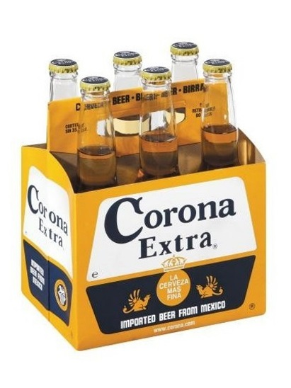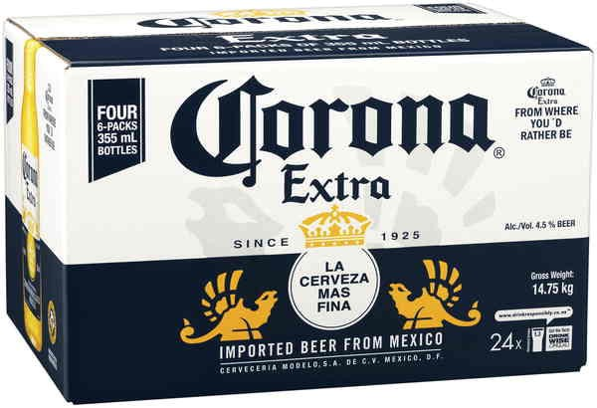

[Worksheet]
- Complete the shopping items with the container words from the box. You can use the container words more than once. Several items may have more than one correct answer. Talk with your partner!
bar bottle box can carton
case crate jar tin tube packet
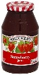
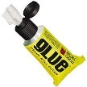

- a ______________ of glue
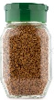
- a ______________ of beer
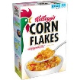
- a ______________ of coffee
- a ______________ of cereal
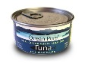
- a ______________ of soap
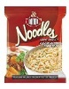
- a ______________ of tuna
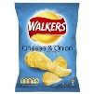
- a ______________ of noodles
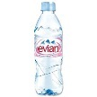
- a ______________ of crisps
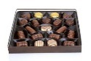
- a ______________ of water
- a ______________ of chocolates

- a ______________ of jam
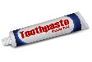
- a ______________ of milk
- a ______________ of toothpaste
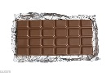
- a ______________ of orange juice
- a ______________ of chocolate
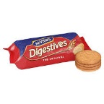
- a ______________ of Coke
- a ______________ of biscuits
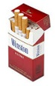
- a ______________ of honey
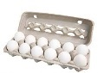
- a ______________ of cigarettes
- a ______________ of eggs
- Now, make a short conversation with your partner for role-playing! Make sure you use all of the assigned container words. Talk with your partner!
For example) A: Wife / B: Husband
A : You bought a lot for groceries! Did you buy what I asked for?
B : I got a case of soft drinks and four cans of tomato juice!
A : What?! I asked for you to buy mango juice, not tomato one!
B : Oops! Sorry!

[Worksheet]
- Complete the shopping items with the container words from the box. You can use the container words more than once. Several items may have more than one correct answer. Talk with your partner!
bar bottle box can carton
case crate jar tin tube packet

- a ______________ of glue
- a ______________ of beer
- a ______________ of coffee
- a ______________ of cereal
- a ______________ of soap
- a ______________ of tuna
- a ______________ of noodles
- a ______________ of crisps
- a ______________ of water
- a ______________ of chocolates

- a ______________ of jam
- a ______________ of milk
- a ______________ of toothpaste
- a ______________ of orange juice
- a ______________ of chocolate
- a ______________ of Coke
- a ______________ of biscuits
- a ______________ of honey
- a ______________ of cigarettes
- a ______________ of eggs
- Now, make a short conversation with your partner for role-playing! Make sure you use all of the assigned container words. Talk with your partner!
For example) A: Wife / B: Husband
A : You bought a lot for groceries! Did you buy what I asked for?
B : I got a case of soft drinks and four cans of tomato juice!
A : What?! I asked for you to buy mango juice, not tomato one!
B : Oops! Sorry!

[Answer sheet]
Answer key (some answers may vary)
1. a tube of glue
2. a bottle/can/case/crate of beer
3. a jar of coffee
4. a box of cereal
5. a bar of soap
6. a can/tin of tuna
7. a packet of noodles
8. a packet of crisps
9. a bottle of water
10. a box of chocolates
11. a jar of jam
12. a bottle/carton of milk
13. a tube of toothpaste
14. a bottle/carton of orange juice
15. a bar of chocolate
16. a can/bottle of Coke
17. a packet of biscuits
18. a jar of honey
19. a packet of cigarettes
20. a carton of eggs

