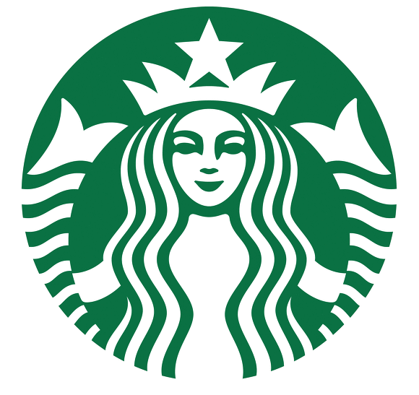
<Picture>

<Worksheet>

Discussion - No purchase needed to sit in Starbucks cafes

STUDENT A’s QUESTIONS (Do not show these to student B)
- What images are in your mind when you hear the word 'cafe'?
- What do you know about Starbucks?
- Do you think Starbucks has made the right decision?
- What are the disadvantages for Starbucks of the new policy?
- Would you sit in Starbucks without buying anything?
- Do you think the new policy will make Starbucks more money?

STUDENT B’s QUESTIONS (Do not show these to student A)
- What do you think of when you hear the word 'purchase'?
- What do you think about what you read?
- What do you think about cafes?
- Have you ever been asked to leave a place?
- Will Starbucks now become a public bathroom?
- What questions would you like to ask the CEO of Starbucks?

