☐ Listening ☐ Speaking ☐ Reading ☐ Grammar ☐ Writing

Topic: What was the most embarrassing moment in your life?

Instructor:  Mia, Park | Level:  Intermediate | Students:  6 | Length:  30min

Materials:
- Computer
- TV Screen
- PPT file (slide for pre-activity, main activity)
- MP3 file of a song and new vocabularies (recorded by Jayme)
- Video file of the ‘when I kissed the teacher’ singing part of the ‘Mamma mia’
- Speaker
- Worksheet #1 – Cloze test, Worksheet #2-Crossword Puzzle
- White board, Board markers

Aims:
- Main Aim: Ss will be able to improve their listening skills by listening to a song and a voice recording file of the new vocabularies
- Secondary Aims: Ss will be able to understand lyrics of the song and improve their speaking skills by sharing their experience with the classmates
- Personal Aim: I want to increase STT

Language Skills:
- Listening: Ss will listen to the recording file of the new words and music.
- Speaking: Ss will talk and share about their own experience of the embarrassing moment in their life.
- Writing: Ss will write the correct phrases from the song.
- Reading: Ss will read phrases from the song, new vocabularies, past tense sentences.

Language Systems:
- Phonology: [ i ], [ i:]
- Lexis: New vocabularies in the lyric of the song.
(Scream, Dream, Believe, Blush, Fool, Petrified, Take by surprise, Go wild, Hold my breath, etc.)
- Grammar: Past tense
- Functional: Sharing the personal experience
- Discourse: Lyrics

Assumptions:
Ss already know
- Their personal experience
- Musical Movie ‘Mamma Mia’
- How the class is organized and operated (3 at each table)
- They need pencils and papers for the class

Anticipated Errors and Solutions:
- If Ss do not want to come out to the front and present their story
- I will explain the benefit of having a chance to speak in English in front of other classmates. (e.g. Saying it helps to improve their speaking skills and become more confident.)
- If Ss need linguistic support,
- I will encourage them to inquire a teacher anytime or let them use the dictionary or internet website.
- If a certain student contributes too much to the discussion
- I will kindly point out the next person to speak

References:
- Listening file & script : Googled.
- Video file : https://www.youtube.com/watch?v=BWnKGYnuE8o&start_radio=1&list=RDBWnKGYnuE8o&t=61
- Vocabularies recorded by Jayme

Lead-In
Materials: None
Time | Set Up | Student Activity | Teacher Talk
1min | Whole class | Answer to the teacher’s question | Good afternoon, everyone.  Let’s start with my story today. Oh my god. This morning, on the way to come to this class, I was a bit late, so I ran really fast to catch a subway, but I couldn’t make it. Because, I tripped my ankle and fell off. So many people were looking at me and even laughing.  Can anyone imagine how I felt at that time?  (Ss answer)

Pre-Activity
Materials: Computer, PPT file, TV Screen, Voice recorded file, white board, board markers
Time | Set Up | Student Activity | Teacher Talk
4min  4min | Whole class  Whole class | Answer to the question out loud  Listen & Repeat words and sentences on the screen | Procedure:  1.Prediction  Elicit  (PPT slide on the screen)  Please, look at the screen. What do you see in the picture? Can you guess how the guy on the picture is feeling?  (Ss answer)  How about the next picture? Can you guess how she is feeling now?  Model  (Write the topic “the most embarrassing moment in your life” on the board)  Today’s topic is “the most embarrassing moment in your life”.  CCQ  How do people normally react when you feel embarrassed?  2. New Vocabulary  Instruction  (PPT slide on the screen)  We are going to learn new vocabularies & expressions before we listen to the music. Let’s look at the screen. We will listen the MP3 file first and repeat it. And, anybody who knows the words or expressions, please, explain shortly what it means for the classmates.  ICQ  What will you do after listening?  Who will explain the meaning of the words? Teacher? Or someone who knows the words?  Let’s start.  (If Ss give any answer, say ‘good job’ or ‘that’s great’ and so on)

Main Activity
Materials: Worksheet(6copies), Listening MP3 file, PPT file, Computer, TV screen
Time | Set Up | Student Activity | Teacher Talk
5min  4min  2min | Individual/Whole class  Whole  class  Individual | Ss complete the worksheet #1  Listen and repeat | 1. Listening to the song  We will listen to the song related to the topic ‘the embarrassing moment’. This song is from the musical movie ‘Mamma mia2’.  Instruction  I will give you a worksheet. It’s lyrics of the song and also a cloze test. Please, find correct words and fill in the blanks individually while listening to the music. After listening 2times, we will discuss the correct answer together.  (Hand out worksheet #1)  ICQ  Are you working individually or in groups?  How many times are we going to listen to the song?  Let’s listen!  Monitoring  (Play a song 2times, ask if Ss finish the worksheet. If they want to listen again, do it.)  Check answer  (After 2 or 3times listening)  Was there any difficult part? Let’s share the answer.  Wrap-up  (After discussion)  We will watch a part of the ‘Mamma mia’. Just the singing part ‘When I kissed the teacher’. Let’s see and listen carefully again.  2. Learning the past tense sentences  (PPT slide on the screen)  Instruction  You may catch that the lyrics of the song ‘when I kissed the teacher’ are full of the past tense sentences. So, We are going to learn the past tense grammar now. Look at the screen. First, you will listen to the sound, and read it loudly.  ICQ  What grammar are we going to learn?  What are you going to do? Only listen? Or listen and repeat?  (Once Ss practice to speak the whole sentences together, Ss take turn to read for each sentence)

Post-Activity
Materials: White board, Board marker
Time | Set Up | Student Activity | Teacher Talk
5min  4min  1min | Group  Whole class  Whole class | Ss talk about the topic  Presenters present their story  Ss listen and answer to the teacher’s question | 1. Sharing the experience  Instruction  (There are 3 in each group. Ss share the most embarrassing moment in their life in groups. Each group choose the best story.)  Please, think of the most embarrassing moment in your life now. And, share your story with your groups. After that, each group should choose one person who has the most embarrassing moment in your groups. I will give you 5minutes.  ICQ  What story are you going to talk?  Do you work individually or in groups?  How many minutes do you have?  Are you going to choose more than one person who has the most embarrassing moment?  You may begin now.  Monitoring  (Quietly walk around the class room. Check to see if the Ss are on track. Answer to questions.)  (After 5 minutes)  Sharing  Presenters of each group, please come out to the front. Please, write the keyword of your story on the board and share your story with the classmates shortly. Everybody please listens carefully.  2. Wrap-up  (Recap the new vocabularies and sentences of the past tense learned today. Pick out grammatical and pronunciation errors Ss made during the class and find correct answers with Ss.)  Well done everybody. Please, try to remember all the vocabularies and sentences we learned today. Especially, I want to suggest repeatedly saying the past tense sentences we learned today. As many times as you can until the next class! I will check if you remember them. If you have any questions, please feel free to keep in touch with me. Thanks!

SOS Activity
Materials: Crossword Puzzle worksheet (6 copies)
Time  4min  1min  1min | Set Up  Group  Whole class  Whole class | Student Activity | Teacher Talk
 |  | Ss complete the crossword puzzle using new vocabularies from the song learned today | - Crossword Puzzle  Instruction  Now, we are going to complete the crossword puzzle using the words we learned today. Read the definition below the puzzle and find out the answer. You can discuss with your group. Share some ideas. I will give you 4 minutes to complete the mission. Once you finish it, please let me know.  (Hand out worksheet #2)  ICQ  Do you work individually or in groups?  How many minutes do you have?  Monitoring  (Quietly walk around the class. See if Ss are on track. Answer to questions.)  Check Answer  Ask the answer to each student I choose. Everyone takes their turn at least once.  Wrap-up  Let’s read the answers out loud all together and finish today’s class.

When I Kissed the Teacher
Song from ‘Mamma Mia 2’
Sung by Lilly James

Everybody screamed
When I kissed the teacher
And they must have thought they dreamed
When I kissed the teacher
All my friends at school
They had never seen the teacher blush
She looked like a fool
Nearly petrified 'cause she was taken by surprise

When I kissed the teacher
Couldn't quite believe her eyes
When I kissed the teacher
My whole class went wild
As I held my breath
The world stood still but then she just smiled
I was in the seventh heaven
When I kissed the teacher

Pre-Activity : Prediction

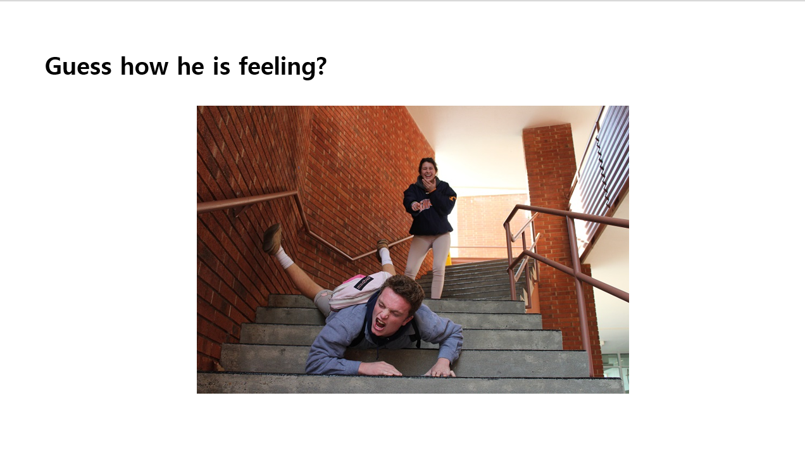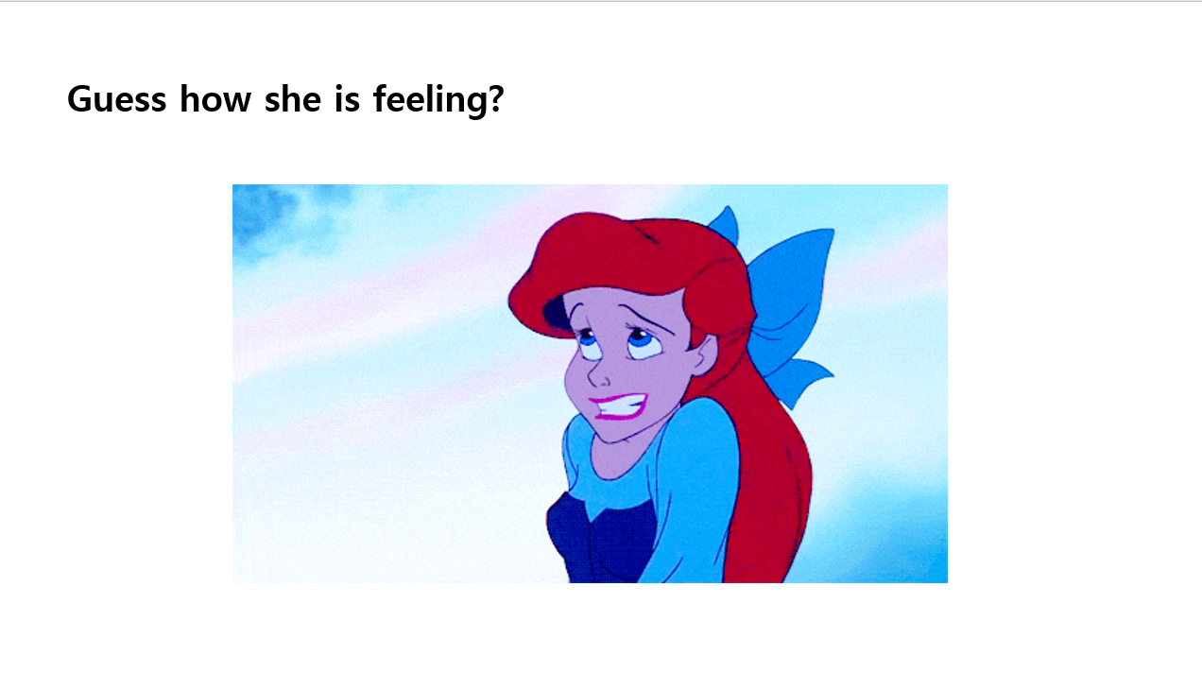

Pre-Activity: New Vocabularies

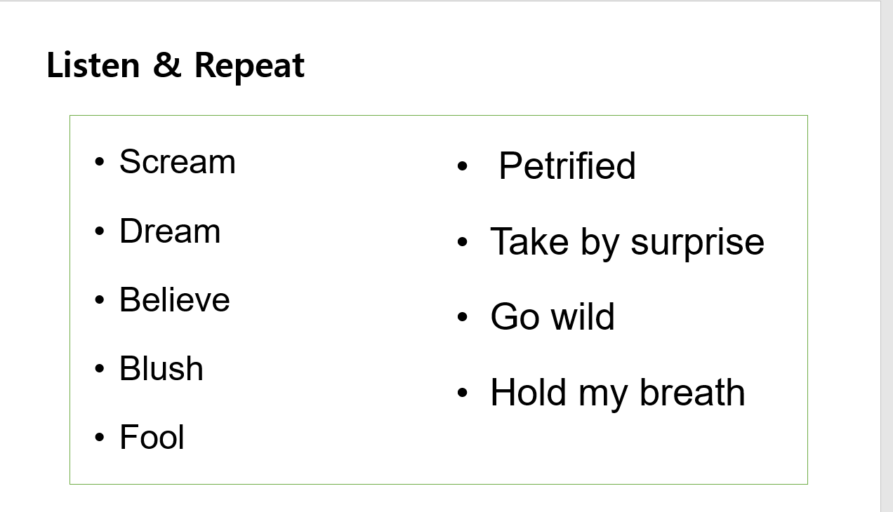

Main Activity: Cloze test (Lyrics of a song, Worksheet #1)

When I _______ the teacher
Song from ‘Mamma Mia 2’
Sung by Lilly James

Everybody __________
When I _______ the teacher
And they must have ________ they _________
When I _______ the teacher
All my friends at school
They ____ never seen the teacher _______
She _______ like a ____
Nearly _______ 'cause she was taken by _______

When I ______ the teacher
Couldn't quite ________ her eyes
When I ______ the teacher
My whole class _____ wild
As I _____ my breath
The world _______ still but then she just ______
I ____ in the seventh heaven
When I ______ the teacher

Main Activity: Cloze test (Lyrics of a song, Worksheet #1) Answer Key

When I Kissed the Teacher
Song from ‘Mamma Mia 2’
Sung by Lilly James

Everybody screamed
When I kissed the teacher
And they must have thought they dreamed
When I kissed the teacher
All my friends at school
They had never seen the teacher blush
She looked like a fool
Nearly petrified 'cause she was taken by surprise

When I kissed the teacher
Couldn't quite believe her eyes
When I kissed the teacher
My whole class went wild
As I held my breath
The world stood still but then she just smiled
I was in the seventh heaven
When I kissed the teacher

Main Activity: Practice of Past tense sentences (ALM)
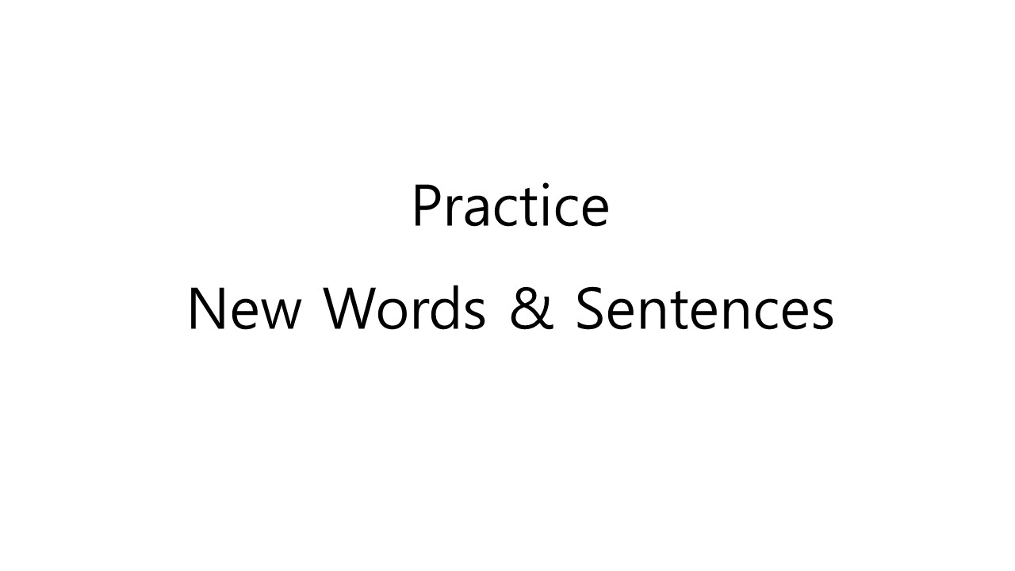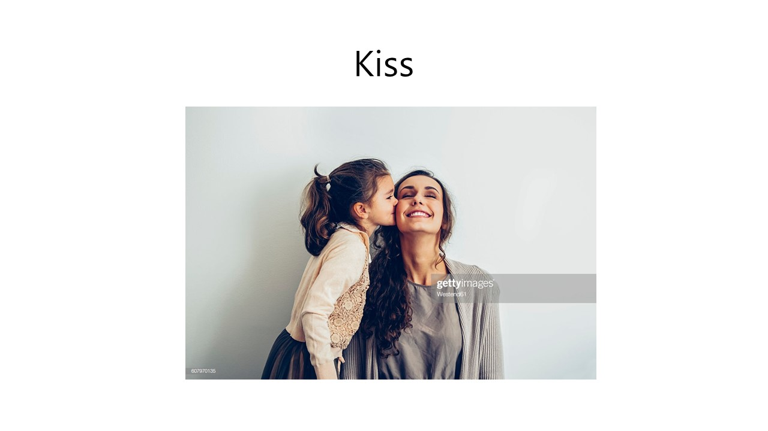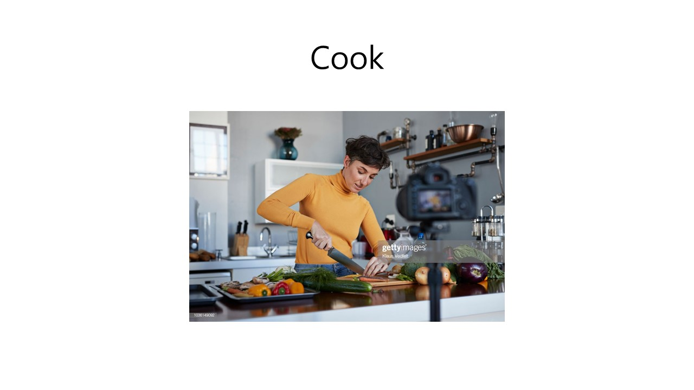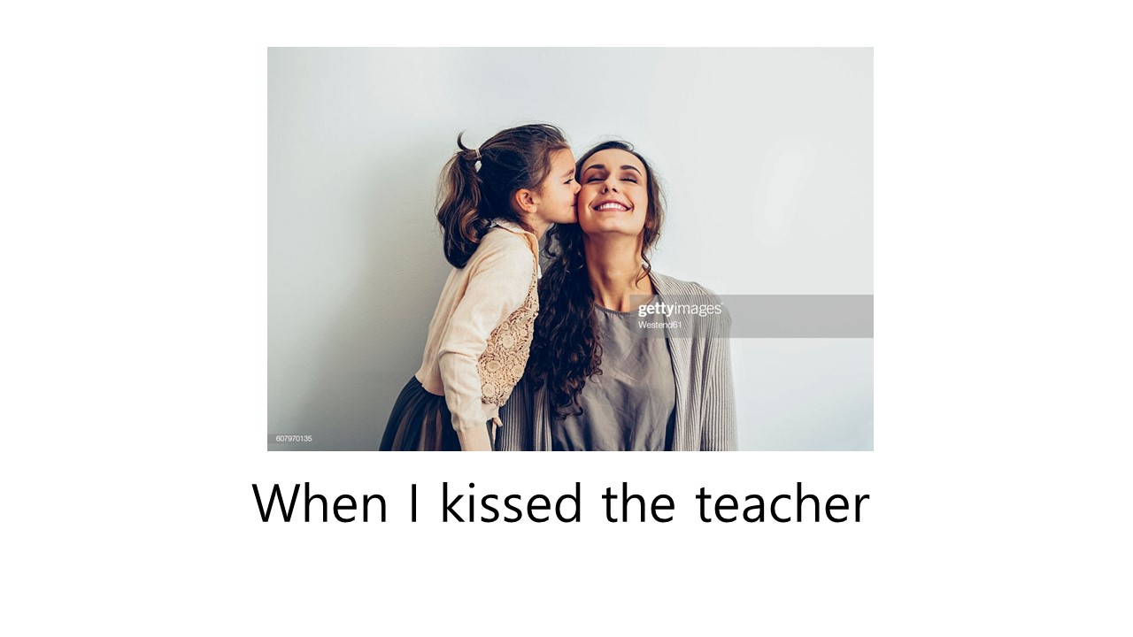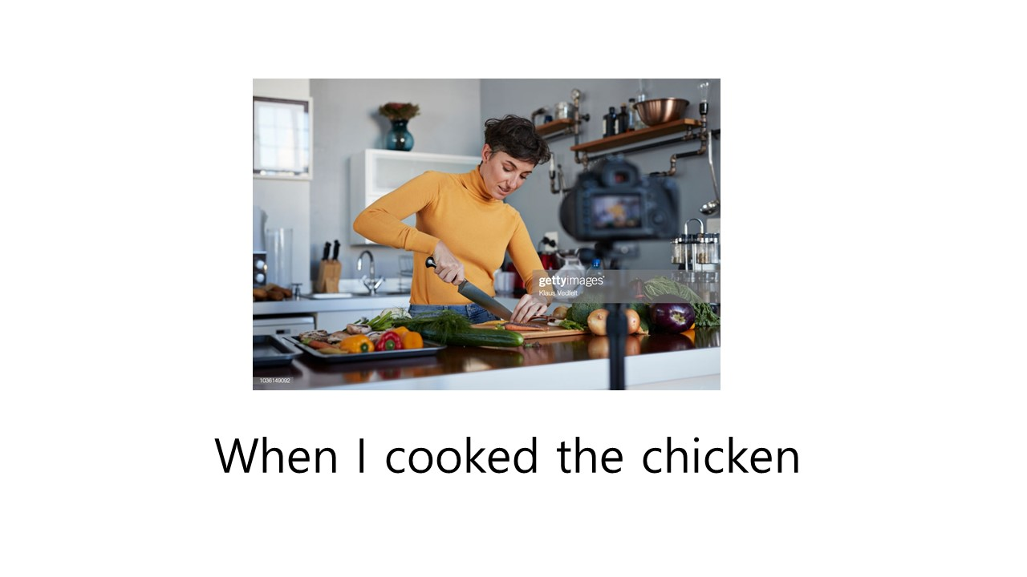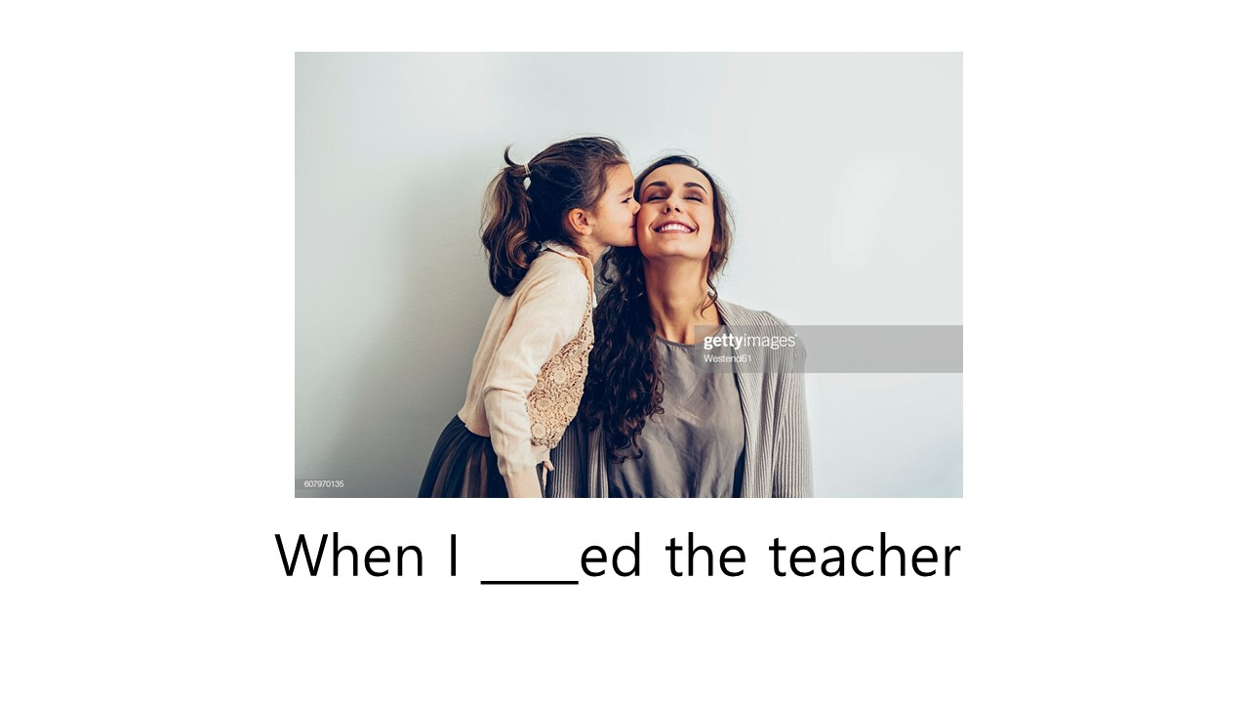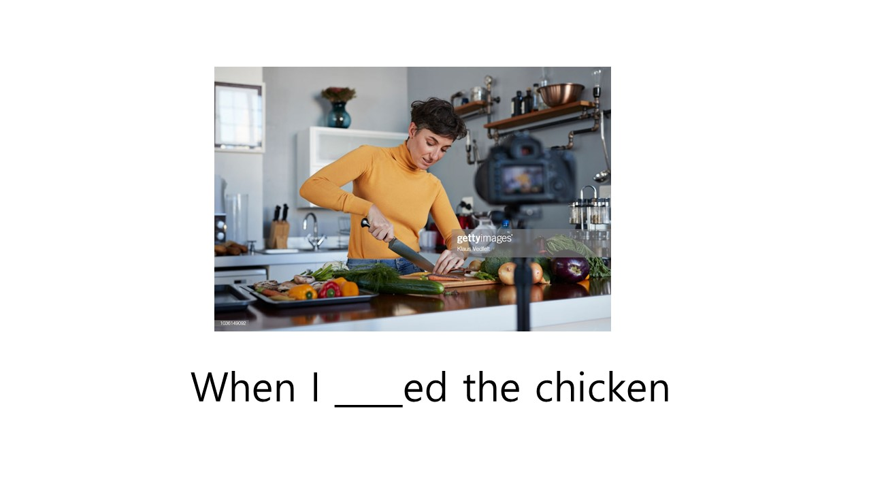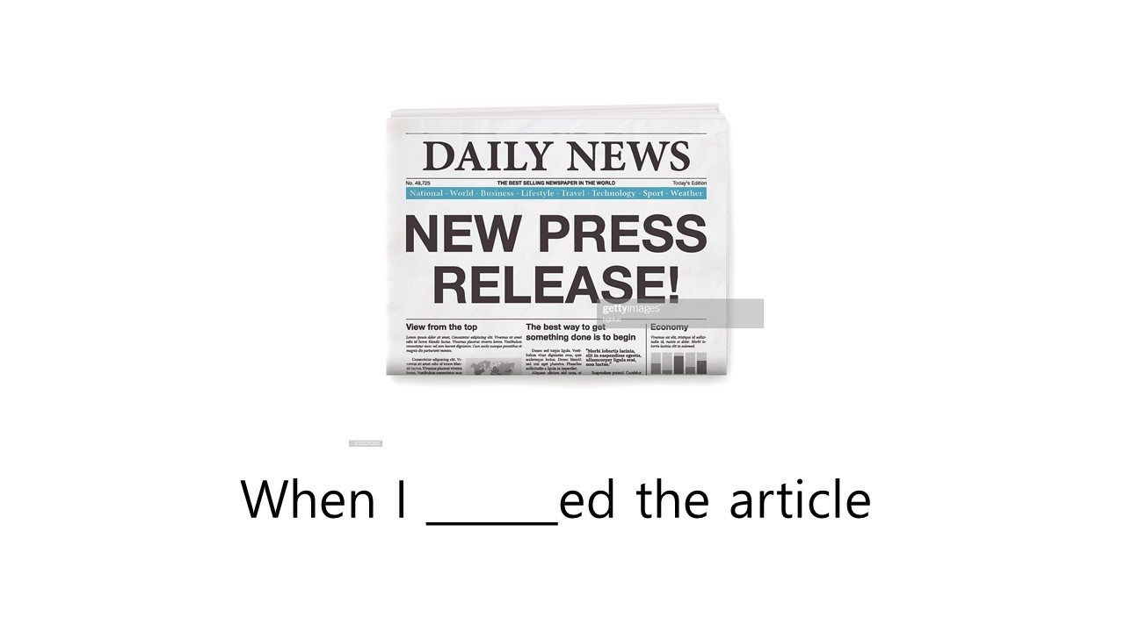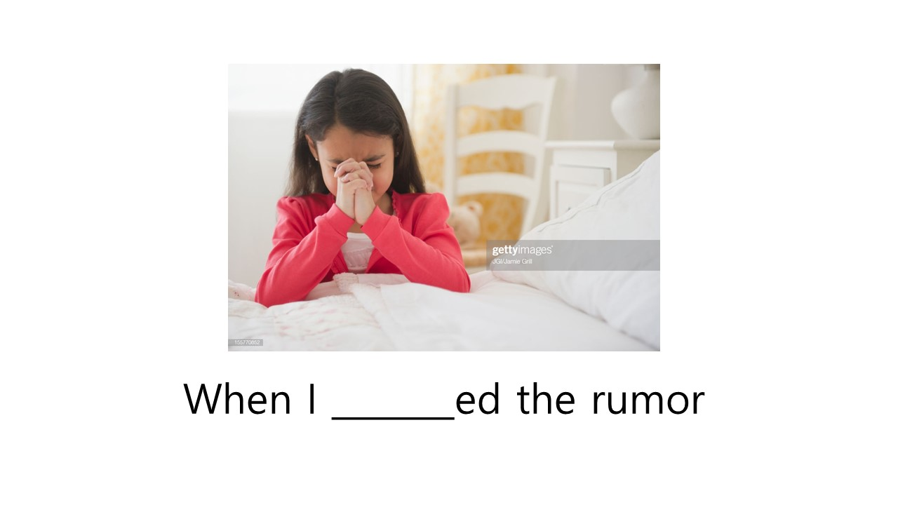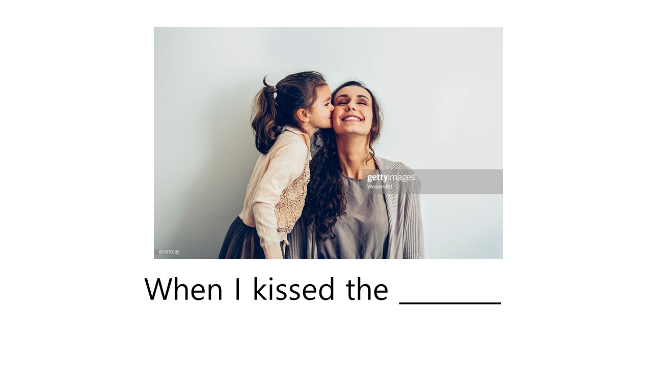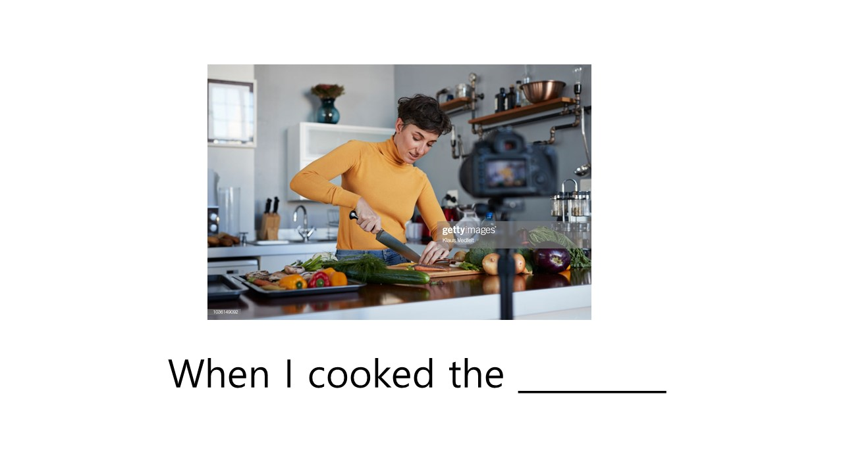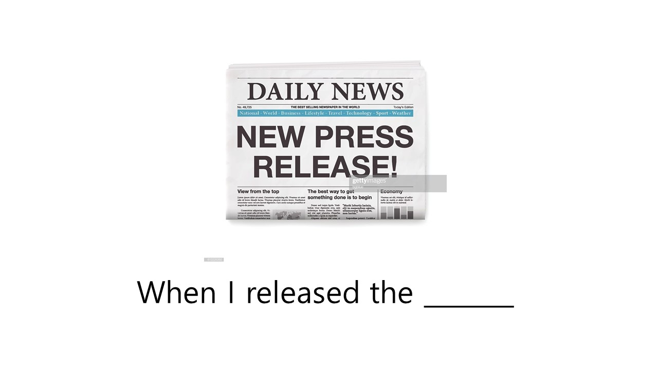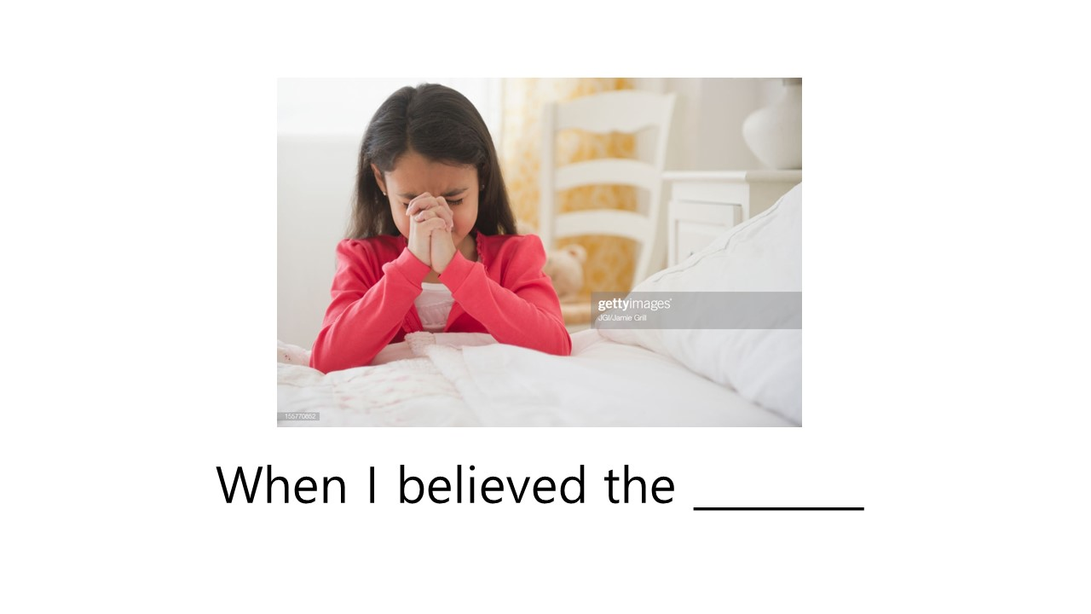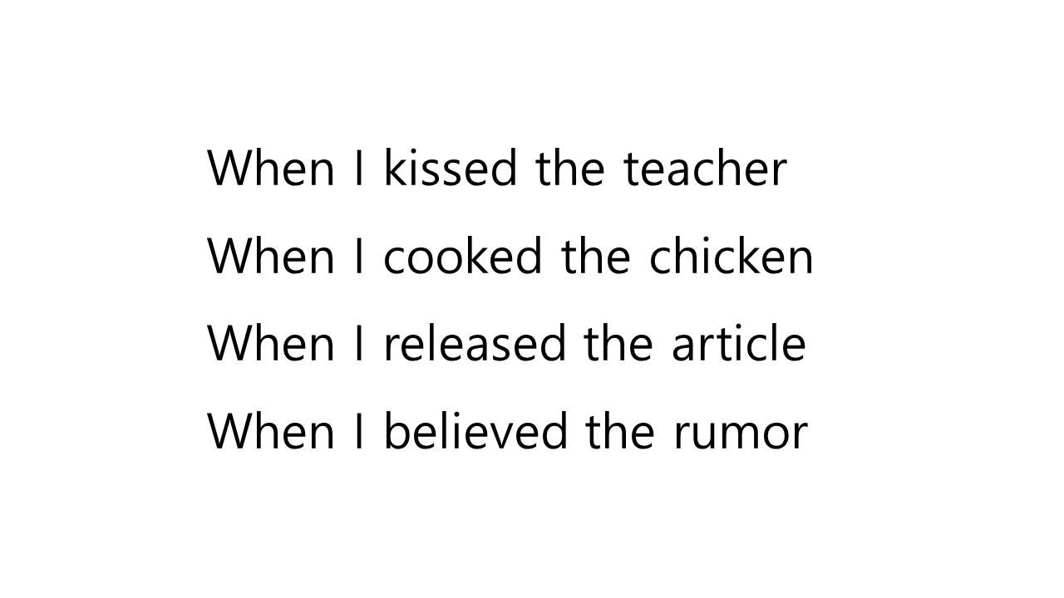

SOS Activity: Crossword Puzzle (Worksheet #2)

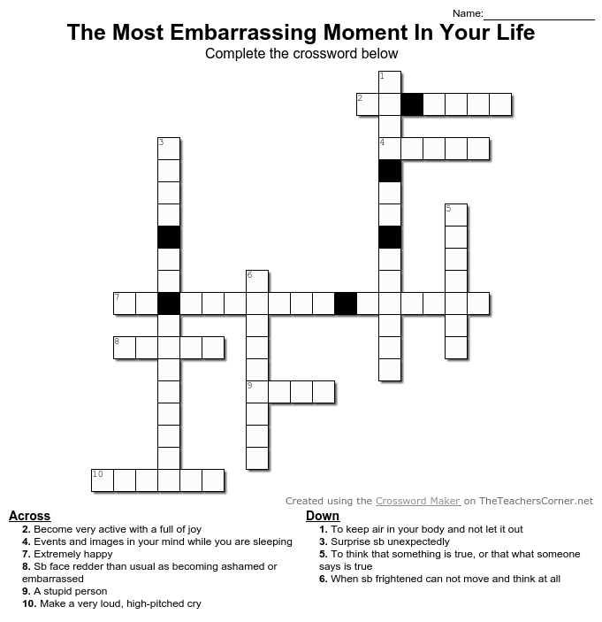

SOS Activity: Crossword Puzzle (Worksheet #2) Answer key

