■Listening □ Speaking □Reading □Grammar □ Writing

Topic: “How to make stress your friend” - Kelly mcgonigal

Instructor:  Ju myo Gyoung | Level:  Intermediate (Adult) | Students:  7 students | Length:  30 Minutes

Materials:
- Computer
- PPT file (Elicit) as pre-activity
- PPT file (Vocabularies) as pre-activity
- White board and marker
- Video script sheets
- Worksheet #1
- Worksheet #2 (Sos activity_cryptogram)
- Materials for poster (pens, papers, etc.)
- Playing Music (on the website as youtube) during post activity.

Aims:

- Main aim: Ss will be able to improve their listening abilities by listening to Kelly mcgonigal speech and understanding contents.

- Secondary aim: Ss will be able to learn the meaning of vocabularies through activities. And have a positive mind through listening the speech.

- Personal aim: I want to have an organized class and teach fluently without hesitating.

Language Skills:
- Reading : Ss will read phrases from the script.
- Listening : Ss will listen to the Ted speech video.
- Speaking : Ss will speaking how to make their stress friend their own ways, Let them be a speaker in front of Ss.
- Writing : Ss will write on the board and poster in activities.

Language Systems:

- Phonology : sh vs. s
- Lexis : New vocabularies in the video about “how to make stress your friend”
(confession,psychologist,cardiovascular,relative,estimate,homicide,freak out)
- Grammar : comparative degree (happier, healthier)and superlative (lowest)
- Function : Giving information and sharing how to remove stress Ss themselves.
- Discourse : research(study)

Assumptions:

SS already know :
The basic effects of stress to their health.
They have their own way to make stress friendly.
What will discuss about after main activity.

Anticipated Errors and Solutions:

If Ss do not know the word, so they can not give an answer in pre-activity
- I will give an answer and discuss synonym that Ss know.

If Speakers system isn’t working
- Prepare the Bluetooth speaker.

If Ss can not understand the speech well.
- I will give a chance to listen again
- I will allow make speech speed slowly (1.5)

If presenters afraid to present in front of the class
- I allow presenter just stand up from her/his seat.

If Ss need more time to do activity
- I will allow them to do more.

References:
- https://www.ted.com/talks/kelly_mcgonigal_how_to_make_stress_your_friend
- Pictures : google.com
- Vocabularies : Wikipedia,
- Script from the TED.
- Music : https://www.youtube.com/watch?v=IThrTTFYDn4
- Sos activity : Speech of Kelly macgonigal,
http://www.wordles.com/getmycrypto.aspx (making Cryptogram)
- Web Timer : https://ssl.pstatic.net/sstatic/keypage/outside/timer/timer_160627_2.html

Lead-In
Materials:None
Time | Set Up | Student Activity | Teacher Talk
30 Sec | Whole  class | Answering to the teacher’s questions | Hello, everyone! How was your week?  Was it happy weekdays? Or blue weekdays? What made you happier or worse feeling?

Pre-Activity
Materials: PPT,Computer,Web timer,white board,Markers
Time | Set Up | Student Activity | Teacher Talk
1.5min  1min  5min | Individual  pairs  Pairs | Think and following the Tt and answer what they think one by one.  Students give an answer  Students give an answer  And participating | Procedure:  1.prediction  Elicit . (PPT)  (show some pictures on the screen)  What you felt when you look some pictures "is it good for you?"  "Which one is bad for you?"  To me, I enjoy having a time to travel. That is important to me in my life. Through travel I can get charge my mind and soul It makes me reset my condition. Why do I need this time for what???  (Students answer)  - Stress (Write on the board)  Model  (Write the topic “how to make stress your friend” on the board)  2.New vocabulary  Instruction  We are going to learn new vocabularies before we listen to the video.  Please, look at the screen. (PPT)  This is a quiz.  Guess the hide word as green color.  Demonstration  Show First slide (word “stress”)  What is the word of?  Inference, the word!  I will give 10seconds,Each groups  Work together with your partners.  Please, Make 3 groups.  If you got an answer the vocabulary,  During time, Raise your hands.  ICQ  Are you working in pairs or not?  How much time do you have?  How can you give an answer?  Let’s start!  Monitoring  Each slide/word  (Give time warnings : you now have 5seconds/3seconds left)  Times up!  Check answers  After Right answer.  -Read the words on the slide.  -Read examples sentence.  (Do same 7 slides also) .

Main Activity
Materials: video script(7copies),video link(URL) using internet, Computer
Time | Set Up | Student Activity | Teacher Talk
3min  5min  (playing  Video  03:06) | Individuals/  Pairs  Pairs | Students read script and talk what will be on the next.  Students listen to the video. | 1.Overview of the Video  Instruction  Today’s topic is “How to make stress your friend”  First, we are going to read some parts of video script one by one.  Second, Guess what tells the video follow the script after.  After reading, I will give you 2minutes to think what will follow next.  (hands out Video Script/folded half)  ICQ  What do we First?  After reading what should we next?  How many times do you have?  Now, Let’s watch the video.  2.Listening to the video with script  Instruction  Now, let’s listen to Kelly mcgonigal’s the speech carefully.  (turn on the video 00:00~03:06)  ICQ  What will you do after listening?  Are you working Individually or not?  (give hands out, worksheet #1)  Monitoring  (If students need to listen more, give the chance to listen again)  CCQ  Does stress can draw people die?  What will you going to do If someone get stress? How can you help them?  Check answers  After match Right answer,  And sharing the ideas.

Post-Activity
Materials: Materials for making posters (color pens, papers etc.), Audio for music(youtube),web timer
Time | Set Up | Student Activity | Teacher Talk
10min  2min  2min | Pairs  Pairs  Whole  class | Students are making a poster each group and sharing their ideas. | Making a poster  Instruction  Now we are going to make a poster.  And Let’s share how to treat your stress yourselves. Which method was good to you effectively?  Make 2groups, I will give 5min  Write 5 methods on the poster.  ICQ  How many time do you have?  Are you working in groups or individuals?  How many methods?  You may start now!  Monitoring  (Play the Music minimum volume)  (Quietly walk around the classroom. Check Ss are on track. Give answers to Questions)  (Give time warnings : Now you have 3min/1min left)  Times up!  Sharing  (Presenting each group)  Please, come front each presenter of groups, who is the first?  Listen and carefully.  2.Conclusion  Alright, Thank you for sharing your own way of making stress friendly.  You all did great job!  (Do error correction ,  - Which they do not correct grammar, sentences etc  - During the presentation.  Giving some advice for presenting,  quick review  - Vocabulary,  - Phonology  - Speech contents  and wrap up the class)  Have a good dinner with your happy stress!

SOS Activity
Materials: cryptogram worksheet (7copies),web timer
Time  10min | Set Up  pairs | Student Activity  Students complete the crytogram  and | Teacher Talk  1.Cryptogram  Instruction  We are going to do cryptogram  Do you know what is this?  (explain if they do not know)  Working groups and take 10minutes!  It is related today’s topic.  Now, you may start!  ICQ  How much time do you have?  Are you working Individually or not?  (give hands out, worksheet #2)  Monitoring  (If students need to listen more, give the chance to listen again)  Check answers  After Sharing answer.  -Read that sentence.  -Remind today’s topic .

Elicit

Pre-activity (vocab) 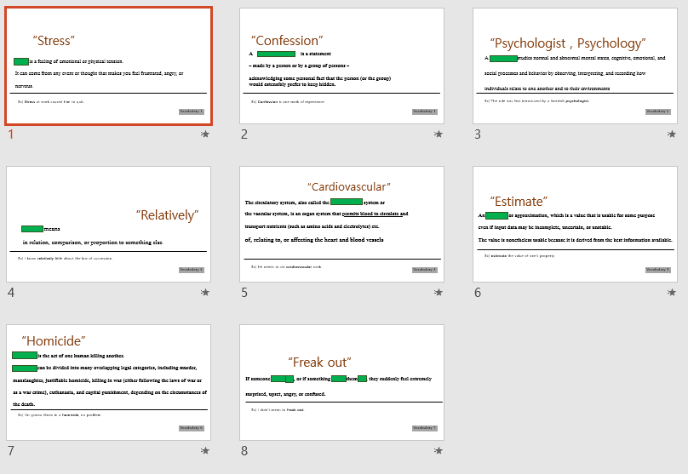

Video script
How to make stress your friend
I have a confession to make, but first, I want you to make a little confession to me. In the past year, I want you to just raise your hand if you’ve experienced relatively little stress. Anyone?
How about a moderate amount of stress? Who has experienced a lot of stress? Yeah. Me too.
But that is not my confession. My confession is this: I am a health psychologist, and my mission is to help people be happier and healthier. But I fear that something I’ve been teaching for the last 10 years is doing more harm than good, and it has to do with stress. For years I’ve been telling people, stress makes you sick. It increases the risk of everything from the common cold to cardiovascular disease. Basically, I’ve turned stress into the enemy. But I have changed my mind about stress, and today, I want to change yours.

(folding half)
Let me start with the study that made me rethink my whole approach to stress. This study tracked 30,000 adults in the United States for eight years, and they started by asking people, “How much stress have you experienced in the last year?” They also asked, “Do you believe that stress is harmful for your health?” And then they used public death records to find out who died.
Okay. Some bad news first. People who experienced a lot of stress in the previous year had a 43% increased risk of dying. But that was only true for the people who also believed that stress is harmful for your health. People who experienced a lot of stress but did not view stress as harmful were no more likely to die. In fact, they had the lowest risk of dying of anyone in the study, including people who had relatively little stress.
Now the researchers estimated that over the eight years they were tracking deaths, 182,000 Americans died prematurely, not from stress, but from the belief that stress is bad for you. That is over 20,000 deaths a year. Now, if that estimate is correct, that would make believing stress is bad for you the 15th largest cause of death in the United States last year, killing more people than skin cancer, HIV/AIDS and homicide.
You can see why this study freaked me out. Here I’ve been spending so much energy telling people stress is bad for your health.

Worksheet#1
- What does she confess?

- What is her mission?

- Does much of stress affect death?

- What makes them to lead to death people in the research?

Answer
1 : Stress is not harmful if you change mind it is not harmful.
2: Helping people be happier and healthier.
3: No, it is not. It is not consideration of how stress much.
4: Believe that stress is harmful for their health

Worksheet#2
Sos Activity_Crytogram

GX ABKMQ SZAK DK DF KZAK CQMAKMF TMAPDPG DP UXIQ NDBM APW KZMP KQIFK UXIQFMNB KX ZAPWNM KZM FKQ
MFF KZAK BXNNXWF.
And here is your hint:
Z = ”T”

Go after what it is that creates
meaning in your life and then
trust yourself to handle the stress that follows

From the speech of Kelly mcgonigal

