Listening √ Speaking Reading Grammar Writing

Topic: Weird but Creative products

Instructor:  GenalynBal(Jenny) | Level:  Advance (Adult) | Students:  Six(6) students | Length:  30mins.

Materials:
- Computer
- PPT File (Slides for the whole topic)
- Pictures
- White board & marker
- Timer
- Dice
- Candies (6pieces)
- Activity paper (6copies)
- SOS crossword puzzle (6 copies)

Aims:
- Main aim: Ss will be able to help and improve their speaking skills through the topic to be taken in the class.
- Secondary aim: Ss will be able to increase their speaking time and opportunity by participating in the class activity.
- Personal aim: Teacher will be able to make an interaction in the class and increase STT.

Language Skills:
- Listening : Ss will listen to the teacher discussing the topic on ppt.
- Reading : Ss wil read some words on the PPT while discussing it.
- Writing : Ss will write the answer on the board in pre-activity time
- Speaking : Ss will discuss on how to make an advertisement role-play.
Ss will do a role play advertisement. Ss will answer questions.

Language Systems:
- Phonology : / i / short i sound Ex: weird
/ ē / long e sound Ex: creative
- Lexis : or Vocabulary (weird, innovative, hybrid, boost, enhancer, creative)
- Grammar : Present tense, Past tense
- Function : Declarative Sentences and Question sentences (W5)
- Discourse : Daily life Article

Assumptions:
- Ss may already know on how the class are organize and operated.
- Ss may feel very uncommon on the topic
- Students may feel shy and awkward on presenting or discussing activity in the front.
- Some Ss may not participate well.
- Ss may give a long and short answers that will make the activity time confusing.
- I may not be sure if Ss will answer relatedly on some questions.
- I will not be sure if Ss will deliver the role-play well as I’m expecting.

Anticipated Errors and Solutions:
- If Ss is so shy to present or discuss activity in the front,
I will allow Ss to do it in their place.
- If Ss find some CCQ are difficult to answer
I will give them hint or clue and lead them to answer it.
- If Ss find it hard to think of concepts for discussion activity
I will give them some of my opinion that will lead them to answer.
- If Ss answer the questions in a long time
I will tell to say just give the important key points.

References:
- Listening File & script
→ https://www.boredpanda.com/funny-inventions/?utm_source=google&utm_medium=organic&utm_campaign=organic
- SOS crossword puzzle
→https://www.education.com/worksheet-generator/reading/crossword-puzzle/cm191d

Lead-In
Materials: none
Time | Set Up | Student Activity | Teacher Talk
1min | Whole class | SS will answer to the teacher’s question. | Hello everyone, how’s everyone doing today?  Can everyone tell me what is the first thing or important thing that you used today? Why?

Pre-Activity
Materials: Dice, white board & marker, PPT
Time | Set Up | Student Activity | Teacher Talk
2mins  4mins  8mins | Whole class  Pair  Whole class | Ss will listen and answer.  Ss will answer on the ff. questions  Ss will play the game (Name game with dice)  Ss will read the words on the dice  Ss will brain storm for the answer.  Ss will write the answer on the board.  Ss will read their answer.  Ss will answer the question.  Ss will read the words.  Ss will answer the question  Ss may ask some questions.  Ss will answer the question. | Procedure:  1. Prediction  Elicit  Project the PPT slide on the screen.  Okay everyone, please look at the screen. What do you see on the screen? Yes! That’s right! We see a pen, ring, dice, oat, umbrella, chair, T.V and what letter does these pictures starts with? Okay, letter p, r, o, d, u, c, t. Good! Let’s arrange these letter to make a word. Look at all the pictures I show you. What is the common thing between them? Where can we see them?  Wait for the Ss answer  Yes, we can see some of them in our house, and do we use them?  Wait for the Ss answer  Yes! Of course. Do you know it now?  Wait for the Ss answer  Alright, it’s PRODUCT! Good job!  We have many things that we buy, use, need, and sometimes we make it. These things are called PRODUCT. As you can see here, these products can find anywhere and everywhere. Alright, now let’s find out what products can we find in a place and where can we find them.  We will play a game named, “name game with dice”. I have a dice here with me. As you can see every part of the dice has words. Let’s read them first. Okay, now you just throw the dice and answer the part that comes out.  Demonstration  Let me show it to you.  Throw the dice. Answer the part that comes out. Okay, you will do it like this. Proceed.  Instruction  Okay, let’s do it by pair.  Team C will throw the dice 1st then team B and last A.  I’ll give you 2 minutes to think and 2 minutes to write the answers on the board.  ICQ  Are you working in a pair or by your- self?  How much time do you have?  Where are you going to write your answer?  Monitoring  Walk around the class. Check if the Ss are working on the right track Give some opinions or hint if needed.  Times up! Alright write your answer on the board now.  Discuss the Ss answer.  CCQ  Now, as we do our activity, have you ever think of a new must item or product that we will definitely need in the future?  What it is? Why?  Wait for the Ss who will answer it.  Topic  Project the topic slide in PPT.  I know that you have an idea of what topic are going to be discuss now.  Alright, Our topic for today is about, “weird but creative products”.  But before we proceed, let’s 1st learn the vocabularies in this topic.  Show the slide of vocabularies.  Okay, these are the list of words we will talk about. Everyone, let’s read it.  Let the Ss read the words.  Good, Now, let’s find out the meaning of each word.  Proceed.  Show the vocabulary 1st and ask Ss if they know it then show the picture that describe the word. After that show the synonyms of the vocabulary.  Repeat the same thing with the rest vocabulary.  Then show the slide where the last vocabulary is define by a famous scientist as a quote.  According to Albert Einstein………  Now, I will show how these products are weird but creative.  Proceed. Show each slide (pictures) discuss and explain to Ss. Be aware of the unexpected questions from Ss.  So those are some of the products that are much unknown to us but not now anymore coz we know them now, and I want everyone to think of a way on….  CCQ  How these products are to be known to other people? How would we introduce it to them?  Wait for the Ss to answer.  Well, this will be our main activity.  Proceed

Main Activity
Materials: PPT, Pictures, timer
Time | Set Up | Student Activity | Teacher Talk
1min  4mins  5mins | Pair | Ss will read the question  Ss will answer the ICQ  Ss will have brain storm with their partner.  Ss will do advertisement role-play  Ss will answer the questions. | 1.Overview  Like what some of you said that, if we want other people to be known of these products we need to sell it. So, we should make or think of a way on how to sell it right?  Show the PPT slide of the activity.  Will everyone read the question?  Okay, Thank you! Alright, we will do a role play in advertising these products.  Instruction  I will give candies for each of you  Those who have the same color are partner.  Move the Ss seat.  From here yellow, then orange and pink.  Put the pictures of the products with color cover on it then let Ss to choose.  Look at the board. Choose what color you want.  I will give you 4 minutes to talk with your partner on how to do it.  ICQ  Are you working in pair or individual?  How much time do you have?  What questions are you going to use?  Okay, You may start now  Monitoring  Walk around the class. Check if the Ss are working on the right track. Give Ss some opinions and help if needed.  Time warning  1 minute left. Please be prepare on everything that you need.  After the given time…..  Okay everyone let’s start with pink team then orange and last yellow.  Everyone please respect and let’s listen to every team presentation.  Alright, Pink team will you please come on the front.  Pink team will presents their role-play.  Wow that was a cool advertisement. Okay, thank you. Let’s give them claps.  Next team please.  Oh! That was remarkable. Thank you orange team.  Claps….  The last but not the least yellow team.  Good job! That was awesome. Thank you yellow team  Claps…..  Alright everyone you did a great job!  All of you did your role great.  CCQ  If you will buy or choose a product from these 3 teams, what it would be and why?  Give Ss time to answer.  Wait for Ss who will answer it  Proceed

Post-Activity
Materials: activity paper (6 copies), pictures
Time | Set Up | Student Activity | Teacher Talk
1min  2mins  2mins | individual | Ss will listen to the instruction.  Ss will answer the ICQ  Ss will write their answer on the worksheet.  Ss will answer the questions  Ss will listen and answer the questions | 1.Discussion  Instruction  Put the pictures on the board.  Let’s think of these product’s uses in our life. Everyone will pick 3 products that you think will be helpful to you. I will give worksheets here to write on. I will give you 2 minutes to work on it.  Hand out the worksheets.  ICQ  Are you working individually or whole?  How much time do you have?  Alright you may start now.  2.Monitoring  Walk around the classroom. Give opinions if needed.  Time warning  30 seconds left.  After the given time…  Times up!  Discussing the Ss answer.  So let’s see what everyone’s choices.  Let’s start with Mia, What did you choose? And why did you choose it? Oh! you choose it because…….  Say and shows you are interested.  Call another Ss to share their answer.  How about Lydia, What did you choose? And why did you choose it?  Say and shows you are interested.  Alright, so every one of you has different reasons on choosing these products. Like our status, gender, preferences and need to them affects on how we chooses.  3.Conclusion  Wrap-up  Review on the topic taken today.  Okay guys, What do we call things that we need and use and sometimes we also make?  Can you give me some synonym of the word creative? How about the word weird?  What is the thing that will wakes us in the morning with refreshing drink? Wow! Good job. Everyone is so impressive today. Try to keep in mind those things we did today. Thank you for your great participations.  Class dismissed. Bye!

SOS Activity
Materials: cross word puzzle worksheet (6 copies)
Time | Set Up | Student Activity | Teacher Talk
5mins | individual | Ss will solve the crossword puzzle.  Each Ss will answer each puzzle problem one by one. | Crossword puzzle  Instruction  Okay guys, since we still have time.  Now let’s complete this crossword puzzle using the words we learned today.  Read the synonym of the words at the bottom part and write the correct word on the puzzle.  You have 3minutes to do so.  Distribute the worksheet.  ICQ  Are you working in group or individually?  How much time do you have to work?  You may start now.  Monitoring  Walk around the class. Check if the Ss are working on the right track. Give help or opinions if needed.  15 seconds left. Hurry up!  After the given time…  Check the answers.  Let’s check your answer. Let’s start from Jinny. What’s no.1?  Next……..  Let the Ss answer each puzzle one by one.  Call the next Ss and so on….  Good job! Everyone has a good memory.  Class dismissed.

Speaking Script
I have list of some weirdest and the coolest inventions that I have found and want to share, so let’s see these marvelous invention!
Let’s start with….
1. Baby Mop (a cleaning tool)
- A baby outfit with a mop attached so that parents could send little crawlers out to clean their floors.
- It will keep you amused while they do the mopping and in turn your baby will respond to laughter and the smile on your face.
2. Ab Hancer
- The Ab Hancer is a quick way to complete a set of abs in minutes, without the work-out. This is a handy metal bar tool that allows you to gain a 6 pack of abs in minutes.
All you have to do is wrap it around your waist or mid-section and leave it there for as long as you desire for the maximum results.
3. Pizza Scissor
- Use these for perfectly cut and even pizza slices. That means everybody gets the same amount of food.
- Plus, to ensure a perfect slice of pizza arrives on your plate without any damage, the Pizza Scissors also include an integrated spatula. So just cut the slice, lift it up and let it glide onto your plate. The spatula works as a measure for the next slice, too.
4. Roller Buggy - Baby Stroller & Scooter hybrid
- The Roller Buggy is a multi-functional baby carriage transformable into a scooter. Through a simple pull motion of the lower body, it extends the normal baby carriage into a scooter, making a more sportive and faster transportation on various terrains and giving both parties a good time.
5. Flask Tie
- it comes with a hidden pouch inside the fabric where you can hold your favorite beverage of choice. That way, you can walk around wearing a full load of alcohol around your neck, ready to loosen you up any time you feel the stresses of the day taking over.
6. Full body Umbrella
- the awesome ‘full-body’ umbrella looks like five umbrellas put together, with some extra material to fill up gaps, and is held by a handle in the center—so the umbrellas surround its user keep him/her dry.
If it’s raining cats and dogs, no umbrella can keep you dry unless it’s the full body umbrella. Yeah it’s a weird mish-mash of umbrellas, probably not that comfortable either, but if it works for you, it works.
7. Hug Me Pillow
- For those who can’t fall asleep alone, the Hug Me pillow should be as must have item.
- Use the pillow as a body pillow; as a neckroll; unique pillow shape; great for snuggling.
8. The Barisieur – the coffee alarm clock
- The Barisieur Coffee Brewing Alarm System” is a godsend for those of us who need their caffeine fix as soon as they wake up! As the alarm goes off, your nose is embraced by the scent of freshly brewed coffee, and you get your energy boost right there, in bed!
- it will serve you a cup of coffee in the morning. Imagine what it will be like to be awakened by the smell of your favorite drink.

So these are only some of weird and creative products and there more of them if you search it on internet.

Post-Activity: Activity paper
Student’s Name :

Direction: Choose 3 products that you think you need and useful for you. Write your answers on the space below.
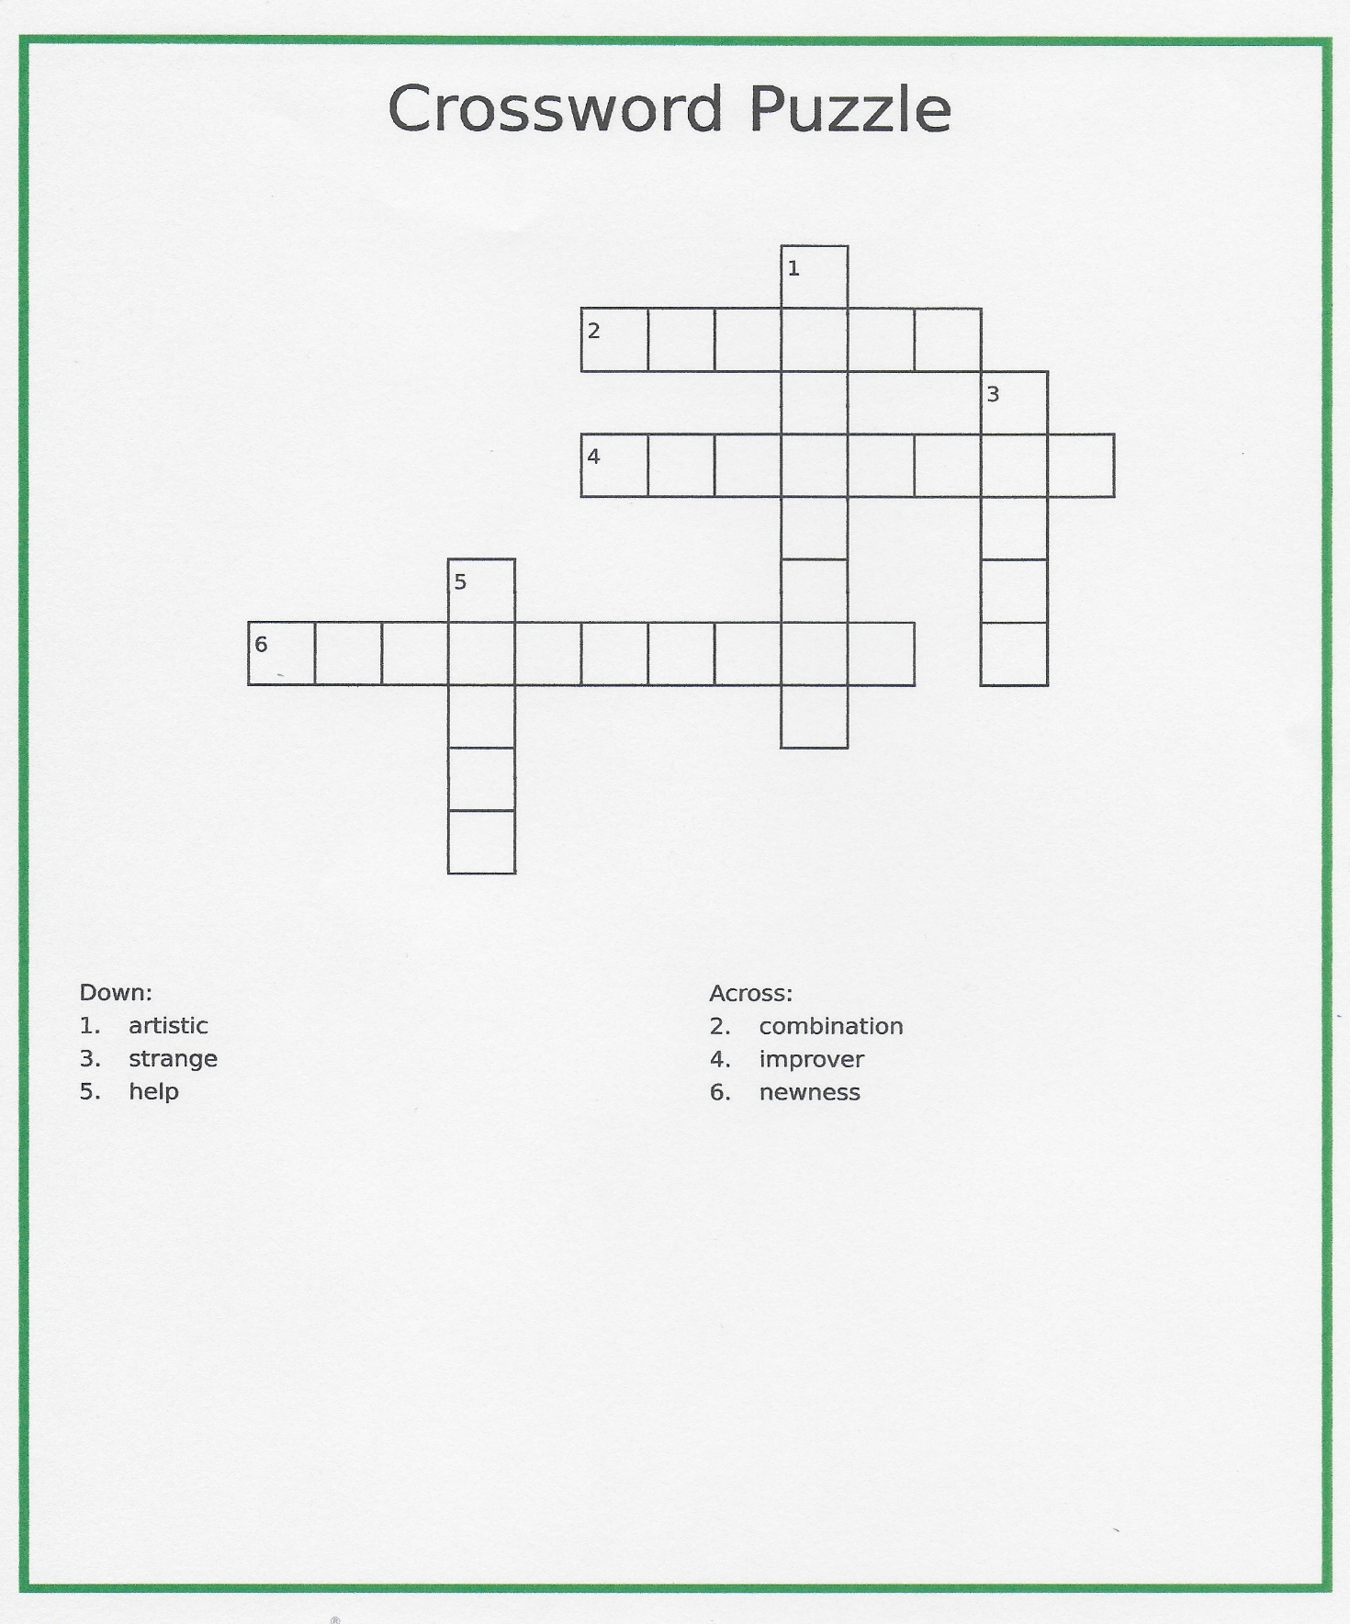
SOS Activity: Cross-word puzzle- worksheet

SOS Activity: Cross-word puzzle- Answer key
