☐ Listening ☐ Speaking ☐ Reading ☐ Grammar ☐ Writing

Topic: Make your own commercial

Instructor:  Mia, Park | Level:  Intermediate | Students:  6 | Length:  30min

Materials:
- Computer
- TV Screen
- PPT file (slide for pre-activity, main activity, SOS activity)
- Video file of example commercial: Mercedes Benz ‘Smart’ pop up billboards
- Speaker
- Hand out: Worksheet (For the know how of persuasive commercial script)
- Board game (for SOS activity)
- 3 different things from home, Flash cards (for main activity)
- 3 white paper
- White board, Board markers

Aims:
- Main Aim: Ss will be able to improve their speaking skills by discussing to make a commercial and doing the presentation. And learn the persuasive speaking
- Secondary Aims: Ss will be able to understand vocabularies related to commercials and improve their listening skills by watching the video
- Personal Aim: I want to increase STT

Language Skills:
- Listening: Ss will listen to the video file of the impressive commercial.
- Speaking: Ss will share the example of the commercial and idea to make their own commercial and do the presentation
- Writing: Ss will write the script for their commercial
- Reading: Ss will read phrases from their script, new vocabularies, the tips for the persuasive commercial script

Language Systems:
- Phonology: [ r ], [ l ]
- Lexis: New vocabularies related to commercials
(Create, Advertisement, Commercial, Director, Photographer, Camera operator, Actors, Editors, Dialog, Character, Film, Record, Slogan, etc.)
- Grammar: Make a suggestion (Why don’t you? Would you like? How about?)
- Functional: Suggestion, Explain something
- Discourse: Commercial

Assumptions:
Ss already know
- The example of the commercial
- The process of making a commercial
- Basic vocabularies
- How the class is organized and operated (4 & 2 at each table)
- They need pencils and papers for the class

Anticipated Errors and Solutions:
- If Ss do not want to come out to the front and present their story
- I will let them stay and do the presentation.
- If Ss need linguistic support,
- I will encourage them to inquire a teacher anytime or let them use the dictionary or internet website.
- If a certain student contributes too much to the discussion
- I will kindly point out the next person to speak

References:
- Video file : https://www.youtube.com/watch?time_continue=66&v=ADqDWvLDGl4
- Pictures for flash cards : https://www.wikihow.com/Make-a-Commercial

Lead-In
Materials: None
Time | Set Up | Student Activity | Teacher Talk
1min | Whole class | Answer to the teacher’s question | Good afternoon, everyone.  How are you today?  (Ss answer)

Pre-Activity
Materials: Computer, PPT file, Video file, TV Screen, white board, board markers
Time | Set Up | Student Activity | Teacher Talk
4min  3min  2min | Whole class  Paris  Wholeclass | Answer to the question out loud  Discuss the example of the commercial  Share the example of the commercial | Procedure:  1.Prediction  Elicit  (PPT slide on the screen)  Please, look at the screen. We will watch a short video before the class.  (After watching)  What type of video is it? What is for?  (Ss answer)  Model  (Write the topic “Make your own commercial” on the board)  Today’s topic is “Make your own commercial”.  CCQ  Where can you see the commercial?  Who usually appears on it?  2. Discuss  Now, please share the examples of commercial that you can remember with your partner sitting next you. Choose 1 example and talk about why? I will give you 3minutes.  ICQ  Do you work alone or with your partner?  How much time do you have?  Monitoring  (Quietly walk around the class room. Check to see if the Ss are on track. Answer to questions.)  Time’s up!  Sharing  Does anyone who can share the example of the commercial and explain why to the classmates?  (Ss give an answer, I will say ‘Good job’, ‘Great’)

Main Activity
Materials: Flash card(3copies), PPT file, 3 things for making a commercial, Computer, TV screen, white paper(3)
Time | Set Up | Student Activity | Teacher Talk
3min  2min  5min | Pairs  Whole class  Pairs | Ss find a correct order of how to make a commercial  Ss share their ideas  Discuss to write a commercial script | 1. Arrange flash cards In correct order and explain  We will learn how to make a commercial.  Instruction  I will give you 7 pictures. Please, discuss with your partner to find a correct order of making a commercial. I will give you 3 minutes.  (Hand out flash cards)  ICQ  Are you working individually or in groups?  How many pictures do you have?  You may begin.  Monitoring  (Quietly walk around the class room. Check to see if the Ss are on track. Answer to questions.)  1minute left.  Times up!  Check answer  Jina and Claire, can you share your answer and explain why?  (If they do not have correct answer) Good job! Does anyone have a different idea?  (If they have a correct answer)  Yes, great. Look at the screen. It is an answer!  2. Write a commercial script  (Hand out a different product to each pair)  Instruction  Now you will work with your partner. First of all, let’s assume all of you are successful commercial directors. Please, give the product a name and create 30 to 60 seconds script for the commercial including lots of characters. Don’t forget you are supposed to attract people to buy! I will give you tips to create a persuasive speaking script in commercials. You should use the expressions of making a suggestion at least once.  After this, you will perform the commercial.  (Hand out a worksheet)  I will give you 5minutes.  ICQ  What expression should you use at least once?  Who do you assume from now?  How much is your commercial, more than 1 minute?  You may begin.  Monitoring  (Quietly walk around the class room. Check to see if the Ss are on track. Answer to questions.)  1minute left.  Times up!

Post-Activity
Materials: White board, Board marker
Time | Set Up | Student Activity | Teacher Talk
8min  2min | Group/Whole class  Whole class | Ss practice and perform the commercial  Ss listen and answer to the teacher’s question | 1. Doing the presentation  Now we will perform the commercial.  Instruction  First, I will give you 3minutes to practice your performance. Who wants to do the first?  (Ss answer)  ICQ  How much time do you have for the preparation?  You may start.  (After 3minutes)  Times up!  Please, 1st presenter comes out to the front and start.  Monitoring  (Listen to Ss presentation, Write grammatical and pronunciation erros Ss made during the presentation)  Everybody good job. All of you have a good idea.  2. Wrap-up  (Recap vocabularies and sentences for suggestion. Pick out grammatical and pronunciation errors Ss made during the class and find correct answers with Ss.)  We will practise vocabularies related to commercials. (Create, Advertisement, Commercial, Director, Photographer, Camera operator, Actors, Editors, Dialog, Character, Film, Record, Slogan, etc.)  And expressions for suggestion from the commercials you created.  Well done everybody. All of you have made such a great effort today. Everyone has a good potential in speaking in English! If you have any questions, please feel free to keep in touch with me. Thanks!

SOS Activity
Materials: Board game 'Zip-it
Time  5min  1min | Set Up  Group  Whole class | Student Activity | Teacher Talk
 |  | Ss paly a board game | - Zip it  Instruction  Now, we are going to play a board game ‘zip it’. It is a word race game. First, we will make 2 teams for a team competition. Each team gets 12 cubes to make crosswords. Words must read horizontally or vertically left to right or top to bottom. Look at the screen. It is an example.  Any player who complete making crosswords without remaining cubes calls out ‘Zip’. That’s the winner. We will go 10 rounds. Any team wins more round is the final winner.  If you have words we learned today. You can get a bonus point.  ICQ  What do you have to say when you finish it?  How can you get a bonus point?  Which team is a winner?  Monitoring  (Watch Ss playing a game. If there is any difficulties, teacher help to solve it)  Wrap-up  Congratulations the winner team!  Good team work! Thanks for all of your effort for today’s class!

Pre-Activity : Prediction

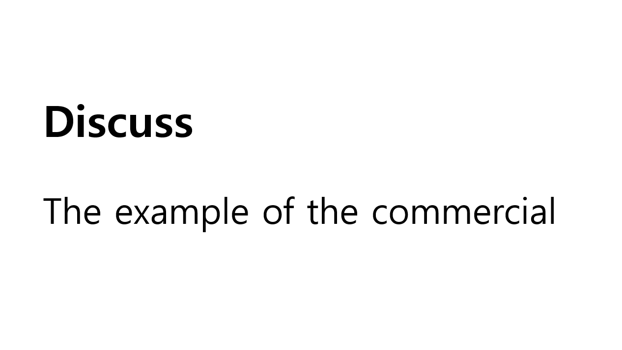

Main Activity: How to make a commercial (with Flash cards)
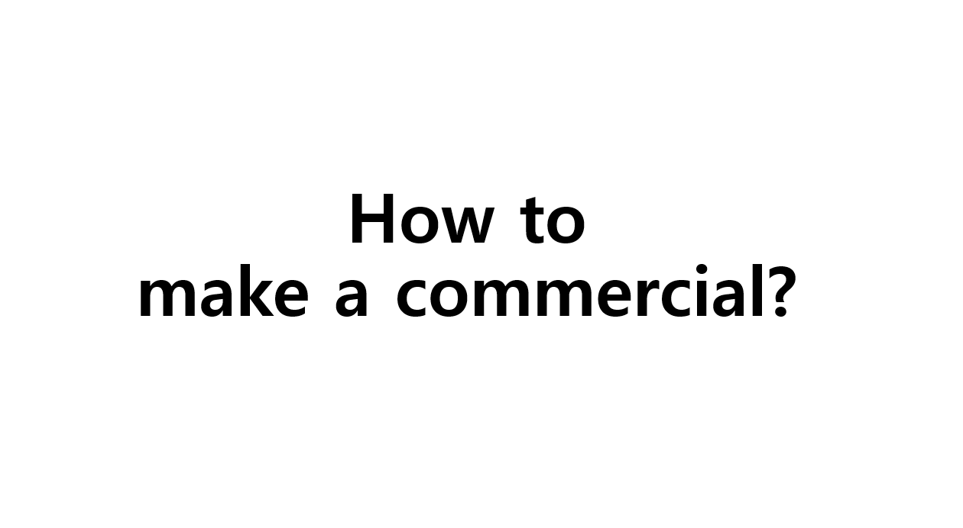
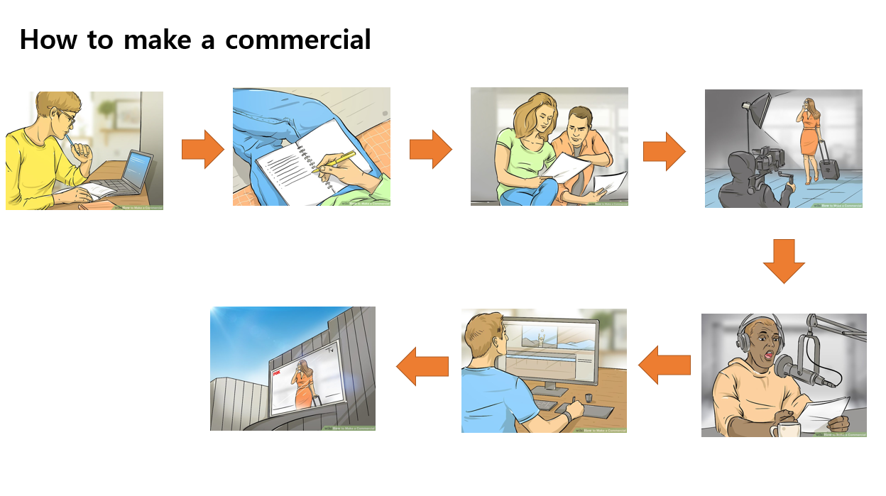

Main Activity: Make your own commercial scrip (Handout)

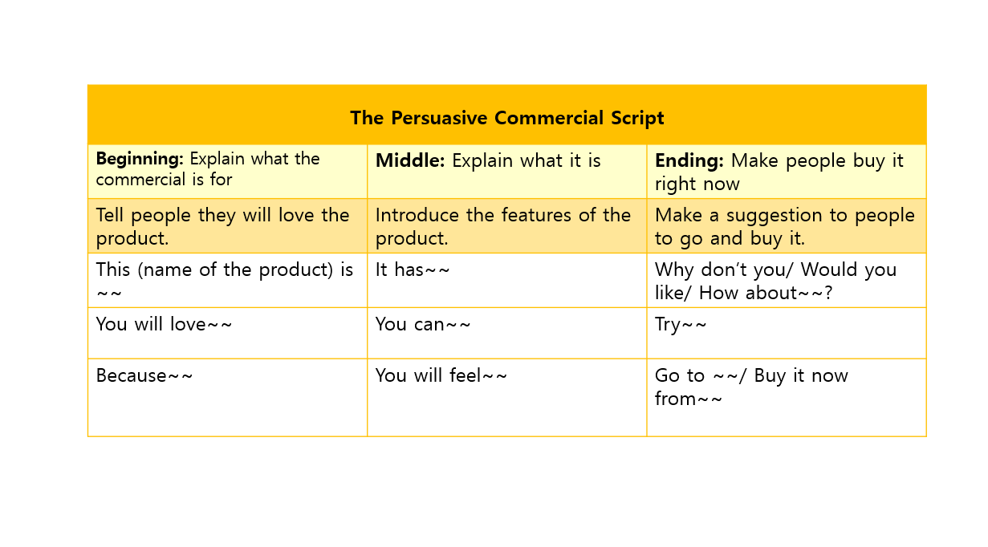

Post Activity: Practice vocabularies about commercials

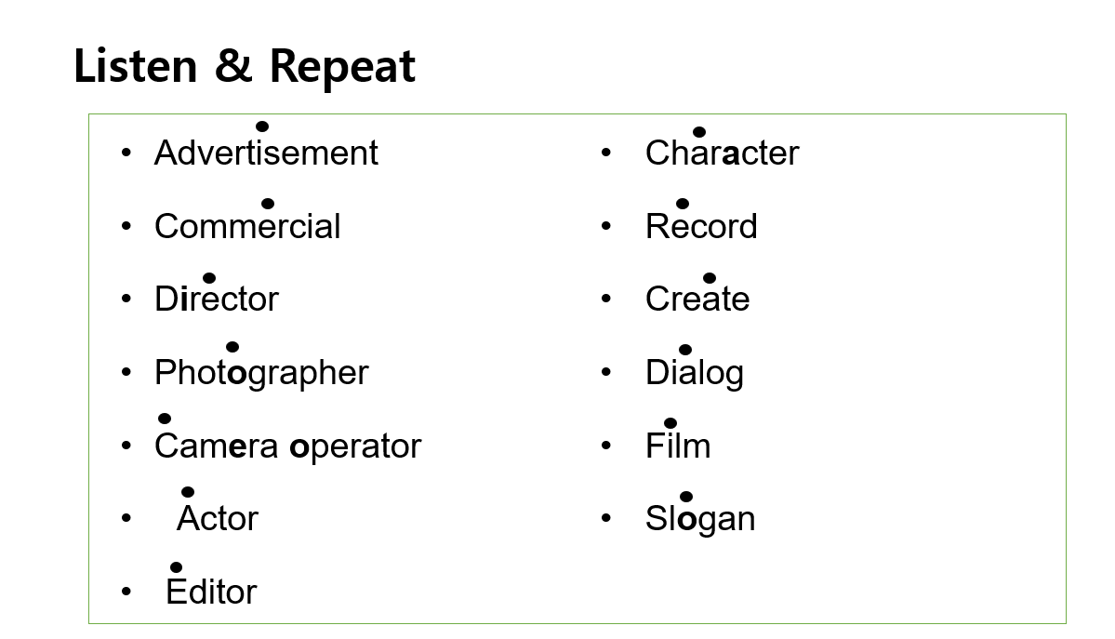

SOS Activity: Board game ‘Zip it’

