Listening Speaking Reading √ Grammar Writing

Topic:
have to (modal verb)

Instructor:  GenalynBal(Jenny) | Level:  Intermediate | Students:  six(6)students | Length:  30mins

Materials:
- Computer
- PPT File (Slides for the whole topic)
- Questioners for pre-activity (6 pcs.)
- White board & marker
- Timer
- Dice
- Worksheet (6 copies)
- SOS cryptogram puzzle (6 copies)

Aims:
- Main aim: Ss will be able to help and improve their grammar skills through the topic to be taken in the class.
- Secondary aim: Ss will be able to increase their speaking time and opportunity by participating in the class activity.
- Personal aim: Teacher will be able to make an interaction in the class and increase STT.

Language Skills:
- Listening : Ss will listen to the teacher discussing the topic and activity.
- Reading : Ss wil read the questioners in pre- activity and situations in main activity
- Writing : Ss will write the paragraph using the modal verb have to.
- Speaking : Ss will speak by playing the situational board game.
.

Language Systems:
- Phonology : / ə / schwa sound Ex: have
- Lexis : or Vocabulary (outfit, ruin, )
- Grammar : have to (Modal verb), Present tense
- Function : Expressing necessity and obligation
- Discourse : situational board game

Assumptions:
- Ss may already know on how the class are organize and operated.
- Some Ss may feel shy and awkward on presenting or discussing activity in the front of the class.
- Some Ss may not participate well.
- Ss may give a long and short answers that will make the activity time confusing.
- I may not be sure if Ss will answer relatedly on some questions.

Anticipated Errors and Solutions:
- If Ss is so shy to present or discuss activity in the front,
I will allow Ss to do it in their place.
- If Ss answer the questions in a long time
I will tell to say just give the important key points.
- If the time planned is shorter than I expected,
I will do the SOS activity
- If the time planned is longer than I expected,
I will do the cut activity and give it to Ss as homework and dismissed the class

References:
- Listening File & script
→ https://www.englishpage.com/modals/haveto.html
- SOS crossword puzzle
→ http://puzzlemaker.discoveryeducation.com/code/BuildCryptogram.asp

Lead-In
Materials:
Time | Set Up | Student Activity | Teacher Talk
1min | Whole class | SS will answer to the teacher’s question. | Good afternoon, how’s everyone today?  Can anyone tell me what things you need to do today?

Pre-Activity
Materials: white board& marker, pictures, pocket, timer
Time | Set Up | Student Activity | Teacher Talk
9mins | individual | Ss will answer the question they pick in the pocket. | Procedure:  1. Prediction  Elicit  I have some questioners here. Some of the questions are very common. You need to answer it showing your responsibility or need to do it. I’ll start with this side.  Call a Ss to start with. Come in the front and pick a question inside this pocket. Please read the question 1st then answer.  Do the same to all Ss.  Alright, everyone did a good job!  Topic  Project the PPT.  Show the topic on ppt.  So, today we will learn about one of the modal verb have to. Let’s read an example here.  I have to leave early.  And so on…….  Do the rest with the same procedure.

Main Activity
Materials: PPT, dice, timer
Time | Set Up | Student Activity | Teacher Talk
15mins | Group | Ss will play the board game in PPT.  Ss will answer the situation given on the board using have to modal verb. | - Overview  So everyone, you have now some ideas on how to use have to in a sentence. And now, let’s use have to in some situations. We will play this situational board game by using the modal verb have to.  Show the PPT slide of this game.  Instruction  We will begin this game by throwing the dice. Roll the dice according to the color that you have to move. You have 2 chances to roll the dice. The 1st group who will finish is the winner. Alright, let’s make two groups in the class, yellow and pink. Choose a representative to do rock scissor paper and will be the 1st group to play. Let’s play this for 15minutes.  ICQ  Are you working in group or individual?  How many chance do you have to roll the dice?  Monitoring  Teacher will watch Ss playing the game and will be the one to move Ss symbol group on the PPT board game. Give Ss some help if needed.  CCQ  What questions do you have regarding in activity we had?

Post-Activity
Materials:
Time | Set Up | Student Activity | Teacher Talk
5mins |  |  | 1.Discussion  Instruction  Now I will give you worksheet to write a paragraph using have to. Write 4 – 5 sentences. The topic is about the things you need to do tomorrow. You have 4 minutes to work.  Hand out the worksheets.  ICQ  Are you working in group or individual?  How much time do you have?  You may start now.  Monitoring  Walk around the class. Check if the Ss are on the right track. Give some help If needed.  Time warning  30 seconds left. Please, finish it at time.  Sharing  Choose Ss to share her own paragraph.  Can you share your paragraph with us Gina? Please read your work in your seat. Thank you.  Give feedback if needed.  3.Conclusion  Wrap-up  Review on the topic taken today.  Okay guys, can anyone tell me what is the function of have to in our sentence? Yes! It’s used to express obligation or necessity.  Wow! Good job. That’s all for today. Class dismissed, Bye!

SOS Activity
Materials: worksheet
Time | Set Up | Student Activity | Teacher Talk  Cryptogram puzzle  Instruction  Okay, since we still have time left.  Now let’s do cryptogram puzzle.  You have 3minutes to do so.  Distribute the worksheet.  ICQ  Are you working in group or individually?  How much time do you have to work?  You may start now.  Monitoring  Walk around the class. Check if the Ss are working on the right track. Give help or opinions if needed.  Time warning  20 seconds left  After the given time…  Check the answers.  Let’s check your answer.  Class dismissed

Listening Script
Have to
- is used to express certainty, necessity, and obligation.
Examples:

- I have to leave early.

- We have to decide right now.

- You have to give her a Christmas present.

Pre-Activity: Questioners in a pocket. Picking 1 question and answer.
What do I have to do to improve my English?

Why do people have to go to work?

What do I have to do to pass the exam?

What do I have to do to make more friends?

What do you have to do after class?

Why do you have to sleep early today?

Main-Activity: Situational Board game on PPT slide with dice
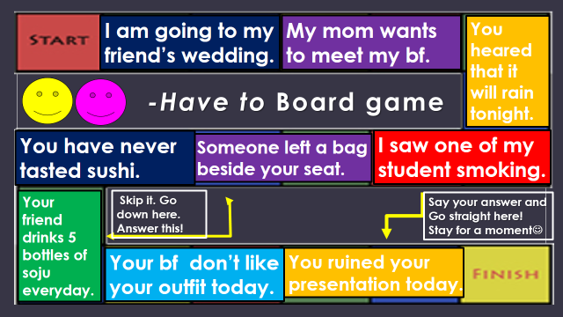

Name:
Write your paragraph on the given space. Use have to in your sentences.
Post-Activity: worksheet

SOS-Activity:
Try to determine the phrase given below.
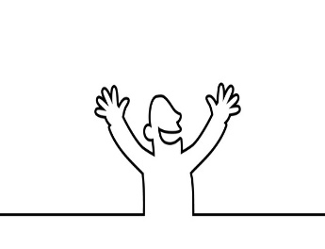
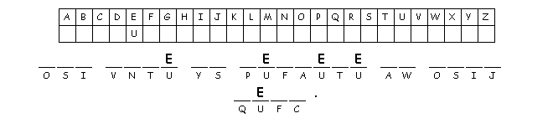

Answer: You have to believe in your-self.

