Listening Speaking Reading Grammar Writing

Topic: Funny Manuals

Instructor: Gina | Level:Intermediate(Adult) | Students:6 students | Length:30mins

Materials: computer / PPT file / Projector and screen/ worksheet #1/ SOS activity worksheet/White board and markers/things to present(a mouse, a bag, a mirror, a doll, one perfume and a string for exercise)

Aims:
Main Aim: Ss will be able to improve their Reading by reading manual and learning new vocabularies related to the topic.
Secondary Aims: Ss will be able to improve their speaking skills by presenting their own ideas in pairs.
Personal Aim: I want to increase student talking time and decrease unnecessary teacher talk.

Language Skills:
-Reading: Ss will read funny sentences and new vocabularies related to the topic.
-Listening: Ss will listen to fun video clip and others’ opinion during activities.
-Speaking: Ss will talk and discuss their thought through quiz and activity.
-Writing: Ss will write down their ideas by presenting their own manual in front of other Ss.

Language Systems:
-Phonology: glaciers, parachute, fire extinguisher
-Lexis: precipice, glaciers, wrap around, cardboard compactor
-Grammar: Don’t~, Never~
-Function: Information, instruction
-Discourse: Manual

Assumptions:
Students already know
-How the class is organized and operated(2students at each table)
-Which partner they belong to during partner discussion time
- What the manual is.

Anticipated Errors and Solutions:
If students don’t know the words or sentences exactly: I will make them understand by using body language, acting and dictionary.
If students’ discussion time is longer than expected: I will go to the group and check if they are on the track.

References:
- SOS activity: made by Gina
- Various manuals:
1) Missing laptop manual : https://stajich.wordpress.com/2006/11/06/missing-laptop-manual/
2) tourist manual : http://themetapicture.com/tourist-shot-user-manual/
3) Nintendo manual: https://www.google.com/url?sa=i&rct=j&q=&esrc=s&source=images&cd=&ved=2ahUKEwjO07Kt2YvhAhWMwbwKHXxuDzIQjRx6BAgBEAU&url=https%3A%2F%2Fwww.pinterest.com%2Fpin%2F130041507960185202%2F&psig=AOvVaw2iuUD0TwrBncHj87icCCxA&ust=1552998653991932
4)baby manual: https://www.pinterest.co.kr/pin/281967626643372516/
- Short clip for topic introduction: Nintendo manual video clip
https://youtu.be/IIQlp2TtcR8

Lead-In
Materials:
Time | Set Up | Student Activity | Teacher Talk
4min | Whole class | Answering to the teacher’s questions | Introduction  Hello everyone! How are you today? Good.  When you buy something, what is usually in it? If you don’t know how to make things when you assemble, what do you check?  I am going to show you a short clip related to today’s topic. Let’s check.  (Play the video.)  CCQ  Can you guess what the video is for?  (Nintendo manual)  Yes, it is a real Nitendo manual.  Modeling  We are going to talk about ‘Manual’ today.  (Project slide of ‘Manual’)

Pre-Activity
Materials: Computer, PPT file, projector, screen
Time | Set Up | Student Activity | Teacher Talk
8min | Whole class | Learn some new vocabularies and read some manuals before getting into main activity. | 1. Introduction  Elicit  Okay, then, what is the manual?  Manual is ‘a book which tells you how to do something or how a piece of machinery works.’  When we get manual?  Yes, from the product.  Why we read manual?  To know some information about the product.  In the manual, they continuously say something bad should not happen to their product.  You would listen they say  “Don’t~” or “Never~”.  Now, let’s learn about new vocabularies.  (project PPT)  1. operate  2. Wrap around  3. Glaciers  4. precipice  5. Fire extinguisher  6. Cardboard compator  7. Juggling  8. Saw blade  9. Parachute  (practice if some words are difficult to pronunce)

Main Activity
Materials: Worksheet #1(6copies)
Time | Set Up | Student Activity | Teacher Talk
12mins | In groups | Students read manual and answer the questions for quiz | Instruction  Now, I will divide you into 2 teams for quiz. First, we will read the manual together.  (Hand the worksheets out to Ss.)  Let’s read together. No.1.  (Read together for the manual)  Good. Now, I will give you 2mins to look through the manual, and then we will start the quiz. You cannot check the sheet during the quiz, so please read it throughly.  ICQ  How much time do we have to read the manual? (2mins)  Good. Let’s start!  (give time warnings 1min/20sec.  after 2mins)  Times up. Let’s see the PPT together.  Whichever team wants to answer, please say team A or team B!  What shoud you say if you want to answer?(Name the team/Team A!)  Good. Let’s start!  (Write team A and team B on the board)  Quiz No 1.  What word should be in the blank? Parachute  Quiz No 2. Can you guess the word?  Campfire  Quiz No 3. Make the word in order.  Glaciers  Quiz No 4. Correct the sentences.  Do not build an indoor campfire on laptop without a fire extinguisher nearby.  Quiz No 5. Make the sentences in order.  Do not operate computer  while juggling razor sharp saw blades.  Quiz No 6. Fill in the blanks.  Never, tightly  Quiz No 7. What is this?  Precipice  Quiz No 8. Select the right picture for the sentence.  No. 2  Quiz No 9. Choose the right answer from the manual(Answers can be multiple).  No3, No4.

Post-Activity
Materials:
Time | Set Up | Student Activity | Teacher Talk
6min | In pairs | Students write a sentences about manual for products. | Instruction  Now, we are checking some manuals for examples before we do our activity.  After we saw these, I want you to make a short manual for some products.  First, it is for Nintendo. Can you guess what the picture tell you about?  Next, it is special manual for baby.  Can you guess what the hiding picture will be?  Demonstration  And I am going to show you my example of manual. I chose ‘needle’.  Don’t needlework if you are not a detail -oriented person.  Never torture your friend with a needle!  Don’t use it for acupuncture!  Never use it as a toothpick!  Never try voodoo on a doll!  Now, you can choose any product from here after discussing with your partner and present the manual in front of students. We have a mouse, bag, mirror, a doll, perfume and this string.  I will give you 3mins to talk about it with your partner. In addition, (change the slide) please use Don’t and never for the manual since we have learned today.  ICQ  How much time do we have?(3mins)  Are we working in pairs or individual?(In pairs)  What words should we use for manual? (Don’t and never)  Okay, you may begin.  Monitoring  (Check if students are on the right track. Give time warning 1min/20sec)  Okay. Let’s present it from this group.  Wrap-up  Okay, students. Before we end this class, let’s check the vocabulary we used today.  And what we have learned from manual?  What we said to the product? Don’t and Never. Right. Good job and thank you for your time today.

SOS Activity
Materials: Handout(6copies)
Time  5mins | Set Up  Individual/In pairs | Student Activity  Students write their answer for cryptogram related to manual topic. | Teacher Talk  Instruction  Now, I will give you handouts for cryptogram.  I will give you 4mins to get the answer and you can discuss it with your partner.

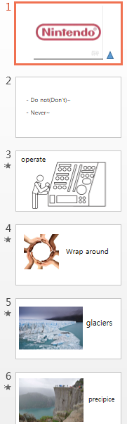
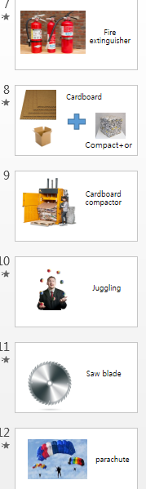
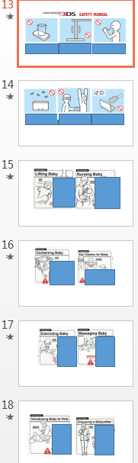

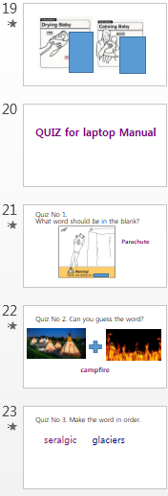
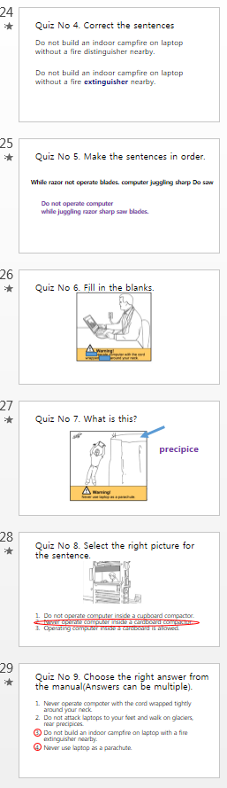
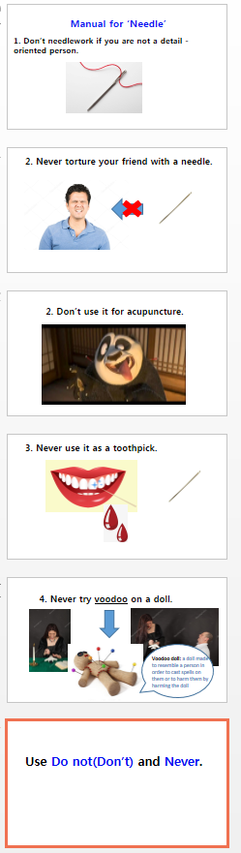

[ Laptop Manual ]
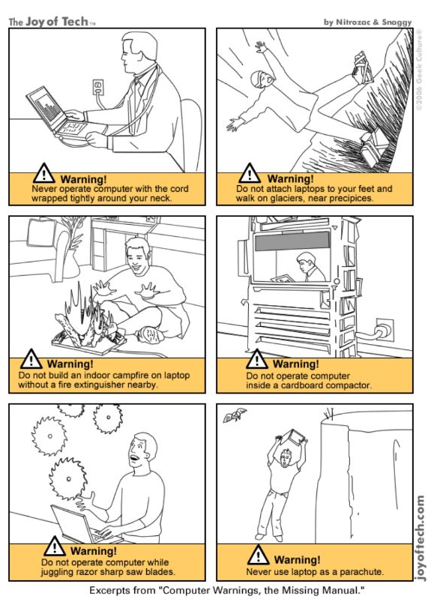
[SOS activity] Please check the hidden sentence which is related to today’s topic with your partner.

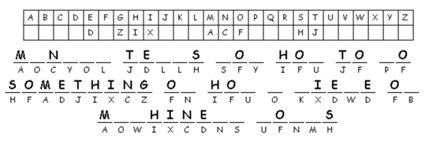

[SOS activity] Please check the hidden sentence which is related to today’s topic with your partner.

Manual tells you how to do something or how a piece of machinery works.

