Background Information Sheet
Name | Class | Date | Lesson Type | Length
Jin | 191st | 27-03-2019 | Listening | 40 min

Lesson
Topic | Dialogue: In a language school cafe
Main Aim | Ss will practice and check their listening skills.
Secondary Aim | Ss will practice their speaking fluency during the lesson
Materials and References
https://www.teachingenglish.org.uk/dialogues
worksheets, whiteboard, coloured markers, eraser, papers

Student Profile
Level | Intermediate
Age | Teenagers | Number of Students | 10
Detail | There are 8 girls and 2 boys. Everyone can participate in class. They’ve got no difficulty attending the class and all the students are passionate.
Assumptions about students’ knowledge as required for this lesson:
The class may know some of the words in the dialogue. They can all take part in speaking and sharing their answers.

Anticipated Difficulties and their Solutions:
Use of L1- Remind students to talk in English in the class.
Absence, lateness- If possible hoping the students not to late or absent.

My Personal Aim
What I hope most to demonstrate in this lesson is the ability to make an interesting lesson.

Stage Name: Lead-in
Purpose of this stage: to relax both the students and the teacher; to start the lesson in a natural way; to focus the attention of the students; to involve students and allow them to share ideas related to the topic.
Materials: picture
Timings | Interactions | Procedure
30 sec  30 sec | T-S  T-S | “Hello class, how are you feeling today?  Did you guys all ate breakfast?  Look at this picture! Where is this place?  Okay today we are going to listen to the dialogue that takes place in café.

Stage Name: Presentation
Purpose of this stage: Teacher presents new language, concepts, themes and involves students.
Materials: whiteboard, coloured markers, eraser, photo
Timings | Interactions | Procedure
5 min  2 min | T-S  T-S | Pre-teach keywords (elicit, ccq, drill, board).  Class~ Look at this picture. Are they looking like family? Or friends?  If friends they are looking like living together. (roommate)  (Keyword) Flatmate- is a person who shares a room with them.  Ccq: Did they living separately? (no)  Did they share the room? (yes)  Teacher writes the word ‘Flatmate’ on the board.  “Everybody” follow after me, flatmate,  (Point the word flatmate on the board)  How many syllabus are there? (2)  What kind of speech is this? (noun)  Guiding question: How do you feel when it is your first day of going to the place like school, academic etc..

Stage Name: Practice Detailed Listening – Literal Comprehension
Purpose of this stage: Ss practice listening to details. Checking their accuracy is needed.
Materials: worksheets
Timings | Interactions | Procedure
30 sec  1 min  3 min  3 min | T  T  S-S  T-S | Now you’re going to listen to the dialogue and answer 1-2 questions.  After that check your answer with your partner sitting next to you.  (Play the dialogue.)  Ss pair check.  Feedback to check answers.
Stage Name: Practice More Detailed Listening – Interpretive Comprehension
Purpose of this stage: Ss listen thoughtfully to interpret meaning. Accuracy focused.
Materials: worksheets
Timings | Interactions | Procedure
30 sec  1 min  3 min  3 min | T  S  S-S  T-S | Let’s listen it one more time and then answer 3-4 questions on your worksheet. For this time listen to the dialogue more carefully.  Students are listening to the dialogue.  Students compare their answers in pairs.  Check the answers with students

Stage Name: Production – Applied Comprehension
Purpose of this stage: Ss practice speaking. Fluency focused stage. Teacher mainly monitors and may offer necessary support.
Materials: papers, coloured markers, eraser, whiteboard
Timings | Interactions | Procedure
20 sec  10 min  5 min | T  S-S  T-S | The applied question is “If you were going to share room with other people what are some advantages and disadvantages?” Share your opinions with your partner sitting next to you.  .  Okay class~ what was the advantages and disadvantages?  (Teacher write the students opinion on the board)

Stage Name: Wrap-up
Purpose of this stage: To end the lesson on a positive feeling, and to handle any classroom management matters before ss go home.
Materials:
Timings | Interactions | Procedure
1 min | T-S | Good job everyone~ How was the lesson?  I feel happy that everyone was taking part to listen and speak through this lesson. There’s no homework for today and see you tomorrow bye.

Instructor’s Comments and Assessment
Pros
Cons
Change
Overall Comments
Grade
Above Standard 85%-100% | Standard 70%-84% | Below Standard 69%-0%
Instructor | Student Signature | Date
Taute, David

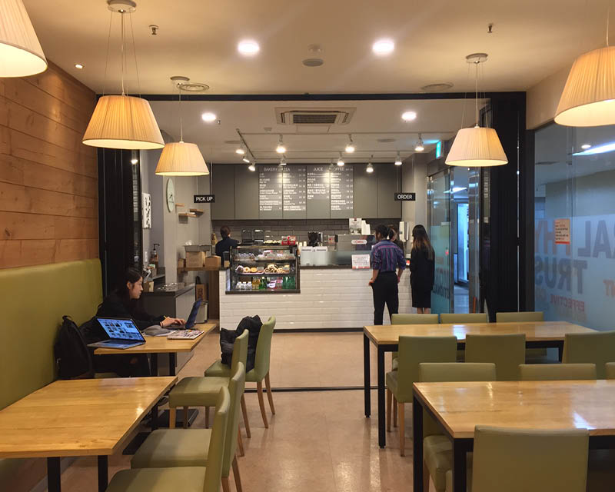

Audio bank - Dialogues © BBC | British Council 2006

Dialogue 1: Two students in a language school café.
Hong lei : Hi! I'm Hong lei. What's your name?
Ricky: Hello, Hong Lei. My name's Ricky.
Hong lei: Hi Ricky. Are you a new student here?
Ricky: Yes, I had my first lesson this morning. Are you a new student too?
Hong lei: No, I've been here for six months.
Ricky: Six months. That's a long time.
Hong lei: It's not so long really. What class are you in? Intermediate or …?
Ricky: Intermediate Three. And what about you?
Hong lei: I'm in Advanced One. Who's your teacher?
Ricky: I can't remember her name, but she's got curly red hair.
Hong lei: Ah! Does she wear glasses?
Ricky: Yes, I think so.
Hong lei: That's probably Anne Wallis.
Ricky: Yes that's right. Do you know her? Is she your teacher too?
Hong lei: No. But she taught me last term. How long have you been here?
Ricky: Only a week.
Hong lei: Wow, not long. Where do you live? With a family?
Ricky: Well, I'm staying at the YMCA at the moment. I'm looking for somewhere
more permanent. Do you know of any good places?
Hong lei: Yes. Actually my friend has a spare room in here apartment and she's
looking for a flatmate. Would you like her phone number?
Ricky: That would be great! Thanks for your help. Can I buy you coffee?
(Questions)
- How long does she studied in this language school?
- Does the man staying with his family?

3. Describe how Anne Wallis looks like.
4. what is the meaning of ‘more permanent’ in the dialogue?

<Talk with your partner>
If you were going to spare room with other people what are some advantages and disadvantages? Share it with your partner sitting next to you.

(Answer sheet)
1.How long does she studied in this language school?
Answer: for six months
2.Does the man staying with his family?
Answer: no
- Describe how Anne Wallis looks like.
Answer: She’s got curly red hair and wear glasses.
- what is the meaning of ‘more permanent’ in the dialogue?
Answer: In this dialogue it means place to stay more longer.

