**Background Information Sheet**

|  |  |  |  |  |
| --- | --- | --- | --- | --- |
| **Name** | **Class** | **Date** | **Lesson Type** | **Length** |
| Rosa | 191st | 27-03-2019 | Listening | 40 min |

|  |  |
| --- | --- |
| **Lesson** | |
| **Topic** | What will I be when I grow up? |
| **Main Aim** | Ss will learn new vocabulary and develop their listening comprehension. |
| **Secondary Aim** | Ss will practice their speaking fluency by sharing their ideas. |

|  |
| --- |
| **Materials and References** |
| <http://learnenglishkids.britishcouncil.org/short-stories/what-will-i-be-when-i-grow-up>  computer and speakers for audio file  A picture of my puppy  comprehension questions & discussion worksheet (10 copies)  homework worksheet (10 copies)  whiteboard and markers |

|  |  |  |  |
| --- | --- | --- | --- |
| **Student Profile** | | | |
| **Level** | Intermediate | | |
| **Age** | Teenager (10-12) | **Number of Students** | 10 |
| **Detail** | There are 4 boys and 6 girls. They are all Koreans. They are close and friendly. They are highly involved and participate in the class actively. | | |
| **Assumptions about students’ knowledge as required for this lesson:** | | | |
| How the class is set and run.  Ss can make sentences.  Ss are comfortable discussing their ideas with peers in the class | | | |

|  |
| --- |
| **Anticipated Difficulties and their Solutions:** |
| If Ss cannot listen the audio file - > control the volume that they can listen well  If Ss cannot understand the stories -> give them one more chance to listen.  If Ss cannot know some vocabulary -> explain the meaning through eliciting, CCQ, drill and boarding. |

|  |  |  |
| --- | --- | --- |
| **My Personal Aim** | | |
| What I hope most to demonstrate in this lesson is the ability to make students more active and enjoyable in the class. I want to decrease TTT and increase STT. | | |
| **Stage Name:** Lead-in  **Purpose of this stage:** to relax both the students and the teacher; to start the lesson in a natural way; to focus the attention of the students; to involve students and allow them to share ideas related to the topic. | | |
| **Materials:** a picture of my puppy | | |
| **Timings** | **Interactions** | **Procedure** |
| 30 sec  1 min | T  S  T  S-S | Hello everyone! how are you today?  (Ss answer)  Ok. Great Today's weather is good. Spring has come.  These days in the weather, I like to take a walk with my puppy.  Showing the picture I prepared, do you have a cat or puppy at home? What is good or bad about having a cat or puppy at home?  (Ss discuss with a partner) |

|  |  |  |
| --- | --- | --- |
| **Stage Name:** Presentation  **Purpose of this stage:** to teach keywords and new vocabulary found in the recording to help students understand the main thought of recording.  Monitor to make sure they discuss, but do not offer unnecessary help. | | |
| **Materials:** Whiteboard and markers | | |
| **Timings** | **Interactions** | **Procedure** |
| 2 min  3min | T-S  T-S / S-S | What are living creatures such as puppies or cats which are different from plants? (animals)  Yes! Good!  So, can animals be sick? (yes)  If animals are sick, do you leave them alone or go to hospital?  (go to hospital)  Who would treat animals, if they were sick or injured?  (veterinarian)  Veterinarian is an animals’ doctor.  Could you repeat me? Veterinarian!  *While students repeat the words 3 times, a teacher writes the word on the board.  How many syllables?  (Ss answer) four, Vet/eri/nar/ian  Where is the stress?  (Ss answer) First  Could you repeat me again? Veterinarian  Is that word easy? (Ss answer)  So, we can make it short. “Vet”  Could you repeat me? Vet, Veterinarian  Wow, well done everybody!  **[Guiding Q]**  What kinds of jobs are there for animals?  (Ss discuss with a partner or brainstorm ideas as a class.) |

|  |  |  |
| --- | --- | --- |
| **Stage Name:** Practice Detailed Listening – Literal Comprehension  **Purpose of this stage:** Ss practice listening to details. Checking their accuracy is needed. | | |
| **Materials:** computer, speakers, audio file,comprehension questions & discussion worksheet | | |
| **Timings** | **Interactions** | **Procedure** |
| 1 min  2 min  2 min  1 min  1 min | T  S  S-S  T-S | Hand out the worksheet to students.  Read the comprehension questions with students.  And let them listen carefully and answer the “comprehension questions”.  ▶ Dialogue play  (Ss listen for the 1st time)   * 1. Can some birds say some words? (yes)   2. Who is a veterinarian? (his brother)   3. Which animals does his mother love**?** (dogs)   Ss compare their answers in pairs.  Feedback to check answers. |
| **Stage Name:** Practice More Detailed Listening – Interpretive Comprehension  **Purpose of this stage:** Ss listen thoughtfully to interpret meaning. Accuracy focused. | | |
| **Materials:** computer, speakers, audio file,comprehension questions & discussion worksheet | | |
| **Timings** | **Interactions** | **Procedure** |
| 2 min  3 min  4 min  2 min | T  S  S-S  T-S | Let’s listen one more time and answer the “think more questions”.  ▶ Dialogue play  (Ss listen a 2nd time, more carefully than before)   1. How many family members does he have? 2. Does he really want to get a job about animals? Why or why not?   Ss compare their answers in pairs.  Feedback to check accuracy. |

|  |  |  |
| --- | --- | --- |
| **Stage Name:** Production – Applied Comprehension  **Purpose of this stage:** Ss practice speaking. Fluency focused stage. Teacher mainly monitors and may offer necessary support. | | |
| **Materials:** comprehension questions & discussion worksheet | | |
| **Timings** | **Interactions** | **Procedure** |
| 6 min  5 min  2 min | T  S-S  T-S | Do we think more?  What will you be when you grow up? Why?  (Ss discuss in pairs.)  Some students present their thought.  Feedback. |

|  |  |  |
| --- | --- | --- |
| **Stage Name:** Wrap-up  **Purpose of this stage:** To end the lesson on a positive feeling, and to handle any classroom management matters before ss go home. | | |
| **Materials:** homework worksheet, whiteboard and markers | | |
| **Timings** | **Interactions** | **Procedure** |
| 2min | T-S | Give corrections, lesson feedback, suggestion and tips  I will give a very exciting homework!  Do the worksheet I gave at home and submit them next class.  Bye~ |

**What will I be when I grow up?**

When I grow up I’ll work with animals. I don’t know which job yet.

Maybe like my brother. He’s a special vet.

He looks after scary snakes, some just out of eggs.

He says that snakes are easy as they don’t have any legs.

My father is a scientist. He works to save rare birds. Some are really clever and can even say some words. ‘How do you do?’

My mother is a dog groomer. She loves dogs big or small. Once she styled a poodle. It looked just like a ball.

My sister, she trains dolphins. They practice in the pool. She hears the dolphins talk and sing. That sounds really cool!

So many animal jobs to choose but which one’s right for me? Because I’m only ten years old, I’ll have to wait and see!

[ WorkSheet ]

**Comprehension Questions>**

1. Can some birds say some word? (yes)
2. Who is a veterinarian? (his brother)
3. Which animals does his mother love? (dogs)

**Think more Questions>**

1. How many family members does he have?
2. Does he really want to get a job about animal?

**Talk with your partner>**

What will you be when you grow up? Why?

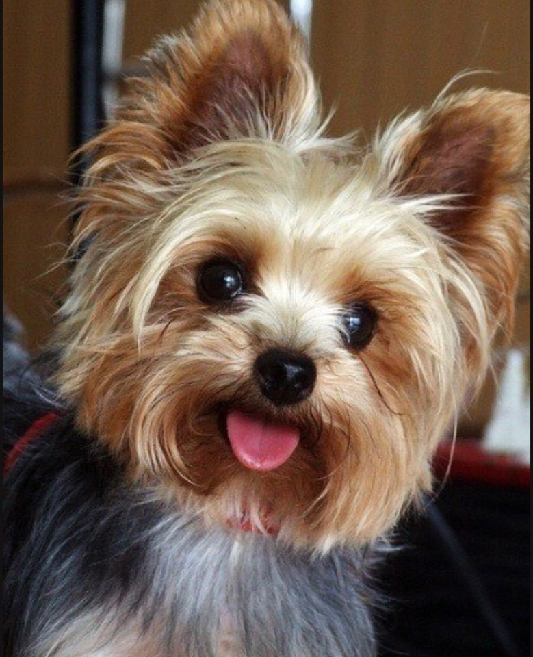

[ Homework ]

What will I be when I grow up?

1. What’s the word?

Write the word under the pictures.

|  |  |  |
| --- | --- | --- |
| brother | Vet | eggs |
| Leg | Sister | dolphin |

  

 

2. Fill it in!

Listen the story. Write the missing words in the sentences.

a. When I grow up, I’ll animals.

b. Maybe my brother. He is a special .

c. He scary snakes, some just out of eggs.

d. My father is a . He works to birds.

e. Some are really and can even say some .

f. My mother is a . She loves dogs big or small.

g. she styled a poodle. It just like a .

h. My sister, she dolphins. They practice in the .

i. She hears the dolphins and . That sounds really cool!

j. So many animal jobs to but which one’s for me?

k. Because I’m only years old, I’ll have to and !

**Instructor’s Comments and Assessment**

|  |  |  |
| --- | --- | --- |
| **Pros** | | |
|  | | |
| **Cons** | | |
|  | | |
| **Change** | | |
|  | | |
| **Overall Comments** | | |
|  | | |
| **Grade** | | |
| **Above Standard 85%-100%** | **Standard 70%-84%** | **Below Standard 69%-0%** |
| **Instructor** | **Student Signature** | **Date** |
| **Taute, David** |  |  |