Background Information Sheet
Name | Class | Date | Lesson Type | Plan type | Length
Elijah Chun | TESOL | 4/7/2019 | Grammar | PPP | 25 min

Lesson
Topic | In, on, at preposition of time
Main Aim | Students will learn the preposition of time
Secondary Aim | Students will practice their usage of grammar with preposition of time and will learn to speak correct + fluently.

Materials and References
Board, and colored markers, worksheets

Student Profile
Level | Lower intermediate
Age | Adults | Number of Students | 8
Detail | Students are all native Korean. Most of them can speak little English and are able to communicate basically. They are motivated to always learn.
Assumptions about students’ knowledge as required for this lesson:
Students understand basic preposition and are able to communicate with a little bit of context.
They are aware of how grammar lessons work.
Students are able to use different tenses to communicate and are able to perform work/group work.

Anticipated Difficulties and their Solutions:
Students may not clearly understand correct propositions to use as they are using them frequently but is not correct at times.
Students are able to correct themselves when given them but may still be confused at which preposition to use.

My Personal Aim
What I hope most to demonstrate in this lesson is the ability to present the target language using a situational presentation.

Stage Name: Lead-in
Purpose of this stage: To relax both the teacher and students. To focus attention on the lesson. Create a situation for students to experience or think about, and then to elicit the target language.
Materials: Board and the colored markers.
Timings | Interactions | Procedure
2 min | T-S | “Hey guys when are you planning to eat lunch? Are you going with a classmate?”  ask for students’ response on their lunch plan.  Draw out my lunch plan for 4/10 Thursday with friend at 2pm.  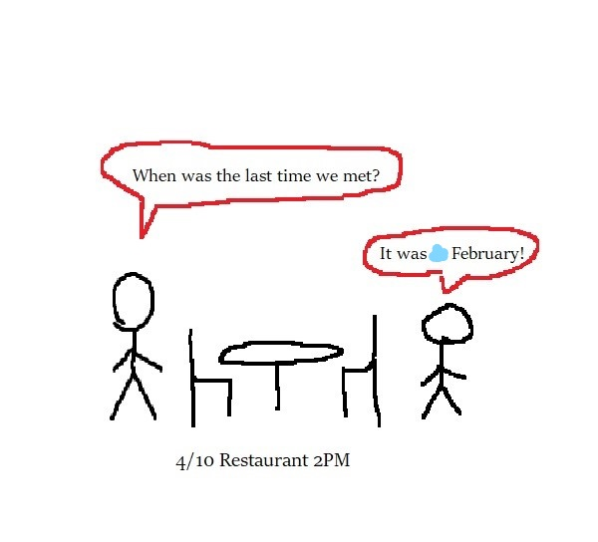  Question regarding the time.  “What day am I meeting my friend?” (on April 10th)  Point to when we last met. Let them figure out the preposition ‘in’  “When was our last meeting?” (In February)  “What time?” (at 2 p.m.)  “Could you guys help me write out a sentence for this picture starting with I?”

Stage Name: Presentation
Purpose of this stage: Make the students think about the situation. To clarify the meaning, form, and pronunciation features of the target language.
Materials: List all materials that will be needed in this stage.
Timings | Interactions | Procedure
1 min  1 min  4 min  1 min | T-S  T-S  T-S  T-S | Board the model sentence  (I have a lunch plan with a friend on April 10th, at 2 p.m.)  CCQ  - Did I already go to the meeting? (No.) Is it in the future? (Yes.)  Past________NOW________X____4/12  - Is it during the day or at night? (it’s in the afternoon. 2pm)  AM_______12PM____X___4PM  “There are three prepositions of time we will be learning today.”  Write In, On, At on the board.  “Do you know when each of them is used?” Get them to speak and guess  When do we finish class today? On 3pm? At 3pm? Or in 3pm? (it’s at 3pm)  When did do graduate? At April? In April? Or on April? (In April)  Draw a table for in, on, at  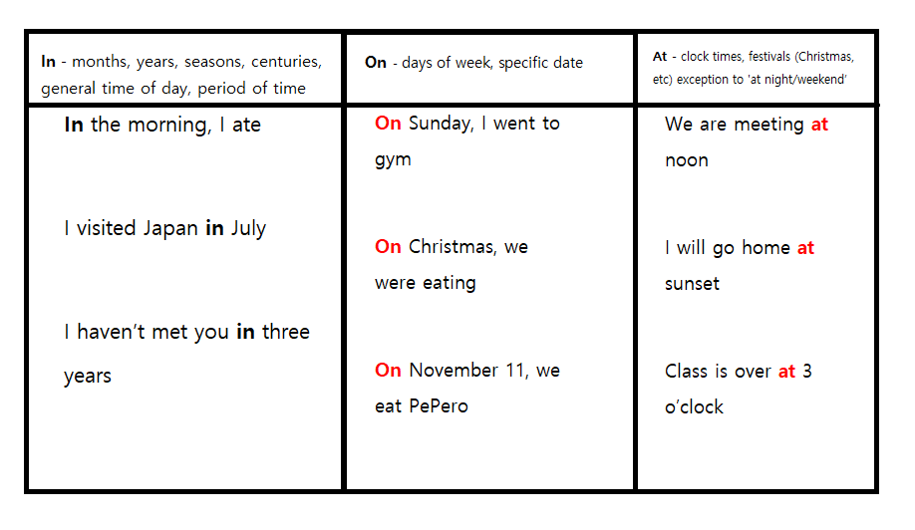  In- months, years, seasons, centuries, general time of day, period of time  Just some examples to tell the class  In the morning, I ate  I visited Japan in July  I haven’t met you in three years  On- days of week, specific date  On Sunday, I went to gym  On Christmas, we were eating  On November 11, we eat PePero  At- clock times, festivals (Christmas, valentine) exception to at ‘night/weekend’  We are meeting at noon  I will go home at sunset  Class is over at 3 o’clock  “Copy this down on your notes! It’s very important as people are always confused!  Drill  “I have an appointment x 6 o’clock” (at) say it, then make them fill in the x, drill together with class 3x  “My last vacation was x March” (in) ) say it, then make them fill in the x, drill together with class 3x  “x Sunday, she went out to go shopping” (on) same as above.

Stage Name: Controlled Practice
Purpose of this stage: students practice working with the form. Accuracy must be checked.
Materials: Worksheet for students
Timings | Interactions | Procedure
30 sec  4 min  1 min | T  S  T-S | Instructions to worksheet. ICQ then pass out  “You guys will do the 1st page first, then we will check for answers. Don’t solve page 2 yet  You may talk with your partners and solve it together.”  ICQ  “When you’re finished with 1st page, do you do page 2? (no)  “Can you work with your partners? (no)  Students work individually  Go over the answers with students  “What did you guys get for number 1?” until no. 12 and nominate students to read out their own sentence.

Stage Name: Less Controlled Practice
Purpose of this stage: students practice working with the meaning. Accuracy must be checked.
Materials: Worksheet
Timings | Interactions | Procedure
10 sec  4 min  1 min | T  S  T-S | “Now can you guys do page 2? It’s similar to the 1st page”  Students work individually  Go over the answers with students  “Can you read out your answer please? (ask a student as there are 7 questions)

Stage Name: Production – Freer Practice
Purpose of this stage: is to get students to practice the grammar communicatively.
Materials: Reference to their worksheet, and note
Timings | Interactions | Procedure
30 sec  5 min  1 min | T  S-S  T-S | Show an example of my filled-out plan.  Now with the partner next to you, ask them about their weekly plan for the weekend!  From Friday to Sunday, ask them when they are planning to wake up to what time they plan to do during the rest of the day.  Students ask their partners what they do for weekend.  Tell students to read out one of their partner’s day  “Could you read out your partner’s Friday plan? (Saturday or Sunday doesn’t matter)

Stage Name: Wrap-up
Purpose of this stage: is to end the lesson on a positive note so that students feel they have achieved progress.
Materials: List all materials that will be needed in this stage.
Timings | Interactions | Procedure
1 min | T  T – S | Tell the students that they did a good job with the activity and taking notes.  “How was the lesson? Was it difficult to understand or was it easy? What do you think?”  Go over some errors the students made during the worksheet or interview activity.  “I noticed you guys were getting ___ wrong often. Why do you think that?”  Finish off the class by letting them know that there would be a light quiz next time.

Instructor’s Comments and Assessment
Pros
Cons
Change
Overall Comments
Grade
Above Standard 85%-100% | Standard 70%-84% | Below Standard 69%-0%
Instructor | Student Signature | Date
Taute, David

