Background Information Sheet
Name | Class | Date | Lesson Type | Plan type | Length
Jin | TESOL | 10-04-2019 | Grammar | PPP | 25 min

Lesson
Topic | My father is bigger than my brother.  My father is the biggest person in my family.
Main Aim | Students will learn comparative and superlative adjectives.
Secondary Aim | Students will practice the use of comparative and superlative adjectives by speaking.

Materials and References
Board and coloured markers, worksheets and photo.

Student Profile
Level | Lower intermediate
Age | Adults | Number of Students | 9
Detail | Students are all native Korean. A few students have lived abroad.  Everyone is motivated to learn English.
Assumptions about students’ knowledge as required for this lesson:
Students are able to get the information from the picture used in the lead-in.
Students have had formal grammar lessons and are familiar with grammatical terms.
Students know how to compare things like person, place etc.

Anticipated Difficulties and their Solutions:
Students may confuse the difference between comparative and superlative forms.
If students ask, give an example to get them understand.

My Personal Aim
What I hope most to demonstrate in this lesson is the ability to present the target language using a situational presentation.

Stage Name: Lead-in
Purpose of this stage: To relax both the teacher and students. To focus attention on the lesson. Create a situation for students to experience or think about, and then to elicit the target language.
Materials: picture
Timings | Interactions | Procedure
2 min | T-S | Hello everyone. Look at this picture. Show the picture of a family. Tell me about this family. Point the picture and ask. Does this man look taller than him? (No), Does this old man look taller than him? (Yes) Make a sentence. (The old man is taller than this man.)  Who is the tallest in this family? (The old man) Make a sentence. (The old man is the tallest in this family.)

Stage Name: Presentation
Purpose of this stage: Make the students think about the situation. To clarify the meaning, form, and pronunciation features of the target language.
Materials: Board and coloured markers, eraser.
Timings | Interactions | Procedure
30 sec  3 min  2 min  3 min | T-S  T-S  T-S  T-S | Board the model sentence (She is more active than last year. She is the most active person in the class.)  CCQ  - Did the woman exercised last year? (No)  - Is she exercising now? (Yes)  Last year(no exercise) Now(exercising)  - Is she the most active person in her class? (Yes)  Form  Can I say “she is tallest than him.”? (No)  Why? (Because in comparing two items we have to add –er to the adjectives.)  Board careful. How many syllables are in the word ‘careful’? (2)  If the adjectives have 2 syllables we have to use “more”. (She is more careful than him.)Board the sentence.  Can I say “He is the smarter in the class.”?(No)  Why? (Because to show that one item is the greatest in a group we have to add –est to the adjectives.)  For two syllables adjectives we have to use “most” and also use “the” in the comparison.  Board the sentence. (She is the most thoughtful person in our class.)  One-Syllable Adjective Comparative Form Superlative Form  tall taller tallest  old older oldest  long longer longest  Two-Syllable Adjective Comparative Form Superlative Form  peaceful more peaceful most peaceful  pleasant more pleasant most pleasant  careful more careful most careful  thoughtful more thoughtful most thoughtful  Drill  Listen. Indicate silence. Teacher reads “She is taller than him”  Which words are stressed? (She, taller, than). Mark the stress with a red marker.  Which words are unstressed? (is, him) Mark the weak stress with a blue marker.  What happens to the pronunciation of ‘taller than him’? ( it joins together and is fast)  Listen, and repeat 3 times. “She is taller than him” Conduct the drill chorally 3 times with gestures. Nominate for individual drilling.  Listen, and repeat 3 times. “He is the oldest person in the family” Conduct the drill chorally 3 times with gestures. Nominate for individual drilling.

Stage Name: Controlled Practice
Purpose of this stage: students practice working with the form. Accuracy must be checked.
Materials: Worksheet, board and marker, eraser.
Timings | Interactions | Procedure
30 sec  2 min  1 min  1 min | T  S  S-S  T-S | Instructions. Hold up the worksheet, point to exercise A.  Exercise A says to read each sentence and decide the form that fits in the blank.  Students do a worksheet.  Comparative form(-er) or the superlative form (-est)  Hand out the worksheets.  Students do worksheet exercise A  Pair check.  Feedback to check accuracy. Board answers.

Stage Name: Less Controlled Practice
Purpose of this stage: students practice working with the meaning. Accuracy must be checked.
Materials: Worksheet, board and marker.
Timings | Interactions | Procedure
30 sec  2 min  1 min  1 min | T  S  S-S  T-S | Instructions  Turn over your worksheet. Exercise B says explain your answers using comparative sentences.  Students do a worksheet.  Pair check.  Feedback to check accuracy.

Stage Name: Production – Freer Practice
Purpose of this stage: is to get students to practice the grammar communicatively.
Materials: None
Timings | Interactions | Procedure
30 sec  3 min  1 min | T  S-S  T-S | Instructions.  Talk to your group about your family using comparative and superlative forms.  For example, My brother is the youngest in my family.  Students discuss about their family using the target language naturally.  Feedback.

Stage Name: Wrap-up
Purpose of this stage: is to end the lesson on a positive note so that students feel they have achieved progress.
Materials: None
Timings | Interactions | Procedure
1 min | T | Lesson feedback  T: Everybody did well today and now you know how to make a sentence with comparative and superlative form. For homework make two sentences using comparative and superlative adjectives. I will check it tomorrow morning. Bye

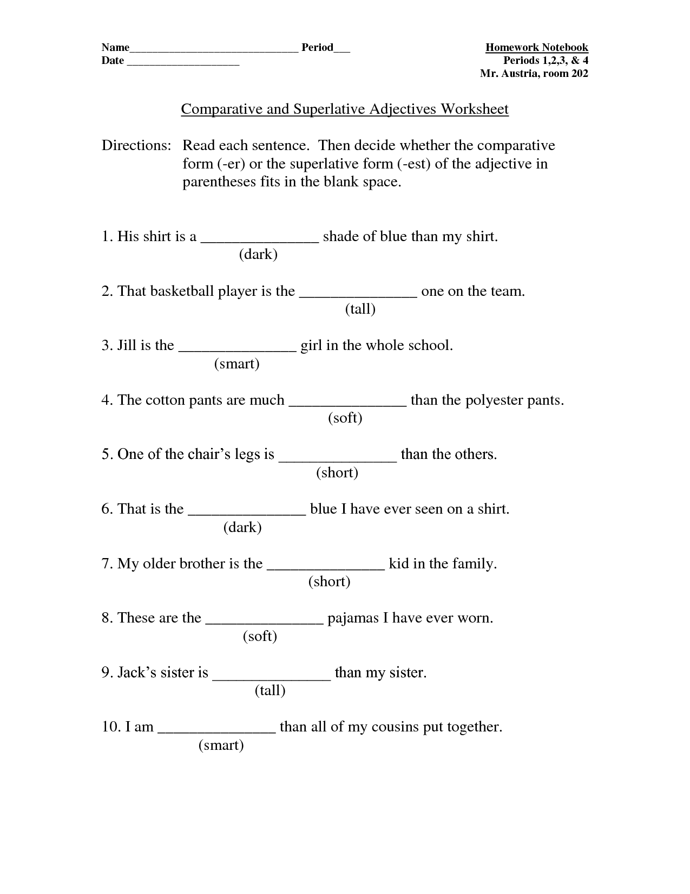

Answer sheet for exercise A
- darker
- tallest
- smartest
- softer
- shortest
- darkest
- shortest
- softest
- taller
- smartest

Answer sheet for exercise B
1.I prefer <a> house because..
-is higher
-is bigger
-is larger
I prefer <b> house because..
-is cheaper
-is smaller
2.I prefer <a> car because..
-is more colourful
-is bigger
-is more spaceful
-is faster
I prefer <b> car because..
-is smaller
-is easier
Exercise B
Which one do you prefer? Explain your answers using comparative sentences.
Which house would you choose and why?
- B. 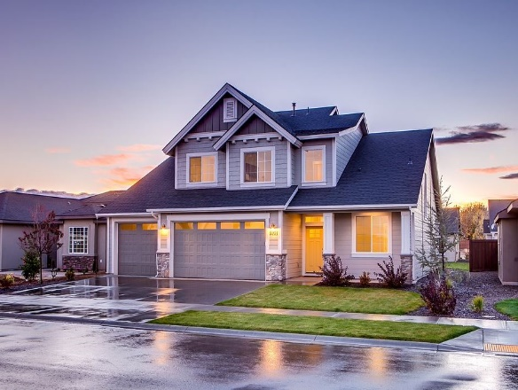
1)

2)

Which car is better and why?
- B. 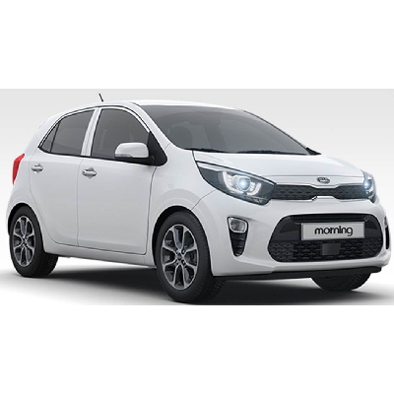

1)

2)
Instructor’s Comments and Assessment

Pros
Cons
Change
Overall Comments
Grade
Above Standard 85%-100% | Standard 70%-84% | Below Standard 69%-0%
Instructor | Student Signature | Date
Taute, David

