Background Information Sheet
Name | Class | Date | Lesson Type | Plan type | Length
Diane | TESOL 191st | 10-04-2019 | Grammar | PPP | 25 min

Lesson
Topic | There’s some coffee in the cup.
Main Aim | Students will learn ‘some/any’.
Secondary Aim | Students will practice their speaking fluency.

Materials and References
Board, coloured markers, PPT, Signboard, Worksheets

Student Profile
Level | Lower Intermediate
Age | Adults | Number of Students | 9 (devide in 3 groups)
Detail | Most of the students are native Koreans. Some students are strong in speaking than grammar, others are good at grammar than English speaking. Everyone is motivated to learn English.
Assumptions about students’ knowledge as required for this lesson:
• Students can distinguish countable noun from uncountable noun.
• Students learned the concept of singular and plural.
• Students know the form of negative sentence and question.

Anticipated Difficulties and their Solutions:
• Students sometimes have problems with the usage of ‘some’ or ‘any’, when to use ‘some’ or when to use ‘any’. Even if they learned grammar rules, students still can be confused or make mistakes.
By giving some main principles, not the rules and exceptions which have number of cases, help students being familiar with positioning ‘some’ and ‘any’ more naturally.

My Personal Aim
What I hope most to demonstrate in this lesson is the ability to present the target language using a situational presentation.

Stage Name: Lead-in
Purpose of this stage: To relax both the teacher and students. To focus attention on the lesson. Create a situation for students to experience or think about, and then to elicit the target language.
Materials: PPT
Timings | Interactions | Procedure
2 min | T-S | Show PPT. Ask students.  “Can you guess the word fit in the blank?”  Elicit the answer by using your gestures, face expressions and reaction.  Go to next picture when students say the answer.  Stop at page 2-3  “Can you think of a sentence with these words? There is/are, coffee, cup……?”  Give students time to think for 15-20 seconds.  (There is some coffee in the cup.)  Go PPT page 24.

Stage Name: Presentation
Purpose of this stage: Make the students think about the situation. To clarify the meaning, form, and pronunciation features of the target language.
Materials: PPT, Board, coloured markers, Eraser, Signboard
Timings | Interactions | Procedure
1 min  1 min  4 min  2 min | T-S  T-S  T-S  T-S | Board the model sentence. There’s some coffee in the cup.  If students are unable to tell you, just board it.  CCQs  1.”Is the cup empty?” (No, it’s not.)  2. “Do you ‘know’ that coffee ‘is’ in the cup? (Yes, we do.)  3. “Do you know the exact amount of coffee?” (No, we don’t.)  Form  “Can I say ‘there’s coffee some in the cup.’?”  (No, we use ‘some’ and ‘any’ before the noun or noun phrase.)  Ask one student to come front and have a seat.  Put signboards ‘HOST’, ‘GUEST’ and ‘a heavy coffee drinker’ on the desk.  “My guest seems to need coffee now. What should I say?”  (Would you like some coffee? / Do you want some coffee?)  “Or, What could she/he say for asking coffee?”  (Can/May I have some coffee?)  Board. ‘Would you like some coffee?’ and ‘Can I have some coffee?’  “Does everybody agree?” (Yes……)  “Right. We use ‘some’, when we offer or request something.  In these 3 sentences [indicating the board], we know, think or, at least, expect that something exists.”  Say thanks to student and ask to go back to her/his seat.  “Can I say ‘there’s any coffee in the cup.’?” (…No…?)  “Or, can I say ‘there isn’t any coffee in the cup,’?” (…Yes…?). “Why?”(…???…)  Board. There isn’t any coffee in the cup.  “We use ‘any’ in negative sentences or the meaning is negative. Even though the meaning of ’some’ and ‘any’ seem similar, the situation when to use ‘some’ or when to use ‘any’ is quite different.”  Board. Is there __________ coffee in the cup?  “This is a question. Can you guess which word fits in this blank?”  (Any…?)  “[Indicating the sentence above] we use here ‘some’ since there ‘is’ coffee. You ‘know’ that.  “Do you ‘know’ whether the cup is empty or not?” (No, we don’t.)  “When we do not know if the thing or person exists, we use ‘any’.“  Write any in the blank.  (If possible, with PPT, briefly review the usage of ‘some’ and ‘any’)  Drill  “Listen. / ðeəz sʌm ˈkɒfi ɪn ðə kʌp. / “ (x1)  “Which words are stressed? (there, coffee, cup)  Mark the stress with a red marker.  “Which words are unstressed?” (is, some, in, the)  “Listen. / wʊd juː laɪk sʌm ˈkɒfi? / (x1)  “Which words are stressed? (Would you, coffee)  Mark the stress with a red marker.  “/ kæn aɪ hæv sʌm ˈkɒfi? / “ (x1)  “Which words are stressed?” (I, coffee) Mark the stress.  “/ ðeər ˈɪznt ˈɛni ˈkɒfi ɪn ðə kʌp / “ (x1)  “Which words are stressed?” (isn’t, coffee, cup) Mark the stress.  “/ ɪz ðeər ˈɛni ˈkɒfi ɪn ðə kʌp?/ “ (x1)  “Which words are stressed?” (any, coffee, cup) Mark the stress.  “Listen. And repeat 3 times. / ðeəz sʌm ˈkɒfi ɪn ðə kʌp. /  Conduct the drill chorally 3 times with folding 3 fingers one by one.  Repeat this drill steps with other four sentences on the board.  And then, nominate for individual drilling. Try the sentences in order, from top to bottom.

Stage Name: Controlled Practice
Purpose of this stage: students practice working with the form. Accuracy must be checked.
Materials: Worksheet, PPT
Timings | Interactions | Procedure
30 sec  30 sec  2 min  1 min  1 min | T  T-S  S  S-S  T-S | Hold up the worksheet. Point to exercise A.  “In exercise A, the words are jumbled and ‘some/any’ is missing.  Arrange the words in order and add ‘some/any’ to complete the sentence.”  ICQs  “Do you need to rearrange the order of words? (Yes.)  “Besides the words in the question, which word should you add to. Complete the sentences? (some or any)  Hand out the worksheets.  Students do worksheet exercise A.  Check with partners.  Go around the classroom. Check students’ worksheets.  Feedback to check accuracy.  Show the answers in PPT.  Based on your notes that you wrote during the pair check, nominate for reading the answer. Give tips if you need.

Stage Name: Less Controlled Practice
Purpose of this stage: students practice working with the meaning. Accuracy must be checked.
Materials: Worksheet, PPT
Timings | Interactions | Procedure
30 sec  30 sec  2-3 min  1 min  1 min | T  T-S  S  S-S  T-S | Hold up the worksheet. Point to exercise B.  “I will show you a picture of check out counter for 30 seconds.  Mark in your worksheet (step1) the things that you find. Or you can try to memorize as many things as possible and then mark.”  “In step2, With the words in step1, make sentences using ‘there is/are (not) ~’ and ‘some or any’.  ICQs  “Should you mark on your worksheet step1? (Yes.)  “Will you try to make as many sentences as possible? (Yes.)  Students do worksheet exercise B.  Show students the picture.  Check with partners.  “In step3, check with your groups for 1 minute. How many sentences did you/your group make?  Check students’ worksheets. Listen what they say.  Feedback to check accuracy.  Hand out answer sheets. Give tips if you need.

Stage Name: Production – Freer Practice
Purpose of this stage: is to get students to practice the grammar communicatively.
Materials: PPT
Timings | Interactions | Procedure
30 sec  3-4 min | T  S-S | Show the questions for interview in PPT.  “You will be interviewed by your group members. 1 minute per person.  Pick one question in the screen and tell the things you ate or bought.  Students interview their partners. Tell their experiences.

Stage Name: Wrap-up
Purpose of this stage: is to end the lesson on a positive note so that students feel they have achieved progress.
Materials: none
Timings | Interactions | Procedure
1 min | T – S | Lesson feedback.  Tell the class what they did well, and what needs to improve.  Offer delayed corrections to the previous stage.

Worksheet

Exercise A
Arrange the jumbled words in correct order. You have to add ’some/any’ to complete the sentences.
- we, bread, have, got

? (question)

- beer, can, you, pub, in, buy

.

- have, I, more, juice, can

? (question)

- London, in, in, winter, there, hardly, is sunlight, the

.

- got, furniture, have, we

, but we still need a table.
Worksheet
Exercise B
Step1, See the picture and check the things that you find. (for 30 seconds)

cake pizzas jam tomatoes yogurt onions carrots pasta

bread Salad beans fruit juice sausages biscuits milk

crisps chicken legs oranges curry soup

Step2, Make sentences using ‘there is/are (not) ~’ and ‘some/any’. (for 2 minutes)

Step3, Check with your group members. How many sentences did you or did your group make? (for 1 minute)

Picture (PPT)

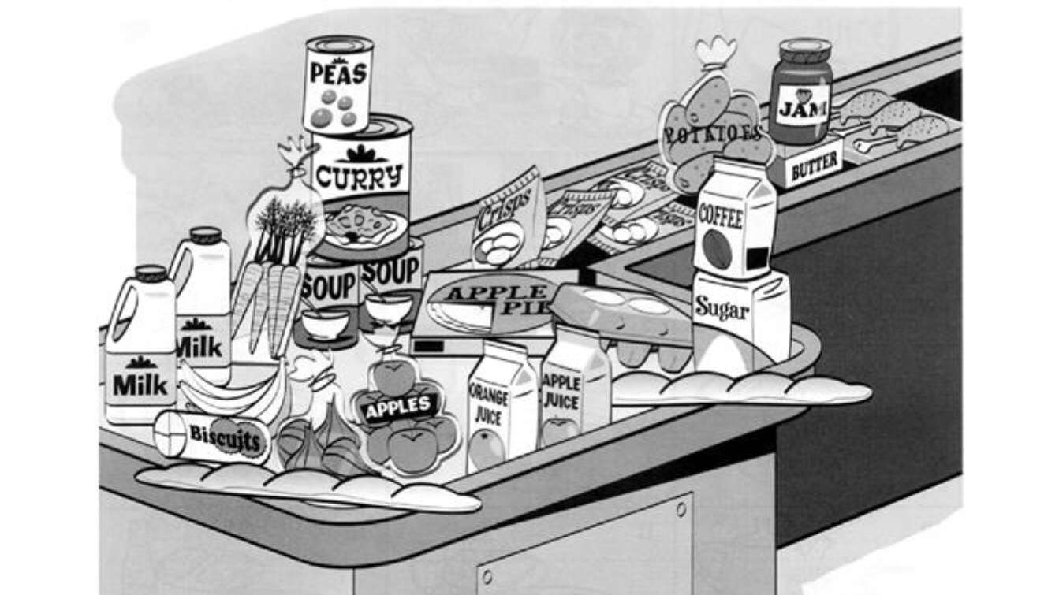

ANSWERS
Exercise A
- Have we got any bread? (A real question, I have no idea.)
- You can buy beer in any pub. (It doesn’t matter which pub.)
- Can I have some more juice? (I expect you will say ‘Yes’)
- In London in the winter there’s hardly any sunlight. (The meaning is negative.)
- We’ve got some furniture, but we still need a table. (Positive)
Exercise B
- There isn’t any cake. 11. There aren’t any beers.
- There aren’t any pizzas. 12. There’s some fruit juice.
- There’s some jam. 13. There aren’t any sausages.
- There aren’t any tomatoes. 14. There are some biscuits.
- There isn’t any yogurt. 15. There’s some milk.
- There are some onions. 16. There are some crisps.
- There are some carrots. 17. There are some chicken legs.
- There isn’t any pastas. 18. There aren’t any oranges.
- There’s some bread. 19. There’s some curry.
- There isn’t any salad. 20. There’s some soup.

Instructor’s Comments and Assessment
Pros
Cons
Change
Overall Comments
Grade
Above Standard 85%-100% | Standard 70%-84% | Below Standard 69%-0%
Instructor | Student Signature | Date
Taute, David

