Background Information Sheet
Name | Class | Date | Lesson Type | Plan type | Length
Daniel Kim | TESOL | 10 April, 2019 | Grammar | PPP | 25 min

Lesson
Topic | Look! They’re dancing.
Main Aim | Students will learn “Present Continuous”.
Secondary Aim | Students will practice their speaking fluency through communicative activity and built up their skills to talk in the form of present continuous.

Materials and References
Basic Grammar in use (Cambridge)

Student Profile
Level | Lower Intermediate Level
Age | Adults | Number of Students | 9
Detail | Students are from different countries (Korean, Turkish, Persian, Mongolian, and Chinese etc…).  They have ability to understand and speak basic English and have a great interest in learning English. They willing to listen and consider other students ideas.
Assumptions about students’ knowledge as required for this lesson:
Students are capable to have a basic English communicative activity such as lead-in and game etc…
Students know the verb “to be” and “Simple Present Tense (Present Indefinite)”.

Anticipated Difficulties and their Solutions:
Students may confuse Present Continuous and the present simple, In this case, I will show them the differences between the two tenses by giving them the examples.

My Personal Aim
What I hope most to demonstrate in this lesson is the ability to present the target language Inductively and to provide more opportunities for students to practice it.

Stage Name: Lead-in
Purpose of this stage: To relax both the teacher and students. To focus attention on the lesson. Create a situation for students to experience or think about, and then to elicit the target language.
Materials: PowerPoint, Board, Colored marker
Timings | Interactions | Procedure
3 min | T-S | Hello everyone, How are you? Are you feel sleepy? Let’s do some exercise, please stand up.  Ask students, what we doing now? Ans: we are standing up.  Instruct them four Physical Activities (stretching, Turning Lumbar, running, dancing), and ask them “what we doing? Encourage them to repeat after you while doing exercise (we are stretching; We are Turning Lumbar; etc……)

Stage Name: Presentation
Purpose of this stage: Make the students think about the situation. To clarify the meaning, form, and pronunciation features of the target language.
Materials: : PowerPoint, Board, Colored marker.
Timings | Interactions | Procedure
1 min  2 min  2 min  2 min | T-S  T-S  T-S  T-S | Board and show the model sentence in PPT and asks them to write down the sentence.  CCQ.  - Is this happing now? (Yes)  ?  Past___________________________Now________________________future  (or around now)  - Can you see it? (Yes)  - Is the dancing finish? (No)  - Are they dancing now? (Yes)  We use the present continuous for Action happening now or around now.  Form  - Can we say “they dancing”? No  - Why? Because the present continuous of any verb is composed of two parts - the present tense of the verb to be + the present participle of the main verb. (The form of the present participle is: infinitive+ing, e.g. talking, playing, moving, smiling) Affirmative.  - Show the sleeping person picture to the student.  - To teach the question form, ask them “Is he dancing? (No)  - To teach the negative form, show them the answer (if they didn't give the right answer) “NO, he isn't dancing. He is sleeping”.  Positive  I am dancing  You are dancing  He, she , it Is dancing  We are dancing  You are dancing  they are dancing  Question  Am I dancing  Are you dancing  Is he, she , it dancing  Are We dancing  Are you dancing  Are they dancing  Negative  I ‘m not dancing  you aren’t dancing  he, she , it isn’t dancing  We aren’t dancing  you aren’t dancing  they aren’t dancing  Drill  Where is the sentence stress? ‘Look! They’re dancing’.  intonation  Pronunciation:  - Listen, and repeat three time; they’re /ðer/. Conduct the drill chorally 3 times with gestures. Nominate for individual drilling  - Put all together ‘Look! They’re dancing’.  - Listen, and repeat it after me tree time, conduct the drill chorally 3 times with gestures. Nominate for individual drilling  - Nominate a student to ask a question to another student ‘what are you doing?’  - Another student must answer using present continuous (negative or positive).

Stage Name: Controlled Practice
Purpose of this stage: students practice working with the form. Accuracy must be checked.
Materials: Board, Colored marker, worksheets .
Timings | Interactions | Procedure
30 sec  2 min  1 min  1 min | T  S  S-S  T-S | Instructions. Hold up the worksheet, point to exercise A.  Exercise A says look at the picture and guess what are the other people in the picture doing, then fill in the blanks  a) What’s the man …………?  He’s …………….a newspaper.  b) What are the young couple ……………….?  They’re …………………………….  c) What’ ……….the young girl ………………?  She’s …………………………..on envelope.  d) What’s the ……………… …………………….?  ………………..’s ………………………at her watch.  e) …………….. ……………..the children ……………?  …………… ………………… …………………….. With the dog.  Hand out the worksheets.  Students do worksheet exercise A.  Pair checks.  Feedback to check Accuracy. Board answer.

Stage Name: Less Controlled Practice
Purpose of this stage: students practice working with the meaning. Accuracy must be checked.
Materials: Board, Colored marker, worksheet B
Timings | Interactions | Procedure
30 sec  2 min  1 min  1 min | T  S  S-S  T-S | Instructions: Distribute your worship, exercise B, say look at the picture and Write 6 true sentences about the Emily. Use she’s-ing or isn’t-ing.  ICQ: how many questions? 6  Hand out  1. (have dinner) she isn’t having dinner.  2. (watch television) she’s watching television.  3. (sit on the floor) she…………………………………….............................  4. (read the book) ……………………………………………………………………….  5. (play the piano) ……………………………………………………………………….  6. (laugh) ……………………………………………………………………………………..  7. (wear the hat) ………………………………………………………………………….  8. (write the letter) ……………………………………………………………………..  Students do a worksheet.  Pair check.  Feedback to check accuracy.

Stage Name: Production – Freer Practice
Purpose of this stage: is to get students to practice the grammar communicatively.
Materials: Board, Colored marker.
Timings | Interactions | Procedure
30 sec  5 min  1 min | T  S-S  T-S | Instructions:  - Split students in pair  - Students Show to his/her partner the pictures on his/her phone. Describe what is happening in the photo.  Student pair discussion, using present continuous naturally.  Feedback

Stage Name: Wrap-up
Purpose of this stage: is to end the lesson on a positive note so that students feel they have achieved progress.
Materials: homework exercises, Board, Colored marker
Timings | Interactions | Procedure
2 min | T  T – S  T  T | Lesson feedback. Tell the class what they did well, and what needs to improve.  Offer delayed corrections to the previous stage.  handout homework exercises  For the next class, we are going to study more about the present continuous and simple present And the differences between them.

Worksheet A
Look at the picture and guess what are the other people in the picture doing, then fill in the blanks.

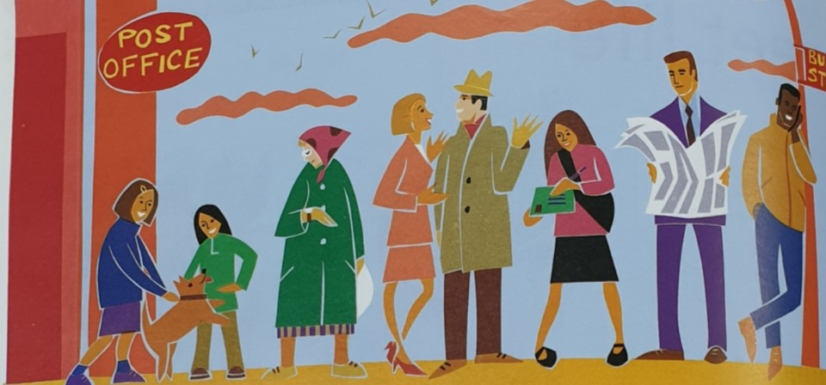

- What’s the man …………?
He’s …………….a newspaper.
- What are the young couple ……………….?
They’re …………………………….
- What’ ……….the young girl ………………?
She’s …………………………..on envelope.
- What’s the ……………… …………………….?
………………..’s ………………………at her watch.
- …………….. ……………..the children ……………?
…………… ………………… …………………….. With the dog.

Worksheet B
Look at the picture. Write 6 true sentences about the Emily. Use she’s-ing or isn’t-ing.
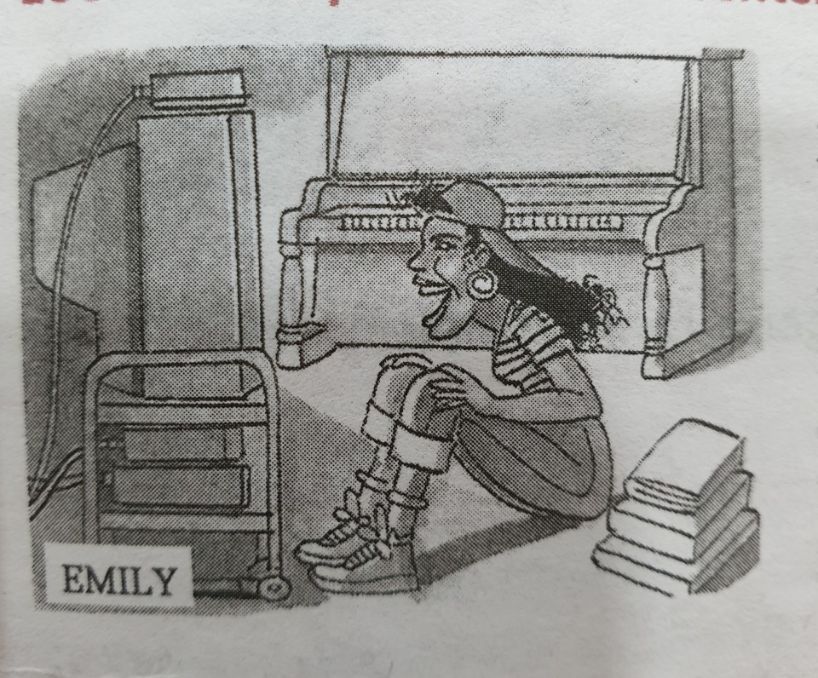

1. (have dinner) she isn’t having dinner.
2. (watch television) she’s watching television.
3. (sit on the floor) she…………………………………….............................
4. (read the book) ……………………………………………………………………….
5. (play the piano) ……………………………………………………………………….
6. (laugh) ……………………………………………………………………………………..
7. (wear the hat) ………………………………………………………………………….
8. (write the letter) ……………………………………………………………………..

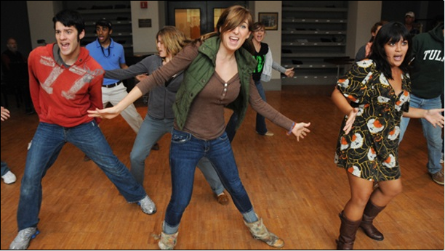

Is this happing now? (Yes)
Can you see it? (Yes)
Is the dancing finish? (No)
Are they dancing now? (Yes)

Instructor’s Comments and Assessment
Pros
Cons
Change
Overall Comments
Grade
Above Standard 85%-100% | Standard 70%-84% | Below Standard 69%-0%
Instructor | Student Signature | Date
Taute, David

