Background Information Sheet
Name | Class | Date | Lesson Type | Plan type | Length
Carli Chung | TESOL | 2019.04.17 | Reading | PPP | 25 min

Lesson
Topic | News Article: “10ways to celebrate National Pet Day”
Main Aim | Ss practice their reading comprehension.
Secondary Aim | Ss practice their speaking fluency.

Materials and References
Whiteboard, colored Markers, short YouTube video (Song: I have a pet), PPT, ‘10ways to celebrate National Pet Day article, literal question worksheet, Interpretive question worksheet, role play example handout.

Student Profile
Level | Intermediate
Age | High school students | Number of Students | 9
Detail | Native Korean students, 2 boys and 7 girls. All students get along very well. Jin is one of the shy students that require more motivation in active participation in class. Eli and Sue are the 2 most outgoing students in class. All students have a strong desire to enhance their English reading comprehension.
Assumptions about students’ knowledge as required for this lesson:
The students have practiced reading short articles on different subjects. They also have experience doing role plays. Today’s article is bit long but it simply lists different ways to celebrate with a pet, so it will not be too difficult for the students to read. Some of the vocabularies such as pamper or fret may be unfamiliar to the students. However, the context of the text will help students follow the meaning of the word or sentence.

Anticipated Difficulties and their Solutions:
Absence/lateness: Students being late for class may disrupt the class atmosphere and student’s concentration in class. Therefore, I will acknowledge the late student, but continue teaching, so the flow of the lesson is not interrupted. Also, if a student is absent, I will have to pair the students differently for their pair discussions and role play partners.
Technical problems: The computer could malfunction during the lesson, while showing the YouTube video or PPT to the students. To block this problem beforehand, I will double check if the computer is working well before the lesson begins.
Pair discussion problems: During pair discussion, I will monitor each student from a distance to make sure all the students are participating in the discussion and sharing their opinions.
Role Play Confusion/difficulty: To ensure students are not confused or do not face difficulties while preparing their role play, I will give clear instructions and hand out an example of a role play script between a pet and its owner.

My Personal Aim
What I hope most to demonstrate in this lesson is the ability to enhance students reading comprehension and help them gain confidence and improve their speaking fluency. Also, I hope to improve my classroom time management ability by following the timeline of my lesson plan while also keeping track of the time and by giving students clear and straightforward instructions, so there is no confusion about the worksheets and activity the students have to perform. My final aim is to keenly monitor each student and give them helpful feedback.

Stage Name: Lead-in
Purpose of this stage: To relax both the teacher and students. To focus attention on the lesson. To lead in to the topic, activating background knowledge.
Materials: List all materials that will be needed in this stage.
Timings | Interactions | Procedure
30 sec  2 min  1 min  30 sec | T-S  S-S  T | Greetings  “Hello class! How is everyone this morning/afternoon?”  Ss answer  “Does anyone know the song ‘I have a pet?”  Ss answer (most likely no)  “Okay let’s listen to it together!”  Show YouTube video (Song: I have a pet)  “Okay, so do YOU have a pet?”  Ss answer  “If you don’t, why not? I want you to discuss with a partner about your pets. If you don’t have one, talk about why you don’t have a pet and what pet you want to have in the future”  (Show the question on PPT: “Do you have a pet? If you don’t have a pet, what pet do you want to have in the future?)  Brainstorm/talk to a partner.  “Talk with a partner.”  (Pair students in groups of 2)  Feedback  “I heard most of you have/don’t have pets…”

Stage Name: Presentation
Purpose of this stage: To pre-teach keywords if necessary, and consider guiding questions. These steps provide extra help for students to comprehend the text.
Materials: List all materials that will be needed in this stage.
Timings | Interactions | Procedure
1 min  2 min  1 min | T-S  S-S  T-S | Pre-teach keyword: Celebrate  “Everyone, look at this picture. What are they doing?”  (Show several pictures of people celebrating a party or a special holiday)  Ss answer  “Yes, they are having a party to celebrate a holiday!”  CCQ – check students properly understand the meaning  “Is this a special day?” Yes  “Do people do special, fun activities?” Yes  “Do people have traditional or special meals together?” Yes  “Can we celebrate with just one person?” Yes  “How about with many people?” Yes  (Show meaning of the word ‘Celebrate’) – PPT  Drill – choral and individual drilling for correct pronunciation  Board – Write the word celebrate on the board.  Guiding Question: If you could celebrate 1 day with your pet, what would you do? If you don’t have a pet, imagine you have one!  Students discuss the question with a partner  “Discuss with your partner”  Feedback. Nominate a few students to share their ideas.

Stage Name: Practice – Literal Comprehension
Purpose of this stage: is to get students to practice reading for literal detail.
Materials: List all materials that will be needed in this stage.
Timings | Interactions | Procedure
30 sec  2 min  1 min  1 min | T  S  S-S  T-S | Instructions  “This is a news article about ‘National Pet Day.’ The article lists 10 ways to celebrate this special day with your pet. I will give you time to read this article. Once you are finished reading, I would like you to read the questions on this handout. You can find the answers in the article. Please highlight or underline the information where you find the answer.”  (Hand out article and worksheet)  Students read the whole text for the 1st time, and highlight or underline their answers.  Pair check. (Monitor the students)  “Ok time is up. Check your answers with a partner.”  Feedback to check accuracy.  “Let’s go over the answers together.”

Stage Name: Practice – Interpretive Comprehension
Purpose of this stage: is to get students to get students to practice interpreting a text correctly This will require more detailed, careful reading, and thinking time to arrive at the correct answer.
Materials: List all materials that will be needed in this stage.
Timings | Interactions | Procedure
30 sec  2 min  2 min  1 min | T  S  S-S  T-S | Instructions.  “I will give you another worksheet. If you look at the top of the worksheet, there is a question. I will give you 2 minutes to answer the question.”  (Hand out worksheet)  Interpretive question: “Why do people have pets? Think of the reasons and the purpose of having pets”  Students read for the 2nd time. Students write their answers down.  Pair check. (Monitor the students)  Feedback to check accuracy.

Stage Name: Production - Applied Comprehension
Purpose of this stage: is for students to practice their speaking fluency on a topic related to the lesson.
Materials: List all materials that will be needed in this stage.
Timings | Interactions | Procedure
30 sec  2 min  4 min | T  S-S  S-S | Instructions.  “We are going to do a role play. You will work with the same partner. Each group will role play a pet and the pet owner spending National Pet Day together. I will give each group a piece of paper with a type of animal written on it. For example, this paper says Dog, so your group will roleplay a dog and the dog owner. I will give you 2 minutes to talk with your partner. This is an example role play to help you guys. Yours can be shorter than this. If you have any questions, please raise your hand.”  Students discuss how they will role play  Students take turns role-playing the script

Stage Name: Wrap-up
Purpose of this stage: is to end the lesson on a positive note so that students feel they have achieved progress.
Materials: List all materials that will be needed in this stage.
Timings | Interactions | Procedure
1 min | T-S | Lesson feedback. Tell the class what they did well, and what needs to improve.  “That’s the end of today’s class. Everyone did a great job today..Ss name, I heard you do this..it will be better if you don’t..”  Inform students about the topic for the next lesson.  “Next class we will read more about celebrating different holidays of different countries!”

https://www.youtube.com/watch?v=RAObh4cLDAI
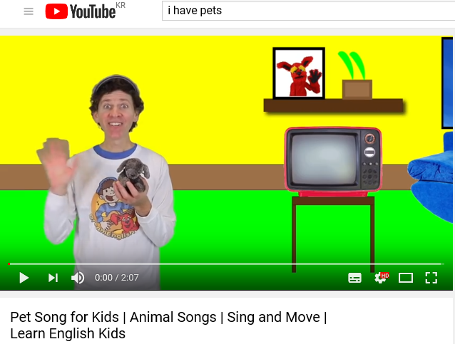

Presentation Stage
Pre-teach the word ‘Celebrate’

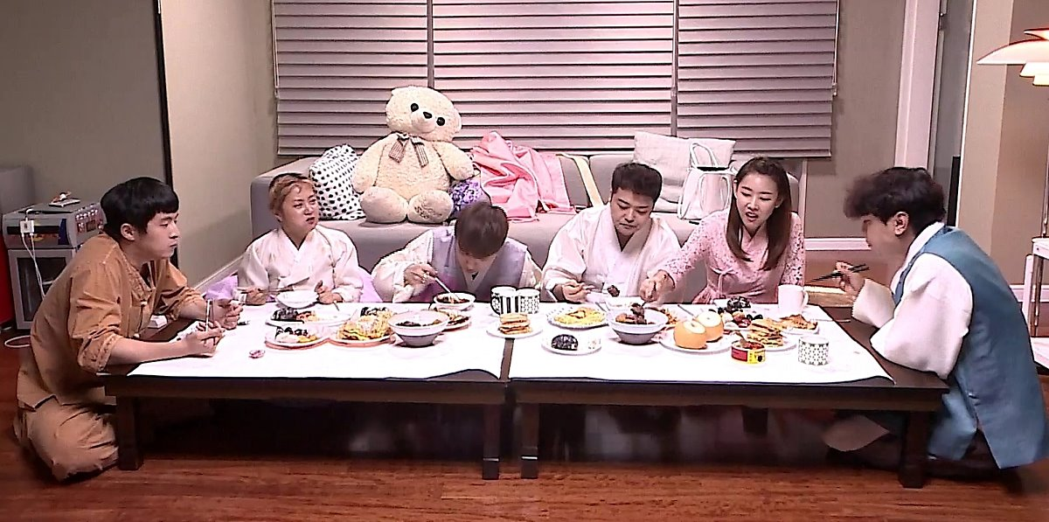

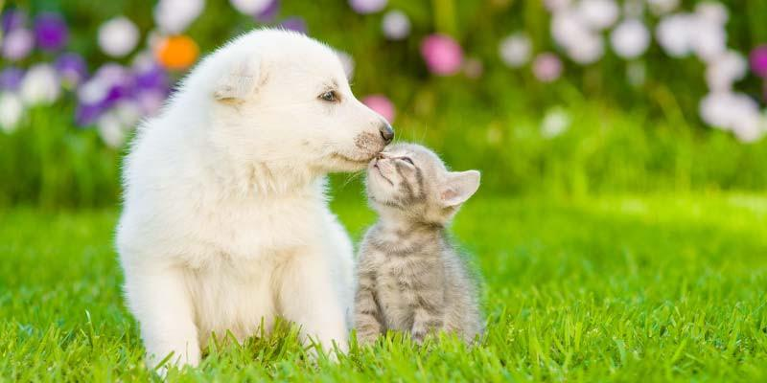

10 Ways to Celebrate National Pet Day
Home / News
Previous / Next
April 11, 2017 4 min read

National Pet Day is here! It’s time to show your pet some extra love and spoil them endlessly. National Pet Day was founded in 2006 by Colleen Paige - a Pet & Family Lifestyle Expert, as well as, an Animal Welfare Advocate. She dedicated this day to celebrating the happiness and joy pets bring to our lives on a daily basis. National pet day isn’t just celebrating the pets at home, but dogs and cats everywhere. This day was also founded to created public awareness for all the different animals awaiting a forever home in shelters and rescues around the world. Adopt don’t shop!
So, without further ado, here are 10 ways for you to celebrate National Pet Day:
- Pamper your pet. Did you know you can pamper your pet by booking them a day at the spa? Yes, there are spas for your pet. Crazy, right? Some pet spas include a pool, a private massage room, and long baths for your pet. Sounds like our kind of spa!
- Make some yummy, homemade treats. Just like you, your pet deserves some homemade treats every once in a while. So, why not make them on one of their special days? There are countless options for homemade pet treats. Some of the most common treats are pet cookies, dog biscuits, and dog bones. They sound like normal treats, but once you add in different petlicious flavors, your furry friend will love you forever and keep begging for more!
- Donate toys or food to a local shelter, or become a volunteer. Don’t have a pet? Don’t fret! You can still celebrate by donating toys, food, and other items to a local animal. You can also volunteer a few hours of your time. Shelters are always looking for more people to help keep their shelter’s running, give their pets the love and attention they deserve, while they wait to become adopted. You’ll be amazed at just how good it feels to volunteer at a pet facility. You’ll get that warm, fuzzy feeling inside when you volunteer – especially from our fuzzy, furry pets.
- Take your dog to the park. Let your pup socialize and roam with other dogs. Interacting with other dogs and people isn’t just fun for your four legged friends, but is a learning experience. Dogs that regularly meet new pets and people are better behaved, diminishing behavioral problems like aggression or separation anxiety. What an easy and fun way to teach your dog good habits, plus your pup will feel like he’s being spoiled. Your pup will happily have his tongue out the entire time while playing with his other canine friends. Don’t forget to bring toys for your dog to play with to give him a little one-on-one playtime with you. Bring a frisbee, a tennis ball, or a rope he can tug on with you. He’ll enjoy every second of it!
  - Split a meal. Lady and the Tramp meal with your dog, anyone? No, we don’t mean split the dog food between you and your pup. There are plenty of doggie friendly restaurants that will let you sit on their patio. So, why not split a meal you will both love and enjoy the, hopefully, nice weather.
- Have a photo shoot. What’s more perfect than having photos of your pet all around your home? Plus, as your pet grows older, these pictures will mean the world to you as you recall every wonderful passing year with your best four-legged friend. The more photos you have the better, so call up a friend or hire a photographer. Take a ridiculously wonderful amount of pictures that you can share all over your Facebook page, Twitter and Instagram, or proudly display your pet portraits around the house.
- Show some extra love. You’re the only person who knows how to show your pet you care. Whether that’s extra cuddles, longer belly rubs, playing outside together, or simply watching a movie together, showing some extra love to your pet is one of the best ways to celebrate National Pet Day.
- Bring your pet home a new toy… or two. Nothing makes your dog’s tail wag faster than bringing him home a new toy… or two. I mean, why not spoil him on this special day? Whether it’s a squeaky toy or a chewy toy, your pet will be jumping on all fours.

- Adopt a furry friend, or make an addition to your furry family. There’s never a better time to adopt another furry friend. Or, if you don’t currently have a pup or kitty cat, this is the perfect time to adopt one! Everyone needs some joy and entertainment in their life, and a pet will do just that. Plus, if you have one furry friend, he is going to need a friend, right?
- Take your pet on an adventure. Is your pet big on the outdoors? Take them on a long hike, or go for a swim in a local lake or river. Spoil them with outdoor adventures, exposing your dog or cat to new smells to sniff and sights to see. Even if your pet just likes car rides so he can stick his head out the window, that’s always an option as well!
So, take your pet out to a park, bring home some new toys, or just cuddle up and watch a movie together. Whatever you choose either way, show them some extra love today. Oh, and don’t forget to give them an extra hug from all of us here at Particular Paws! Happy National Pet Day!

Name Date

10 Ways to Celebrate National Pet Day

Directions: Use the information from the article to answer the questions below. Underline or highlight the sentence where you found the information.

1. Who created ‘National Pet Day’?

2. Why did he/she create this holiday?

3. What are the 10 ways we can celebrate ‘National Pet Day’?

4. What homemade treats do pets often eat?

5. How can we show our love to pets?

Name Date

10 Ways to Celebrate National Pet Day

<Answer Sheet>

Directions: Use the information from the article to answer the questions below. Underline or highlight the sentence where you found the information.

1. Who created ‘National Pet Day’?
National Pet Day was founded in 2006 by Colleen Paige - a Pet & Family Lifestyle Expert, as well as, an Animal Welfare Advocate. (Underline/Highlight 1st paragraph 3rd Sentence)
2. Why did he/she create this holiday?
She dedicated this day to celebrating the happiness and joy pets bring to our lives on a daily basis. National pet day isn’t just celebrating the pets at home, but dogs and cats everywhere. This day was also founded to created public awareness for all the different animals awaiting a forever home in shelters and rescues around the world. (Underline/Highlight 1st paragraph 4, 5, 6th Sentence)
3. What are the 10 ways we can celebrate ‘National Pet Day’?
Pamper your pet. Make some yummy, homemade treats. Donate toys or food to a local shelter, or become a volunteer. Take your dog to the park. Split a meal. Have a photo shoot. Show some extra love. Bring your pet home a new toy… or two. Adopt a furry friend, or make an addition to your furry family. Take your pet on an adventure. (Underline/Highlight the headline for the 10 different ways listed in the article)
4. What homemade treats do pets often eat?
Some of the most common treats are pet cookies, dog biscuits, and dog bones. (Underline/Highlight the 2nd list: Make some yummy, homemade treats, 4th sentence)
5. How can we show our love to pets?
Whether that’s extra cuddles, longer belly rubs, playing outside together, or simply watching a movie together, showing some extra love to your pet is one of the best ways to celebrate National Pet Day. (Underline/Highlight 7th list: Show some extra love, 2nd Sentence)

Why do people have pets? Think of the reasons and the purpose of having pets

Why do people have pets? Think of the reasons and the purpose of having pets

People have pets for various reasons. Some people keep pets because of their physical attractiveness. Other people keep pets for their playfulness or other unique personalities and characteristics. Many people keep pets for companionship. The majority of pet owners enjoy the attachment and fun their pet(s) bring into their lives. Pets can help their owners relieve stress and loneliness. Pets such as dogs will increase their owners’ opportunity for exercise and outdoor activities. Most dog keepers walk their pets on a daily basis. Many retired old folks would carry their bird cages out for a walk to a nearby park in the morning. There they gather around with many other bird keepers. While the birds are socializing by singing with one another, their keepers are socializing with each other too. This is beneficial for both the birds and their owners both physically and mentally. Keeping pets can also increase our sense of responsibility. Unlike wild animals, pets depend on their owners for food and shelter. Parents can take the opportunity to teach their kids to become more responsible, and more warm-hearted if they let the kids to own and to take care of their little pets. Children in general love to play with pets and parents can engage their kids in some games that involve their pets. One such game is the “fetch.” Keeping pets helps reduce anxiety and enhance mood. Pets help boost their keepers’ self-esteem because pets are not “snobbish” or “prejudiced” against their owners by their social status or their appearance. Whether we are rich or poor, good-looking or “ugly,” overweight or underweight, our pets just do not care. Their unconditional loyalty gives us a sense of satisfaction and pleasure.

Role Play
Tip: Use the article to help make your role play script!

Pet: Male dog, his name is Max
Owner: Female, her name is Katie

Katie: “Max, today is National Pet Day! Let’s do something special today!”
Max: “Okay!! But..what is National Pet Day?” (Looks confused)
Katie: “This day is to celebrate you Max! Think of this day as your birthday. What do you want to do?”
Max: “My birthday? Wow!! Okay, let’s go outside. I want to go to the park and play ‘fetch the ball’!” (Show a motion of a dog shaking its tail by shaking your butt)
Katie: (laughing) “You never get tired of that game. Okay let’s go out!”
(Katie and Max walk towards the park)
Katie: (Throws the ball) Catch Max!
Max: (Jumps and catches the ball) Thanks Katie. This is fun!
Katie: Now let’s take some photos! Max, stand near that tree.
Max: (Runs to the tree and makes a cute pose) How do I look Katie?
Katie: You look so cute! Now let’s take a picture together!
Max: (Jumps into Katie’s arms)
(Katie and Max take a photo together)
Katie: Oh no. It’s already getting dark. We should go back home.
Max: Okay. I had fun today. Can you make me a homemade snack when we get home?
Katie: Sure! I will make you your favorite dog biscuits.
Max: Thank you Katie. I will remember this day forever!!

Instructor’s Comments and Assessment
Pros
Cons
Change
Overall Comments
Grade
Above Standard 85%-100% | Standard 70%-84% | Below Standard 69%-0%
Instructor | Student Signature | Date
Taute, David

