Background Information Sheet
Name | Class | Date | Lesson Type | Plan type | Length
Daniel kim | TESOL | April 17th, 2019 | Reading | PPP | 25 min

Lesson
Topic | Let’s shop!
Main Aim | Ss practice their reading comprehension.
Secondary Aim | Ss practice their speaking fluency.

Materials and References
PPT, Board, board eraser, Colored marker, worksheets, hand out
Hemispheres 2 (unite 6, page 46)

Student Profile
Level | Lower-intermediate
Age | Adult | Number of Students | 9
Detail | Students are from Turkey, Mongolia, and Korea. All the students are very eager and interested in learning English and they are very friendly and cooperative with each other.
Assumptions about students’ knowledge as required for this lesson:
The student gets the general idea of what they read but usually has some difficulties He/she can read and write simple texts and is able to hold a basic conversation about topics.

Anticipated Difficulties and their Solutions:
Absence, Lateness__This lesson plan, design for 3 groups of 3. I would need to make 2 groups of 3 and one group of 2 till the latecomer join the group.

My Personal Aim
What I hope most to demonstrate in this lesson is:
- To give clear instructions and check their understanding.
- To give the students appropriate guidance with different tasks in the lesson.

Stage Name: Lead-in
Purpose of this stage: To relax both the teacher and students. To focus attention on the lesson. To lead in to the topic, activating background knowledge.
Materials: PPT, Board, Colored marker, worksheets
Timings | Interactions | Procedure
30 sec  2 min  30 sec | T  T-S/S-S  T-S | Hello everyone, how are you this morning?  What do you like to shop for the most?  Show the pictures (PPT) and ask students these questions.  - How often do you buy these items? Frequently, sometimes, rarely, or never?  - Add your own idea to the last frame.  - Talk to a partner.  - Share with class  Feedback if appropriate.

Stage Name: Presentation
Purpose of this stage: To pre-teach keywords if necessary, and consider guiding questions. These steps provide extra help for students to comprehend the text.
Materials PPT, Board, Colored marker, video (https://www.youtube.com/watch?v=2NlJ03hhwms)
Timings | Interactions | Procedure
2 min  10 sec  1 min  50 sec | T-S  T  S-S  T-S | Pre-teach keywords  Elicit: Show the students pictures and ask them below questions.  CCQ  Shows off (phrasal verb): to do something to attract attention to yourself, display something you’re proud of.  “What are these people try to do? (Point out to the photo)?”  - Are they display something they're proud of? (yes)  - Are they just doing this for personal use? (No)  - Are they doing this to attract others' attention?  Drill  How many syllables in show off /ʃəʊ/ ? 2 syllables / phrasal verb [ˈshō-ˌȯf]  also can be Noun  – choral and individual drilling for correct pronunciation  Board – highlight special areas of pronunciation  Guiding Question  Is shopping as a hobby good or bad?? Why?  Students discuss the question with a partner.  Feedback. Nominate a few students to share their ideas.

Stage Name: Practice – Literal Comprehension
Purpose of this stage: is to get students to practice reading for literal detail.
Materials: : Board, Colored marker, worksheets
Timings | Interactions | Procedure
30 sec  3 min  1 min  1 min | T  S  S-S  T-S | Instructions:  - I will give you hand out (text) and worksheet A.  - You need to read the text and then answer the questions on the worksheet A.  - You have 4 minutes to read and answer.  - Distribute handouts and worksheets.  Q1N: Who has Hello Kitty all over in his/her place?  AN: Julia Chio  QN2: whose home filled with many purchases?  AN: Matt Anderson  QN3: How did Julia manage his budget to buy the guitar?  AN: she save up for a year  QN4: 4. If Matt doesn't cut back on buying things, what will happen to him?  AN: His roommate will kick him out  QN5: What do we call the person who collects things that reflect his/her personality?  AN: “self-expressive buyers”  QN6: What do we call the person who don’t plan their purchases, and shop without self-control?  AN: “Impulsive buyers”  ICQ:  - How many minutes you have?  - Can you see your partner answer?  Students read the whole text for the 1st time, and write answers on the worksheet.  Pair check  Feedback to check accuracy

Stage Name: Practice – Interpretive Comprehension
Purpose of this stage: is to get students to practice interpreting a text correctly This will require more detailed, careful reading, and thinking time to arrive at the correct answer.
Materials: Colored marker, worksheets
Timings | Interactions | Procedure
30 sec  2 min  1 min  1 min | T  S  S-S  T-S | Instructions:  - I will give you worksheet B.  - You need to read the text for the 2nd time more carefully.  - Then answer the questions on worksheet B.  - You have 5 minutes to read and answer.  - Distribute worksheets  QN1: Have they come to realize that too much and unnecessary shopping isn't a good hobby to have?  AN: Yes, because Julia Chio realizes that she will face the problem with her future husband on this unhealthy hobby, that’s why she said if she married she’ll spend less money on shopping. And Matt also worries for been the wind up broke because that and he want to cut back on buying things.  QN2: Are they addicted to shopping? How?  AN: Yes, because even though they realized that shopping is not a good hobby but they can’t stop doing that. Julia said she can’t do without (something you need to survive, continue, or succeed). And Matt worry to spend his whole paycheck in a week on shopping, he want to reduce but he can’t.  ICQ:  - How many minutes you have?  - Can you see your partner answer?  Students read for the 2nd time. Students write their answers down.  Pair check. Monitor.  Feedback to check accuracy.

Stage Name: Production - Applied Comprehension
Purpose of this stage: is for students to practice their speaking fluency on a topic related to the lesson.
Materials: Colored marker
Timings | Interactions | Procedure
1 min  2 min  1 min | T  S-S  T-S | Instructions: Give student the question to discuss in groups.  - Make 3 group of 3  - Give students a question and tell them to discuss it within their group.  - Students have 5 minutes to discuss.  Question: Are you a “self-expressive buyer or an “impulsive buyer”? Describe your shopping habits?  Students discuss.  Feedback. Students share their ideas with the class.

Stage Name: Wrap-up
Purpose of this stage: is to end the lesson on a positive note so that students feel they have achieved progress.
Materials: List all materials that will be needed in this stage.
Timings | Interactions | Procedure
2 min | T | Lesson feedback. Tell the class what they did well, and what needs to improve.  Offer delayed corrections to the previous stage.  Set homework.  Inform students about the topic for the next lesson.

Worksheet A

- Who has “Hello Kitty” all over in his/her place?
………………………………………………………………

- Whose home filled with many purchases?

…………………………………………………………..

- How did Julia manage his budget to buy the guitar?

………………………………………………………….

- If Matt doesn't cut back on buying things, what will happen to him?

………………………………………………………………………………

- What do we call the person who collects things that reflect their personality?

……………………………………………………………………………..

- What do we call the person who don’t plan their purchases, and shop without self-control?

……………………………………………………………………………

Worksheet B

- Have they come to realize that too much and unnecessary shopping isn't a good hobby to have? Explain How?

- Are they addicted to shopping? Explain How?

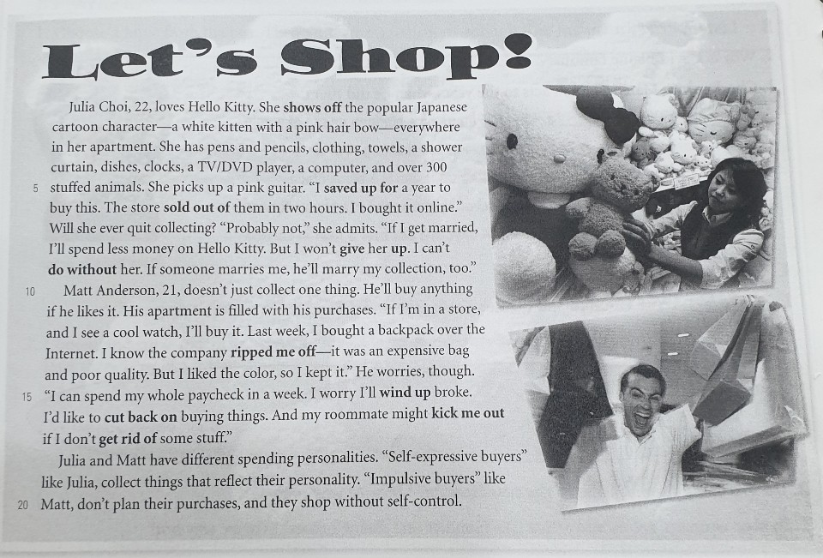

Instructor’s Comments and Assessment
Pros
Cons
Change
Overall Comments
Grade
Above Standard 85%-100% | Standard 70%-84% | Below Standard 69%-0%
Instructor | Student Signature | Date
Taute, David

