Background Information Sheet
Name | Class | Date | Lesson Type | Plan type | Length
You-mi | 193rd TESOL | 27TH.APR | Listening | PPP | 35 min

Lesson
Topic | Traveling by airplane
Main Aim | SS practice their listening comprehension.
Secondary Aim | SS practice their speaking fluency.

Materials and References
Audio file; speakers and computer; map; PPT file; worksheets; white board and markers; P
You tube listening practice file(https://www.youtube.com/watch?v=lh51xrVQyA0)

Student Profile
Level | Intermediate
Age | 14-16 (middle school student) | Number of Students | 5
Detail | They are middle school students in Korea.  There’re 3 females and 2 male students.  It seems that 2 male students are more active and outgoing.  Everyone can speak English quite well.  But their parents usually call me after the class to check what they have done, especially they want me to train for speaking more.

Anticipated Difficulties and their Solutions:
Technical failure- Prepare a backup audio file on my smartphone.
Two male students are talking too much. Because they are more active and outgoing.
It might have some difficulty for the rest of them to speak->Varying the group for each activity

My Personal Aim
I hope I can increase STT and reduce TTT.

Stage Name: Lead-in
Purpose of this stage: To relax both the teacher and students. To focus attention on the lesson. To lead in to the topic, activating background knowledge.
Materials: No materials are needed in this stage.
Time | Interaction | Procedure
30sec  30sec  2 min  1 min | T  S  T  T-S  S-S  T-S  T | Greet. Instructions.  Good morning everyone!  How are you doing today?  SS: Fine, teacher! (answer)  Good, the weather is so nice today, isn’t it?  Sometimes, I really want to go somewhere especially, when it’s sunny outside.  Do you guys want to travel somewhere?  Is there any place that you want to go for travel with your family in this summer vacation?  Brainstorm/talk to a partner.  Please, talk to your partner(group) about the place you want to go.  Ok, You Guys are together and three of you guys are together this time (gesture)  Divide into 2 groups  (1boy & 1 Girl /1boy & 2 girl)  Students talk together.  Feedback if appropriate.  All right, Let’s share together.  Tell us about your place that you really want to go and why.  (Pointing everyone to ask)  SS: Answer (Everyone)  Interesting!!

Stage Name: Presentation
Purpose of this stage: To pre-teach keywords if necessary, and to help students be better able to understand a difficult part of the audio.
Materials: white board, marker, map, ppt file
Time | Interaction | Procedure
3 min  3 min  2min | T-S  T-S  T-S  T-S  T  S-S | Pre-teach keywords: International, Class  Elicit – elicit/mime  Put the map on the white board.  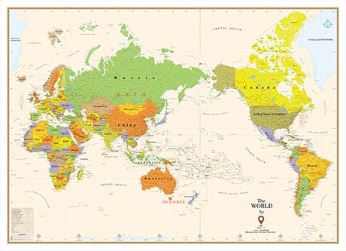  If I want to fly from here to here, what kind of flight is that called?  (point 2 point just located in one country)  SS: domestic  If I want to fly from here to there (with pointing 2 different places between two countries)  What kind of flight is it called?  SS: International  CCQ – check students properly understand the meaning  Is it an international flight if I fly over from here to here? (point 2 points inside one country)  SS: No. it’s domestic  Can we say this is an international flight if we travel from here to there(point 2 place between 2 countries)?  SS: Yes. It’s international  .What did I just say about when we travel to the other country from here?  SS: International flight  Yes. Right. We use international flight with 2 different countries.  .  Drill – choral and individual drilling for correct pronunciation  Could you please guys repeat after me.  Inter-nation-al (Repeat 3 times together)  Repeat individually (teacher correct pronunciation errors)  Board – highlight special areas of pronunciation  Board this word international.  What part of speech?  T: Adjective (Teacher just board)  How many syllables are?  (Point one student) Please come out to the front and mark it with a green pen.  (If she or he doesn’t know, Teacher can help them)  It’s ok, we can do it together.  3 (inter/nation/al)  Where is the stress?  (Point one student) Come to the front, please. (give him or her blue marker)  Second part  Alright, Good.  Elicit – elicit/mime  Show the PPT file (it shows each type of class inside an aircraft)  Are all seats the same in an airplane?  SS: No  What word do we use to talk about the different type of seats?  SS: Class (If they don’t know about it, I will let them know)  CCQ – check students properly understand the meaning  Are all seats the same in economy class?  SS: Yes  Are they serving different food in each class?  SS: Yes  Drill – choral and individual drilling for correct pronunciation  Could you please guys repeat after me?  Class (Repeat 3 times together)  Repeat individually (teacher correct pronunciation errors)  Board – highlight special areas of pronunciation  How many syllables are? 1  Where the stress is? first  What part of speech is this? Noun  Guiding Question  E.g., Students discuss the question with a partner.  Feedback. Nominate a few students to share their ideas  Anyway, when you guys would have a chance to take an international flight,  What kind things would you care about the most?  (The food quality, Comfortable seats, TV or Movie programs)  Talk to your partner again. This time you guys are together.  (Teacher change the partner for better practice)  Alright, what is the most important thing?  (Nominate 2 students to share the ideas)  Thank you guys to share it.  We’ll listen about some comment about Traveling by airplane.  Just imagine that PPT picture during your listening which will help you to understand more about it.

Stage Name: Practice - Literal Comprehension Listening
Purpose of this stage: is to get students to practice their literal listening skill.
Materials: Work sheet A
Time | Interaction | Procedure
30 sec  2 min  30 sec  1 min  2 min | T  S  T  S-S  T  T-S | Now, I have a worksheet A with 3 questions (gesture and point worksheet)  You can just mark down the right answer after listening.  Before listening, read this question first.  If you guys are ready, then I will start.  Hand out.  Students listen for the 1st time, and write answers on the worksheet.  Give 30 sec to think and write down the answer  Guys, Compare with your partner.  SS: Compare the answer.  Monitor (Just watching and hanging around)  Do you guys have a same answer?  Let’s compare the answer all together  Feedback to check accuracy.  Ok. Let’s move to the next exercise.

Stage Name: Practice - Interpretive Comprehension Listening
Purpose of this stage: is to get students to practice their interpretive listening skill.
Materials: Work sheet B
Time | Interaction | Procedure
30 sec  2 min  30 sec  1 min  2 min | T  S  S-S  T-S | Now, Please, turn to the next page with exercise B.  I have two more questions. At this time, you guys need to listen more carefully.  Read the questions, then take a short note about the answer during your listening.  It will help you to find an answer easily.  Students listen for the 2nd time.  Give 30 sec for answer.  Pair check.  Monitor. If students need, then replay the audio a 3rd time.  Feedback to check accuracy.  Did you guys have a same answer or different?

Stage Name: Production - Applied Comprehension Speaking
Purpose of this stage: is for students to practice their speaking fluency on a topic related to the lesson.
Materials: No materials are needed
Time | Interaction | Procedure
1 min  8 min  1min | T  S  T-S | Let’s talk about more.  Imagine, now you are just arrived at the airport with very close friend.  Then the crew said,  “How lucky you, we offer you an upgrade chance from economy class to business class.  But there is only 1 seat available”  What will you do in this situation?  SS talk  Ok, let’s talk about it more  (Give them more chance to talk)

Stage Name: Wrap-up
Purpose of this stage: is to end the lesson on a positive note so that students feel they have achieved progress.
Materials: No materials are needed.
Time | Interaction | Procedure
1 min | T | Alright.  How was it today? All of you guys did really well.  I am so happy with it.  Now we Know the differences about the class type, right?  SS: Yes  We have a homework today.  Talk to your parents about the class type that we’ve learned from today’s lesson.  Then find out which class type they want to take in the future.  If they don’t have any idea about the class type, you guys might let them know about it, right?  Anyway, you guys did really good job today.

Instructor’s Comments and Assessment
Pros
Cons
Change
Overall Comments
Grade
Above Standard 85%-100% | Standard 70%-84% | Below Standard 69%-0%
Instructor | Student Signature | Date
Taute, David

Work sheet

Exercise A
Read the questions.
Listen and write your answers

- Why do people mostly buy economy class ticket?
- Because it’s expensive
- Because it’s cheaper than the other class

- Is it easy to sleep in economy class?
- Yes, it is easy to sleep
- No, it is hard to sleep

- First class is suitable for short flight. True / False

Exercise B
Read the questions.
Listen more carefully and write your answers.

- Why do airplane travelers pay more money with a long flight?
-->travelers might feel more tired with a long flight.
Taking a better seat can make them feel more relax.

- Why does each class offer a different service and seat?
-->Because people pay more to get a better service.

Traveling by Airplane

Airplane travelers can choose between three kinds of tickets: first class, business class, and economy class. Most people buy economy class tickets. They are cheaper, so travelers can go to more places more often. Business class is more expensive, with good seats and good service. First class is very expensive, but offers very comfortable seat and excellent service.
In economy class, the seats are small and close together. There is not much legroom. In first class, the seats are huge and wider apart. There is lots of room for passengers to stretch their legs. Economy class passengers usually must all watch the same movie. First class passengers have their own TVs, and each person can watch different movies. Economy class passengers eat cheaper food. First class passengers are served delicious, fresh food. It is difficult to sleep in economy class because of the small seats and all the noise. In first class, the large seats can be pushed back to make a comfortable bed.
There is a curtain between sections, so it is nice and quiet.
Economy class is a good choice for short flights within the same country. Business class or first class is a good choice for business travelers taking an international flight across an ocean. These people often have to get off the plane and go right to work.
For them, it is important to arrive fresh, rested, and ready for a full, exciting day.

PPT file

- Traveling by airplane

- Where is it?
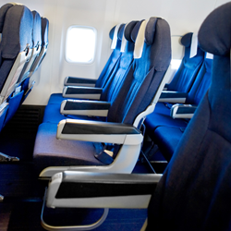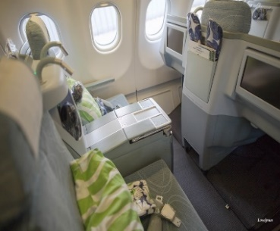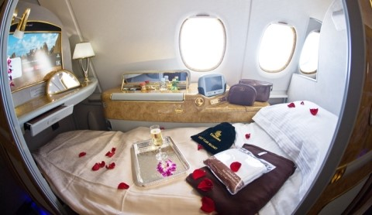

3.what is the difference?
