Background Information Sheet
Name | Class | Date | Lesson Type | Plan type | Length
Lily | 193th TESOL | 2019/04/27 | Listening | PPP | 35 min

Lesson
Topic | Shopping for clothes
Main Aim | Ss practice their listening comprehension.
Secondary Aim | Ss practice their speaking fluency.

Materials and References
Audio file https://learnenglishteens.britishcouncil.org/skills/listening/elementary-a2-listening/shopping-clothes
Audio Transcript
Speakers, Computer and Monitor
Worksheets
Pictures
Realia
White board and Color board markers

Student Profile
Level | Pre-intermediate
Age | 14-16 | Number of Students | 5
Detail | There are 4 female students and 1 male student.  Everyone is Korean.  They enjoy sharing their experiences and tend to get involved more in the lesson when they work together.

Anticipated Difficulties and their Solutions:
Technical failure - Prepare a backup audio file on my smartphone.
Use of L1 – Remind students of the rule speaking English only.

My Personal Aim
What I hope most to demonstrate in this lesson is the ability to write a detailed and accurate lesson plan.

Stage Name: Lead-in
Purpose of this stage: To relax both the teacher and students. To focus attention on the lesson. To lead in to the topic, activating background knowledge.
Materials: A picture of dress, Computer, Monitor
Time  (7min) | Interaction | Procedure
1min  30sec  4 min  1min  30sec | T-S  T  T-S  S-S  T-S | [Greeting/Lead in]  Hello everyone! How are you today? (Ss: Good! )  Great. The weather is so nice. I feel spring has already come!  So, yesterday, I went to ‘Hyundai’ department store and bought my new dress.  This is what I bought in the shop.  (Through a monitor, show students a picture of dress I bought in the department store).  Do you have your favorite clothes? When do you usually wear it?  You have 2 minutes to discuss each.  “  [I.C.Q ]  “What do you need to talk about?” (Ss : about our favorite clothes, when do we wear it)  “How long can you talk for?” (4minutes)  [Ss talk to a partner.]  Monitor the students. Alarm them the remain time.  “1 minute left”  [Warm up]  Time is up. Can you share your discussion with your class?  Nominate 2 students to share the discussion to the class.

Stage Name: Presentation
Purpose of this stage: To pre-teach keywords if necessary, and to help students be better able to understand a difficult part of the audio.
Materials: White board, Color markers , Paper doll/Paper dress
Time  (13min) | Interaction | Procedure
2min  1min  30sec  1min  2min  30sec  30sec  4min  1min  30sec | T-S  T  T-S  T-S  T  T-S  S-S  T-S | [Pre-teach keywords]  - Try on - miming  - Credit card – realia  - Receipt – realia  - Pound – picture  [Elicit – elicit/anecdote/mime]  We will play an episode game. I’ll show you the day I buy my dress with this paper doll.  Say the name of the action or item I show you to go to the next episode.  “I went to England and went to a shop to buy my dress.  I picked one dress and ask can I______?”  (hold a paper doll with left hand and hold a paper dress with right hand. Mime the action of wearing by putting the dress on the doll’s body)  Let’s move to the next scene. I’ve tried on the dress.  “Do you know what is the money called?”  (showing the picture of pound)  Ss say dollars! Pound! Good  How much is one Pound in Won?  Ss say 1000won! 1200won! 1500won! Yes.  I didn’t have cash in my wallet. I used ________ (showing my real credit card)  Ss say card! Plastic card! Credit card! Good.  After I pay, I get this _________ (showing my real receipt)  Ss say paper! List! Receipt! Perfect.  [CCQ – check students properly understand the meaning]  - Why did I try on the dress? (to see/ to check if the dress is good on you)  - How much 20Pound in Won? (30,000won!)  - With a credit card, are you paying now or later? (Later)  - What can you find in the receipt? (total amount paid/ price for the dress/ refund period/exchange period/ date you bought/ address of the shop…)  [Drill – choral and individual drilling for correct pronunciation]  I will say a word repeat after me 2 times together with a class.  1) Try – on (repeat 2 times together)  2) Pound (repeat 2 times together)  3) Credit-card (repeat 2 times together)  4) Receipt (repeat 2times together / make sure not to pronounce the sound of p)  [Board – highlight special areas of pronunciation]  Write the 4 words with black marker; try on / Pound/ credit card / receipt on the white board  Ask student how many syllables, what part of speech and where to put the stress.  - How many syllables? 2  (pointing the word ‘try on’ / divide the word into two with a slash with a blue marker)  - What part of speech? [verb]  (write the word ‘verb’ in a bracket with a green marker)  - Where should we put the stress? (first part)  (draw a filled circle above the letter ‘a’ with a red marker.)  - How many syllables? 1  (pointing the word ‘try on’ / divide the word into two with a slash with a blue marker)  - What part of speech? [verb]  (write the word ‘verb’ in a bracket with a green marker)  - Where should we put the stress? (first part)  (draw a filled circle above the letter ‘a’ with a red marker.)  Next,  - How many syllables? 2  (pointing the word ‘credit card’ / divide the word into two with a slash with a blue marker)  - What part of speech? [noun]  (write the word ‘noun’ in a bracket with a green marker)  - Where should we put the stress? first part  (draw a filled circle above the letter ‘e’ with a red marker.)  Last,  - How many syllables? 1  (pointing the word ‘receipt’)  - What part of speech? [noun]  (write the word ‘noun’ in a bracket with a green marker)  - Where should we put the stress?  (draw a filled circle above the letter ‘e’ with a red marker.)  [Guiding Question]  E.g., Students discuss the question with a partner.  How do you shop for your clothes?”  “Talk to your partner for 2 minutes each  [I.C.Q ]  “What do you need to talk about?” (Buying clothes by myself in a shop)  “How long can you talk for?” (4minuteS)  Ss talk to a partner.  [Feedback. Nominate a few students to share their ideas.]  Time is up. Can you share your experience with your class?  Nominate 2 students to share their experience to the class.

Stage Name: Practice - Literal Comprehension Listening
Purpose of this stage: to get students to practice their literal listening skill.
Materials: An audio file (1:25), A picture of British money, Worksheet
Time  (3min) | Interaction | Procedure
30sec  1min  30sec  30sec  30 sec | T-S  S  S-S  T-S | [Instructions]  “Now, we are going to listen to a dialogue about shopping for clothes.  A is a shop assistant and B is a customer. They are in England.  (showing a picture of British money; 1 pound/ 1 penny / 20 pounds)  Listen carefully. While you listen, answer the questions.”  [Hand out worksheet to students]  “Are you ready? Now, I will play the audio.”  [Students listen for the 1st time, and individually write the answers about the 5 literal questions on the worksheet.]  [Pair check]  Now, share your answers with your partner  [Feedback to check accuracy]  Alright, Class. Let’s check the answer together

Stage Name: Practice - Interpretive Comprehension Listening
Purpose of this stage: is to get students to practice their interpretive listening skill.
Materials: An audio file (1:25), Worksheet
Time  (4min) | Interaction | Procedure
30 sec  1min 30sec  1min  1 min | T  S  S-S  T-S | [Instructions.]  Now, you will listen to the audio file again. You have 2 questions to answer. Please turn over the paper. While listening, Write some keywords in the box. When you finish listening, you have 1 minute more to answer the questions in your complete sentences.  Students listen for the 2nd time. They will answer the 2 interpretive questions in the worksheet  Monitor the time. Alarm the remained time.  30seconds left…  Pair check. Monitor. If students need, then replay the audio a 3rd time.  …Okay time is up. discuss your answer with your partner  Feedback to check accuracy.  Alright, Class. Let’s share your discussion.  Nominate 2 students to share their experience to the class.

Stage Name: Production - Applied Comprehension Speaking
Purpose of this stage: is for students to practice their speaking fluency on a topic related to the lesson.
Materials: No materials will be needed in this stage.
Time  (6min) | Interaction | Procedure
30 sec  4min  30sec  1 min | T  S-S  T-S | [Instructions.]  Okay. I have a question for you.  1) If you have your own shop in the future, what items you want to have?  2) If you are a shop assistant, how can you deal with a customer who shows bad manner? (backup question)  Discuss it with your partner.  [Students discuss.]  Feedback.  Students share their ideas with the class.

Stage Name: Wrap-up
Purpose of this stage: is to end the lesson on a positive note so that students feel they have achieved progress.
Materials: List all materials that will be needed in this stage.
Time  (2min) | Interaction | Procedure
1 min  1min | T  T | Lesson feedback. Tell the class what they did well, and what needs to improve.  “Well done. Thank you for your active participation today. We discussed about shopping for clothes today. Can you tell me the things to check when we buy clothes?  Ss: size! Color! Existence of changing room! Keeping a receipt! Different payment!  Set homework.  Inform students about the topic for the next lesson.  Next class, we will have role playing for shopping clothes. Group A will be shop assistants and Group B will be customers. Bring a picture of your favorite clothes on your smartphone. On your note, make two columns. On the left side, write questions for helping the customer as a shop assistant and on the right side, write questions for buying as a customer.  Show the sample on the board  Shop assistant Customer  - Can I help you? - What item are you looking for? - Don’t you need a skirt for that blouse? - Do you have a bigger size? - Can you check if other branch has its stock ( in case that the item is out of stock)

[A picture of dress]
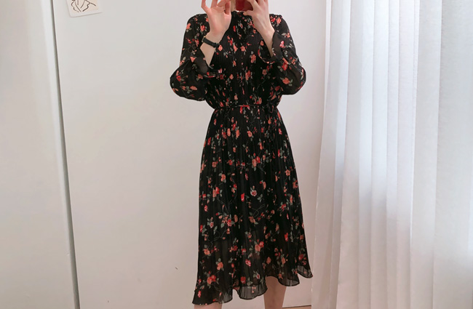
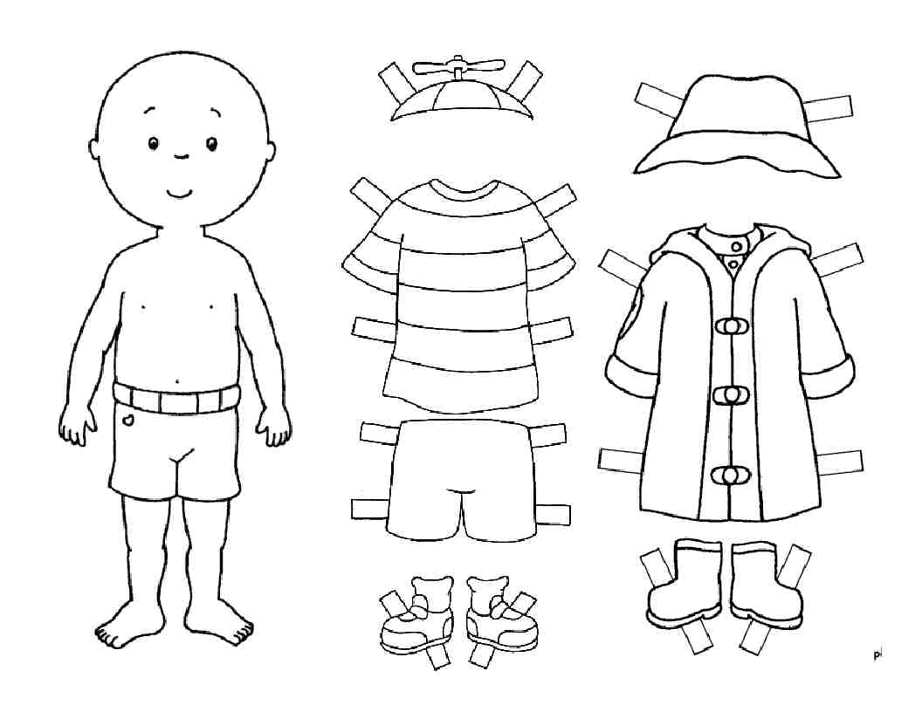
[A paper doll/paper dresses]
[British Money]

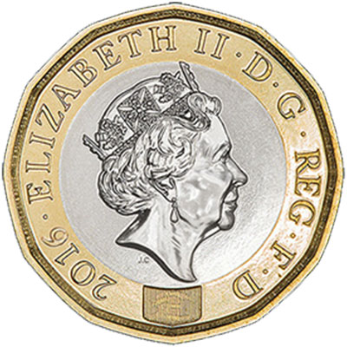

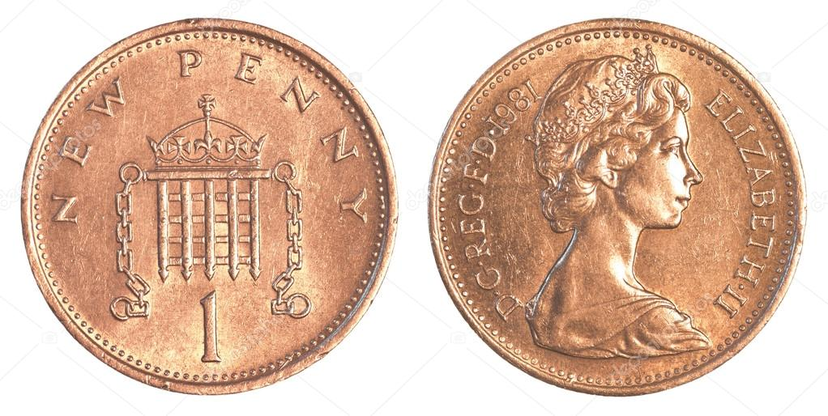

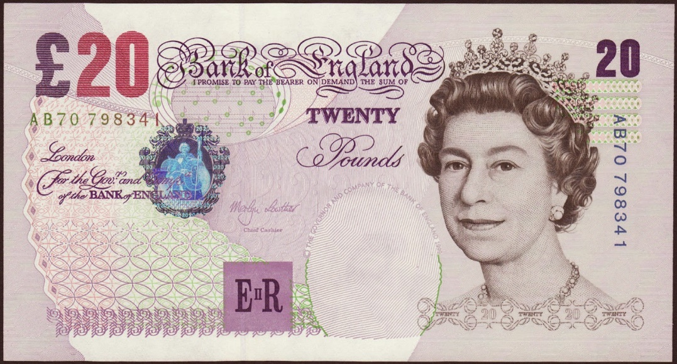

Listen carefully.
Write your answers under the questions

- What size of T-shirt does the customer want?

- What color does the customer buy?

- Where does she try on the clothes?

- How does the customer pay?

- What does the customer get after the payment?

[Worksheet#1 / Back]

Listen again.
Write your answer and discuss it with your partner

- Why didn’t the customer choose the black or red color as her first choice?

- Why did the customer try on the clothes before paying?

[Worksheet#1 / Front] – answer key
Listen carefully.
Write your answers under the questions

- What size of T-shirt does the customer want?

- Medium

- What color does the customer buy?

- Red

- Where does she try on the clothes?
- Changing room

- How does the customer pay?
- By cash
- What does the customer get after the payment?

- Receipt

[Worksheet#1 / Back] – answer key

Listen again.
Write your answer and discuss it with your partner

- Why didn’t the customer choose the black or red color as her first choice?

She prefers purple to black and red because she asked “and in purple?” to the shop assistant although he already told her “in medium we’ve got black and red.”

- Why did the customer try on the clothes before paying?
She wanted to check if she looks good with the medium size and the red color of that t-shirt. She doesn’t want to come to the shop again to refund or exchange.

[Transcript for Shopping for clothes.]
Shop assistant: Can I help you?
Customer: Yes, have you got this T-shirt in other colours?
Shop assistant: We’ve got it in white, black, red and purple. What size do you want?
Customer: Medium.
Shop assistant: OK, in medium we’ve got black and red.
Customer: And in purple?
Shop assistant: No, just black and red.
Customer: OK, red. Can I try it on?
Shop assistant: Yes, of course. The changing rooms are over there.
(pause)
Shop assistant: Is it OK?
Customer: Yes, I’ll take it.
Shop assistant: That’s £10.95. Would you like to pay by credit card or with cash?
Customer: Cash please. Here’s twenty.
Shop assistant: OK, thanks, that’s nine pounds, 5p change and here’s your receipt.
Customer: Thanks. Bye.

Instructor’s Comments and Assessment
Pros
Cons
Change
Overall Comments
Grade
Above Standard 85%-100% | Standard 70%-84% | Below Standard 69%-0%
Instructor | Student Signature | Date
Taute, David

