Background Information Sheet
Name | Class | Date | Lesson Type | Plan type | Length
You-mi | 193rd TESOL | 11.MAY.19 | Grammar | PPP | 35 min

Lesson
Topic | Do you have a plan for this year?  Model sentence: “I am studying English, this year”
Main Aim | SS will learn about another use of present continuous tense with time expressions
Secondary Aim | SS will practice their speaking fluency from natural conversation

Materials and References
English grammar in use, Pictures, PPT file, White board, Colored marker
https://www.youtube.com/watch?v=pMHNJyRL9dQ
https://www.youtube.com/watch?v=Mlqiz_Vh3eo

Student Profile
Level | Lower intermediate
Age | Adults in their 30s | Number of Students | 4
Detail | All of them are native Korean speakers  3 females and 1 male students in the classroom
Assumptions about students’ knowledge as required for this lesson:
All students know the meaning of present continuous tense. However, they have confused how to use it correctly in the sentences.

Anticipated Classroom Management Difficulties and their Solutions:
Students may confuse with using the correct tense - > provide more exercise for practice
Technical issues - > Prepare the pictures

My Personal Aim
What I hope most to demonstrate in this lesson is the ability to present the target language with using a present continuous tense.
I will provide a clear instruction so that the student can understand easily.
I’d like to monitor my students carefully to I find a mistake for their grammar accuracy.
Stage Name: Lead-in (2min)
Purpose of this stage: To relax both the teacher and students. To focus attention on the lesson. Create a situation for students to experience or think about, and then to elicit the target language.
Materials: Hand out (dialogue)
Timings | Interactions | Procedure
2min | T-S | Greeting & Elicit  Good morning!  How are you doing?  SS: Fine  Guys, Look at this dialogue  We will practice this dialogue with a partner (gesture)  (Nominate A & B with gesture then hand out)  Who is A and who is B? Ready? Start it!  -------------------------------------------------------------  Dialogue  -At the street-  A: Hi, it’s been a long time to see you  B: Yeah, I am so glad to see you again  A: I heard you moved to the other city, right?  B: No, I didn’t. who said that?  A: Really? Never mind  Do you have a plan for this year?  B: Yes. I am studying English, this year.  I want to go to the U.S for travel  A: Good  -----------------------------------------------------------  (After practicing, change the role and do it again)  let’s talk about what B said  Q: Does B have a plan for this year?  SS: Yes  Q: What’s his plan?  SS: He is studying English, this year.  Right. (move to the next stage)

Stage Name: Presentation (8min)
Purpose of this stage: Make the students think about the situation. To clarify the meaning, form, and pronunciation features of the target language.
Materials: White board, Colored marker
Timings | Interactions | Procedure
2min  3min  3 min | T-S  T-S  T-S | Board the model sentence  (if students are unable to tell you, just board it)  Put the model sentence on the white board  model sentence: I am studying English, this year.  Alright, Let’s look at the board  This is today’s model sentence (Draw timeline)  (asking CCQ with showing the timeline)  CCQ  - Is this right now? -> No  - Is this started? ->Yes  - Is it finished already? ->No  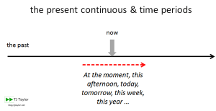  As you can see, we can use the present continuous when things happening around this moment, like this week, this year, these days  but may not be happening just right now.  Now, he is talking to his friend right? He started it, but he is still studying it.  .  Form  Let’s talk more about this sentence  1. Underline today’s grammar point with colored marker  I am studying English, this year.  Here’s today’s grammar point  2. Ask students to identify the sentence  Where is the verbs?  SS: study, am.  Yes, we have two verbs here. “Study” is main verb and “am” is helping verb. (write down with colored pen and explain shortly)  S + Be v +~ing + O +Ad  I am studying English, this year.  3.positive/negative/question forms  positive  I am studying English this year  He/she Is  You/we/they are  Negative  I am not studying English this year  He/she is not  You/we/they are not  Question  Am I studying English this year  Is He/she  Are You/we/they  We can make a negative & question forms together.  How can I make positive into negative? How can I make it into the question form? (try to make them involved, do it together)  + I am studying English this year  - I am not studying English this year  ? Am I studying English this year?  If I change this subject (pointing “I”) into this (writing “he”)  What happens here (pointing “am”)?  SS: Answer  Or If I change this subject (pointing “he”) into this (writing “You”)  What happens here (pointing “is”)?  SS: answer  Good  Drill  Where is the stress?  (wait for SS answer then mark it)  SS: Answer  (mark strong & weak stress with a color marker and draw intonation line)  -------------------------------------------------------  I am studying English, this year.  ------------------------------------------------------  Ok! Guys just listen first.  (manage it with gesture)  T: I am studying English, this year  One more time (hand gesture)  T: I am studying English, this year  Ok this time, listen and repeat, please (hand gesture)  T: I am studying English, this year  (Whole class repeats together)  SS: I am studying English, this year  Try it few times together with hand gesture  Then nominate each student to speak it naturally  If someone has a problem with a stress or intonation, let the other student do it first, then come back for him or her again.

Stage Name: Controlled Practice (6min)
Purpose of this stage: students practice working with the form (scrambled sentences, split sentences, select the correct form of the verb, correct incorrect sentences, and change one form into another form). Accuracy must be checked.
Materials: Work sheet A
Timings | Interactions | Procedure
1min  3min  1min  1min | T  T  S  S – S  T - S | Instructions.  Now, we will do a grammar exercise that you can practice  with present continuous tense.  First, read an example on the top (pointing the work sheet)  Second, complete the sentences with correct form.  It should be done by individually.  I will give you guys 3 min to finish it.  ICQ.  - What should we do at first? -> Read an example, first  - Can we do it together? -> No, it’s an individual work  - How long do we have? -> 3 min  Hand out.  SS do their worksheet  Give them time notification  Alright times up  Let’s compare to your partner  Pair check.  Feedback to check accuracy.  Everyone has a same answer?  Let’s do it together  Point each student to ask an answer  (try to nominate the students who have the correct answer  It can give them more confidence with a grammar)
Stage Name: Less Controlled Practice (7min)
Purpose of this stage: students practice working with the meaning (match timelines to sentences, choose the sentence that matches a picture, gap-fill a paragraph). Accuracy must be checked.
Materials: Work sheet B
Timings | Interactions | Procedure
1min  4min  1min  1min | T  T-S  S  T  S-S  T-S | Instructions.  We’ll do another exercise that you guys can practice more!  This time, check the words from each box first.  Then make two sentences for each picture with using the word from here (pointing the box)  It should be done by individually.  I will give you guys 4 min to do it.  ICQ.  - What should we do at first? -> check the words from each box  - Can we make just one sentence? -> No, two sentences  - How long do we have? -> 4 min  Hand out.  SS do their worksheet  (Give them time notification)  1 min left  Times up  Let’s compare to your partner  Pair check.  Feedback to check accuracy.  Let’s do it together.  Point each student to ask an answer  Perfect!

Stage Name: Production – Freer Practice (10min)
Purpose of this stage: is to get students to practice the grammar communicatively.
Materials: White board, Marker
Timings | Interactions | Procedure
1min  9min | T  S-S  T | Instructions  Now, let’s talk about general thing with these time expressions.  (show PPT file or, write down time expressions on the board)  These days This year  Nowadays This week  Ask some questions to your partner with using it.  Then talk more with your partner  For example,  A: what are you doing, these days?  B: I am practicing ~~, these days.  I will give you guys 9 min to talk  ICQ  - Can we finish it by individually?  -> No, we can do it with a partner  - Do we need to use time expressions? -> Yes  SS pair work  Monitor  Alright times up
stage Name: Wrap-up (2min)
Purpose of this stage: is to end the lesson on a positive note so that students feel they have achieved progress.
Materials: no materials needed
Timings | Interactions | Procedure
2 min | T – S  T | Offer delayed corrections to the previous stage.  (Write down sentences on the board with a mistake from the previous student’s conversation)  Look at the board again, I heard these sentences from you guys.  Could you please find a mistake with it?  SS: Answer  Yes, thank you.  We can fix it like this (give them delayed error correction)  Set the homework  Actually, we have homework for next time.  Please read your textbook about present simple.  It’s page 13 on your textbook  Inform students about the topic for the next lessons  Our topic for next week will be a present simple.  Don’t forget to read it before the class  You did really good today thank you guys

Instructor’s Comments and Assessment
Pros
Cons
Change
Overall Comments
Grade
Above Standard 85%-100% | Standard 70%-84% | Below Standard 69%-0%
Instructor | Student Signature | Date
Taute, David

Dialogue
-At the street-

A: Hi, it’s been a long time to see you
B: Yeah, I am so glad to see you again
A: I heard you moved to the other city, right?
B: No, I didn’t. who said that?
A: Really? Never mind
Do you have a plan for this year?
B: Yes. I am studying English, this year.
I want to go to the U.S for travel
A: Good

Work sheet A
Complete the sentences using the correct form
-Example -
They ____ (make) breakfast this week
They are making breakfast this week

- This year, Amy _________(take) five courses.

- We_________ (learn) about trees this week.

- _________ (I/ not take) violin class these days.

- A: ___________ (she/ drive) a car, these days?
B: NO, ________________

- I want to lose my weight, so this week ______________ (I/ eat) lunch

Answer sheet A
Complete the sentences using the correct form
-Example -
They ____ (make) breakfast this week
They are making breakfast this week

- This year, Amy is taking (take) five courses.

- We are learning (learn) about trees this week.

- I am not taking (I/ not take) violin class these days.

- A: Is she driving (she/ drive) a car, these days?
B: No, she’s not driving a car, these days.

- I want to lose my weight, so this week I’m not eating (I/ eat) lunch

Work sheet B
Make two sentences about the picture with words from each box
work get prepare take enjoy have hold eat check travel pack

now, today, this week, this year, these days, nowadays

For example,
I am doing this, now… because this week, I am planning …
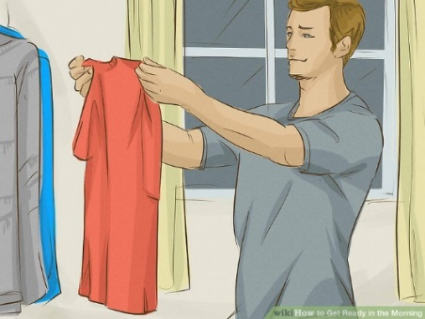
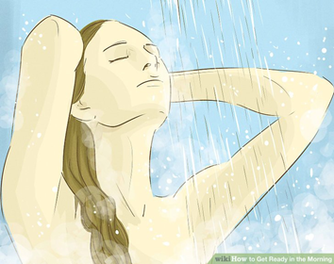
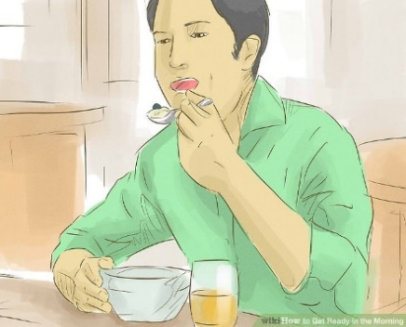

Answer sheet B
Make two sentences about the picture with words from each box
work get prepare take enjoy have hold eat check travel pack

now, today, this week, this year, these days, nowadays

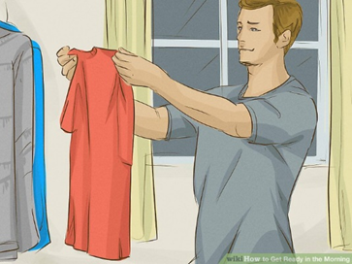
He is checking/preparing his shirts, now. This week, he is meeting his girl friend
She is enjoying/taking a shower, now. She is working hard today
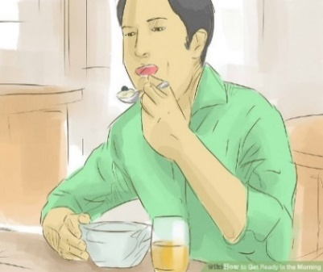

He is having/eating some food, now. This week, his wife is not staying home

