Background Information Sheet
Name | Class | Date | Lesson Type | Plan type | Length
Ryatt / 이경호 | TESOL | 18.05.2019 | Reading | PPP | 35 min

Lesson
Topic | A bluffer’s guide to ‘white nights’.
Main Aim | Students will practice their reading comprehension.
Secondary Aim | Students will practice their speaking fluency.

Materials and References
Reading materials, worksheets(Question & Answer); board and markers.

Student Profile
Level | Intermediate
Age | Adult | Number of Students | 4
Detail | All the students are native koreans.

Anticipated Difficulties and their Solutions:
Technical failure - Prepare a printed pictures..

My Personal Aim
What I hope most to demonstrate in this lesson is the ability to give clear instruction to students.

Stage Name: Lead-in (3 min)
Purpose of this stage: To relax both the teacher and students. To focus attention on the lesson. To lead in to the topic, activating background knowledge..
Materials: List all materials that will be needed in this stage.
Time | Interaction | Procedure
1 min  1 min  1 min | T-S  S-S  T-S | “Hello, everybody. I’m English teacher Ryatt. How are you today?”  Ss “Fine.”  “Good.”  Show some pictures of festivals on the screen.  “What about those pictures?”  Ss “Festival.”  “Right. Have you ever been any festival? What kind of festival did you go to ? and how was it?”  “Talk to your partner about the festival. Where did you go to? What was your memorable? I’ll give you 1 min.”  “Ok. Time’s up. Who wants to share own experience?”

Stage Name: Presentation(5 min)
Purpose of this stage: To pre-teach keywords if necessary, and to help students be better able to understand a difficult part of the audio.
Materials: List all materials that will be needed in this stage.
Time | Interaction | Procedure
4 min  1 min | T-S  S-S | [Pre-teach keywords]  - Firework  [Eliciting] - Firework  “Have you stayed until night at the festival or been there at night?”  Ss “yes”  “So at that time, maybe we could see any fabulous things. So much bright in the night sky, very noise sound and a lot of people. Do you imagine that? The main event at the festival in night. What is this?”  Ss “Firework”  “Right. Firework.”  [CCQ]  - Have you seen that in day time? (No)  - Is the reason for the noise that because something explodes? (Yes)  - Do lots of people gather for seeing it? (Yes)  [Drill]  T speaks loudly.  [ Firework ] X2  Gesture follow together.(T doesn’t speak)  Gesture one student follow. x 4.(T doesn’t speak)  [Board]  Write ‘Firework’ on the board.  /ˈfī(ə)rˌwərk/  ”How many syllables (are there)?” (Two)  Check on the board with red marker.  “Where is the stress?” (First syllable, On the vowel ‘i’)  Check on the board with blue marker.  [Guiding Question]  “What kind of festivals are there that you can go to at night?”  Talk to your partner for 1 min.  (Teacher monitoring)

Stage Name: Practice - Literal Comprehension Listening (10 min)
Purpose of this stage: is to get students to practice their literal listening skill.
Materials: List all materials that will be needed in this stage.
Time | Interaction | Procedure
30 sec  1 min  30 sec  6 min  1 min  1 min | T  T-S  T-S  S  S-S  T-S | [Instruction]  Just showing worksheet.  “Here is our worksheet. Loot at Exercise A. .Total 5 Questions. After reading, you can find the answers. You have to do this work individually. Don’t look the back-side of worksheet yet”  Hand out worksheet(Exercise A).  “who can read those questions?”  Select 1 S.  [Literal Q]  S reads.  - What are ‘white nights’?  (The White nights come in summer, when it never gets fully dark in this part of Russia)  2. How long does the white nights last?  (Begin in late May and continue until July)  3. What is the biggest event in St Petersburg’s white nights?  (The Scarlet Sails)  4. Where is the ideal time to visit in St Petersburg’s white nights?  (State Heritage Museum)  5. Where are three more all-night festivals?  (Paris in France, Catemaco in Mexico, Melbourne in Australia)  “Ok. Thank you S. Do it individually. I’ll give you 6 min.”  [I.C.Q]  “Are you going to work alone?” - Ss “Yes.”  “How long do you have?” - Ss “6 min”  Hand out reading material.  Students read and solve individually.  (Teacher monitoring.)  “Time’s up. Share your answers in your partner with 1 min.”  (Teacher monitoring.)  “Ok. Time’s up. Now we are going to check the answers together.”

Stage Name: Practice - Interpretive Comprehension Listening(6 min)
Purpose of this stage: is to get students to practice their interpretive listening skill.
Materials: List all materials that will be needed in this stage.
Time | Interaction | Procedure
10 sec  1 min  3 min  1 min  1 min | T  T-S  S  S-S  T-S | “Now you can see the back of worksheet.”  “who can read those questions?”  Select 1 S.  [Interpretive Q]  S reads.  - What kind of magazine is this article in? (Travel magazine.)  - This article made me want to go to the white nights festival. What would I say when I ask my friend to go to with me?  (There's a period in Saint Petersburg that doesn't get dark at night. It's called a white night and there's a festival then. We could enjoy Carnival, street performances, All Night Museums and main event are Scarlett Sale, watching a mix of tall ships, pirates and fireworks.)  “Ok. Thank you S. Do it individually. I’ll give you 3 min.”  [I.C.Q]  “Are you going to work alone?” - Ss “Yes.”  “How long do you have?” - Ss “3 min”  “Ok. Let’s start.”  Students read and solve individually.  “Time’s up. Share your answers in your partner with 1 min.”  (Teacher monitoring.)  Listen each pairs answer and give them some feedback.

Stage Name: Production - Applied Comprehension Speaking(9 min)
Purpose of this stage: is for students to practice their speaking fluency on a topic related to the lesson.
Materials: List all materials that will be needed in this stage.
Time | Interaction | Procedure
1 min  2 min  5 min  1 min | T  S  S-S  T-S | “This time. Look at this worksheet.”  [Applied Q]  Teacher read.  - Is there any festival that you want to go to?  - If you go there, who you go with?  - What are you going to do at the festival?  “Think about this questions individually. You can google it. I’ll give you 2 min.”  Teacher monitoring.  “Time’s up. Now talk to your partner with your answer. I’ll give you 5 min”  Pair work.  Teacher monitoring.  And give them feedback.

Stage Name: Wrap-up(2 min)
Purpose of this stage: is to end the lesson on a positive note so that students feel they have achieved progress.
Materials: List all materials that will be needed in this stage.
Time | Interaction | Procedure
2 min | T | Lesson feedback.  Tell the class what they did well, and what needs to improve.  Offer delayed corrections to the previous stage.  Inform students about the topic for the next lesson. Homework.  “Ok. tomorrow, we will do speaking lesson. Think about your speaking. The topic is ‘your last summer’.”

[Pictures about festival]
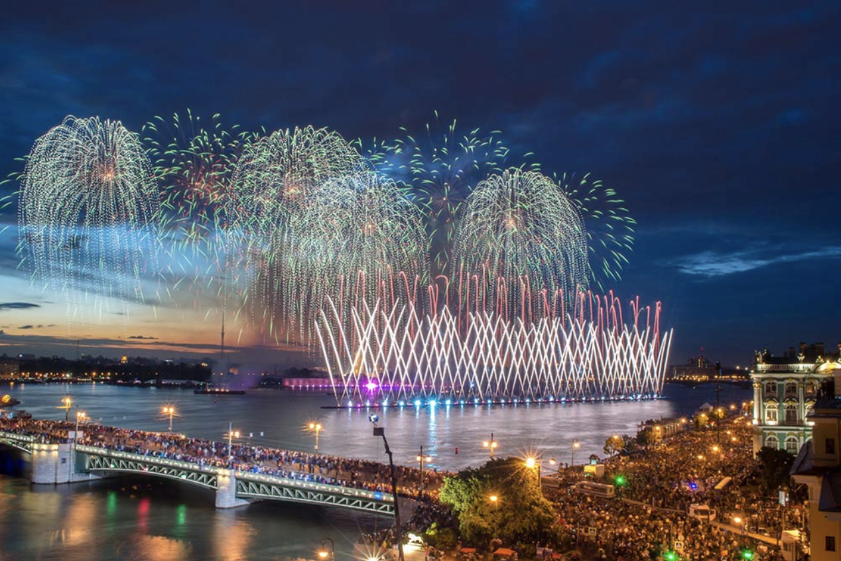
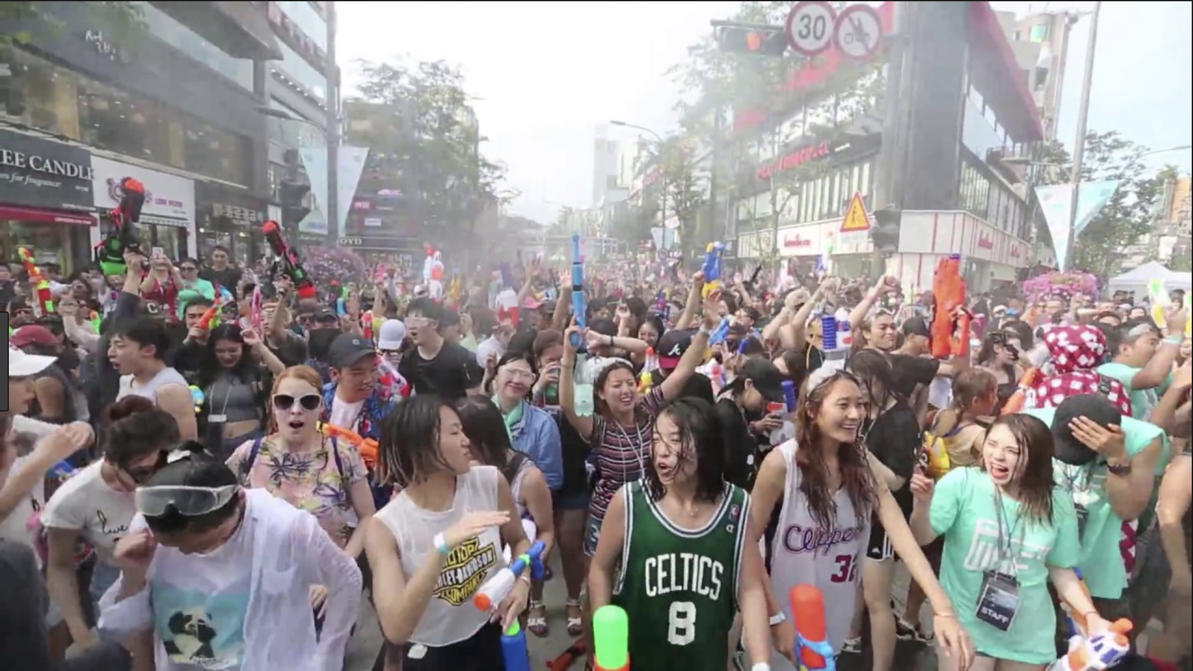

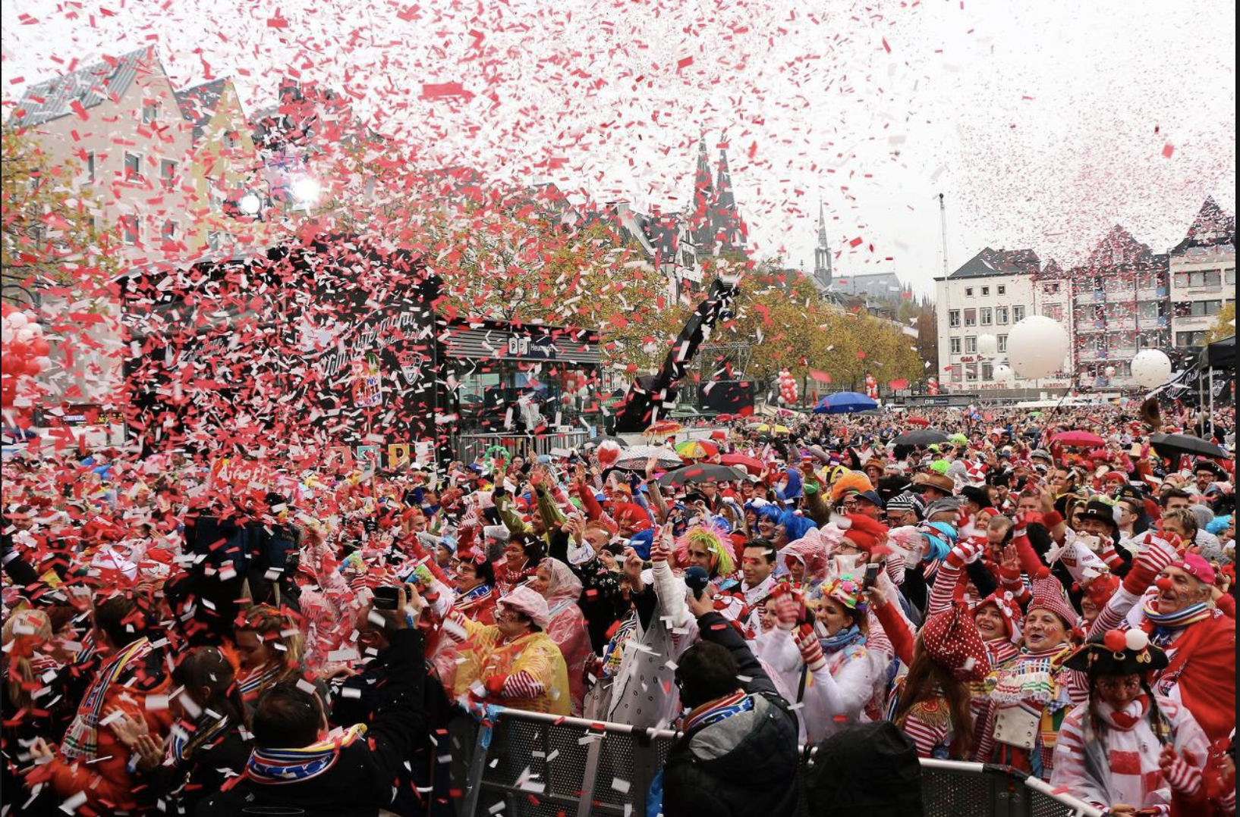
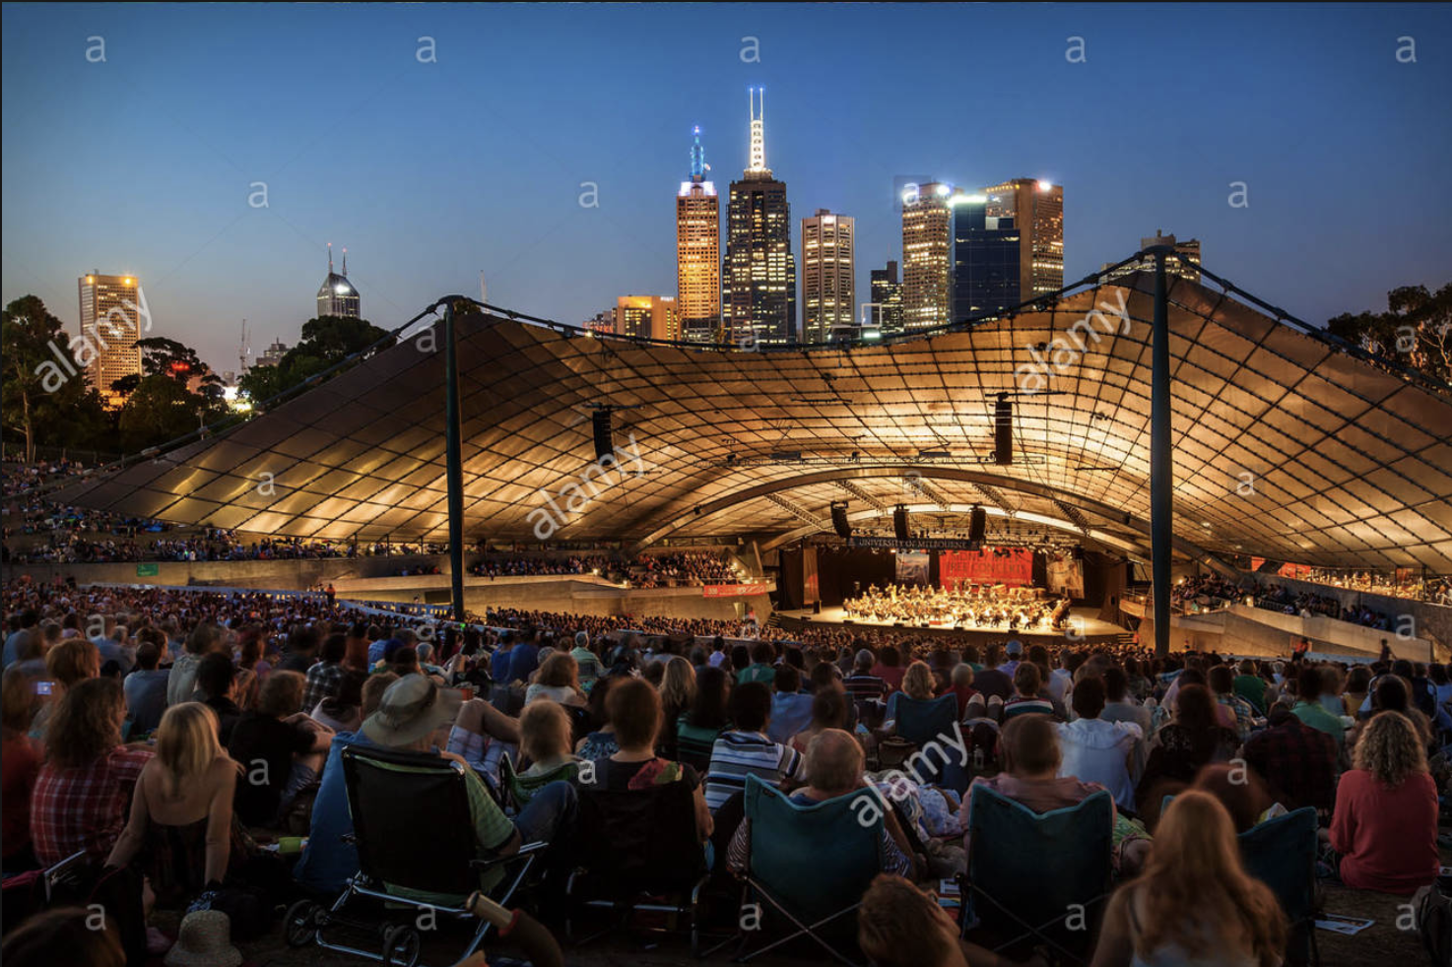
[Reading Material]
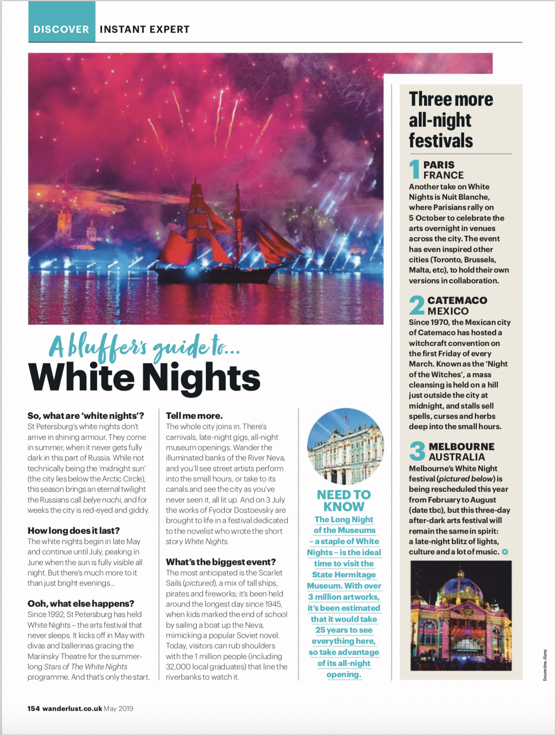
<Question>
Exercise A
- What are ‘white nights’?

2. How long does the white nights last?

3. What is the biggest event in St Petersburg’s white nights?

4. Where is the ideal time to visit in St Petersburg’s white nights?

5. Where are three more all-night festivals?

Exercise B
- What kind of magazine is this article in?

- This article made me want to go to the white nights festival. What would I say when I ask my friend to go to with me?

Exercise C
- Is there any festival that you want to go to?

2. If you go there, who you go with?

3. What are you going to do at the festival?
<Answer>
Exercise A - Literal Question
- What are ‘white nights’?
(The White nights come in summer, when it never gets fully dark in this part of Russia)
2. How long does the white nights last? (Begin in late May and continue until July)
3. What is the biggest event in St Petersburg’s white nights? (The Scarlet Sails)
4. Where is the ideal time to visit in St Petersburg’s white nights? (State Heritage Museum)
5. Where are three more all-night festivals?
(Paris in France, Catemaco in Mexico, Melbourne in Australia)

Exercise B - Interpretive Question
- What kind of magazine is this article in? (Travel magazine.)
- This article made me want to go to the white nights festival. What would I say when I ask my friend to go to with me?
(There's a period in Saint Petersburg that doesn't get dark at night. It's called a white night and there's a festival then. We could enjoy Carnival, street performances, All Night Museums and main event are Scarlett Sale, watching a mix of tall ships, pirates and fireworks.)

Instructor’s Comments and Assessment

Pros
Cons
Change
Overall Comments
Grade
Above Standard 85%-100% | Standard 70%-84% | Below Standard 69%-0%
Instructor | Student Signature | Date
Taute, David

