Exercise A
*Please circle the best answer
1. Why is Pete in a bad mood?
- He cannot make a pizza with his dad
- He cannot go out with his dad
- He cannot play ball with his friends
- He cannot eat a pizza

2. What is Pete made into?
- A guy
- A pepperoni
- An oven
- A pizza

*Put pictures in right order
[Example: 6-2-3-4-5-1]
⓵ ⓶ ⓷
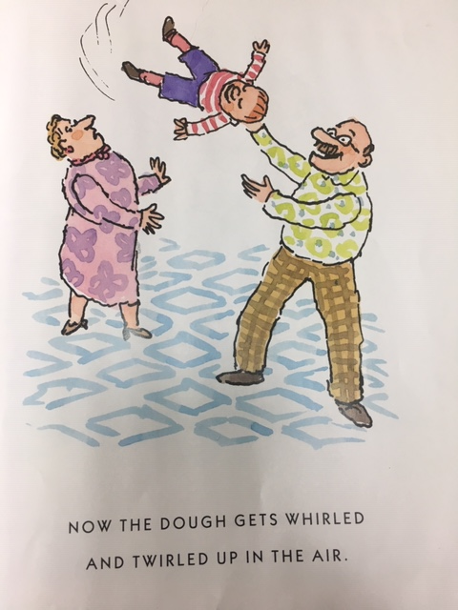
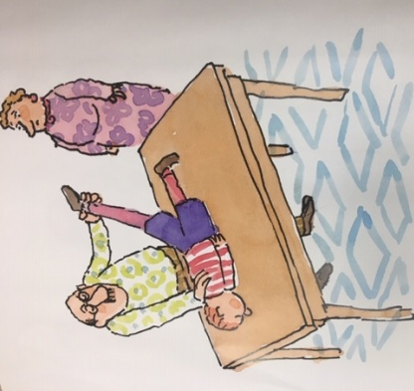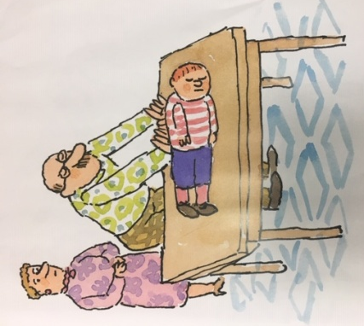
⓸ ⓹ ⓺
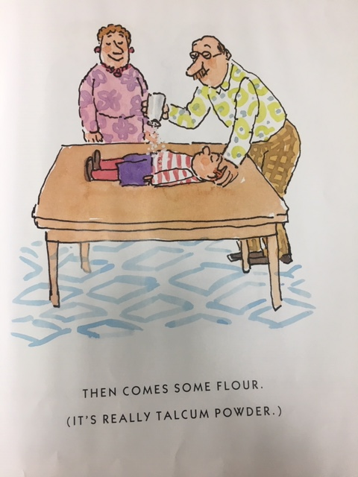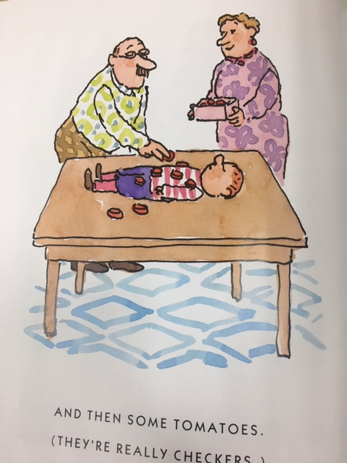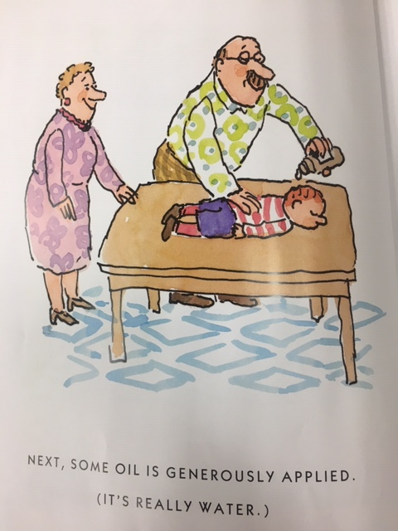
____ -____ -____ -____ -____ -____

Exercise B

Answer Sheet
Exercise A
*Please circle the best answer
1. Why is Pete in a bad mood?
1) He cannot make a pizza with his dad
2) He cannot go out with his dad
3) He cannot play ball with his friends
4) He cannot eat a pizza

2. What is Pete made into?
1) A guy
2) A pepperoni
3) An oven
4) A pizza

*Put pictures in right order
⓵ The dough gets whirled and twirled up in the air
⓶ Strestching the dough
⓷ Starts kneading the dough
⓸ Sprinkle some flour
⓹ Put some toppings on the dough
⓺Apply some oil
Answer: ⓷-⓶-⓵-⓺-⓸-⓹

Exercise B
Interpretive Questions
- Why do you think Pete’s parents make Pete into a pizza?
(They want to make Pete feel better)
-What do you think Pete would do the next time it rains?
(He might play with his parents again. They can play another game.
Or his dad can make him into another food)

Exercise C

_________________________________ __________________________________________

_________________________________ _________________________________________

__________________________________ __________________________________________

_________________________________ ___________________________________________

_________________________________ __________________________________________

_________________________________ __________________________________________

