Background Information Sheet
Name | Class | Date | Lesson Type | Length
Kim/김지양 | 194 | 5/24/2019 | Speaking | 20min

Lesson
Topic | Zoom: How we view things in a picture
Main Aim | Students will practice speaking.
Secondary Aim | Students will practice listening to other students’ description of pictures.
Materials and References
-Istvan Banyai, Zoom by The Penguin Group
-Pictures that are randomly ordered
-3 envelops
-PPT file

Student Profile
Level | Upper Intermediate
Age | Adult | Number of Students | 3
Detail | All of the students are females and have studied in U.S. They are able to communicate in English. One of the students is talkative and has a good sense of humor. The other two students are a bit shy compare to her and are more considerate. They might take a little more time to think before they speak.
Assumptions about students’ knowledge as required for this lesson:
Students are capable of describing images and communicating in English. They have practiced describing pictures through picture differences activity in the class before.

Anticipated Difficulties and their Solutions:
-Technical failure- The computer in the classroom might not work the way I want.
Solution: I arrive in the classroom earlier to check. I can have printouts.
-Interaction- Shy students might not talk much and just hear a talkative student talking.
Solution: I can give you a rule so that everyone has to speak up. They will work as a group. To solve a problem, they will push each other to achieve a goal.
-Timing- They might take more time to understand a rule or solve a problem.
Solution: I will demonstrate more when they don’t understand my instruction clearly. If they need more time to do the activity, I will spend less time for feedback. Or I keep monitoring them and give some hint so that they can solve a problem faster.

My Personal Aim
What I hope most to demonstrate in this lesson is the ability to increase student-talk-time so that students spend enough time to talk.

Stage Name: Pre Task [4min]
Purpose of this stage: Create interest in the topic. Brainstorm ideas which will be useful for the next stage. Students may be given a communicative task e.g. discuss, arrange/sort, create a list, etc.
The aim is to relax students, activate their background information, and gather useful ideas for the lesson.
Materials: PPT file
Time | Interaction | Procedure
1min  2min  1min | T  S-S  T-S | [Set up]  Before the class starts, check if my PPT file works.  Arrange desks.  [For Pre-Task and individual work]  [For Task-Preparation]  [For Task-Realization]  (They will write down the order of pictures and check answers)  [Greeting]  [Lead-In]  How are you doing, everyone?  We will have a fun activity with pictures today.  Before doing it, let’s talk about how we see a picture.  What do you do when you try to find your family or friend in the picture of a crowd? (Miming like I zoom-in a picture on my cell phone)  (Students: Zoom- in)  Here is one picture. (Show students Slide A)  What do you see?  Can you guess what it is?  Then, let’s zoom-out a little. (Show Slide B)  What do you see?  Let’s take another step back. (Show Slide C)  What do you see?  Sometimes you need to zoom-in a picture so that you can see it well.  But, do you always zoom-in a picture? (Students: No)  Is seeing a big picture also important? Why?  Talk as a group. (Gesture) You don’t need to write down anything.  I.C.Q- Do you need to write down your thought? (No)  Group Talk  Feedback  What did you think? Is it important? Why?  (After listening to what students say)  We will do the activity with pictures like these.

Stage Name: Task Preparation [10-12min]
Purpose of this stage: This is a student-centered stage, to give students time to prepare and practice a speaking task, which they will perform in Task Realization. Clear detailed instructions or a demonstration must be provided so students know what is expected. Prepared materials may be provided to assist their preparation. Monitor and offer brief tips if necessary.
Materials: 3 envelops- pictures in each envelop, pictures that are randomly ordered
Time | Interaction | Procedure
30sec  1min  1min  6min  4min | T  S  T  S-S  T  S-S | [Instruction]  Each of you will get an envelop like this (Showing them the envelop)  There are pictures in the envelopes, and they are randomly ordered.  You may only look at your own images and must keep your pictures hidden from others.  First, study your pictures for 1 minute. You will need to describe the given pictures to others.  *I.C.Q- Do you show your pictures to other students? (No)  [Hand out the envelops to students]  [Working individually]  [Monitor close]  Are you done? It’s time to gather information!  Before you start, we need to talk about rules.  (Showing the PPT slide)  You can’t show your pictures to others.  You will take a turn to answer questions every 2 minutes.  I’ll set a timer.  When a bell rings, take a turn.  You will talk to each other to find out about pictures.  [Demonstrate]  For example, first, [Student A] will get questions from other students.  You need to get information about pictures as much as possible.  Then, it is [Student B]’s turn. The other two students ask questions to  [Student B].  You can write down the information.  Everyone should have a chance to answer questions.  I’ll give you 6 minutes to work on it.  *I.C.Q- What do you do to find out about pictures? (Asking questions)  Do you just talk freely? (No, taking a turn to answer questions)  How long will you work on? (6 min)  Group Work  [Monitor]  Did everyone have a chance to talk about their pictures? (Students: Yes)  Then now, talk freely to find out more about picture.  Group Work

Stage Name: Task Realization [3min 30sec]
Purpose of this stage: This is a very student centered stage to allow for maximum speaking fluency practice. Monitor discretely and take note of incorrect language. Students perform their task without interruptions from the teacher.
Materials: The pictures
Time | Interaction | Procedure
30sec  2min  1min | T  S-S  T-S | [Instruction]  Did you get enough information about pictures?  Now, the goal is to arrange pictures in the correct order.  Do not take out pictures yet. Still, you shouldn’t show your pictures to others.  Just write down numbers first.  Discuss how you will arrange pictures.  I’ll give you 2 min.  *I.C.Q-What do you do as a group? (Arranging pictures)  Will you take your pictures out? (No)  Group Work  [Monitor from distance]  *When students seem struggle and need more time, I ask them if they need a hint. When they say “Yes”, I give them a hint so that they can finish the work on time.  Time’s up! Let’s check how you arranged the pictures.  [Arrange pictures the way they decide]

Stage Name: Post Task [1min-2min]
Purpose of this stage: To end the lesson with a final student centered task such as voting, summarizing, discussing, deciding etc. The teacher may offer delayed error correction to the previous stage, as well as mention positives and points to improve for next time such as useful strategies.
Materials: pictures
Time | Interaction | Procedure
1min  30sec | T-S | [Summarize & Wrap-up]  How was the activity? Was it easy or difficult?  Why was it easy / difficult?  Did this activity show the importance of seeing the big picture?  Can you make a decision based on a small part?  You all did great job!  (Mention about a result of the activity.  They might fail to find out the correct order)  [Feedback]

[Envelope A]
(1) (11)
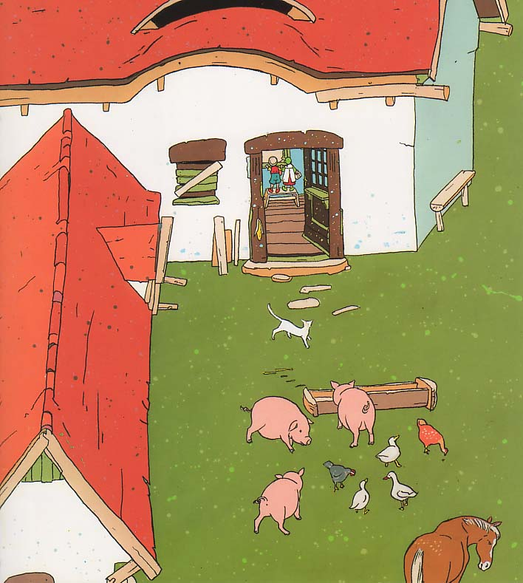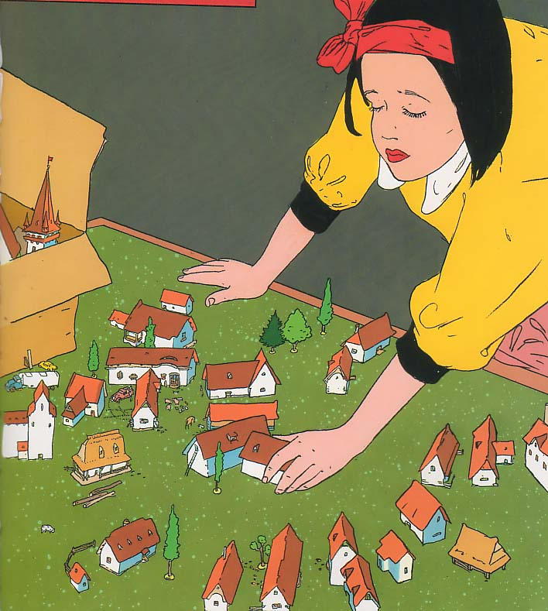

(7) (3)
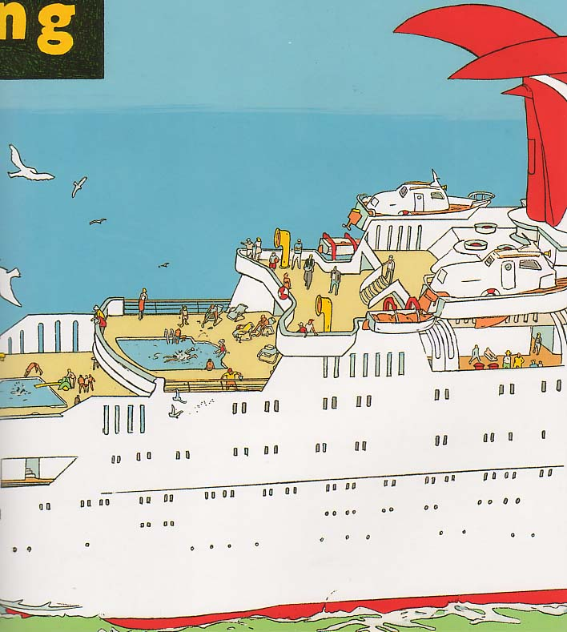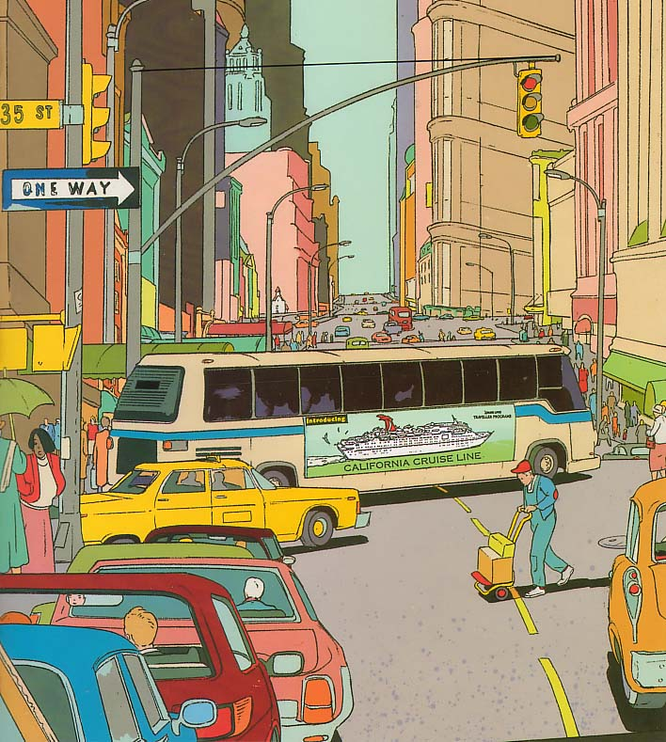

[Envelope B]
(5) (6)
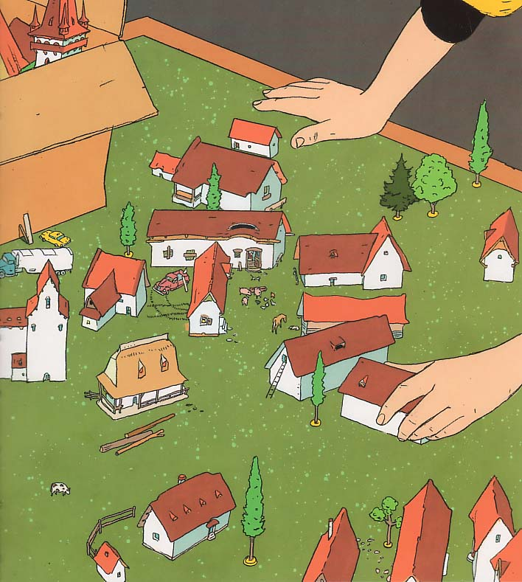

(8) (12)
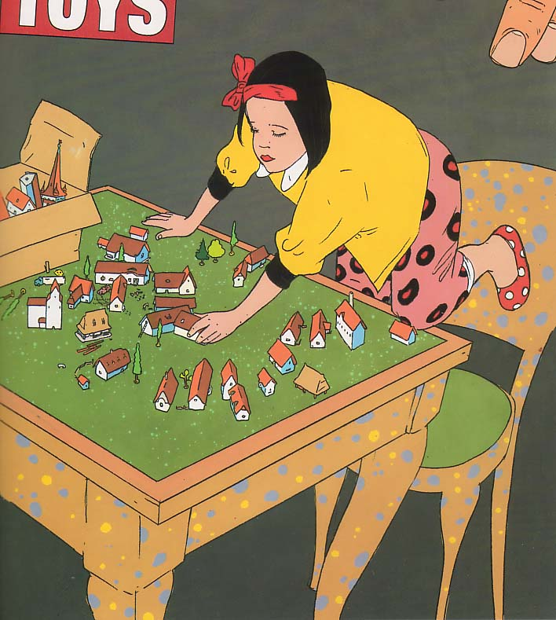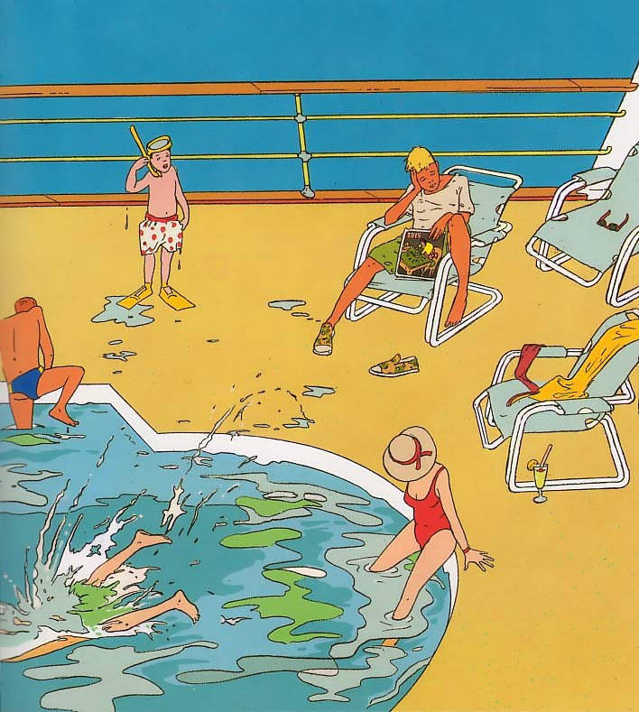

[Envelope C]
(2) (10)
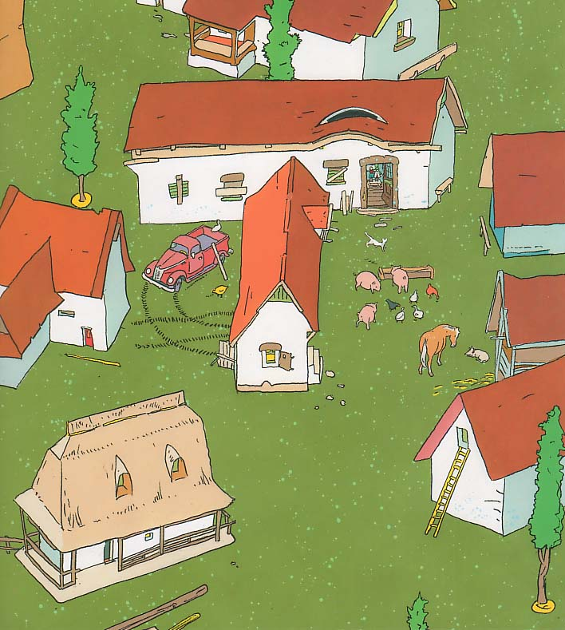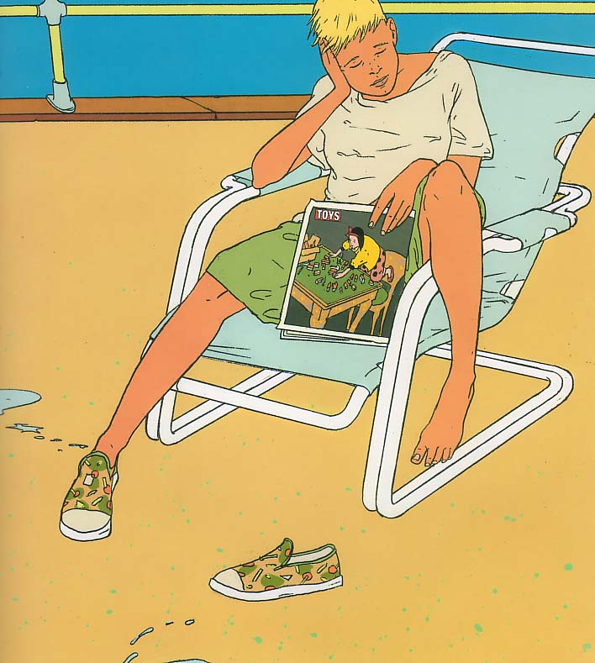
(4) (9)
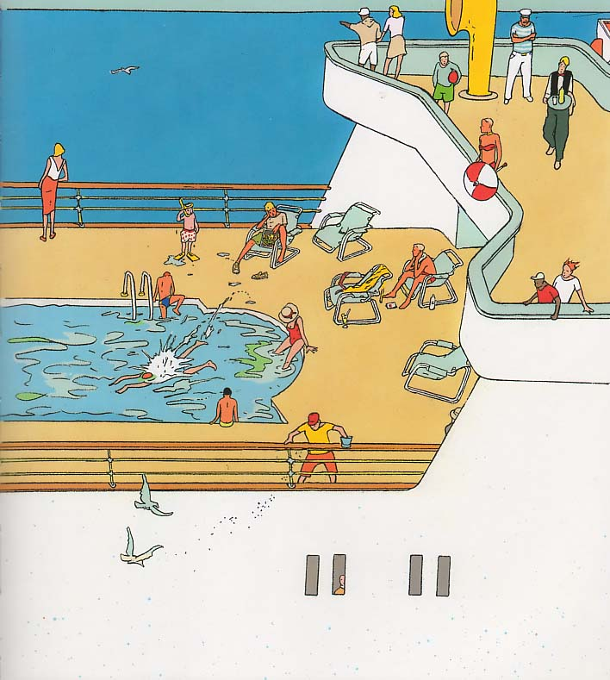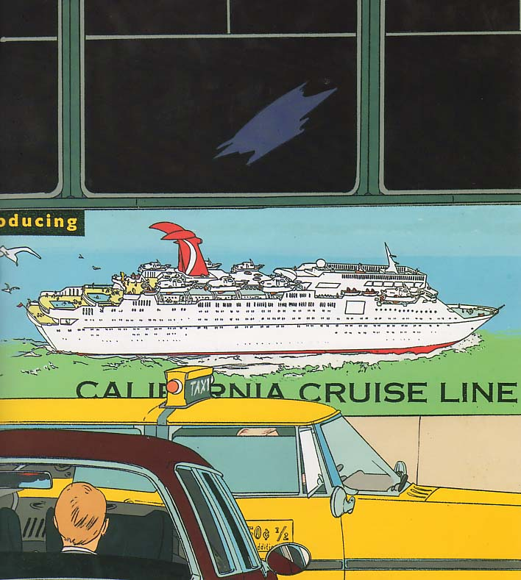

[Answer Sheet]
(1)-(2)-(5)-(11)-(8)-(6)-(10)-(12)-(4)-(7)-(9)-(3)
Instructor’s Comments and Assessment
Pros
Cons
Change
Overall Comments
Grade
Above Standard 85%-100% | Standard 70%-84% | Below Standard 69%-0%
Instructor | Student Signature | Date
Taute, David

