Exercise A

Read the article and answer the questions.

What percentage of Americans eat too much salt?

How much sodium is recommended to eat per day?

_____________________________________________________________________

Circle T for True and F for False

[1] Healthy people who ate more salt had higher blood pressure (T / F)
[2] Sodium is used as a preservative (T / F)
[3] Foods that don’t taste salty have no salt [T / F)

Write down how much sodium a food in the picture has.

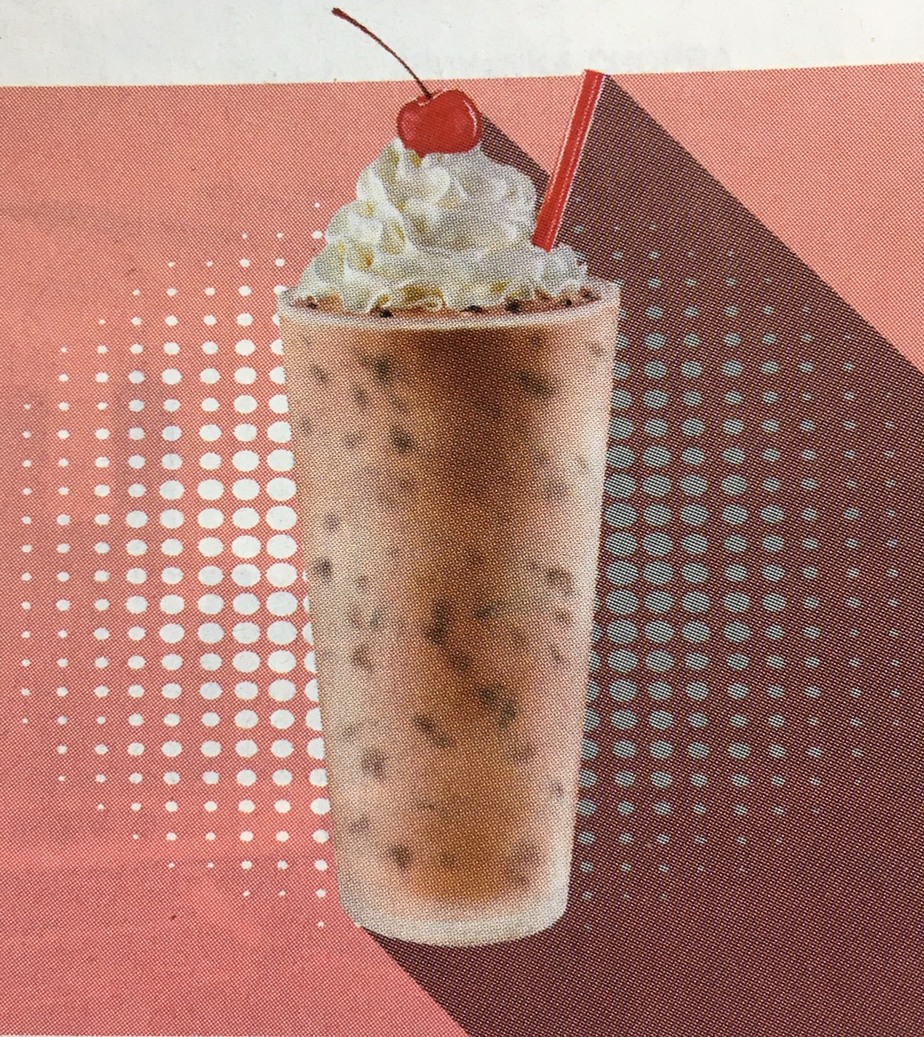 [________________________________mg]
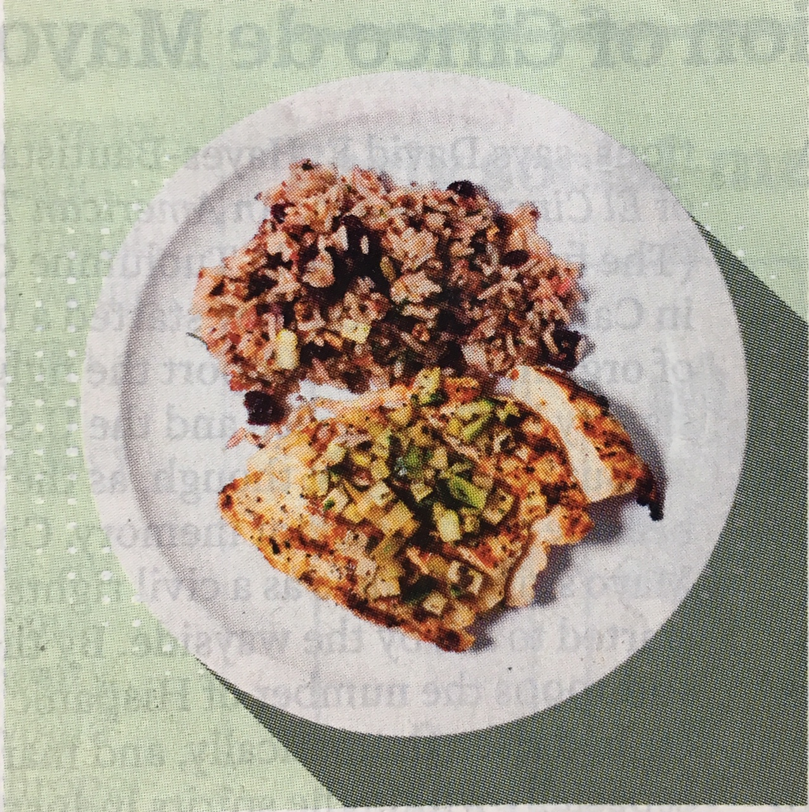 [________________________________mg]
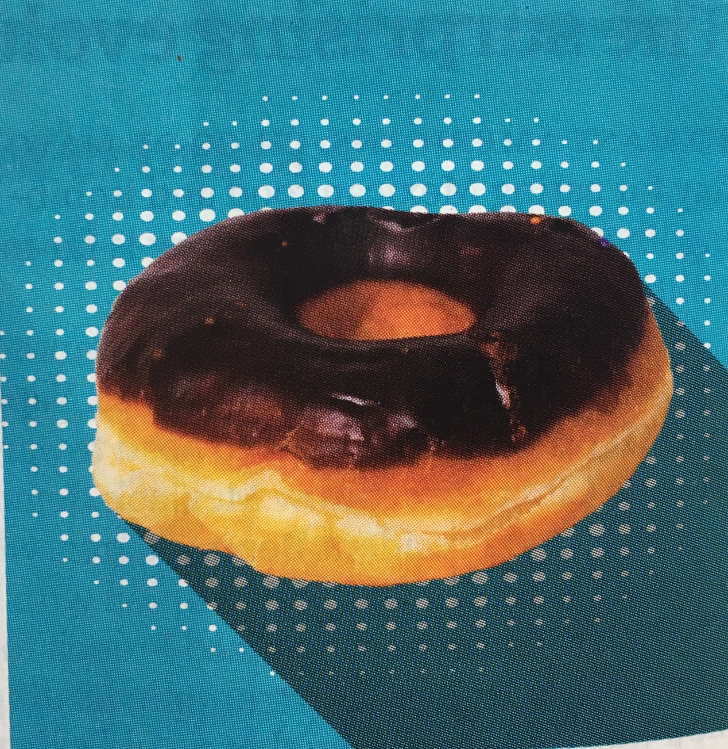[________________________________mg]

Exercise B

Answer the questions based on the article

Who would be happy to hear this news?

Considering the amount of sodium that cedar-grilled lemon chicken has,
What can you tell about foods at the restaurant called Applebee?

Read Sarah’s diary and find out how much sodium she ate that day.

June 1st, 2018
I woke up late and didn’t have time to eat breakfast. When I was
working at my office, I was so hungry. I went to the café and got a
reduced-fat blueberry muffin. After work, I met my best friend, Emily
at Applebee near by my house. I got cedar-grilled lemon chicken.
It was on “lighter fare” menu, so I thought that it might be good for
my health. I got back home and cleaned up my room. I suddenly wanted to eat something sweet and found a chocolate-frosted doughnut that I got two days ago. I ended up eating the doughnut……..

