Background Information Sheet
Name | Class | Date | Lesson Type | Length
Michael | 197th / WK | 03/08/2019 | Speaking | 20min

Lesson
Topic | How was your holiday?
Main Aim | Students will practice their speaking fluency.
Secondary Aim | Students will practice their debate skills.  Students will practice listening other student’s ideas.
Materials and References
worksheets, board, markers.

Student Profile
Level | Intermediate
Age | Adult | Number of Students | 3
Detail | There are three students, and only one male, Jullie had lived in America. Yuna and Julie have highly experienced to teach English Language , and Cris Park is graduate student to master L2.  All of them are native Korean speakers very passionate for the class
Assumptions about students’ knowledge as required for this lesson:
Students have experience with one group discussions consisting of 3 students.

Anticipated Difficulties and their Solutions:
■ Technical failure – Prepare a backup printed hand out
→ Solution: I arrive in the classroom earlier to check. I can have printouts.
■ Interaction- Some students might not talk much and just hear a talkative student talking.
→ Solution: I can give them a rule so that everyone has to speak up. They will take part in talking as a group work.

My Personal Aim
What I hope most to demonstrate in this lesson is the ability to conduct a student and maximize STT
Additionally, I want to practice giving good clear instructions and speaking in a clear manner.

Stage Name: Pre Task
Purpose of this stage: Create interest in the topic. Brainstorm ideas which will be useful for the next stage. Students may be given a communicative task e.g. discuss, arrange/sort, create a list, etc.
The aim is to relax students, activate their background information, and gather useful ideas for the lesson.
Materials: List all materials that will be needed in this stage.
Time | Interaction | Procedure
2min  2min | T  S-S | [Set up seat to improve the efficiency of debate as a group work]  Before the class starts, Arrange desks.  [For Pre-Task and individual work]  Julie  Yuna  Cris  [For Task Realization to Post Task for intensive attention and discussion]  Talk about your holiday  “Hi, Everybody. I’m teacher Michael. I’m going to teach class today.”  We will have a fun lecture with Topic  Today’s topic is “Independence Day” or “Liberation Day”  Talk as a group. (Gesture) You don’t need to write down anything.  I.C.Q- Do you need to write down your opinion? (No)  Absolutely, think about it freely and talk, talk~~  You need to talk about “the meaning of Independence Day” and your thought in turn.  Also, you are required to ask a question and answer in having a confidence, express your opinion in mind.  In particular, it is crucial factor to participate in talking about Topic.

Stage Name: Task Preparation
Purpose of this stage: This is a student centered stage, to give students time to prepare and practice a speaking task which they will perform in Task Realization. Clear detailed instructions or a demonstration must be provided so students know what is expected. Prepared materials may be provided to assist their preparation. Monitor and offer brief tips if necessary.
Materials: List all materials that will be needed in this stage.
Time | Interaction | Procedure
1min  5min | T  S-S | Plan : Korean Independence Day(15th/08)  Before doing it, let’s talk about how we see a Picture.  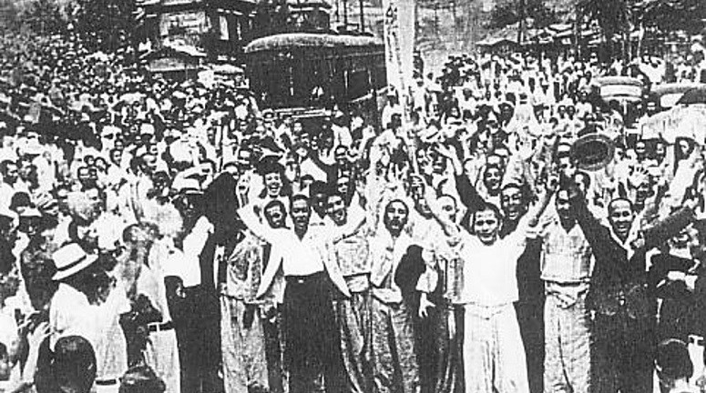  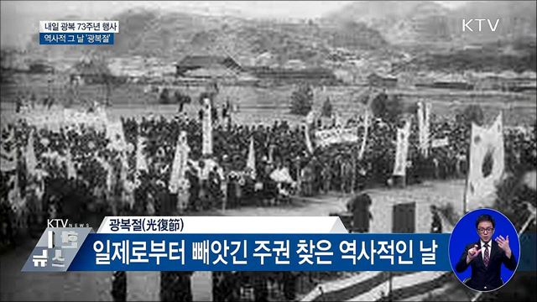a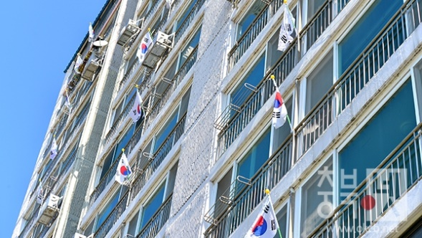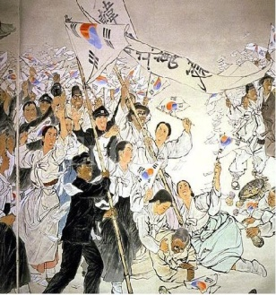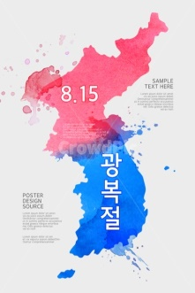  Discussion  - Do you have any plan?  - What do you usually do?  - Have ever been participated in events or official celebration?  - Do you like to watch celebration program on TV ?  - Did you hoist the Korean National flag? (Where, What time)?  - Another expression about “Independence Day” in English?  - Another country has a that day in history?  - What difference of “Korean Independence Day” in contrast to Unite State?  - How many do you know “representative national holidays” in Korea?  ▶ The anniversary of the Independence Movement of March lst  ▶ The Buddha's Birthday  ▶ Memorial Day  ▶ Constitution Day  ▶ Labor Day  ▶ The Foundation Day of Korea  ▶ Hangeul Proclamation Day  ▶ Christmas

Stage Name: Task Realization
Purpose of this stage: This is a very student centered stage to allow for maximum speaking fluency practice. Monitor discretely and take note of incorrect language. Students perform their task without interruptions from the teacher.
Materials: List all materials that will be needed in this stage.
Time | Interaction | Procedure
7min | S-S | Make a group  ■ Plan to discuss freely each other, and after that complete “Plan A” which debated and agreed with today’s Topic as a group.  → Where to go?  → What to do?  → What do you have feeling about Japan?  → Have ever been raised the Korean National flag?  → In addition, anything else activity?  ☞ Need to exchange your viewpoints efficiently and confirm each other.  ■ Everybody agree “Pan A” and has a lot in common?

Stage Name: Post Task
Purpose of this stage: To end the lesson with a final student centered task such as voting, summarizing, discussing, deciding etc. The teacher may offer delayed error correction to the previous stage, as well as mention positives and points to improve for next time such as useful strategies.
Materials: List all materials that will be needed in this stage.
Time | Interaction | Procedure
30sec  2min  30sec | T  S-S | [Closing] - Less talking  Let’s warp up and time to close  I would like to conclude by saying that and thank you so much for listening and enthusiasm in today’s my lecture.  Also, I want to encourage you to learn and study hard to make your dream for getting into a top university, entering the big company in the future.  Finally, I am looking forwarding to seeing you next time and expect you to prepare the class in time.  [Too much talking among students]  Now, Time to discuss about today’s lecture, interest in summary and express your future dream respectively. Here It is very important to engage yourself in debate positively based on students.  I hope that Cris Park give a presentation for comprehensive opinion on behalf of work group(three students)

Instructor’s Comments and Assessment
Pros
Cons
Change
Overall Comments
Grade
Above Standard 85%-100% | Standard 70%-84% | Below Standard 69%-0%
Instructor | Student Signature | Date
Taute, David

