Background Information Sheet
Name | Class | Date | Lesson Type | Plan type | Length
Michael | 197th | 10/08/2019 | Grammar | PPP | 25min

Lesson
Topic | She is swimming now.
Main Aim | Students will learn the 2nd conditional.
Secondary Aim | Students will practice their speaking fluency.

Materials and References
PPT, board, Marker, Ereazer etc

Student Profile
Level |  | Lower Intermediate
Age |  | adult |  | Number of Students | 3
Detail |  | There are three students, and only one male, two female is a English teacher.  All of them are native Korean speakers very passionate for the class
Assumptions about students’ knowledge as required for this lesson:
- Students know the vocabulary used in this lesson
- Students have learned about the subject and ‘be’ verb relationship
- Students know how to make the negative form using ‘not’
What language difficulties to expect when presenting, and how to deal with it:
- Meaning: “If I had a million dollars; I’d buy a new car.” Students may think it is talking about a real situation in the past because of the word ‘had’. Make a clear visual context and C.C.Q.

- Form: Students may confuse how to use the if-clause e.g. ‘If I buy a new car I had a million dollars.’ Identify the two separate clauses being the if-clause and the result/consequence clause. Highlight the variable sentence structure.
E.g. I’d buy a new car if I had a million dollars.

- Pronunciation: Students may not know where to put natural sentence stress. Drill several times chorally, then individually. Ask, “Which words sound stressed?” Board the stress markers in red.

Anticipated Classroom Management Difficulties and their Solutions:
The quantity of new language points to be learned about the 2nd conditional is too much for students to handle in a short 30 minute lesson. This could lead to anxiety, rushing, and a lot of teacher talk. For this lesson I will manage this by selectively presenting only a few new concepts about the 2nd conditional. The remaining new language points can be presented in the next lesson.
My Personal Aim
What I hope most to demonstrate in this lesson is the ability to
- present the target language using a situational presentation
- to be an involver type teacher

Stage Name: Lead-in
Purpose of this stage: To relax both the teacher and students. To focus attention on the lesson. Create a situation for students to experience or think about, and then to elicit the target language.
Materials: List all materials that will be needed in this stage.
Timings | Interactions |  | Procedure
1min | T-S |  | show a picture to create a clear and understandable situation related to your target language. Try elicit the model sentence (a sentence that contains the target language) by referring to the situation.  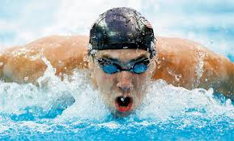
Stage Name: Presentation
Purpose of this stage: Make the students think about the situation. To clarify the meaning, form, and pronunciation features of the target language.
Materials: List all materials that will be needed in this stage.
Timings | Interactions |  | Procedure
1min  2min  2min  3min | T  T-S  T-S  T-S |  | Board the model sentence (He is swimming now). Tell students to draw the picture and write down the sentence.  Show a picture again (to elicit the situation from students)  CCQ – ask questions.  - Is he swimming now?(Yes.)  - Is he finished swimming?(No.)  - Is this in the past, present or future? (Present)  Form – clarify the positive, negative, question form.  - (Positive) S + be-verb + main verb- ing now.  - (Negative) S + be-verb Not + main verb-ing  - (Question) Be-verb + S + main verb-ing ?  -  Drill – drill the spoken form, focusing on contractions, stress and intonation, pronunciation  - He is swimming now  (stress point)  - He isn’t swimming.  (stress and contraction point)  ☞ Is not → Isn’t[iznt]  - Is he swimming now?  (intonation point)
Stage Name: Controlled Practice
Purpose of this stage: students practice working with the form (scrambled sentences, split sentences, select the correct form of the verb, correct incorrect sentences, and change one form into another form). Accuracy must be checked.
Materials: List all materials that will be needed in this stage.
Timings | Interactions |  | Procedure
1min  3min  1min  1min | T  S  S – S  T - S |  | Instructions. Hold up the worksheet, point to excise A.  Excise A says to change the sentence in the new form.  Positive: He is swimming now.  Negative: He isn’t swimming.  Question: Is he swimming now.  Hand out the worksheet.  Students do a worksheet A individually.  Pair check.  Feedback to check accuracy.  Board correct or show answers visually.
Stage Name: Less Controlled Practice
Purpose of this stage: students practice working with the meaning (match a timelines to sentences, choose the sentence that matches a picture, gap-fill a paragraph). Accuracy must be checked.
Materials: List all materials that will be needed in this stage.
Timings | Interactions |  | Procedure
30sec  3min  1min  30sec | T  S  S – S  T - S |  | Instructions. show a new picture.  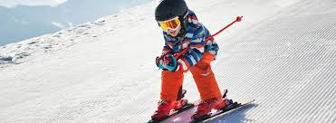  ☜ She was in the past  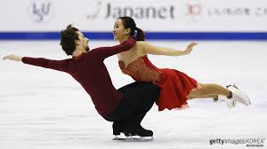  ☜ She is in the present  - Hold up the worksheet, point to excise B.  - Excise B says make 4 true sentence about the picture.  Hand out the worksheet.  Students do a worksheet B individually.  Pair check.  Feedback to check accuracy. Board correct or show answers visually.
Stage Name: Production – Freer Practice
Purpose of this stage: is to get students to practice the grammar communicatively.
Materials: List all materials that will be needed in this stage.
Timings | Interactions |  | Procedure
20 sec  4min | T  S-S |  | Instructions. (Visual.) show a different picture  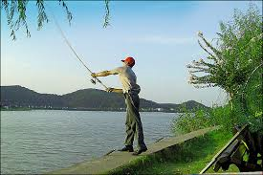  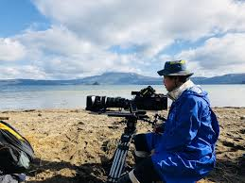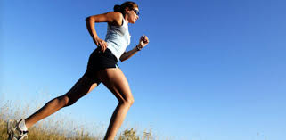  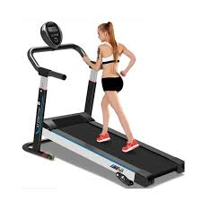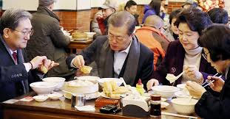
Stage Name: Wrap-up
Purpose of this stage: is to end the lesson on a positive note so that students feel they have achieved progress.
Materials: List all materials that will be needed in this stage.
Timings | Interactions |  | Procedure
30sec  5sec  5sec | T – S  T  T |  | Offer delayed corrections to the previous stage.  - “Look at the board. Here are some sentences I heard. Tell me how to correct them.”  Set homework.  Inform students about the topic for the next lesson.  Greeting(Thank you so much for attention and enthusiasm, interest in my lecture)
Instructor’s Comments and Assessment
Pros
Cons
Change
Overall Comments
Grade
Above Standard 85%-100% | Standard 70%-84% | Below Standard 69%-0%
Instructor | Student Signature | Date
Taute, David

Worksheet: be-verb + ing

Excise A(Form focused)
Change the sentence tod the new form. Write your answers neatly.

Example
Positive: He is swimming now.
Negative: He isn’t swimming.
Question: Is he swimming now?

1) Positive: I am sleeping now.
Negative:
Question: ?

2) Positive:
Negative: I am not looking at the .picture.
Question: ?

3) Positive: They are taking a class for TESOL now.
Negative:
Question: ?

4) Positive:
Negative:
Question: Are they reading a book?

Answer-sheet
Excise A
Change the sentence tod the new form. Write your answers neatly.

Example
Positive: He is swimming now.
Negative: He isn’t swimming.
Question: Is he swimming now?

1) Positive: I am sleeping now.
Negative: I am not sleeping.
Question: Are you sleeping now?

2) Positive: I am looking at the picture.
Negative: I am not looking at the picture.
Question: Are you looking at the picture?

3) Positive: They are taking a class for TESOL now.
Negative: They are not taking a class.
Question: Are they taking a class now?

4) Positive: Thery are reading a book in the classroom.
Negative: They are not reading a book in the classroom.
Question: Are they reading a book?

Worksheet: be-verb + ing.
Excise: B(Meaning focused)
Write 4 true sentences about the picture using “be-verb + ing”
A man is watching TV at a living room alone.
Example

☜ She was in the past.
☜ She is in the past.

Answer-sheet.
Excise: B
Write 4 true sentences about the picture using “be-verb + ing”
A man is watching TV at a living room alone.
Example

☜ She was in the past.
☜ She is in the past.

- She was going skiing in the past.

2) She was enjoying skiing on the snow in winter season in the past.

- Is she looking like entering the competition with partner in the present?

4) She impassionedly is playing ice dancing on an ice-rink in the present.

