Background Information Sheet
Name | Class | Date | Lesson Type | Plan type | Length
Luna | 200thWK | 19/10/2019 | Grammar | PPP | 35 min

Lesson
Topic | She always reads a book.
Main Aim | Students will learn the present simple tense with using adverbs of frequency.
Secondary Aim | Students will practice their speaking fluency.

Materials and References
Whiteboard, Color marker, Worksheet, PPT

Student Profile
Level |  | Elementary
Age |  | Children |  | Number of Students | 2
Detail |  | Students are Korean.  Students have passion to learn about new lesson, and actively participate in the class.
Assumptions about students’ knowledge as required for this lesson:
- Students know the vocabulary used in this lesson
- Students have learned about third-person singular verb, and adverbs of frequency (always, sometimes, rarely, never).
- Students know how to make the present simple tense, interrogative sentence, and negative form.
What language difficulties to expect when presenting, and how to deal with it:
- Meaning: “She always reads a book.” Students may think ‘read a book’ is only one-time event, so make sure indicate the schedule calendar that ‘read a book ‘is her routine(repeated) action. -> Make a clear visual context and C.C.Q.

- Form: Students may confuse to locate the adverbs of frequency in sentence. If the sentence has a verb, we put the adverb after subject and before the verb. Highlight adverb of frequency (always), indicate the subject (She) and verb (reads).
- E.g. She always reads a book. (O) / She reads always a book. (X)
S Adv.fre V
- Pronunciation: Students may not know where to put natural sentence stress. Drill several times chorally, then individually. Ask, “Which words sound stressed?” Board the stress markers in red.

Anticipated Classroom Management Difficulties and their Solutions:
The quantity of new language points to be learned about the adverbs of frequency is too much for students to handle in a short 35 minutes lesson. This could lead to anxiety, rushing, and a lot of teacher talk. For this lesson I will manage this by selectively presenting only a few new concepts about the sentence has a verb (present simple tense) with using adverbs of frequency. The remaining new language points can be presented in the next lesson.
My Personal Aim
What I hope most to demonstrate in this lesson is the ability to
- present the target language using a situational presentation
- to be an involver type teacher
Stage Name: Lead-in
Purpose of this stage: To relax both the teacher and students. To focus attention on the lesson. Create a situation for students to experience or think about, and then to elicit the target language.
Materials: PPT, Whiteboard, Color marker.
Timings | Interactions |  | Procedure
2min | T-S |  | Draw, mime, show a picture etc. to create a clear and understandable situation related to your target language. Try elicit the model sentence (a sentence that contains the target language) by referring to the situation.  T: “Hello everyone~”  #1  “Have you ever seen this animation?” S: “Yes.”  “Do you know the title?” S: “Beauty and the beast!”  T: “Yes. That’s right! What’s her name? (Pointing ‘Belle’)” “S: Belle”  “Yes. Who is he? (Pointing ‘the beast’)” “S: beast”  “Yes”  “What they are doing?” “S: They are dancing/ They dance”  #2  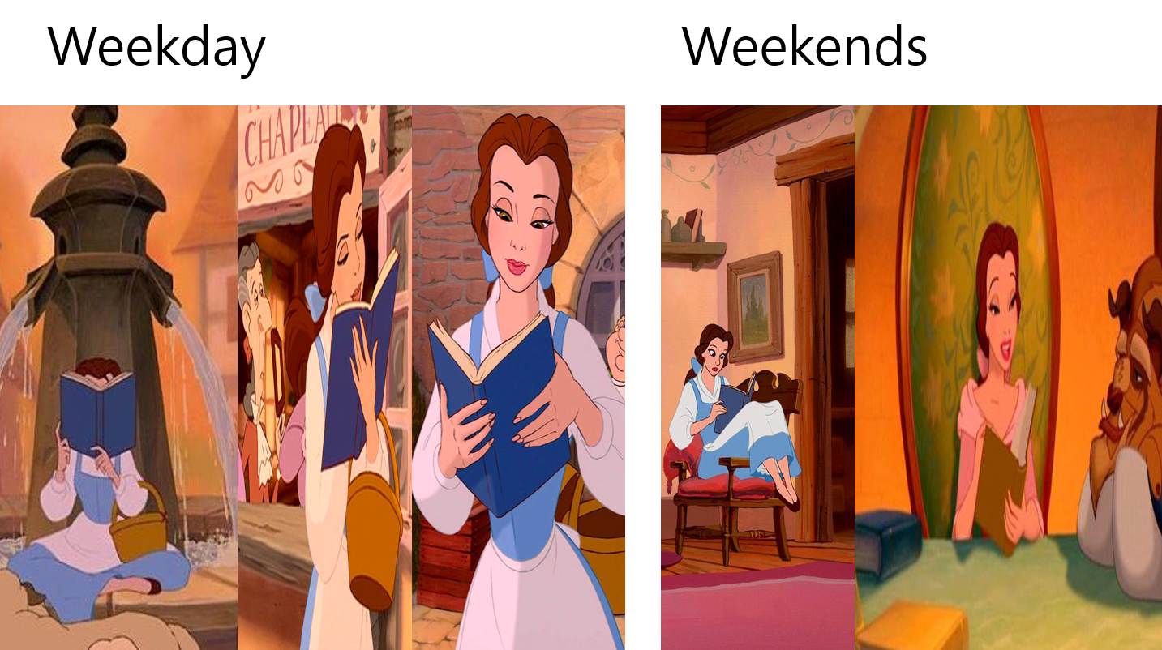  T: “What does she do on weekday?” S: “She reads a book/ She is reading a book”  “What does she do on weekends?” S: “She reads a book”  “Yes. She reads a book.  #3  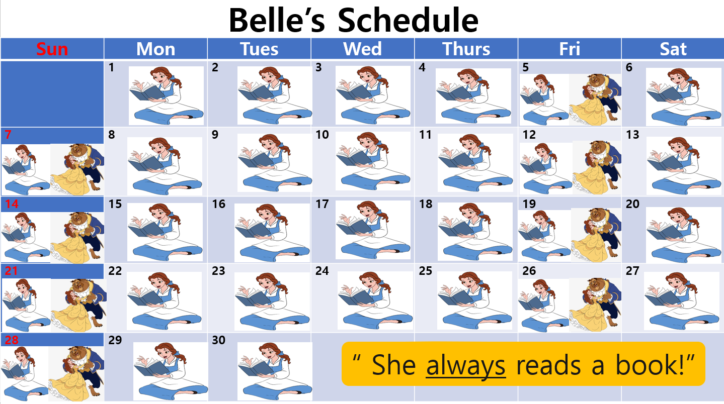  T: “I made the Belle’s schedule template!  Based on her schedule template, can you tell me how often she does this activity? (*Pointing Belle reads a book)”  - S: “She always reads a book”  T: “Correct!”
Stage Name: Presentation
Purpose of this stage: Make the students think about the situation. To clarify the meaning, form, and pronunciation features of the target language.
Materials: Whiteboard, Color markers.
Timings | Interactions |  | Procedure
1min  1min  5min  3min | T  T-S  T-S  T-S |  | Board the model sentence (if students are unable to tell you, just board it).  ----------------------------------------------------------------------------------- ▷ * Write on the board* ___> She always reads a book  CCQ – ask questions, and use time lines or scales where appropriate.  - Involves student, making them think about the situational context.  - Don’t rush, and don’t answer your own CCQs.  - Use the context to help students realize the correct answer.  <CCQ>  1. T: “Does she rarely read a book?” S: “No”  2. T: “Does she read a book every day?” S: “Yes”  3: T: “Do we know what time she read a book?” S: “No”  Form – clarify the affirmative, negative, question form, or other special features. Substitution tables may be of use.  - Identifying sentence / clause structure  - Changes in spelling  - Highlight the grammar structure e.g. ‘be’ auxiliary + simple present verb+ing (+ time reference)  (Positive +): She always reads a book  S Adv.fr V Noun  T: “Where is Subject? Verb? Noun?” S: “Talk..”  T: “Can you make it as negative form?” S: “She doesn’t always read a book”  “Is it read? Or reads?” S: “read”  “Good. Because we use helping(auxiliary) verb (does)”  (Negative -): She doesn’t always read a book.  S H.V Adv.fr V N  T: “Can you make it as a question?” (*Pointing positive form).  -> S: “Does she always read a book?”  “Great!”  (Question): “Does she always read a book?”  H.V S Adv.fr V N  Drill – drill the spoken form, focusing on contractions, stress and intonation.  - Say and gesture “Listen and repeat: [model sentence.]”  - Drill will energy and enthusiasm, using natural intonation and stress.  - Make special pronunciation features visible on the board, using colour.  1. T: “Listen and repeat after me. [‘She always reads a book’] “  *** Show 3 fingers, fold 1 finger each time while student drill ***  S: “She always reads a book” X 3  T: “Where is the stress?” S: “always, reads, book”  “Great!”  She always reads a book.  T: “It sounds like ‘re-za’ and connect it”  T: “Okay. Listen and repeat faster at this time!”  “She doesn’t always read a book” X 3  “Does she always read a book?” X 3  *Pointing each student with showing them 3 fingers and repeat 3 times individually.  S1/S2: “She doesn’t always read a book” X 3  S1/S2: “Does she always read a book” X 3
Stage Name: Controlled Practice
Purpose of this stage: students practice working with the form (scrambled sentences, split sentences, select the correct form of the verb, correct incorrect sentences, and change one form into another form). Accuracy must be checked.
Materials: Worksheet (exercise A), whiteboard, color marker.
Timings | Interactions |  | Procedure
1min  1min  3min  2min  2min | T  T-S  S  S – S  T - S |  | Instructions.  T: “I’m going to give you worksheet.  You’re going to do front page Exercise A.  In this exercise, you’re going to change the sentence to positive/negative/question form with using adverb of frequency.”  “Work individually. I’ll give you 3minutes for this activity.”  ICQ.  T: “Okay~ what page are we going to do now?” S: “Exercise A/front page”  “Yes~ Is this pair-work activity or individual activity?” S: “individual work”  “Great. Please start when you receive the worksheet”  Hand out.  Students do a worksheet.  T; *Clapping for attention**  “Okay~Please check your answer with your partner.”  Pair check.  Feedback to check accuracy. Board correct answers visually.  “Let’s check the answer together!”
Stage Name: Less Controlled Practice
Purpose of this stage: students practice working with the meaning (match a timelines to sentences, choose the sentence that matches a picture, gap-fill a paragraph). Accuracy must be checked.
Materials: Worksheet (Exercise B), whiteboard, color marker
Timings | Interactions |  | Procedure
1min  3min  2min  2min | T  S  S-S  T-S |  | T: “Turn the page.  Q: Choose 5 activities from below and write down your own sentence with using adverb of frequency (Always>Usually>Often>Sometimes>Rarely>Never).  ICQs  T: “Are you going to make the sentence without adverb of frequency?” -> S: “No”  “Good. Please work individually”  Students work individually.  Pair check  T:“Please check your answer with your partner”  Feedback to check accuracy. Board correct answers visually.  T: “Okay. Let’s check the answer together.  Can you share your answer? (pointing one Student)” S: “Talk their answer”
Stage Name: Production – Freer Practice
Purpose of this stage: is to get students to practice the grammar communicatively.
Materials: whiteboard, color marker.
Timings | Interactions |  | Procedure
30 sec  5 min | T  S-S |  | Instructions. (Visual.)  ***** (write on the board) ‘Talk about my routine’ *****  T: “Talk with your partner about your schedule routine.  For example, what do you do every-weekend?  How often do you do that activity?”  Talk to each other.  *******(Monitoring!!!! & Write down that need to cover in the feedback) ************
Stage Name: Wrap-up
Purpose of this stage: is to end the lesson on a positive note so that students feel they have achieved progress.
Materials: Whiteboard, color marker
Timings | Interactions |  | Procedure
1 min  25 sec  5 sec | T – S  T-S  T |  | Offer delayed corrections to the previous stage.  - “Look at the board. Here are some sentences I heard. Tell me how to correct them.”  Set homework.  T: “In the beginning of the class you saw the belle’s calendar, do you remember?”  S: “Yes”  T: “I want you to make your own calendar, and write down 5 sentences with using adverb of frequency”  Inform students about the topic for the next lesson.  “In next class, we will going to check your homework, and learn future tense”
Instructor’s Comments and Assessment
Pros
Cons
Change
Overall Comments
Grade
Above Standard 85%-100% | Standard 70%-84% | Below Standard 69%-0%
Instructor | Student Signature | Date
Taute, David

<Worksheet: Adverb of frequency>
Exercise A
Change the sentence to the new form.
Example
Positive: She always reads a book.
Negative: She doesn’t always read a book.
Question: Does she always read a book?

1. Positive: I often go to the shopping.
Negative: ______________________________________________________________________
Question: ______________________________________________________________________
2. Positive: _______________________________________________________________________
Negative: ______________________________________________________________________
Question: Does he sometimes watch horror movies?
3. Positive: ______________________________________________________________________
Negative: She doesn’t usually drink wine.
Question: ______________________________________________________________________
4. Positive: I always take a shower in the morning.
Negative: ______________________________________________________________________
Question: ______________________________________________________________________
5. Positive: _______________________________________________________________________
Negative: We don’t usually travel on weekends.
Question: _____________________________________________________________________

Exercise B.
Choose 5 activities from below and write down your own sentence with using adverb of frequency (Always>Usually>Often>Sometimes>Rarely>Never).
Ex: I never use my mother’s make-up.
------------------------------------------------------------------------------------------------------
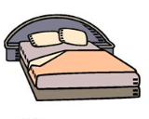

1.
2.
3.
4.
5.

- Answer sheet
<Exercise A>
1. Positive: I often go to the shopping.
Negative: I don’t often go to the shopping.
Question: Do you often go to the shopping?
2. Positive: He sometimes watches horror movies.
Negative: He doesn’t sometimes watch horror movies.
Question: Does he sometimes watch horror movies?
3. Positive: She usually drinks wine.
Negative: She doesn’t usually drink wine.
Question: Does she usually drink wine?
4. Positive: I always take a shower in the morning.
Negative: I don’t always take a shower in the morning.
Question: Do you always take a shower in the morning?
5. Positive: We usually travel on weekends.
Negative: We don’t usually travel on weekends.
Question: Do you/we usually travel on weekends?
<Exercise B>
1. She(he) Always watches TV.
2. She(he) doesn’t usually wakes up at 7.00 am.
3. She(he) never goes to school with her parents.
4. I rarely read a book.
5. She(he) usually goes to travel to Paris.

