Background Information Sheet
Name | Class | Date | Lesson Type | Plan type | Length
Judy Kim | TESOL 198WD | 10/23/2019 | Reading | PPP | 25 min

Lesson
Topic | Modern Olympic Games
Main Aim | Students will practice their reading comprehension.
Secondary Aim | Students will practice their speaking fluency.

Materials and References
Board, markers, reading material and worksheet, picture, computer, screen

Student Profile
Level | Lower Intermediate
Age | Teenagers | Number of Students | 11
Detail | All students are Korean.  All students participate well in class.

Anticipated Difficulties and their Solutions:
* Technological failure - Print out a picture in case the screen doesn't work.

My Personal Aim
What I hope most to demonstrate in this lesson is the ability to be an involver type teacher

Stage Name: Lead-in
Purpose of this stage: To relax both the teacher and students. To focus attention on the lesson. To lead in to the topic, activating background knowledge.
Materials: List all materials that will be needed in this stage.
Timings | Interactions | Procedure
30 sec  1 min  30 sec | T  S-S  T-S | Hello, everyone!  (Show a picture.) Look at the picture on the screen  What do you see? (SS: Pyeongchang Olympic)  What is the most memorable thing for the PyeongChang Olympics? And What is the reason?  Talk to your partner  (Students talk to partners.)  Guys, time’s up. Who want to share ideas?  (ask to a student) Good!

Stage Name: Presentation
Purpose of this stage: To pre-teach keywords if necessary, and consider guiding questions. These steps provide extra help for students to comprehend the text.
Materials: List all materials that will be needed in this stage.
Timings | Interactions |  | Procedure
2 min  10 sec  1 min | T-S  T  S-S | Pre-teach keywords  * initiate  Elicit – Look at this picture. What do you see? (listen to the students) (SS: Hitler)  What did he do? (listen to the students) Yes, he initiated World War II  CCQ – 1. Did he start World War II? (SS: Yes)  2. Did he cause World War II to begin? (SS: Yes)  Drill – Listen and repeat three times. /ɪnɪʃieɪt/ choral and individual drilling for correct pronunciation  Board – (Write initiate on the board.)  How many syllables? (A : four) (divide the word into syllables)  Where is the stress? (A : on the second) (mark the stress)  What part of speech? (A : vowel) (write on the board)  Guiding Question  Okay, guys. (Showing the title of the reading material) This is the title of the article.  What do you know about the Modern Olympics? Talk to your partner.  (Students talk to partners.)

Stage Name: Practice – Literal Comprehension
Purpose of this stage: is to get students to practice reading for literal detail.
Materials: List all materials that will be needed in this stage.
Timings | Interactions | Procedure
30 sec  2 min  1 min  1 min | T  S  S-S  T-S | Guys, (showing a handout to the students) I will give you reading materials.  (Pointing Exercise 1) I want you to circle the answer for Exercise 1 individually while you are reading.  *ICQ - What will you do while reading? (S: circle the answer for Exercise 1.)  Are you going to see the back page now? (S: No)  (Hand out worksheets. When all students have their worksheet, say)  Okay, Let’s start. You have 2 minutes.  Students read the whole text for the 1st time, and check the answers for Exercise 1.  (monitor)  Time is up. Check your answers with your partner.  (Students talk to partners.)  Alright, class. Let’s check the answer together.  What is the answer for question 1? (Check the all answers)  *Literal question  Exercise 1. As you read the text, decide if the sentences below are True or False.  1) Modern Olympic Games began in the 1894. (A: True)  2) The IOC was founded in the 4th century. (A: False)  3) The IOC has the right to choose the host city. (A: True)  4) The Games have always been organized without any problem. (A: False)

Stage Name: Practice – Interpretive Comprehension
Purpose of this stage: is to get students to get students to practice interpreting a text correctly This will require more detailed, careful reading, and thinking time to arrive at the correct answer.
Materials: List all materials that will be needed in this stage.
Timings | Interactions | Procedure
20 sec  3 min  1 min  2 min | T  S  S-S  T-S | Now, look at the back page.  Read the text again, think and write your answer for Exercise 2.  *ICQ - What will you do now? (S: Read again and write answer for Exercise 2.)  Good, you have 3mintues.  Students read for the 2nd time. Students write their answer down.  Time is up. Check your answers with your partner. (monitor)  Alright, class. Let’s check the answer together.  Why are the Olympic Games an opportunity for the host country or city to promote themselves to the world?  Who want to share ideas?  (Nominate 1~2 students and listen their answers first, even some answers are wrong. Then tell them the right answer.)  * Interpretive Question: Exercise 2. Why are the Olympic Games an opportunity for the host country or city to promote themselves to the world? (A: The Olympic Games are a major global sporting event, which attracts huge worldwide interest. The host country or city is exposed to the media worldwide and showcased their cultural wealth, economy, technology, political stability. For example, the host country can build a positive national image through the opening ceremony.)

Stage Name: Production - Applied Comprehension
Purpose of this stage: is for students to practice their speaking fluency on a topic related to the lesson.
Materials: List all materials that will be needed in this stage.
Timings | Interactions | Procedure
30 sec  6 min 30sec  1 min | T  S-S  T-S | Now, look at the Exercise 3.  Nominate a student and ask him or her to read Questions for Exercise 3 aloud.  Can you read questions for Exercise 3?  Applied Question: Exercise 3  1) If the Olympics are to be held in Korea again, what would you like to promote about Korea?  2) What do you think we need to prepare for the Olympic event?  Discuss these with your partner.  (Students discuss.)  Guys, 1 minute left.  (While students are talking, write down homework on the board)  Guys, time is up!  Who want to share ideas?  (Nominate 1~2 students and listen their answers first, even some answers are wrong. Then tell them the right answer.)

Stage Name: Wrap-up
Purpose of this stage: is to end the lesson on a positive note so that students feel they have achieved progress.
Materials: List all materials that will be needed in this stage.
Timings | Interactions | Procedure
1 min | T | Guys. Here is homework. I want you guys to write a paragraph about Exercise 3.  We will talk more about it tomorrow. (Point to the board so students can see their homework written.)  Ok, everyone did really well today.  What was the most interesting during the lesson?  What about the most difficult part?  Well done, guys. See you tomorrow

Instructor’s Comments and Assessment
Pros
Cons
Change
Overall Comments
Grade
Above Standard 85%-100% | Standard 70%-84% | Below Standard 69%-0%
Instructor | Student Signature | Date
Taute, David

Worksheet
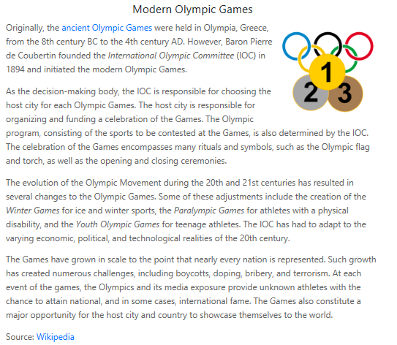
Exercise 1. As you read the text, decide if the sentences below are True or False and circle the answer.

1) Modern Olympic Games began in 1894.
a. True / b. False

2) The IOC was founded in the 4th century.
a. True / b. False

3) The IOC has the right to choose the host city.
a. True / b. False

4) The Games have always been organized without any problem.
a. True / b. False
Exercise 2. Read the text, think and write your answer.
Q. Why are the Olympic Games an opportunity for the host country or city to promote themselves to the world?

Exercise 3. Talk to your partner freely about the questions below. No writing!

- If the Olympics are to be held in Korea again, what would you like to promote about Korea?

- What do you think we need to prepare for the Olympic event?

Answer sheet

Exercise 1. As you read the text, decide if the sentences below are True or False and circle the answer.
1) Modern Olympic Games began in 1894.
a. True / b. False

2) The IOC was founded in the 4th century.
a. True / b. False

3) The IOC has the right to choose the host city.
a. True / b. False

4) The Games have always been organized without any problem.
a. True / b. False
Exercise 2. Read the text, think and write your answer.
Q. Why are the Olympic Games an opportunity for the host country or city to promote themselves to the world?

A. The Olympic Games are a major global sporting event, which attracts huge worldwide interest. The host country or city is exposed to the media worldwide and showcased their cultural wealth, economy, technology, political stability. For example, the host country can build a positive national image through the opening ceremony.

Exercise 3. Talk to your partner freely about the questions below. No writing!

- If the Olympics are to be held in Korea again, what would you like to promote about Korea?

- What do you think we need to prepare for the Olympic event?

Picture for Lead-in
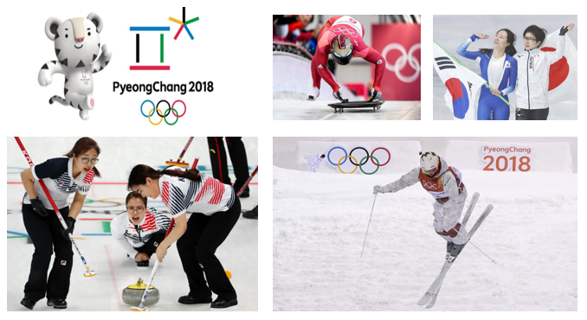

Picture for elicit the word initiate
