Background Information Sheet
Name | Class | Date | Lesson Type | Plan type | Length
Jina | TESOL 198WD | 2019.10.23 | Reading | PPP | 25 min

Lesson
Topic | Institute of Traditional Korean Food Professor Yun Sukja
Main Aim | Ss practice their reading comprehension.
Secondary Aim | Ss practice their speaking fluency.

Materials and References
Jongno tor magazine, worksheets, markers, board, computer, screen, PPT slide show

Student Profile
Level | Intermediate
Age | Adults(20’s-30’s) | Number of Students | 11
Detail | 6 females and 5 males  Most of students have eaten Traditional Korean food.  They are active and willing to participate in the lesson.

Anticipated Difficulties and their Solutions:
Technical failure - Prepare a printed pictures.

My Personal Aim
What I hope most to demonstrate in this lesson is the ability to give clear instruction to students
I would like to give them a meaningful message : Korean Traditional food is precious and valuable.

Stage Name: Lead-in(2min)
Purpose of this stage: To relax both the teacher and students. To focus attention on the lesson. To lead in to the topic, activating background knowledge.
Materials: List all materials that will be needed in this stage.
Timings | Interactions | Procedure
1min  1 min | T-S | “Hello, everyone. I’m Jina. How are you today?”  Ss “Fine.”  “Good.”  (Show some pictures of foods on the screen.)  “Look at those pictures. What do you call these in one word??”  Ss “Food.”  “Right. What was your memorable food? I’ll give you 1 min.” talk to your partner.  “Ok. Time’s up. Who wants to share own experience?”

Stage Name: Presentation(3min)
Purpose of this stage: To pre-teach keywords if necessary, and consider guiding questions. These steps provide extra help for students to comprehend the text.
Materials: List all materials that will be needed in this stage.
Timings | Interactions | Procedure
1 min 20sec  10 sec  1 min  30 sec | T-S  T  S-S  T-S | Pre-teach keywords  - Traditional(ad)  [Eliciting] – Traditional  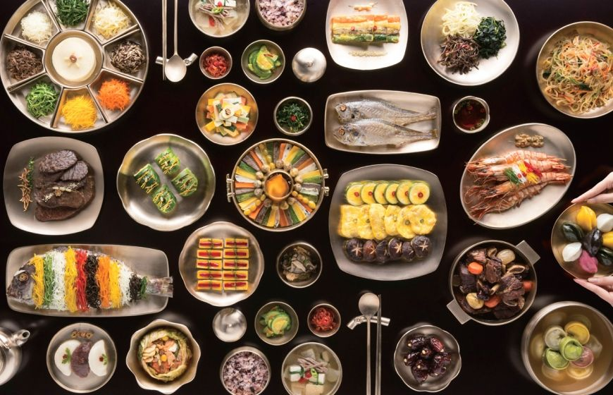  (Show some pictures of foods on the screen.)  “everyone Look at this picture. Do you think what kind of food in this picture?  Ss “traditional Korean food”  “Right. This is Traditional Korean food. We will talk about “traditional”  [CCQ]  - Is this meaning by new one? (No)  - Is this long-established? (Yes)  - what is the opposite meaning?(modern)  [Drill]  Listen and repeat 3X “Traditional”  (Individual drilling for correct pronunciation)  [Board]  Write ‘Traditional [/trəˈdɪʃ.ən.əl/]’ on the board.  ”How many syllables (are there)?” (four)  (Check on the board with blue marker.)  “Where is the stress?” (second syllable, On the vowel ‘i’)  Check on the board with red marker.  [Guiding Question]  “Do you know where is famous Traditional Korean food restaurant?”  Talk to your partner for 1 min.  (Teacher monitoring)  (Nominate a few students to share their ideas)  OOO, what did you talk about?

Stage Name: Practice – Literal Comprehension (5min)
Purpose of this stage: is to get students to practice reading for literal detail.
Materials: List all materials that will be needed in this stage.
Timings | Interactions | Procedure
30 sec  2 min 30sec  1 min  1 min | T  S  S-S  T-S | Instruction]  (Just showing worksheet.)  “Here is our worksheet. Loot at Exercise A. .Total 5 Questions. After reading, you can find the answers. You have to do this work individually. Don’t look the back-side of worksheet yet”  (Hand out text and worksheet(Exercise A).)  (Students read the whole text for the 1st time, and write answers on the worksheet.)  Compare your answers with your partner.  (Students do pair check.)  “Times up. who can read those questions and answers?”  Select 1 S.  (let them know the correct one)

Stage Name: Practice – Interpretive Comprehension(6min)
Purpose of this stage: is to get students to get students to practice interpreting a text correctly This will require more detailed, careful reading, and thinking time to arrive at the correct answer.
Materials: List all materials that will be needed in this stage.
Timings | Interactions | Procedure
30 sec  3 min  1 min  1 min 30 sec | T  S  S-S  T-S | “Now you can see the back of worksheet.”  (Showing the worksheet to the students and pointing to the Exercise 2)  Now, you are going to answer the Exercise 2 question.  Read the text carefully again, and answer the question.  What question are you going to answer now? (SS : Exercise 2 question)  Good, let’s begin.  [Interpretive Q]  (Students read for the 2nd time. Students write their answers down.)  Students read and solve individually.  “Time’s up. Share your answers in your partner with 1 min.”  (Teacher monitoring.)  Listen each pairs answer and give them some feedback.

Stage Name: Production - Applied Comprehension(7min)
Purpose of this stage: is for students to practice their speaking fluency on a topic related to the lesson.
Materials: List all materials that will be needed in this stage.
Timings | Interactions | Procedure
30 sec  5 min  1min 30sec | T  S-S  T-S | “This time. Look at this worksheet the Exercise 3.”  (Showing the worksheet to the students and pointing to the Exercise 3)  Talk to your partner about 2 questions here. Don’t write anything.  What are you going to write? (SS : nothing)  (Teacher monitoring.)  “Time’s up. Now talk to your partner with your answer. I’ll give you 5 min”  Pair work.  (Teacher monitoring.)  And give them feedback. (Nominate some students to share ideas.)

Stage Name: Wrap-up(2min)
Purpose of this stage: is to end the lesson on a positive note so that students feel they have achieved progress.
Materials: List all materials that will be needed in this stage.
Timings | Interactions | Procedure
2 min | T | Lesson feedback.  Good job everyone!  Which part of the lesson did you enjoy the most?  -I'm so glad to hear that.  What word did you learn today?  Which part was the most difficult?  - I know that one is tough, you're getting better.  Offer delayed corrections to the previous stage.  Thank you .

Instructor’s Comments and Assessment
Pros
Cons
Change
Overall Comments
Grade
Above Standard 85%-100% | Standard 70%-84% | Below Standard 69%-0%
Instructor | Student Signature | Date
Taute, David

<PICTURES>

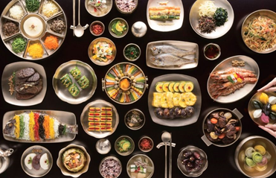
<Article>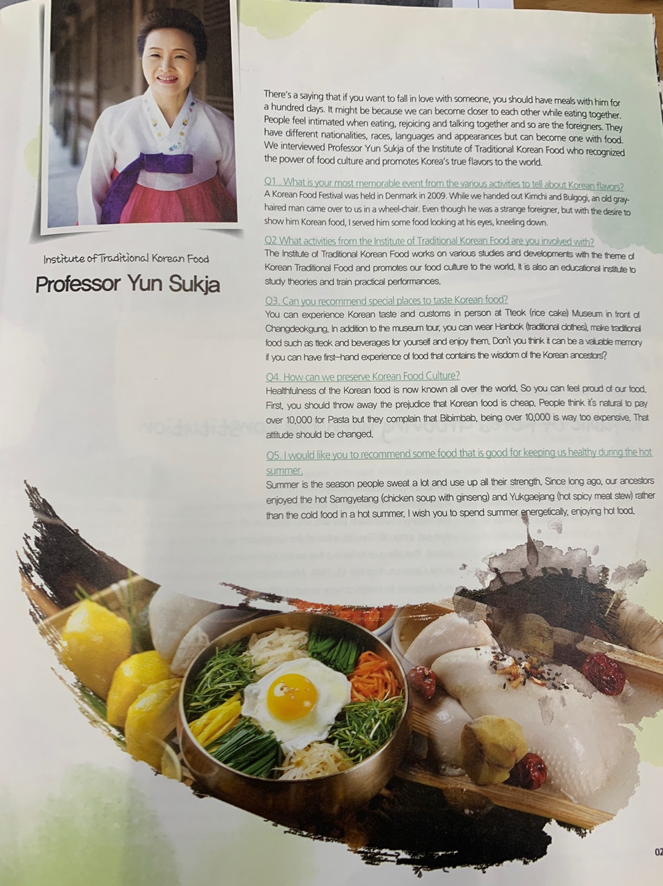
<Question>
Exercise A

- What is the most memorable event from the various activities to tell about Korean flavors?

2. What activities from the Institute of Traditional Koran Food are the professor involved with?

3. Where is special places to taste Korean food?

4. How can we preserve Korean Food Culture?

5. What kind of food that is good for keeping us healthy during the hot summer?

Exercise B

- Why Traditional Korean Food is healthfulness?

2. The professor said “you can feel proud of our food” ,Do you think feel proud of Traditional Korean Food? why?

Exercise C

1. What kind of Korean Traditional food have you tried?

2. Kimchi is traditional Korean food, Why is everyone always talking about kimchi?

