Background Information Sheet
Name | Class | Date | Lesson Type | Plan type | Length
JIN | TESOL | 26/10/2019 | Reading | PPP | 30 min

Lesson
Topic | Cockroach Milk
Main Aim | Ss practice their reading comprehension.
Secondary Aim | Ss practice their speaking fluency.

Materials and References
Worksheets, PPT, photocopies of PPT, board, markers

Student Profile
Level | Intermediate and upper- inter
Age | Adults (30’s) | Number of Students | 2
Detail | 2 Korean Female students  They are friendly and in a good relationship  They are all interested in a new subject

Anticipated Difficulties and their Solutions:
There is a possibility of absence or late.
Be preparing worksheet and study material for the absence student
The pair-work is possible to change individual work and work with teacher.

My Personal Aim
What I hope most to demonstrate in this lesson is the ability to give clear instruction to students and manage the lesson time.
I would like to give them an idea of future food or super food.

Stage Name: Lead-in
Purpose of this stage: To relax both the teacher and students. To focus attention on the lesson. To lead in to the topic, activating background knowledge.
Materials: List all materials that will be needed in this stage.
Timings | Interactions | Procedure
2 sec  30sec  1sec  2 min  30 sec | T  T-S  T  S-S | Hello, everyone!  Look at this picture. (Insect food images…)  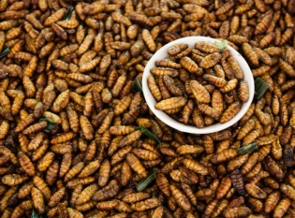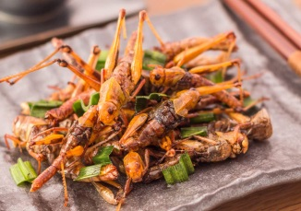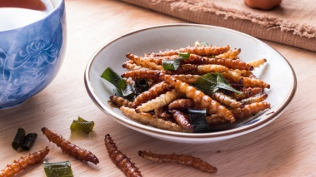  Have you seen this food? (ss-Yes…or not ..)  Do you know what it is?  (Silkworm/looks like grasshopper/ Giant worm …)  Have you ever experience to eat in this kind of food? (ss-Yes..)  Personally, I’ve eaten this silkworm, Korean name is BEMDEAGI , which is steamed silkworm. It tastes very protein~~.  With your partner share your experiences. Where and When did you have and What was the teats like?  (pair work)  (Wow...that’s sounds interesting form you~, )  Well, obviously it is not looks great to eat.. But definitely there are some reason that people made this kind of food ~.  Feedback if appropriate.

Stage Name: Presentation
Purpose of this stage: To pre-teach keywords if necessary, and consider guiding questions. These steps provide extra help for students to comprehend the text.
Materials: List all materials that will be needed in this stage.
Timings | Interactions | Procedure
1secc  1 min  1 sec  1 min  1sec  2min  50 sec | T  T-S  T  T-S  T  S-S  T-S | Now, look at this image.  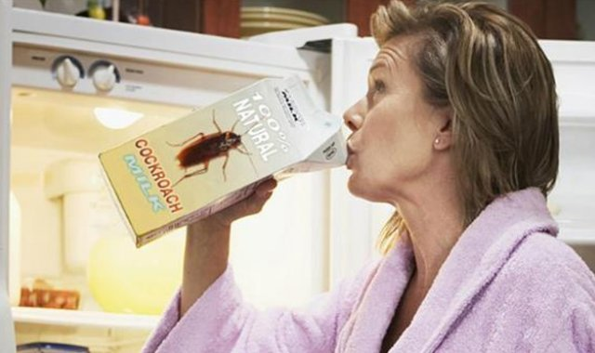  Pre-teach keywords  Does this woman drink a juice? (No)  Does this woman drink a milk? ( Yes)  What does write on it? (Cockroach Milk…)  “Repeat!” Cockroach /ˈkäkˌrōCH/  Please repeat three times! Cockroach, Cockroach, Cockroach( with hand gesture)  choral and individual drilling for correct pronunciation  How many syllables? Two (highlight with color maker) /ˈkäkˌrōCH/  Where is the stress first or second?( first)  And now look at this image.  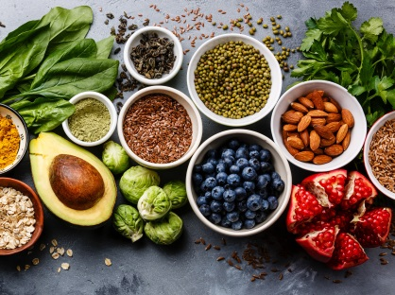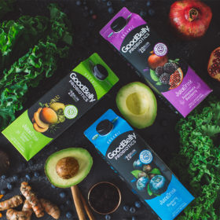  Do they look unhealthy? No  Do they have contained high nutrition? yes  If you have this food, how do you feel unhealthy or healthy? Healthy  Do you know what it is called for this kind of food? “Supperfood” /ˈso͞opərˌfo͞od/  Repeat! Three times- Supperfood ,Supperfood,,Supperfood(indicate individual drilling for correct pronunciation)  How many syllables? two/ˈso͞opərˌfo͞od/ board.  Where is the stress? first highlight special areas of pronunciation on  Guiding Question  If you have chance to drink cockroach milk, what do you feels like? And talk about superfood what you know.  Students discuss the question with a partner.  Feedback. Nominate a few students to share their ideas.

Stage Name: Practice – Literal Comprehension
Purpose of this stage: is to get students to practice reading for literal detail.
Materials: List all materials that will be needed in this stage.
Timings | Interactions | Procedure
1 min  2 min  1 min  1 min | T  S  S-S  T-S | Instructions.  “Here is your worksheet.  Loot at this Exercise A. Total 5 Questions.  After reading, you can find the answers.  This is for individual work.  I will give you 2min to read the article and answer the questions.  How many questions you have? (five~) Please start.  Students read the whole text for the 1st time, and write answers on the worksheet.  Pair check.  Feedback to check accuracy.

Stage Name: Practice – Interpretive Comprehension
Purpose of this stage: is to get students to get students to practice interpreting a text correctly This will require more detailed, careful reading, and thinking time to arrive at the correct answer.
Materials: List all materials that will be needed in this stage.
Timings | Interactions | Procedure
30 sec  4 min  1 min  2 min | T  S  S-S  T-S | Instructions. Set the purpose for reading. Hand out worksheets.  “Now turn over the page, you can see the worksheet B.”  (Showing the worksheet to the students and pointing to the Exercise 2)  Now, you are going to answer the 3 questions.  This time read the text carefully again, and answer the question.  How many questions you have this time? (three question) Good!  I will give you 3min this time.  let’s begin.  Students read for the 2nd time. Students write their answers down.  Pair check. Monitor.  Feedback to check accuracy.

Stage Name: Production - Applied Comprehension
Purpose of this stage: is for students to practice their speaking fluency on a topic related to the lesson.
Materials: List all materials that will be needed in this stage.
Timings | Interactions | Procedure
1 min  8 min  1 min | T  S-S  T-S | Instructions. Give students a question to discuss in pairs or groups.  Students discuss. Or Role play  If you are the scientist, how would you persuade people who does not wanting to try insect milk.  Talk with your partner and find out 5 suggestions to people try insect milk.  Feedback. Students share their ideas with the class.

Stage Name: Wrap-up
Purpose of this stage: is to end the lesson on a positive note so that students feel they have achieved progress.
Materials: List all materials that will be needed in this stage.
Timings | Interactions | Procedure
2 min | T | Lesson feedback. Tell the class what they did well, and what needs to improve.  Good job everyone!  Which part of the lesson did you enjoy the most?  -I'm so glad to hear that.  What word did you learn today?  Which part was the most difficult?  - I know that one is tough, you're getting better.  Offer delayed corrections to the previous stage.  Thank you .  Offer delayed corrections to the previous stage.  Set homework.  Inform students about the topic for the next lesson.

Instructor’s Comments and Assessment
Pros
Cons
Change
Overall Comments
Grade
Above Standard 85%-100% | Standard 70%-84% | Below Standard 69%-0%
Instructor | Student Signature | Date
Taute, David

