Background Information Sheet
Name | Class | Date | Lesson Type | Plan type | Length
MIJUNG SUNG (Mimi) | TESOL | 17/05/2019 | Listening | PPP | 35 min
Lesson
Topic | A Weather Forecast
Main Aim | Students will practice their listening comprehension using an integrated listening model.
Secondary Aim | Students will practice their speaking fluency.
Materials and References
https://learnenglish.britishcouncil.org/skills/listening/intermediate-b1/a-weather-forecast; worksheet; PPT; board pens; P.C. and audio equipment.

Student Profile
Level |  |  |  | Intermediate
Age |  |  |  | Adults | Number of Students | 8
Detail |  |  |  | This is a general English class and students are highly motivated learners. The students are all Koreans and are all currently working. They are quite accustomed to pair work, but still need to be relaxed before they will open up to communicate freely. Many are afraid of making mistakes. They are very enthusiastic learners and engage actively in kinesthetic learning. The students tend to favor the visual learner mode and the auditory learning still needs developing.
Anticipated Classroom Management Difficulties and their Solutions
Nervousness at the start of the lesson Check the equipment is working; to start the lesson, sit down and follow the planned teacher talk.
The audio equipment could fail prepare a portable Bluetooth speakers to use with my smartphone; print an A4 size picture of my PPT.

My Personal Aim
What I aim to demonstrate is the ability to write out a complete, detailed lesson plan.

Stage Name: Lead-in
Purpose of this stage: To relax both the students and the teacher; to increase student talk through the sharing of ideas or experiences; to introduce the topic, or something topic-related.

 | Materials:
 | Time | Interaction | Procedure
 | 30 sec  1 min  30 sec | T  S-S  T-S | Organize seating arrangement into a horseshoe shape so that everyone can see the screen and the board well. Make sure that everyone has a partner. (Groups of 2)  “Hello everyone. How’s the weather today?”  Gesture for students to shout out any answers randomly. Listen for the answers.  “Yes. It’s sunny and cold. Do you usually listen to the weather forecast? If you do, what do you listen for? Talk to your partner about it. You have 1 minute.”  Gesture for students to begin talking to their partners.  Pair check. Students talk to their partners. Monitor for any use of key words.  Feedback. Ask a few groups for feedback.  “Could you tell me what your group talked about?”

Stage Name: Presentation
Purpose of this stage: To offer any needed help which students may need in order to comprehend the text more easily. This includes teaching from 1 to 4 key words using the C.C.C. technique, and asking a guiding question which will allow students the opportunity to think of and share ideas they are likely to encounter when listening. This encourages the use of their schema when comprehending a text.

Materials:
Time | Interaction | Procedure
10 sec  1 min  1 min  1 min  10 sec  2 min  1 min | T  T-S  T-S  T-S  T  S-S  T-S | Prepare PPT slides opened on the PC and turn on the big screen.  Make sure that everyone can see the pictures.  Pre-teach keywords: shower, drizzle, throughout  Elicit – Point to PPT 1.  “We can see that both pictures on the right and the left are showing a rainy weather.  What do we call this kind of rain?”  (Left picture is rain and the right picture is drizzle.)  CCQ – “So is drizzle raining a lot?” (No.)  “Are the raindrops heavy in drizzle?” (No. They are light.)  “Can you see big rain drops?” (No.)  Drill – Listen and repeat 3 times together. (Gesture)  Nominate 2 or 3 individually.  Especially watch out for the sounds [r] and [z], which many Koreans find difficult.  If needed, correct students’ pronunciation.  Board – Write ‘drizzle’ on the board. (with a black pen)  “How many syllables?” (2) Mark with a blue pen.  “Where is the stress?” (1st) Mark with a red pen.  “What type of word is it?” (Noun)  Elicit – Point to PPT 1’s first picture (picture on the left).  “We all know that we call this raining.  But how can we call the rain, that rains unexpectedly only for a very short time and disappears?“  (shower)  CCQ – “So does shower mean it rains for a long period of time?” (No.)  “Can we meet the shower unexpectedly?” (Yes.)  Drill – Listen and repeat 3 times together. (Gesture)  Nominate 2 or 3 individually.  If needed, correct students’ pronunciation.  Board – Write ‘shower’ on the board. (with a black pen)  “How many syllables?” (2) Mark with a blue pen.  “Where is the stress?” (1st) Mark with a red pen.  “What type of word is it?” (Noun)  Elicit – Point to PPT 2.  “Is it raining in just one part of the country?” (No. It’s raining in every part of the country.)  “Correct. Is there another way of saying that it’s raining in EVERY PART of the country?”  (It’s raining throughout the country.)  Show PPT 3 right away.  “Can you say that it’s raining just one day out of the weekend?”  (No. It’s raining the whole/entire weekend.)  “Right. Is there another way of saying that it’s raining for the entire weekend?”  (It’s raining throughout the weekend.)  CCQ – “Does throughout mean it’s happening in every part of something?” (Yes.)  “Does throughout also mean it’s happening during all period of time?” (Yes.)  Drill – Listen and repeat 3 times together. (Gesture)  Nominate 2 or 3 individually.  Listen carefully to the [θru:] sound, which many Koreans find difficult.  If needed, correct students’ pronunciation.  Board – Write ‘throughout’ on the board. (with a black pen)  “How many syllables?” (2) Mark with a blue pen.  “Where is the stress?” (2nd) Mark with a red pen.  “What type of word is it?” (Adverb)  Guiding Question:  “Besides rain, shower and drizzle, what kind of other weather related words can you hear from a weather forecast? Talk to your partner for 2 minutes.”  Gesture for students to begin talking to their partners.  Pair check. Students discuss the question with a partner.  Feedback. Nominate a few students to share their ideas. Draw out the ideas that we could be expecting those weather related words on a weather forecast. If some good words are said, show positive response (e.g. facial expression, gesture etc.).

Stage Name: Practice - Literal Comprehension Listening
Purpose of this stage: For students to listen for the first time in order to get the facts. This may include the overall idea or topic of the text; to notice who the speakers are; where they are; and perhaps why they are speaking. The responses are short, objective, and are only a surface understanding. This is an accuracy focused stage.

Materials:
Time | Interaction | Procedure
1 min  2 min  1 min  1 min | T  S  S-S  T-S | Instructions. Set the purpose for listening before handing out the worksheets.  “Now, we are going to listen to a weather forecast.  As you listen, you must answer these questions in exercise one individually. (Hold up the worksheet)  When you catch the answer, write it down next to the question.  Don’t do exercise 2, yet.”  I.C.Q.s – “Do we need to write down the answers to exercise 1?” (Yes)  “Do we work with the partner?” (No)  “Do we do exercise 2?” (No)  Read each question aloud for the students. Hand out the worksheet.  Students listen for the 1st time, and write answers on the worksheet.  Pair Check. “Compare your answers with your partner.”  Gesture for students to begin talking to their partners.  Feedback to check accuracy. Ask students for answers.  (e.g. “What did you get for number 1?”  & similar method is used for the rest of the questions.  As accuracy is important in this stage, check for student’s accuracy.)

Stage Name: Practice - Interpretive Comprehension Listening
Purpose of this stage: Students listen a second time, more carefully, to infer or interpret meaning of the literal facts. This is still an accuracy focused stage – answers need to be checked for accuracy. Students are required to think about the why in order to support their answers. They may need to focus on things like the overall situation, tone of voice, multiple pieces of information, or a single statement to explain the unspoken, intended meaning.

Materials:
Time | Interaction | Procedure
1 min  4 min  1 min  2 min | T  S  S-S  T-S | Instructions.  “Listen again. This time, answer exercise 2.  These questions are more difficult, but if you listen carefully and think about what you know, you can find the answers.  Write your answers next to the questions, again individually.  I will give you some time afterwards to think and write.”  I.C.Qs.  “Do you have to rush to answer these questions?” (No, we will have time afterwards to write.)  “Do you write down the answers for exercise 2?” (Yes.)  Read the questions aloud for the students.  Students listen for the 2nd time. After the end of the audio, keep silent so the students can have some time to think and finish writing their answers.  Monitor the students and see which groups are finished answering the questions.  If all the students seem to have finished the exercise at a similar pace tell the students to begin talking to their partners. If only some of the groups are finished go and tell those groups quietly to begin talking to their partners.  Pair check. Monitor. If students need, then replay the audio a 3rd time.  Feedback to check accuracy.  Nominate groups for the answers.  (e.g. “Right number 1. This group here? (gesture/point to any group)”.  Similar method is used for the rest of the questions.  Accuracy is still important at this stage, so check for student’s accuracy.)

Stage Name: Production - Applied Comprehension Speaking
Purpose of this stage: For students to practice their speaking fluency. Therefore this stage should be no less than 5 minutes to allow students to practice. Give them a few questions to help them communicate without intervention from the teacher.
This is a fluency focused stage.

Materials:
Time | Interaction | Procedure
1 min  6 min  2 min | T  S-S  T-S | Instructions.  “Now, turn over your worksheets.  Talk to your partner about any of these questions.  You should talk freely, and remember to listen and ask questions to your partner.  You have 6 minutes.”  I.C.Q. – “Do you need to write down your answers?” (No.)  Gesture for students to begin talking to their partners.  Students discuss. Monitor from a distance.  Feedback. Students share their ideas with the class.

Stage Name: Wrap-up
Purpose of this stage: To end the lesson on a positive note. This will give students a sense of accomplishment, encourage students to continue progressing, and realize how to improve in future. A teacher may also get valuable feedback from students regarding the activities used in the lesson.

Materials:
Time | Interaction | Procedure
2 min | T | Lesson feedback. Tell the class what they did well, and what needs to improve.  “Well done guys! You did a great job today. I hope you all feel comfortable talking about the weather. Just watch out for the few difficult pronunciations that we’ve learned today.”  Set homework. “For homework, write down your answer to number 3 on exercise 3. The writing should be no more than just 50 words. It is due tomorrow 9am. Please send your writing to me through E-Mail or text before 9am tomorrow.”  Inform students about the topic for the next lesson. “Tomorrow, we will do a short reading lesson about the weather forecast and move on to a brand new topic.”  Class dismissed.

Instructor’s Comments and Assessment
Pros
Cons
Change
Overall Comments
Grade
Above Standard 85%-100% | Standard 70%-84% | Below Standard 69%-0%
Instructor | Student Signature | Date
Taute, David

PPT 1

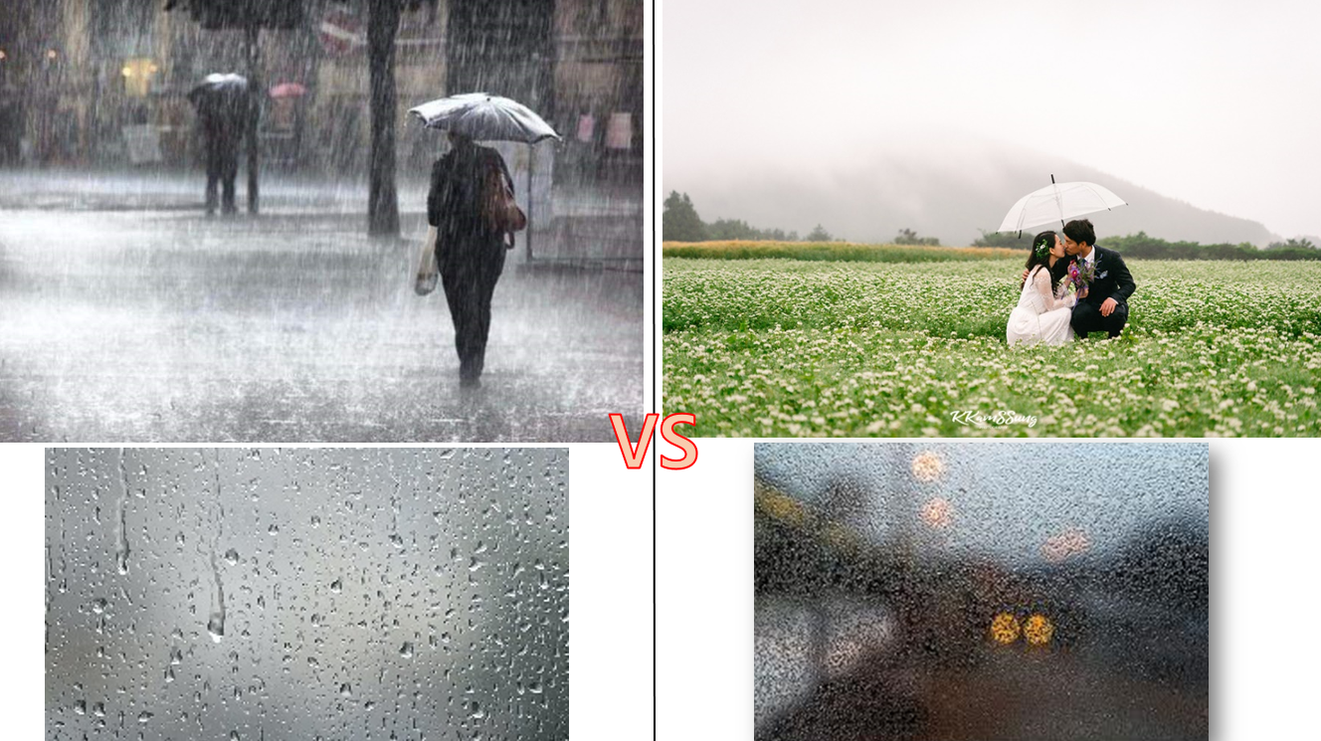

PPT 2

PPT 3

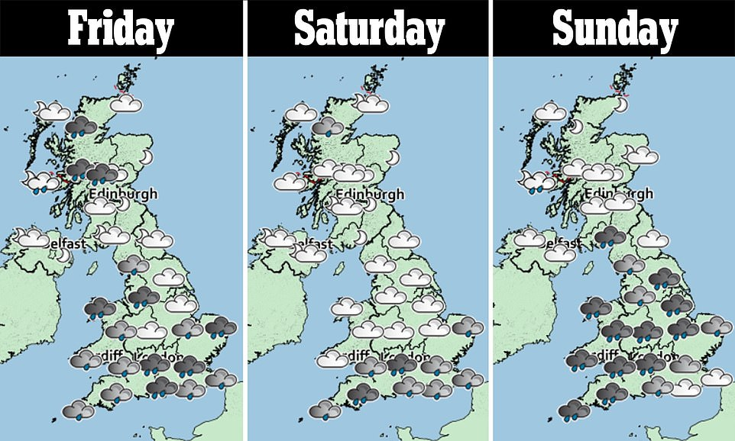

PPT 1 (Left) Bigger Version
in case the monitor/PC doesn’t work

PPT 1 (Right) Bigger Version
in case the monitor/PC doesn’t work

Worksheet - A Weather Forecast

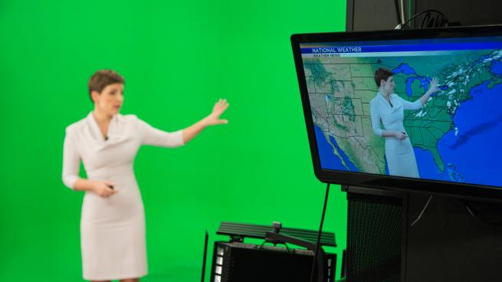

Exercise 1
1) Will it start raining from lunchtime in the east?
2) Will there be a lot of sunshine in the north-west?
3) Will most places in England experience high temperatures for the next week?
4) Where will be raining by Saturday afternoon?

Exercise 2
1) How was the weather at Leeds last week?
2) Is the weather going to stay hot when the rain comes on the weekend?
3) Do English people prefer a sunny weather or a rainy weather?
Exercise 3
1) What is your favorite weather? Why?
2) What is your least favorite weather? Why?
3) What do you like to do on rainy days?

Answer Sheet - A Weather Forecast

Exercise 1
1) Will it start raining from lunchtime in the east? (No.)
2) Will there be a lot of sunshine in the north-west? (No.)
3) Will most places in England experience high temperatures for the next week?
(Yes.)
4) Where will be raining by Saturday afternoon? (The south coast)

Exercise 2
1) How was the weather at Leeds last week?
(Thunderstorms. Because the weather forecast mentions that Leeds will escape the thunderstorms this week.)
2) Is the weather going to stay hot when the rain comes on the weekend?
(No. The weather forecast mentions that the temperature will fall down to ca. 21 degrees, which is a change from their current high twenties and early thirties.)
3) Do English people prefer a sunny weather or a rainy weather?
(Sunny weather. Whereas the weather forecast gives positive expressions related to sunny weather (e.g. good start in the south this week, as the rain has disappeared, ‘dry, bright start’, ‘Enjoy the mini-heatwave’ etc.); it shows negative opinions related to the rainy weather (e.g. ‘not such good news for the north-west this week, I’m afraid.’, ‘By the weekend, unfortunately,’ etc.). This shows that many people are happier with sunny weather.

Exercise 3
1) What is your favorite weather? Why?
2) What is your least favorite weather? Why?
3) What do you like to do on rainy days?

Transcript
Hello and good morning! Well, we’re off to a good start in the south this week, as most of the rain from the weekend has disappeared – just a few patches of cloud and maybe some showers here on the east coast. They’ll all clear up by lunchtime, though. Over the next day or so, London and the area around Kent can expect a couple of isolated showers, but mostly dry through until Thursday.
It’s not such good news for the north-west this week, I’m afraid: more wet weather, and not a lot of sunshine. Some of today’s showers will be heavy – and even thundery in Manchester and across the Pennines. Leeds will escape the thunderstorms, with drizzle and light rain only throughout the rest of the day and tonight.
Elsewhere it becomes dry today, but with some foggy patches towards Wales. In England, tomorrow morning will see a dry, bright start in most places, with high temperatures throughout the week. We might see one or two thunderstorms appearing as the week goes on, with temperatures everywhere at 29 to 30 degrees.
By the weekend, unfortunately, the dry weather will make way for mostly cloudy skies and rain. The rain will move from Scotland, down towards the north and reach the south coast by Saturday afternoon. Temperatures, at least, will stay mostly warm at around 21 degrees for the weekend. It might feel like a nice change from the high twenties and early thirties we’ll see in the week. That’s all from me until tomorrow. Enjoy the mini-heatwave while you can!

