Name | Class | Date | Lesson Type | Plan type | Length
Soomi | TESOL | 2019.11.20 | Listening | PPP | 35min

Lesson
Topic | Advice for Exam
Main Aim | Students will practice their listening comprehension using an integrated listening model.
Secondary Aim | Students will practice their speaking fluency.

Materials and References
https://learnenglishteens.britishcouncil.org/skills/listening/intermediate-b1-listening/advice-exams
; worksheet; board pens; P.C and audio equipment

Student profile
Level | Intermediate
Age | Teens
Number of students | 9
Detail | This is a general English class and students are highly motivated learners. The students are all Koreans, and enjoy science fiction. They are accustomed to pair work, but still need to be relaxed before they will open up to communicate freely. They engage actively in kinesthetic learning and tend to favor the visual learner mode, but auditory learning still needs developing.

Anticipated Classroom Management Difficulties and their solutions
The audio equipment could fail → bring a set of portable speakers to use with my smartphone; print an A4 size picture of my ppt.
Nervousness at the start of the lesson → check the equipment is working; to start the lesson, sit down and follow the planned teacher talk.
My personal Aim
Ability to write out a complete, detailed lesson plan.

Stage name: Lead-in
Purpose of this stage: To relax both the students and the teacher; to increase student talk through the sharing of ideas or experiences; to introduce the topic, or something topic-related
Materials: PPT1
Time | Interaction | Procedure
30sec | T | Organize seating arrangement so everyone has a partner, with one group of 3 sitting together, and all can easily see the screen. Show PPT1.  Hello guys look at this picture. How do you feel about exam?  Point out some student to answer.

Stage name: Presentation
Purpose of this stage: To offer any needed help which students may need in order to comprehend the text more easily. This includes teaching from 1 to 4 key words using the C.C.C technique, and asking a guiding question which will allow students the opportunity to think of and share ideas they are likely to encounter when listening. This encourages the use of their schema when comprehending a text.
Materials: PPT2
Time | Interaction | Procedure
1min | T-S  T-S  T  S-S  T-S | Teach keywords: advice; exam  Elicit-Have you ever told people a suggestion when they needed, or they were in trouble? (yes)  CCQ- can we help people by giving this? (yes)  Giving this to people, is it a good thing or bad thing? (good thing)  Do we have to think when we tell this to other people? (yes)  Drill- Listen and repeat 3 times together. (gesture)  Nominate 2 or 3 individually.  Board- write advice on the left of the board.  How many syllables? (2) mark with the blue pen  Where is the stress? (1st) mark with the red pen.  Elicit- Point to PPT2. What do we do when need to test our level of study? (do the exam)  CCQ- do we have to study for this? (yes)  Do you guys think this is necessary for study? (yes)  Drill- choral and individual drilling for correct pronunciation  Board- How many syllables? (2) mark with a blue pen  Where is the stress? (1st) mark with a red pen  Guiding Question  Talk to your partners. What do you feel about exam?  Students discuss with their partners  Feedback: Nominate a few students to share their answers.  And react to the students about their answers.

Stage name: practice- Literal Comprehension Listening
Purpose of this stage: For students to listen for the first time in order to get the facts. This may include the overall idea or topic of the text; to notice who the speakers are; where they are; and perhaps why they are speaking. The responses are short, objective, and are only a surface understanding. This is an accuracy focused stage.
Materials audio and worksheet
Time | Interaction | Procedure
1min  3min  1min  2min | T  S  S-S  T-S | Instructions. Set the purpose for listening before handing out worksheets.  Hold up the worksheet.  Now it’s time to listen to an advice about the exam.  As you listen, you must answer these questions in exercise one only.  When you catch the answer, write it down next to the question individually.  Don’t do exercise 2.  I.C.Q- do you need to write your answers? (yes)  Do we work with partners or individually? (individually)  Read each question aloud for the students, Hand out the work sheet.  Students listen for the 1st time and write answers on the worksheet.  Pair Check. Compare your answers with your partner. Monitor  Feedback to check accuracy. Ask students for answer, checking if others have the same or different answers. Do you agree with her(his) answer? Tell me reasons about your answer.

Stage Name; practice- Interpretive Comprehension Listening
Purpose of this stage: students listen a second time, more carefully, to infer or interpret meaning of the literal facts. This is still an accuracy focused stage- answers need to be checked for accuracy. Students need to think about the why in order to support their answers. They may need to focus on things like the overall situation, tone of voice, multiple pieces of information, or a single statement to explain the unspoken, intended meaning.
Materials: audio and exercise 2
Time | Interaction | Procedure
1min  5min  2min  2min | T  S  S-S  T-S | Listen again. This time answer exercise 2.  These questions are more difficult than exercise 1, but if you listen carefully and think carefully, you can find the answer.  Write your answers next to the questions.  I will give you time afterwards to think and write.  Read the questions aloud for the students.  Students listen for the 2nd time, and write their answers.  Pair check. Okay now check your answer with your partner.  If students need, then replay the audio the 3rd time.  Feedback to check accuracy.  And ask them why they think about their answers.

Stage name: production- applied comprehension speaking
Purpose of this stage: for students to practice their speaking fluency. Therefore this stage should be no less than 5min to allow students to practice. Give them a few questions to help them communicate without intervention from the teacher. This is a fluency focused stage.
Materials: exercise 3
Time | Interaction | Procedure
1min  5min  1min | T  S-S  T-S | Make 3 groups of students. Wait for students to move.  Now, turn over your worksheets.  Talk with your partner about any of these questions and you don’t need to write.  You can talk freely, and remember to listen and ask questions to your partner. You have 5minutes.  I.C.Q- so, do we have to write answer on worksheet? (no)  Students discuss. Monitor from a distance.  Feedback. Students share their ideas with the whole class.  Nominate one student and let the student share his(her) answer. Then ask to class  who think similar with her(his) answer?  Or Who have different ideas?

Stage name: wrap-up
Purpose of this stage: to end lesson on a positive note. This will give students a sense of accomplishment, encourage students to continue progressing, and realize how to improve in future.
Materials: PPT2
Time | Interaction | Procedure
2min | T | Lesson feedback. Tell the students what they did well, and what needs to improve.  Okay today you guys did well on listening and thinking about answers. I liked your ideas on exercise 2 and 3. It was interesting.  So, what keywords did we learn today? (advice and exam)  Yes, right and keep that keywords on your head and don’t forget.  Okay let’s move on to next lesson.

(Use this picture when teaching keywords ‘advice’)

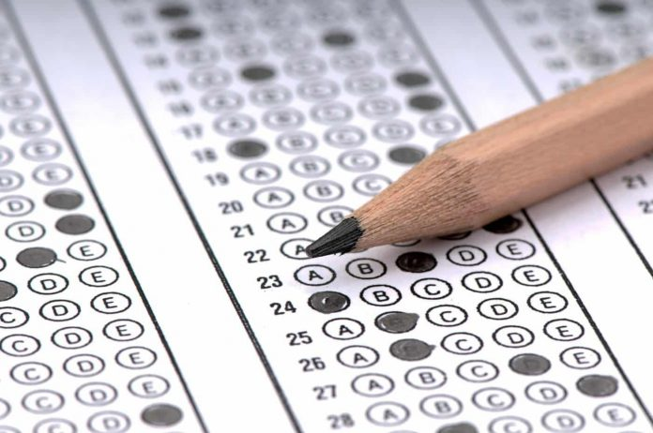
(use this picture when teaching keywords ‘exam’)

Transcript
Morning, everyone. Quiet, please. Right, OK. So, today I’m going to give you some advice to help you prepare for the exams next week. So, make some notes as I’m talking, please. Everybody ready?
Now, while you’re studying, eat food that gives you energy. Don’t be tempted to eat sweets or drink cola. Sugar won’t help you study but fruit and cereals will. Apples, actually, are especially good.
Find a comfortable place with plenty of light when you study. But not ‘too’ comfortable or you’ll fall asleep!
Try and keep a positive mind. It is easier to study when you are positive and relaxed. Now, if you start feeling anxious, have a little break. Go out for a stroll around the block.
Don’t try to learn everything. There isn’t time. Just choose the ‘important’ things, the things that’ll get you the most points in an exam. And if you aren’t sure about this, ask me.
First, learn the main ideas and don’t worry too much about the details. If you have time, you can come back later and read the details.
Make notes of these key points and read them, then cover them up and try to remember all the points. Now, it might be boring, but repetition helps you to remember.
Use past exam papers to study. They will help you understand what kind of questions come up. There are plenty of past exam papers in the library. You can photocopy them and take them home.
Take regular breaks while you’re studying. A five-minute break every half hour is usually enough. Get some fresh air and stretch your arms and legs. Drink a glass of water too. It’s important to keep hydrated.
And, last but not least, good luck! I’m sure you’ll all do your best.

Worksheet
<advice for exam>
Exercise 1)
a: what food can help get energy while studying?
B: what teacher said to have a little break while the are studying?
C: where students can get the past exam papers?

Exercise 2)
a: after students listened to their teacher’s advice, what do you think students will eat while studying?

b: at last, why teacher said “I’m sure you’ll all do your best” to student?

Exercise 3)
-What do you do when your nervous?
-when you have hard time to go to sleep, what did you do to go to sleep?
-when you worry about something< do you usually think positive or negative?

Answer sheet
<advice for exam>
Exercise 1)
a: what food can help get energy while studying?
Fruits (apples) and Cereals.
B: why teacher said to have a little break while they are studying?
Because it can help relax if students start feeling anxious.
C: where students can get the past exam papers?
At the library
Exercise 2)
a: after students listened to their teacher’s advice, what do you think students will eat while studying?
Fruits such as apples and cereals.
b: at last, why teacher said “I’m sure you’ll all do your best” to student?
To encourage the students.

