Background Information Sheet
Name | Class | Date | Lesson Type | Plan type | Length
MIJUNG SUNG(Mimi) | 201WD | 04/12/2019 | Grammar | PPP | 35 min

Lesson
Topic | Present Progressive: ‘now’ and ‘about now’
Main Aim | Students will learn the present progressive and its two different meanings.
Secondary Aim | Students will practice their speaking fluency.

Materials and References
2 photos, magnets or tape to stick the photos on the board, board and board pens (different colours), worksheets.

Student Profile
Level |  | Lower Intermediate
Age |  | Adults |  | Number of Students | 7
Detail |  | This is a general English class with 7 native Koreans. They are all adults and have had formal grammar lessons when they were young. They are not familiar with TESOL grammar teaching style. They are not very accustomed to pair work and need to be relaxed before they will open up to communicate freely. The students tend to favor the visual learner mode and the auditory and kinesthetic learning needs developing.
Assumptions about students’ knowledge as required for this lesson:
- Students know the vocabulary used in this lesson.
- Students have had formal grammar lessons and are familiar with grammatical terms.
- Students have learned about the present simple tense.
- Students know how to make the negative form using ‘not’
What language difficulties to expect when presenting, and how to deal with it:
- Meaning: “He is playing the piano these days.” Many students may know the meaning of “now” in present progressive, but not about “about now”. Make a clear visual context and ask appropriate C.C.Qs.
- Form: Students may confuse using “be-verb + (verb)-ing” and also its negative form. Board both sentences and tell them the structure to make sure that they know that it’s always “be-verb + (verb)-ing” and that in negative form “not” always goes with be-verb, not the verb after it (e.g. isn’t, aren’t).
- Pronunciation: Students may not know where to put natural sentence stress. Drill several times chorally, then individually. Ask, “Which words sound stressed?” Board the stress markers in red.
Anticipated Classroom Management Difficulties and their Solutions:
The quantity of new language points to be learned about the present progressive is too much for students to handle in a short 30 minute lesson. This could lead to anxiety, rushing, and a lot of teacher talk. For this lesson I will manage this by selectively presenting only the main two different meaning in present progressive. The remaining new language points can be presented in the next lesson. (e.g. exceptions: verb that never uses ‘–ing’)
My Personal Aim
What I hope most to demonstrate in this lesson is the ability to
- present the target language using a situational presentation
- to be an involver type teacher
Stage Name: Lead-in
Purpose of this stage: To relax both the teacher and students. To focus attention on the lesson. Create a situation for students to experience or think about, and then to elicit the target language.
Materials: 2 photos & board & board pen
Timings | Interactions |  | Procedure
1min 30sec | T-S |  | Greeting. Show a picture to create a clear and understandable situation related to my target language. Try elicit the model sentence (a sentence that contains the target language) by referring to the situation.  “Hello guys. (Play the music with the smartphone & act)  Oh guys, can you all hear this?” (Yes)  Hold up ‘Picture 1’.  “What is he doing now?” (He is playing the piano now.)  “Yes. He is playing the piano now.”  Stick ‘picture 1’ on the board and board the model sentence:  ‘-Picture 1: He is playing the piano now.‘  Turn off the music & hold up ‘Picture 2’  “Can you all see this picture?” (Yes)  “This is my son and I have arranged piano lessons for him, so he is doing this regularly these days. Can you tell me what he is doing in this picture?”  (He is playing the piano these days.)  “Yes. He is playing the piano these days.”  Stick ‘picture 2’ on the board and board the model sentence:  ‘- Picture 2: He is playing the piano these days.’
Stage Name: Presentation
Purpose of this stage: Make the students think about the situation. To clarify the meaning, form, and pronunciation features of the target language.
Materials: 2 pictures, board, board pens (different colours)
Timings | Interactions |  | Procedure
30sec  1min  3min  2min | T-S  T-S  T-S  T-S |  | Draw timeline to help students with their understanding.  He is playing  Past Now Future  Ask CCQs  Turn on the music on smartphone & point at the ‘Picture 1’.  “Is he playing the piano right now?” (Yes) (Mark ‘O’ on the timeline at now)  “Did he start to play the piano before now?” (Yes) (Mark ‘O’ on the timeline before now)  “Has he finished playing the piano?” (No) (leave a dotted arrow to show it’s continuous)  Turn off the music & point to ‘Picture 2’:  “Is he playing the piano right now?” (No)  “Did he start before now?” (Yes) (Mark ‘X’ on the timeline before now)  “Will he do it again?” (Yes.) (Mark ‘X’ on the timeline after now)  “Is this a habit?” (Yes.) (Draw a wavy line)  “As we’ve seen in the pictures we use the present progressive for something that is happening right now and also about a temporary habit.”  Form.  Pointing at the picture 1’s model sentence:  “Could you tell me where the subject is?” (He)  “Yes. (Underline with a blue pen) And the verb?” (is playing)  “Good! (Underline with a red pen) is it always ‘is’?” (No. It depends on the subject)  “That’s right. If the subject is ‘I’ what would it be?” (am)  “And for ‘they’?” (are)  “Excellent! So it is basically ‘be-Verb’ (write on the board) plus (point to ‘playing’ and wait for students to answer; use facial expression to make students answer)?” (play + ing)  “Great! It is ‘play(verb)+ing’(write it on the board). Can we use only the (verb+ing)?” (No.)  “No. ‘be-Verb’ is also necessary. How about only the ‘be-Verb’ and ‘Verb’ without ‘-ing’?”  (No.)  “No. We need ‘-ing’ at the end of the verb. Good! What’s this? (underline ‘the piano’ with green pen)” (Object)  “Yes. It’s an object. Is this always necessary?” (No)  “Yes. It is not always necessary. And what’s this?(point to ‘now’)” (Time reference)  “Great! Is this also necessary?” (No.)  “Correct. It’s not necessary. (Point at model sentence of picture 2) Like here, different types of time references can be used to make the meaning clearer, but it’s not necessary.”  Write “+” in front of the model sentence and then write “-” beneath “+”.  “What is the negative form for this?”  (He is not playing the piano now.)  “Good! (board the sentence) Is there a shorter way of saying “he is not playing”?”  (He isn’t playing)  “Excellent! And the question form? (write “?” underneath “-” on the board)”  (Is he playing the piano now?)  “Good! (board the sentence starting with “?”)”  Drill – drill the spoken form, focusing on contractions, stress and intonation.  “Alright. Listen and repeat after me 5 times! (hold up the hand and count to 5)”  After choral drilling, ask a few students for individual drilling.  “Which words sound stressed?” – (+) ‘playing’, ‘piano’  – (-) ‘isn’t’, ‘piano’  – (?) ‘he’, ‘now’  Use a red colour pen to mark the stress.  “Does the intonation go up or down?” – (+) down  – (-) down  – (?) up  Use a blue colour pen to mark the intonation at the end.
Stage Name: Controlled Practice
Purpose of this stage: students practice working with the form (scrambled sentences, split sentences, select the correct form of the verb, correct incorrect sentences, and change one form into another form). Accuracy must be checked.
Materials: Worksheet.
Timings | Interactions |  | Procedure
30sec  2 min  1 min  1 min | T-S  S  S – S  T - S |  | Instructions.  “Right guys. Now you are going to do a worksheet individually.  Read the questions and write your answers on the worksheet.  Don’t turn over and only do Exercise A.”  Ask ICQs.  “Do we write the answers?” (Yes.)  “Do we work with the partner?” (No.)  “Do we only do exercise A?” (Yes.)  Hand out the worksheet.  “Let’s begin!”  Gesture for students to work on their worksheet individually.  Students do a worksheet.  Monitor the students and when they seems to be finished let them check the answers with their partners.  Pair check.  Feedback to check accuracy.  “What did you guys get for number 1?” etc.
Stage Name: Less Controlled Practice
Purpose of this stage: students practice working with the meaning (match a timelines to sentences, choose the sentence that matches a picture, gap-fill a paragraph). Accuracy must be checked.
Materials: List all materials that will be needed in this stage.
Timings | Interactions |  | Procedure
30sec  2min  2min  1min30sec | T-S  S  S – S  T - S |  | Instructions.  “Everybody, turn over your worksheets.  Look at the picture and describe what they are doing in this picture right now.  Also, read the table below and describe what they are doing these days.  Work individually and try to write down as much as possible.”  Ask ICQs.  “Do we write the answers?” (Yes.)  “Do we work with the partner?” (No.)  Hand out the worksheet.  “Let’s begin!”  Gesture for students to work on their worksheet individually.  Students do a worksheet.  Pair check.  Feedback to check accuracy. Board correct answers visually.
Stage Name: Production – Freer Practice
Purpose of this stage: is to get students to practice the grammar communicatively.
Materials: List all materials that will be needed in this stage.
Timings | Interactions |  | Procedure
30 sec  9 min | T  S-S |  | Instructions. (Visual.)  “Now we’re going to do a short role play.  I am going to give everyone a picture with some information.  Let’s all think, you are the person on the picture.  Describe what you are doing right now in the picture to your partner.  And also, using the information next to the picture, explain what you are doing these days.  We are going to change partners after 3 minutes!  Don’t show your information to the partners!”  Ask ICQs.  “Do you only talk to one partner?” (No. Go around the class.)  “Do you only talk about the information next to the photo?” (No, also explain what I’m doing in the picture.)  “How long do you have to talk to one person?” (3 minutes.)  Handout the paper.  “Everyone, stand up! Let’s get moving!”  Students go around the class with their piece of paper. Every 3 mins, announce that it’s time to change partners. As there’s 7 people in class, let one group speak in 3s. The change could be made 2 times (altogether 3 rounds of 3 mins)  While the students are going around the class talking to each other, monitor the students.  Don’t disturb them while speaking. Try to write down some errors they make, so that it can be corrected at the wrap-up stage.  After monitoring the students, while they are still talking to each other, write down the sentences with error on the board.  When total of 9 mins are finished, announce the students that the activity is finished.  “Time’s up! Let’s all go back to our original seats.”
Stage Name: Wrap-up
Purpose of this stage: is to end the lesson on a positive note so that students feel they have achieved progress.
Materials: List all materials that will be needed in this stage.
Timings | Interactions |  | Procedure
 | T – S  T  T |  | Offer delayed corrections to the previous stage.  “Well done guys.  Can you all look at the board?  Here are some sentences I heard during your conversations.  Can you tell me how to correct them?”  (e.g. “I looking after a baby.” -> “I am looking after a baby.”)  Set homework.  “I hope you are all clear with the different meanings in present progressive.  For homework, I want you to write a short paragraph about yourself. What you are doing these days. Write no more than 50 words. It is due tomorrow 9am.”  Inform students about the topic for the next lesson.  “Tomorrow, we are going to learn some exceptions in present progressive.  Good job guys!”  Class dismissed.
Instructor’s Comments and Assessment
Pros
Cons
Change
Overall Comments
Grade
Above Standard 85%-100% | Standard 70%-84% | Below Standard 69%-0%
Instructor | Student Signature | Date
Taute, David

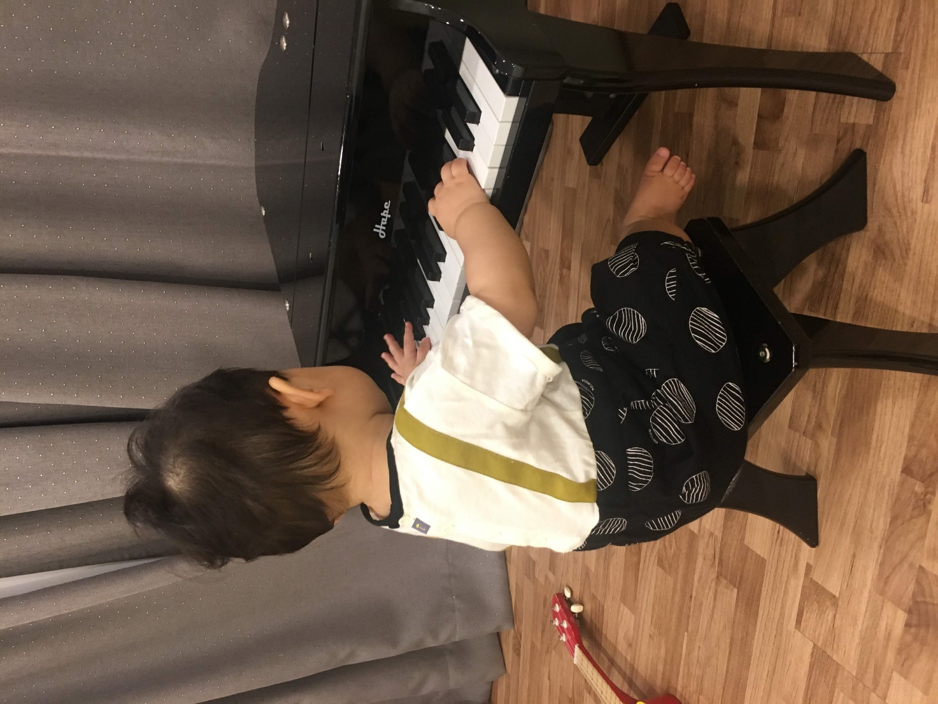

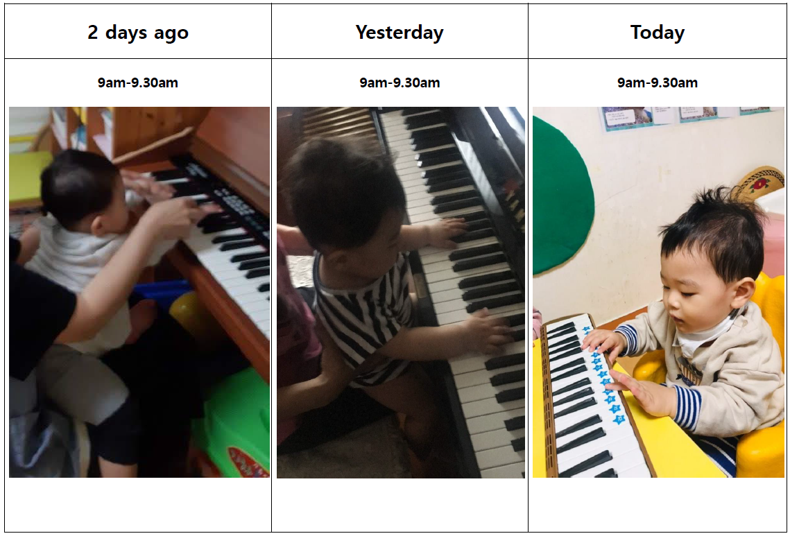

Board plan

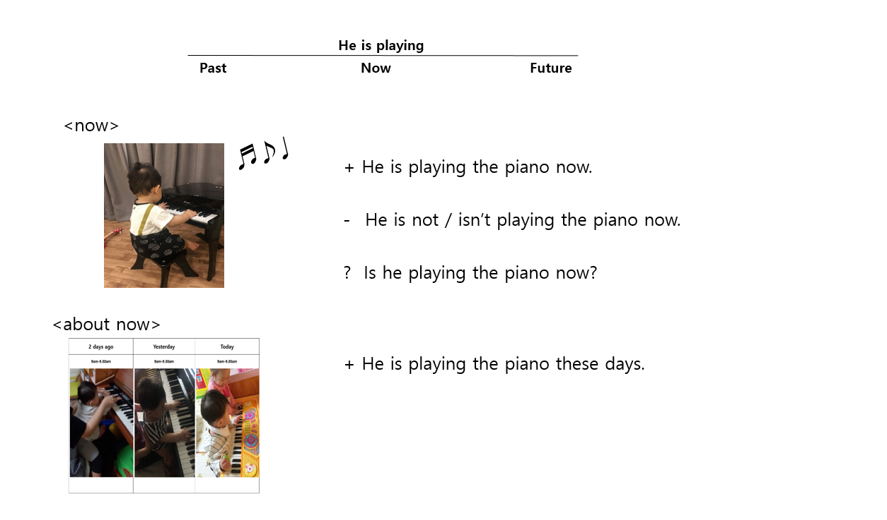

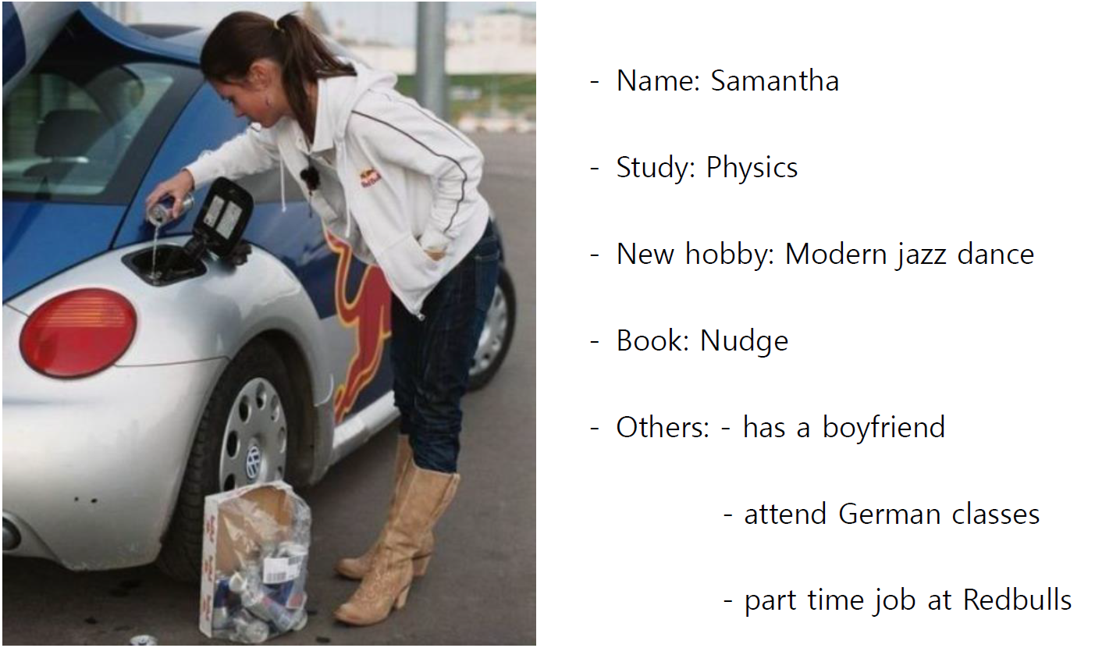
Worksheets for production exercise

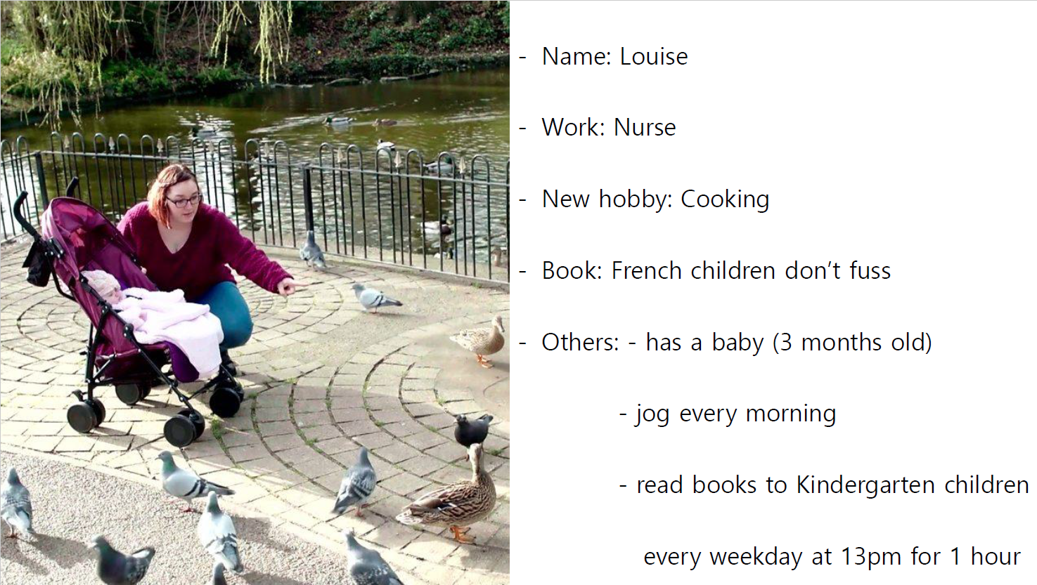

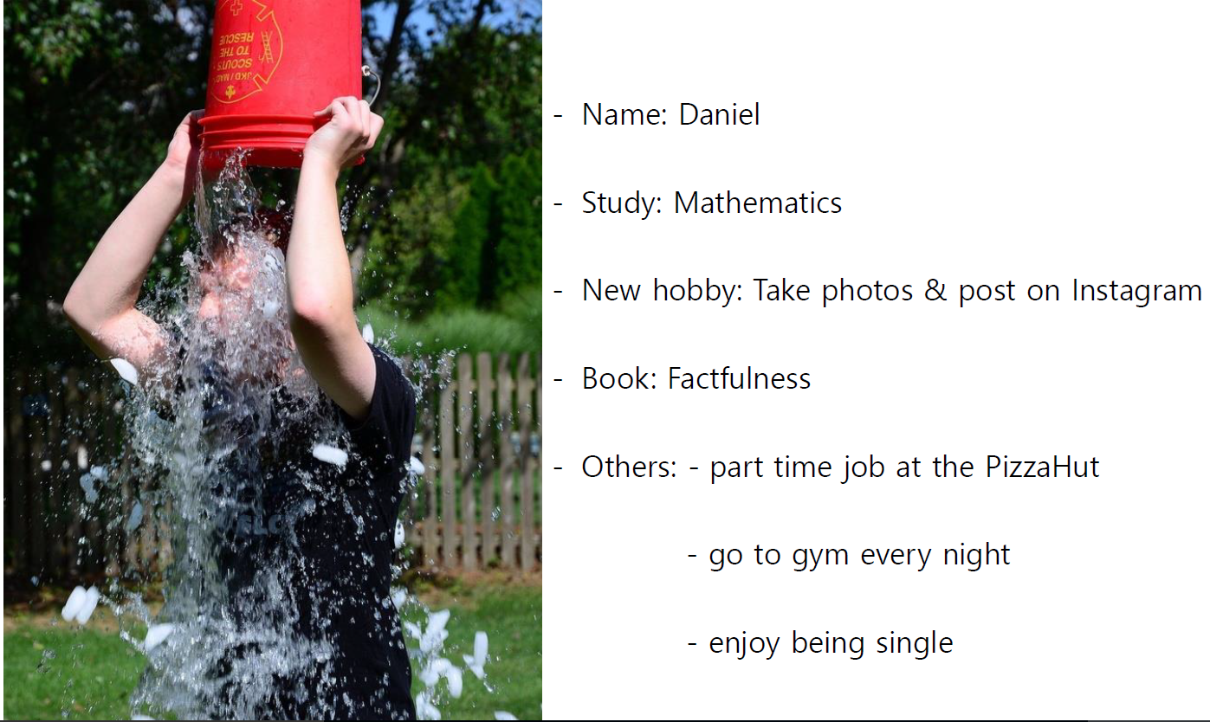

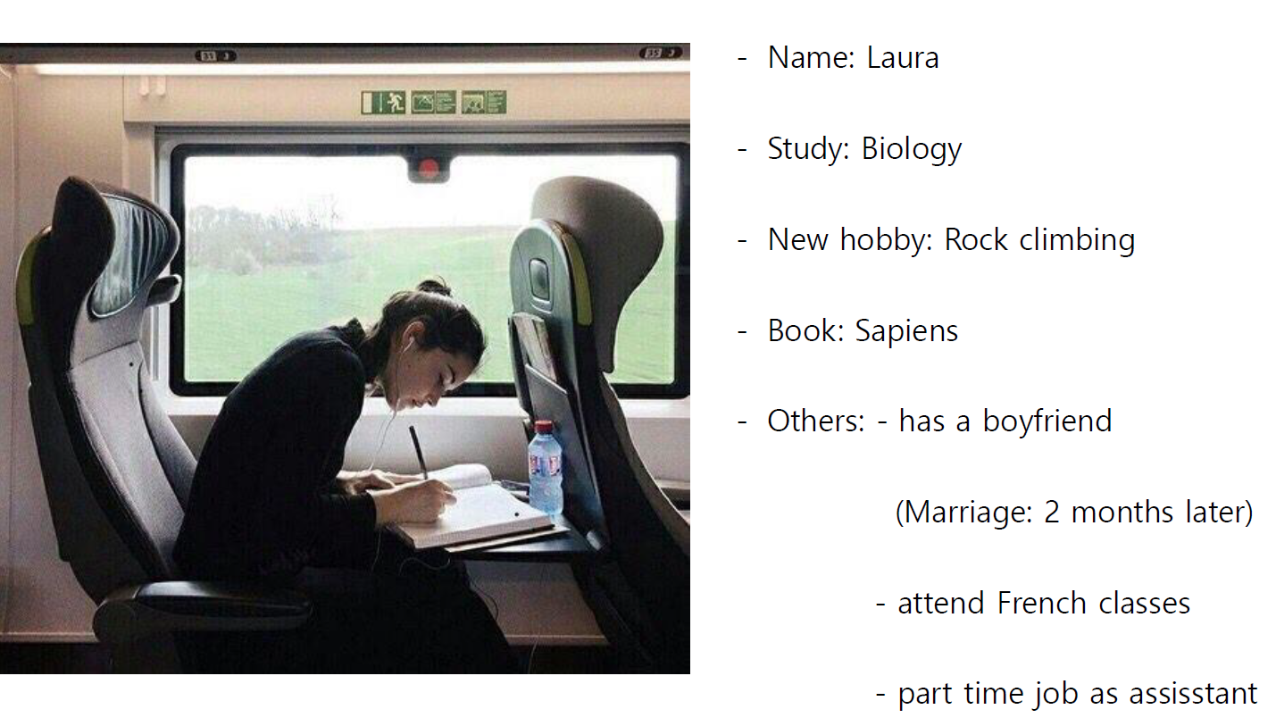

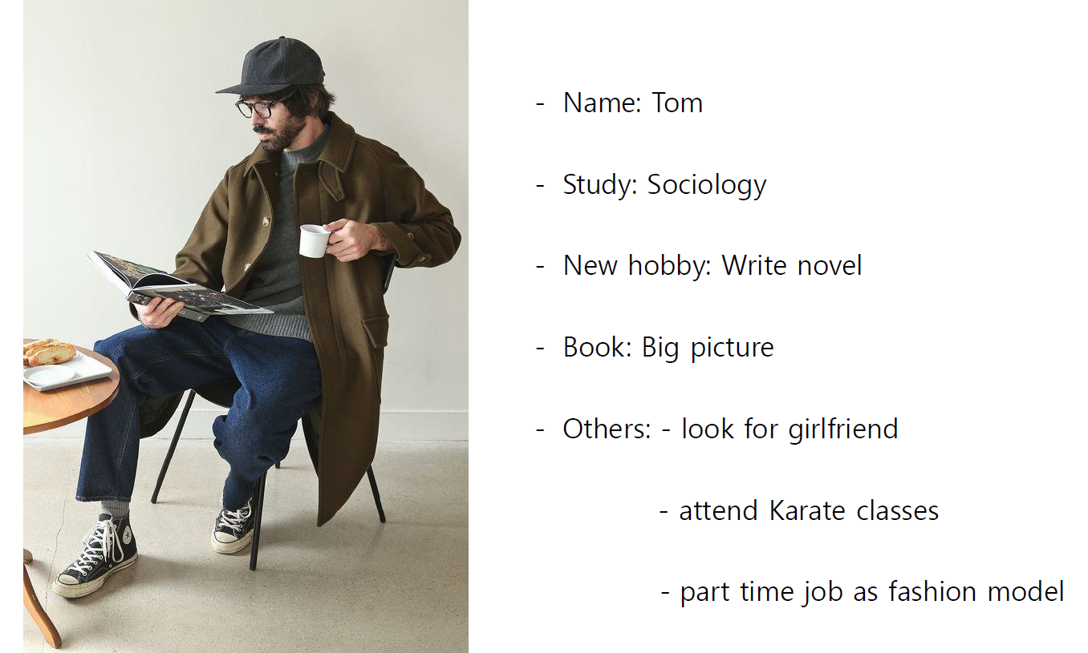

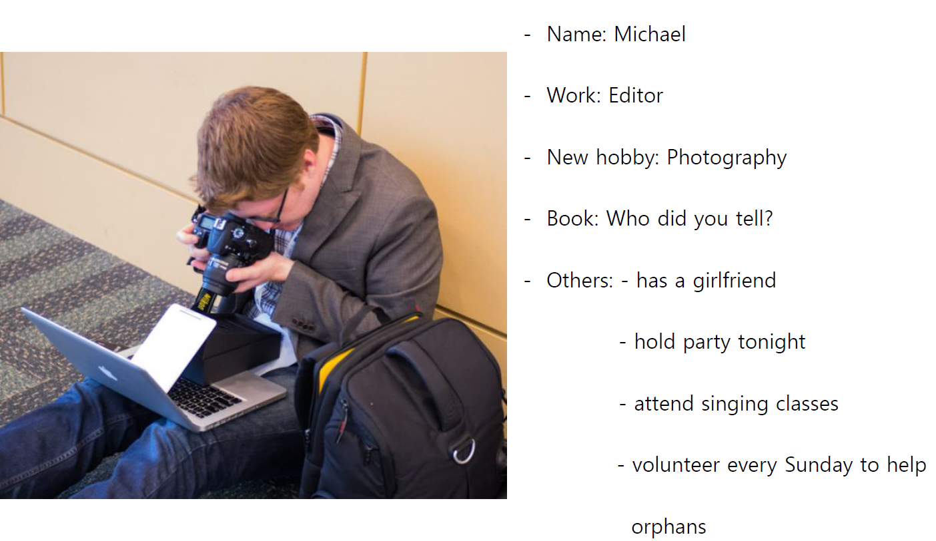

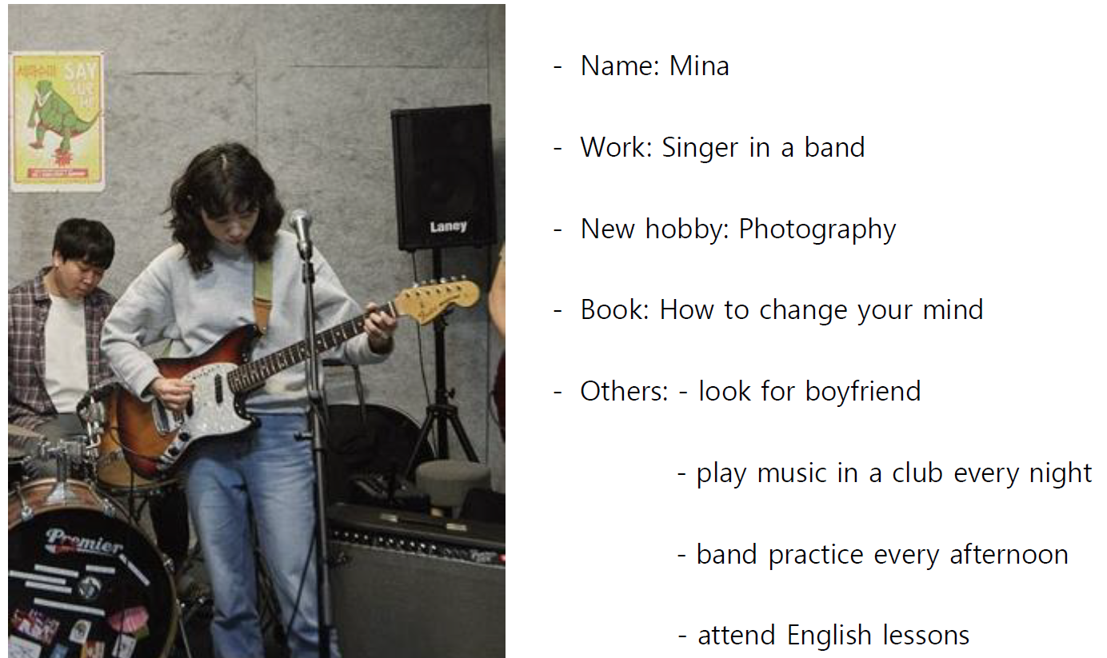

Worksheet: Present progressive

Exercise A
1. Complete the sentences with one of the following verbs in the correct form:
come get try work make
a) ‘You ’re working hard today.’
b) It dark. Shall I turn on the light?
c) ‘Are you ready, Ann?’ ‘Yes, I . ’
d) You a lot of noise. Could you be quieter? I to concentrate.

2. Use the words in brackets to complete the questions.
a) ‘ Is Colin working this week?’ ‘No, he’s on holiday.’ (Colin/work)
b) Why at me like that? What’s the matter? (you/look)
c) ‘Jenny is a student at university.’ ‘Is she? What ?’ (she/study)
d) to the radio or can I turn it off? (anybody/listen)

3. Put verb into correct form using the negative (e.g. I’m not doing… etc.)
a) I’m tired. I ‘m not going (go) to the movies tonight.
b) We can go out now. It (rain) any more.
c) ‘How is your new job?’ ‘Not so good at the moment. I (enjoy) it very much.’
d) Angela wants to lose weight, so this week she (eat) lunch.

Worksheet: Present progressive
Exercise B
Describe what you see in the picture using present progressive. There are also some information in the box for you to use. Write down what they are doing right now and what they are doing these days.
John:  - University student (Major: Psychology)  - Read: Outliers  - language lessons: German | Mia:  - University student (Major: French)  - Sports lessons: Pilates  - New hobby: fishing

(e.g.) They are talking to each other. John is studying Psychology.

Answer sheet: Present progressive

Exercise A
1. Complete the sentences with one of the following verbs in the correct form:
come get try work make
a) ‘You ’re working hard today.’
b) It ‘s getting dark. Shall I turn on the light?
c) ‘Are you ready, Ann?’ ‘Yes, I ‘m coming . ’
d) You ‘re making a lot of noise. Could you be quieter? I ‘m trying to concentrate.

2. Use the words in brackets to complete the questions.
a) ‘ Is Colin working this week?’ ‘No, he’s on holiday.’ (Colin/work)
b) Why are you looking at me like that? What’s the matter? (you/look)
c) ‘Jenny is a student at university.’ ‘Is she? What is she studying ?’ (she/study)
d) Is anybody listening to the radio or can I turn it off? (anybody/listen)

3. Put verb into correct form using the negative (e.g. I’m not doing… etc.)
a) I’m tired. I ‘m not going (go) to the movies tonight.
b) We can go out now. It ‘s not raining (rain) any more.
c) ‘How is your new job?’ ‘Not so good at the moment. I ‘m not enjoying (enjoy) it very much.’
d) Angela wants to lose weight, so this week she isn’t eating (eat) lunch.

Answer sheet: Present progressive
Exercise B
Describe what you see in the picture using present progressive. There are also some information in the box for you to use. Write down what they are doing right now and what they are doing these days.
John:  - University student (Major: Psychology)  - Read: Outliers  - language lessons: German | Mia:  - University student (Major: French)  - Sports lessons: Pilates  - New hobby: fishing

(e.g.) They are talking to each other. John is studying Psychology. Mia is studying French.
John is drinking orange juice. Mia is drinking tea/coffee.
John is holding a pen. John is writing.
Mia is looking at John. John and Mia are talking in the dining room.
John is reading a book nowadays. Mia is doing/learning pilates these days.
John is learning German. Mia is fishing nowadays.

