Background Information Sheet
Name | Class | Date | Lesson Type | Plan type | Length
Yoomin | TESOL 201WD | 12/11/2019 | Reading | PPP | 30 min

Lesson
Topic | Corduroy
Main Aim | Students practice their reading comprehension.
Secondary Aim | Students practice their speaking fluency.

Materials and References
Corduroy book, picture slides, the text, worksheets

Student Profile
Level | Lower Intermediate
Age | 8-10 | Number of Students | 7
Detail | Elementary students who have begun to read short stories and picture books. Reading materials should be appropriate to their level of general knowledge. Visual aids can help their reading comprehension.

Anticipated Difficulties and their Solutions:
TV or computer failure -> prepare A4 size picture slides
Time management ->Short Lead-in. Do not take too much time eliciting keywords.
Shorten or lengthen Produce stage for time management.

My Personal Aim
What I hope most to demonstrate in this lesson is the ability to make the learning as easy and clear to understand as possible.

Stage Name: Lead-in
Purpose of this stage: To relax both the teacher and students. To focus attention on the lesson. To lead in to the topic, activating background knowledge – this will help to contextualize the text.
Materials: The book of <Corduroy>
Timing | Interaction | Procedure
30 sec | T | Hello, everyone. Remember our last lesson about “must be, can’t be, and could be”? (Holding the Corduroy book) Today, we’re going to read a book called Corduroy. Corduroy was a teddy bear. Does everyone have a teddy bear at home? But Corduroy didn’t have a home. He lived here. (show the picture of department store)

Stage Name: Presentation
Purpose of this stage: To pre-teach keywords if necessary, and answer a guiding questions (such as a predicting task, or a specific question). These steps provide extra help for students to comprehend the text.
Materials: Picture slides.
Timing | Interaction | Procedure
3 min  10 sec  1 min  50 sec | T-S  T  S-S  T-S | Pre-teach keywords  - department store  Elicit- (Show the picture) Have you been to this type of a store? Do you know what it’s called? (department store)  CCQ  - Is it a large store? (Yes)  - Do they sell different types of things? (Yes)  - Is the store divided into several different areas? (Yes)  - What are these different areas for different things called? (departments)  Drill - Listen and repeat after me 3 times. (show fingers for 3 times)  Nominate 1 or 2 persons for individual drilling.  Write ‘department store’ on the board.  - How many syllables in department? (3) How many in store? (1)  - Where is the stress? (part)  - What part of speech is it? (noun)  - overalls  Elicit – (show overalls) What is this? Do you know what you call this type of clothes? (Overall)  CCQ  - Are these a pair of trousers? (Yes)  - (pointing) What does this piece of cloth do? (It covers your chest.)  - Is it held in place by shoulder straps? (Yes)  Drill – choral and individual drilling for correct pronunciation  Write ‘overalls’ on the board.  - How many syllables? (3)  - Where is the stress? (O)  - What part of speech? (noun)  - the way you are  Elicit – (Showing the Shrek picture) Who are they? (Shrek and Fiona) Are they monsters? (Yes) Are they ugly? (Yes) But he loves her and doesn’t want to change anything about her. He loves her just (pause) the way she is. And she loves him just (pause) the way he is.  CCQ  - If I love you the way you are, does it mean I love you in the present situation? (Yes)  - If I love you the way you are, do I love everything about you? (Yes)  - If I love you the way you are, is there anything I want to change about you? (No)  Drill – choral and individual drilling for correct pronunciation  Write ‘the way you are’ on the board.  - Where is the stress? (way)  Guiding Question  What’s your favorite toy? How did you get it? How do you treat it? Talk to your partner about your favorite toy for 1 minute.  Students talk with a partner.  Feedback. Nominate 1 or 2 students to share their ideas.

Stage Name: Practice – Literal Comprehension
Purpose of this stage: is to get students to practice reading for literal detail. They will also practice fast reading (skimming and scanning)
Materials: text and worksheet
Timing | Interaction | Procedure
30 sec  4 min  1 min  1 min | T  S  S-S  T-S | Instructions.  (Holding the text and the worksheet) Now we’re going to read Corduroy. Because of the time, I took out some part in the middle. You’ll have 4 minutes to read and answer the questions in exercise A. Do it on your own and don’t do exercise B yet.  ICQ. How many minutes do you have? (4 min)  Do you do exercise B now? (No, just A)  Please begin.  Hand out the text and worksheets.  Students read the whole text for the 1st time, and write answers on the worksheet.  Pair check. Now check your answers with your partner for 1 minute.  Feedback to check accuracy. Okay, what did you write down for question 1? Any other answer?  Do you all agree? Good. Do the same with all the questions.

Stage Name: Practice – Interpretive Comprehension
Purpose of this stage: is to get students to get students to practice interpreting a text correctly This will require more detailed, careful reading, and thinking time to arrive at the correct answer.
Materials: text and worksheet
Timing | Interaction | Procedure
30 sec  3 min  1 min  2 min | T  S  S-S  T-S | Instructions.  Now you’ll answer the questions in exercise B. You need to think harder for those questions. You may want to go back to the story and read it carefully again. You have 3 minutes to do it by yourself.  ICQ. Do you do it with your partner? (No, by myself)  Hand out worksheets.  Students read for the 2nd time. Students write their answers down.  Pair check. Now check your answers with your partner for 1 minute. Monitor.  Feedback to check accuracy. Who would like to answer number 1? Nominate. Do you all agree? Correct the answers if necessary. Do the same with all 3 questions.

Stage Name: Production - Applied Comprehension
Purpose of this stage: is for students to practice their speaking fluency on a topic related to the lesson.
Materials: worksheet
Timing | Interaction | Procedure
10 sec  8 min  50 sec | T  S-S  T-S | Instructions. Now turn the page and look at the exercise C. With your partner, talk about any of the questions there. Ask each other a question and take turns.  Students discuss.  Feedback. Anyone wants to share what they talked about? Nominate 1 or 2 groups.  Very nice, thank you.

Stage Name: Wrap-up
Purpose of this stage: is to end the lesson on a positive note so that students feel they have achieved progress.
Materials: Corduroy book
Timing | Interaction | Procedure
2 min | T | Lesson feedback. Did you enjoy the story of Corduroy? What a happy ending, right? Good job, everyone. I’m happy with what you’ve done today. For homework, check out the Corduroy book from the library and read the whole book at home.  Inform students about the topic for the next lesson. Next lesson, we’ll learn about “I’ve always wanted”. Good work, everyone. Bye!

Instructor’s Comments and Assessment
Pros
Cons
Change
Overall Comments
Grade
Above Standard 85%-100% | Standard 70%-84% | Below Standard 69%-0%
Instructor | Student Signature | Date
Taute, David

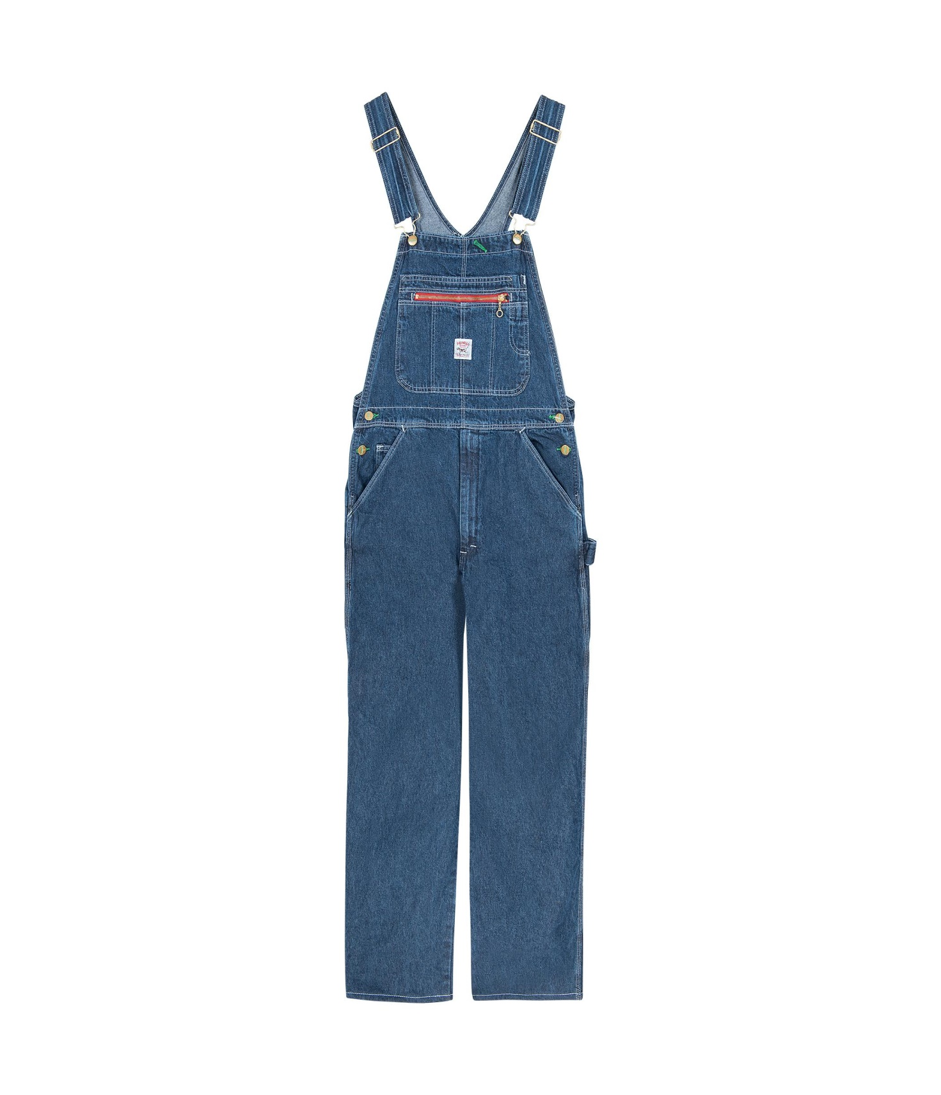
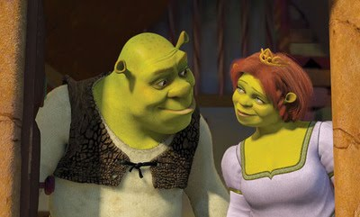

Corduroy
By Don Freeman
Corduroy is a bear who once lived in the toy department of a big store. Day after day he waited with all the other animals and dolls for somebody to come along and take him home.
The store was always filled with shoppers buying all sorts of things, but no one seemed to want a small bear in green overalls.
Then one morning a little girl stopped and looked straight into Corduroy’s bright eyes.
“Oh, Mommy!” she said. “Look! There’s the very bear I’ve always wanted.”
“Not today, dear.” Her mother sighed. “I’ve spent too much already. Besides, he doesn’t look new. He’s lost the button to one of his shoulder straps.”
Corduroy watched them sadly as they walked away.
“I didn’t know I’d lost a button,” he said to himself.
“Tonight I’ll go and see if I can find it.”
Late that evening, when all the shoppers had gone and the doors were shut and locked, Corduroy climbed carefully down from his shelf and began searching everywhere on the floor for his lost button.
Suddenly he felt the floor moving under from him! Quite by accident he had stepped onto an escalator—and up he went!
“Could this be a mountain?” he wondered.
“I think I’ve always wanted to climb a mountain.”
He stepped off the escalator as it reached the next floor, and there, before his eyes, was a most amazing sight—tables and chairs and lamps and sofas, and rows and rows and rows of beds.
“This must be a palace!” Corduroy gasped. “I guess I’ve always wanted to live in a palace.”
…..
Corduroy was just waking up when the first customers came into the store in the morning. And there, looking at him with a wide, warm smile, was the same little girl he’d seen only the day before.
“I’m Lisa,” she said, “and you’re going to be my very own bear. Last night I counted what I’ve saved in my piggy bank and my mother said I could bring you home.”
“Shall I put him in a box for you?” the saleslady asked.
“Oh, no thank you,” Lisa answered. And she carried Corduroy home in her arms.
She ran all the way up four flights of stairs, into her family’s apartment, and straight to her own room.
Corduroy blinked. There was a chair and a chest of drawers, and alongside a girl-size bed stood a little bed just the right size for him.
The room was small, nothing like that enormous palace in the department store.
“This must be home,” he said. “I know I’ve always wanted a home!”
Lisa sat down with Corduroy on her lap and began to sew a button on his overalls.
“I like you the way you are,” she said, “but you’ll be more comfortable with your shoulder strap fastened.”
“You must be a friend,” said Corduroy. “I’ve always wanted a friend.”
“Me, too!” said Lisa, and gave him a big hug.

Worksheet

Exercise A. Please write down your answers.
- What was missing from Corduroy’s overalls? (A button to his shoulder strap)
- What did Corduroy think the escalator was? (A mountain)
- What was the girl’s name who bought Corduroy from the store? (Lisa)
- Did the girl want Corduroy in a box? (No, she wanted to carry him in her arms.)
- Why did she sew the button on Corduroy’s overalls? (To make it more comfortable for him)

Exercise B. Please write down your answers. You may need more than 1 sentence.
- Do you think Corduroy ever lived outside the department store before going home with Lisa? Why do you think so?
(He didn’t know exactly what a mountain or a palace or a home was. He knew about them vaguely but it seems like he’s never actually been to any of those places.)

- Why do you think Corduroy thought furniture department must be a palace?
(He might have heard about what a palace was and heard there was lots of furniture in a palace. So when he saw the furniture department for the first time, he mistook it as a palace.)

- Corduroy guessed wrong when he said “could this be a mountain?” or “this must be a palace!” When he said “you must be a friend”, do you think it was a wrong guess again? If not, why?
(He was right this time because Lisa treated him as a friend would treat another friend. Also, when he said “I’ve always wanted a friend”, Lisa said “me,too!” That means Lisa thinks Corduroy as a friend, too!)

Exercise C.

- Did you ever save up money to buy something you wanted? Talk about your experiences.

- Do you like going shopping to a department store? Why or why not?

- Have you ever been to a mountain or a palace? What was it like?

