Language or Activity Based Storytelling Puppet Play Presentation
Topic: Let’s Create Your Own Holiday!
Instructor:  Iris | Students Competency Level and Student ages  7-8 years old, Elementary | Number of Students:  10 | Lesson Length:  50 min
Materials: (List the Names of all materials used in the lesson. Materials must be shown at the end of this document)
∙Holidays and Celebration Pictures
- Santa Run
- Melon Day
- Mud Festival
- Day of the Dead
- Sunburnt Christmas
- Underwater Music Festival
- Giant Lantern Festival
- Holi
- Gilroy Garlic Festival
- Carnival of Venice
∙ T Own Holiday Worksheet
∙ Create Your Own Holiday Worksheet
∙ Colored Pencils
∙ Pencils
∙ Whiteboard and Markers

Lesson Objectives (What do you want the students to know (new skill or knowledge that you want them to gain)?And what do you want them to be able to do?
Ss will understand various kinds of holidays by listening to T’s explanation and pictures. Ss will improve their creativity to create their own celebration and practice describing it with their own words.
Aims: (What students will be able to achieve by participating in the activities of the lesson. (Ss gain or get by doing…)
Ss will get interested and have fun in lesson by T presentation.
Ss will improve listening, writing and speaking skills by making up a holiday worksheet and responding to T and sharing their ideas in class.
Ss will learn various types of countries and activities by listening to T describing each holiday in different countries.
Ss will improve their creativity by coming up with the ideas for their own holiday.
Ss will practice making descriptive sentences by writing them on the worksheet.

Language Skills: (Lists what activities language skills students will be using by participating in the activities of the lesson.)
- Reading: (Where did reading occur in the lesson?)
Reading T Own Holiday Worksheet
- Listening: (Where did listening occur in the lesson?)
Listening to T and the presentation of other Ss
- Speaking: (Where did speaking occur in the lesson?)
Sharing their own ideas and discussing effectiveness of their holidays
- Writing: (Where did writing occur in the lesson?)
Writing descriptive sentences to describe their own holidays on the worksheet
Assumptions: (What students must already be able to do and what concepts must already be mastered before the lesson in order to achieve the aims of the lesson.)
Ss will enjoy and also have fun.
Ss will easily learn the diversity of different countries and unique celebrations.
Ss can make descriptive sentences of their own holidays with T assistance as needed.

Anticipated Errors and Solutions: (What things might go wrong in the lesson and what the solution will be. An SOS activity should also be included)
Activity takes too long; Describing worldwide celebration activity may be shortened.
Ss have difficulty writing descriptive sentences; T can give some suggestions.
Ss might be shy when giving a presentation; T gives encouragement.
References: Google

Lead-In or Pre-Task Part (Warm-Up Part to activate and create interest in the lesson.)
Materials: (List the Names of all materials used in the Lead-In or Pre-Task Part of the lesson. Materials must be shown at the end of this document)
∙Holidays and Celebration Pictures
- Santa Run
- Melon Day
- Mud Festival
- Day of the Dead
- Sunburnt Christmas
- Underwater Music Festival
- Giant Lantern Festival
- Holi
- Gilroy Garlic Festival
- Carnival of Venice
∙Whiteboard and Markers
∙Create Your Own Holiday Worksheet

Time: | Classroom Set Up: | Student Activity and Goals: | Teacher Procedure &Instructions:
1 min  2 min  2 min  8 min | Whole Class  W  W  W | Greet teacher  Ss share ideas.  Ss listen to T and repeat T and get interested.  Ss listen to T and respond. | Greet students  T talks about Halloween and Christmas this year with students.  T shows holidays and celebration pictures and names them.  T describes each holiday and celebration looking at the pictures and asks some questions related to the information.

Pre-Activity or Task Familiarization Part (Presentation Part for Presenting the language structure to be covered in the lesson. Prepares students for the communication activity.)
Materials: (List the Names of all materials used in the Pre-Activity or Task Familiarization Part of the lesson. Materials must be shown at the end of this document)
T Own Holiday Worksheet

Time: | Classroom Set Up: | Student Activity and Goals: | Teacher Procedure &Instructions:
5 min  1 min | Whole class  Whole class | Ss listen to her demonstration and think of their own work.  Students listen and think about their holidays | T shows her own holiday worksheet and demonstrates hers.  Example: This is my holiday ‘Stop at Every Ice Cream Store in Town Day’. It is held on August 1 because it is the hottest day of the year. We wear the costume of the same color with the ice cream flavor we like the most. On this day, we stop by every ice cream store and see what kinds of ice cream are there. After the research, we choose one flavor and treat ourselves!  Let's look out our own favorite holidays.

Main Activity or Task Realization Part(Practice to Production Part Teacher lead practice of the language presented and move to communication based more student centered activity)
Materials: (List the Names of all materials used in the Main Activity or Task Realization Part of the lesson. Materials must be shown at the end of this document)
Create Your Own Holiday Worksheet
Colored Pencils
Pencils

Time: | Classroom Set Up: | Student Activity and Goals: | Teacher Procedure &Instructions:
2 min  15 min | Whole class  Individual | Ss are given the worksheet and come up with the ideas.  Ss write their ideas in descriptive sentences on their worksheet. They also draw pictures as well. | T introduces and hands out Create Your Own Holiday Worksheet to each S. T explains how to complete their own worksheet by showing T worksheet. T makes sure Ss understand the activity.  T walks around and asks each S about their idea. T responds to what they are saying and gives feedback and advice to each S.

Post Activity or Post Task Part (Wrap-Up Part to Close the Lesson on a high note to and consolidate language learned in a communication based activity new situation.)
Materials: (List the Names of all materials used in the Post Activity or Post Task Part of the lesson. Materials must be shown at the end of this document)
Create Your Own Holiday Worksheet

Time: | Classroom Set Up: | Student Activity and Goals: | Teacher Procedure &Instructions:
8 min  5 min  1 min | Individual  Whole class  W | Ss give presentations.  Ss express their opinions freely.  Ss say good bye. | T checks if Ss are done with their worksheets and makes them present their own one by one. T listens and responds to individual presentations.  T asks how Ss think of each other’s presentation and discuss if the holidays are viable.  T congratulates and thanks Ss for active participation.

∙Holidays and Celebration Pictures
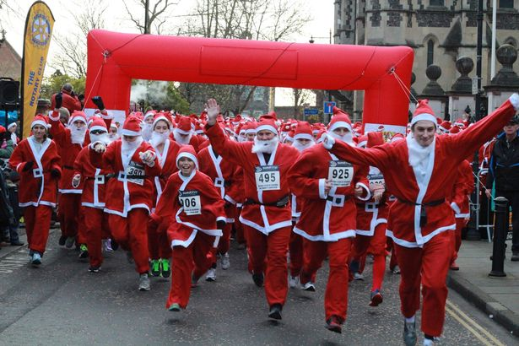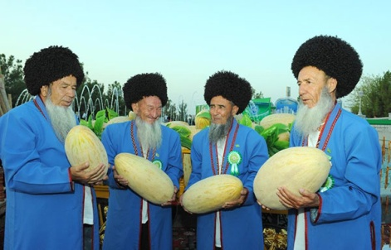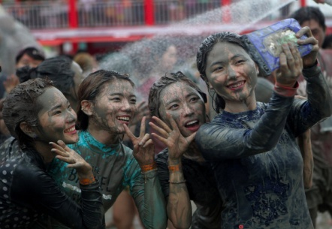
Santa Run Melon Day Mud Festival

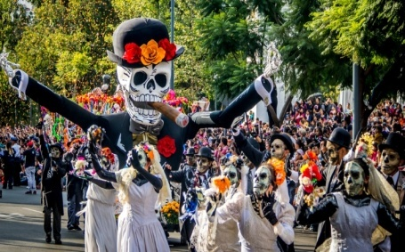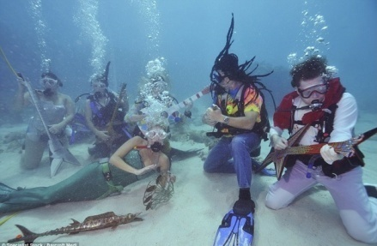
Day of the Dead Sunburnt Christmas Underwater Music Festival

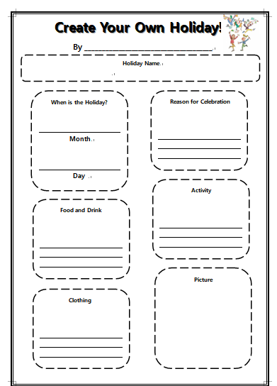
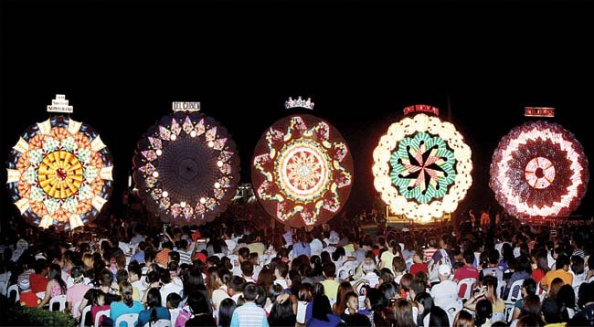
Giant Lantern Festival Holi

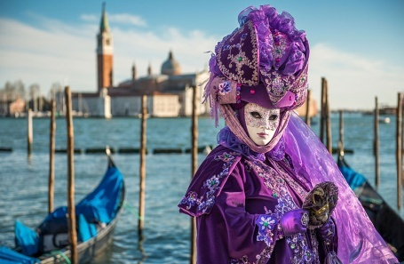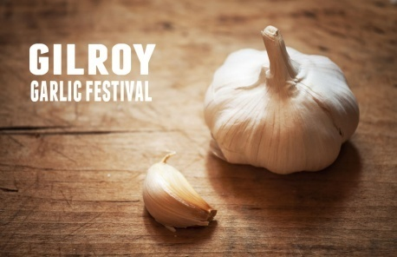
Carnival of Venice Gilroy Garlic Festival

