Language or Activity Based Storytelling Puppet Play Presentation
Topic, Story Title, or Puppet Play Name:How To Make The Snack
Instructor:  Matt | Students Competency Level and Student ages  Elementary, 7-9 | Number of Students:  6 students | Lesson Length:  65 minutes
Materials:(List the Names of all materials used in the lesson. Materials must be shown at the end of this document)
- “Cooking in the Kitchen” Video Clip
- Computer
- TV Screen
- White Board and Markers
- “Cooking Fusion Dish” Audio Files
  - Cook Fusion Dish 1
  - Cook Fusion Dish 2
  - Cook Fusion Dish 3
  - Cook Fusion Dish 4
- 8 Cooking Picture Papers
- A Snack Foods: SonPyeon
- Ingredients List with Pictures
- “How to Make the Snack?” Worksheet
- “How to Bake Cupcakes” Video Clip
- Recipe Table Worksheet
Lesson Objectives(What do you want the students to know (new skill or knowledge that you want them to gain)?and What do you want them to be able to do?
Students will be familiar with the cooking words and expressions and enjoy trying to make their own recipe for the snack food they like.
Aims:(What students will be able to achieve by participating in the activities of the lesson. (Ss gain or get by doing…)
- Improve listening skills by watching movie clips and listening to audio files in all activities
- Improve reading and writing skills by writing recipes in all activities
- Improve speaking skills by presentation in “Cooking Fusion Disk” and “How to Make the Snack” activities
- Understand and enjoy to use the words and expressions for cooking
Language Skills:(Lists what activities language skills students will be using by participating in the activities of the lesson.)
- Reading: (Where did reading occur in the lesson?)
Ss improve reading skills while they are doing “How to Make the Snack?” main activity to read the ingredients list and the sample recipe T shows
- Listening:(Where did listening occur in the lesson?)
Ss improve listening skills while they are doing all activities: “Cooking in the Kitchen”, “Cooking Fusion Dish”, “How To Make The Snack?”, “How to Bake Cupcakes”
- Speaking: (Where did speaking occur in the lesson?)
Ss improve speaking skills while they are doing all activities: “Cooking in the Kitchen”, “Cooking Fusion Dish”, “How To Make The Snack?”, “How to Bake Cupcakes”
- Writing: (Where did writing occur in the lesson?)
Ss improve writing skills while they are doing “Cooking Fusion Dish”, “How To Make The Snack?” and “How to Bake Cupcakes”

Assumptions:(What students must already be able to do and what concepts must already be mastered before the lesson in order to achieve the aims of the lesson.)
- All Ss have basic knowledge about cooking
- All Ss can use basic verbs to express how to cook
- All Ss can understand what the ingredients for foods are
- All Ss have no difficulties to write words they know
Anticipated Errors and Solutions:(What things might go wrong in the lesson and what the solution will be. An SOS activity should also be included)
- Some Ss may feel difficult to understand words being used in the cookingBefore and during activities T give Ss to enough time to understand the words
- Some Ss may not understand clearly how to write the recipe T shows samples and encourage Ss to make recipe with easy words they know.
- If activities lasts too long T cuts the unnecessary parts
- If activities finished too soon T shows additional video clips and talk about it in the whole class (How To Master 5 Basic Cooking Skills - Gordon Ramsay)
References:
https://www.youtube.com/watch?v=qpYD_nCo-AU
https://www.youtube.com/watch?v=xze8atBaVEY
- Pearson English Firsthand Online Free Resources

Lead-Inor Pre-Task Part (Warm-Up Part to activate and create interest in the lesson.)
Materials: (List the Names of all materials used in the Lead-Inor Pre-Task Partof the lesson. Materials must be shown at the end of this document)
- “Cooking in the Kitchen” Video Clip
- Computer
- TV Screen
- White Board and Markers
Time: | Classroom Set Up: | Student Activity and Goals: | Teacher Procedure &Instructions:
1 min  5 min  3 min  5 min  3 min  (17m) | Whole  Whole  Whole  Whole  Whole | Greeting from teacher  Ss try food and became relax.  Ss listen to the T’s talk.  Ss tell about their experiences.  Ss watch the video and get interested in cooking. | Greeting  T provide Ss with several Korean Traditional Snack Foods and let them try the foods.  T tells Ss about cooking experiences. (For me, DweanJangChiGae and Spaghettis, Sandwiches at breakfast)  T asks Ss if they have tried cooking before and if it is fun.  T plays “Cooking in the Kitchen” YouTube Video. Watching the video, T writes words or expressions used in the song on the board.

Pre-Activity or Task Familiarization Part (Presentation Partfor Presenting the language structure to be covered in the lesson. Prepares students for the communication activity.)
Materials: (List the Names of all materials used in the Pre-Activity or Task Familiarization Part of the lesson. Materials must be shown at the end of this document)
- “Cooking Fusion Dish” Audio Files
  - Cook Fusion Dish 1
  - Cook Fusion Dish 2
  - Cook Fusion Dish 3
  - Cook Fusion Dish 4
- 8 Cooking Picture Papers
Time: | Classroom Set Up: | Student Activity and Goals: | Teacher Procedure &Instructions:
1 min  1 min  1 min  2 min  3 min  2 min  2 min  3 min  (15m) | Pairs  Pairs  Pairs  Pairs  Pairs  Pairs  Pairs  Pairs | Ss get pictures and looking at them.  Ss listens.  Ss see T’s selection  Ss choose the proper pictures while listening to the audio.  Ss talk with T and adjust the selection.  Ss listen to the T’s introduction.  Ss see the descriptions T makes.  Ss give presentations. | T setup the class into pairs and introduces and hand out 8 Cooking Picture Papers to each pair.  T plays the “Cooking Fusion Dish”Audio Files which is made of 4 part.  After 1st part stopped, T selects the proper picture for the 1st part.  T goes on playing the audio and let the Ss select proper pictures from 2nd to 4th parts.  T check the Ss’ results and help them to make correct pictures.  T plays the audio sounds again and let the Ss write the descriptions for each pictures while they are listening at the second time.  As same as the 1st listening, T shows demonstration after the 1st part stopped.  After listening 2nd to 4th audio parts, T asks each pair to present their work and appreciate their outputs.

Main Activity or Task Realization Part(Practice to Production PartTeacher lead practice of the language presented and move to communication based more student centered activity)
Materials: (List the Names of all materials used in the Main Activity or Task Realization Partof the lesson. Materials must be shown at the end of this document)
- A Snack Foods: SonPyeon
- Ingredients List with Pictures
- “How to Make the Snack?” Worksheet
Time: | Classroom Set Up: | Student Activity and Goals: | Teacher Procedure &Instructions:
1 min  2 min  3 min  10 min  5 min  (21m) | Groups  Groups  Groups  Groups | Ss gather into groups  Ss get ingredients and listen to the T’s activity introduction  Ss watches what T does and listen to his explanation.  .Ss prepare the recipes and gives presentations.  Ss communicate with T | T asks Ss to select best one from the snack food they ate. According to their choice, T group the Ss.  T hand out Ingredients List with Pictures and “How to Make the Snack?” Worksheet for each group and introduce the activity to make Ss’ own recipe using the ingredients provided.  T write a recipe on the board for the food T selected, which is not included in the Ss choices.  T directs Ss to present their recipes.  T responds to the presentation and appreciates to Ss.

Post Activity or Post Task Part (Wrap-Up Part to Close the Lesson on a high note to and consolidate language learned in a communication based activity new situation.)
Materials: (List the Names of all materials used in the Post Activity or Post Task Part of the lesson. Materials must be shown at the end of this document)
- “How to Bake Cupcakes” Video Clip
- Recipe Table Worksheet
Time: | Classroom Set Up: | Student Activity and Goals: | Teacher Procedure &Instructions:
6 min  5 min  1 min  (12m) | Whole  S  Whole | Ss watch another video and fill in the recipe table.  S gives a presentation.  Listens to T’s wrap-up.  Clap hands together. | T introduce another video clip “How to Bake Cupcakes” and ask students to fill in the recipe table, which is handed out by T.  T asks to a S to present the recipe she made.  T appreciates her job.  T tells Ss how they enjoyed learning cooking and making recipe.  Congratulate and T appreciates Ss participation.

- 8 Cooking Picture Papers

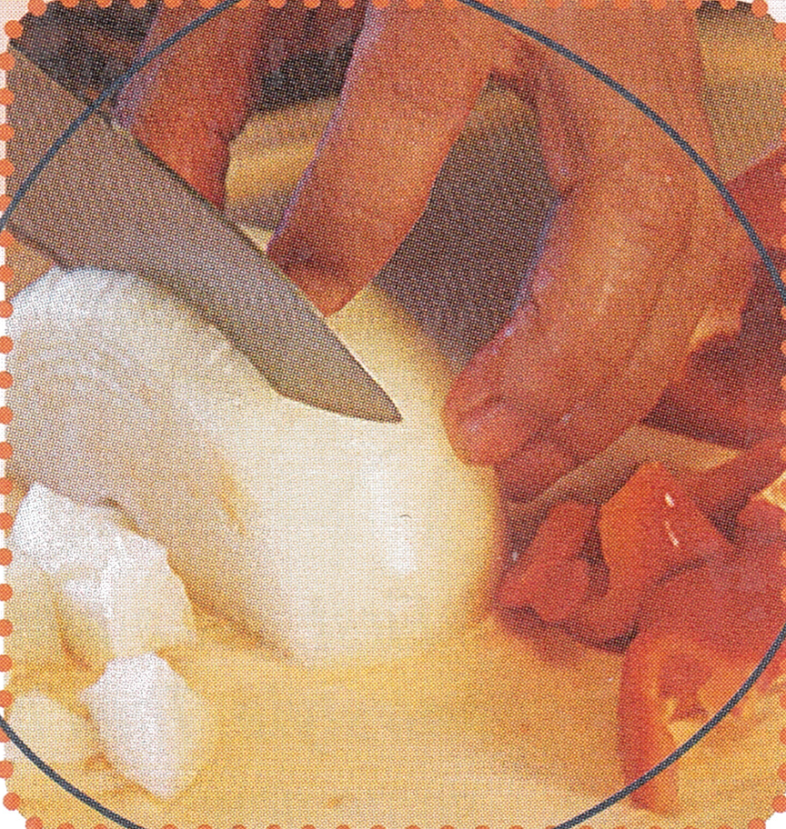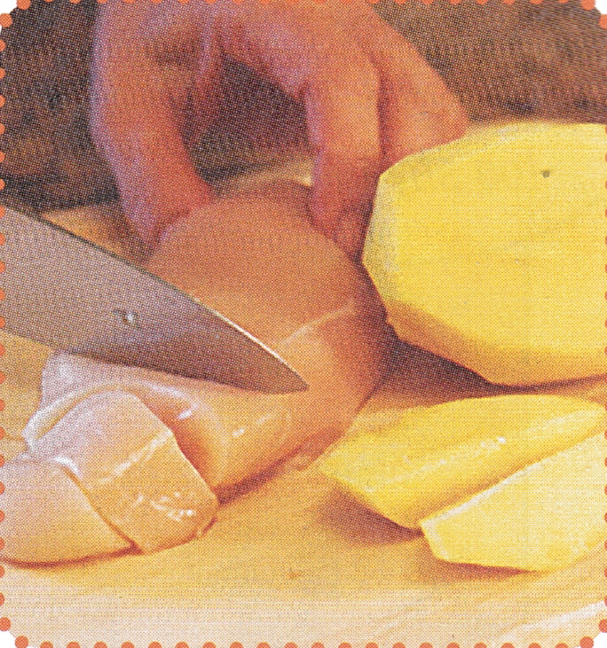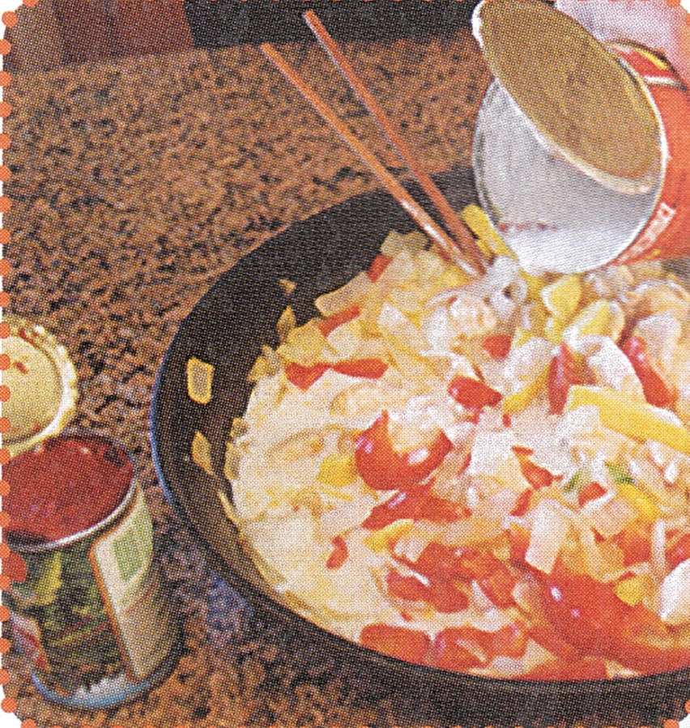

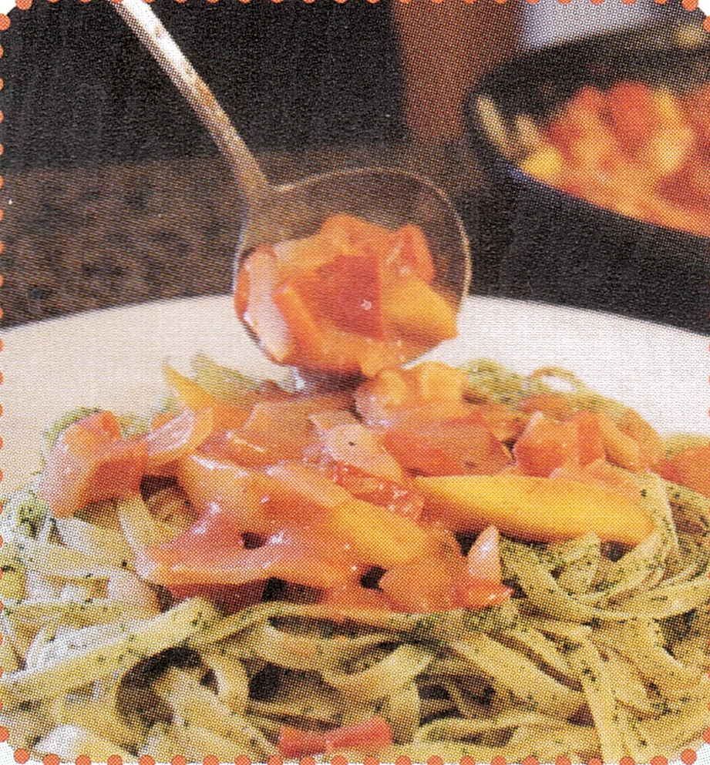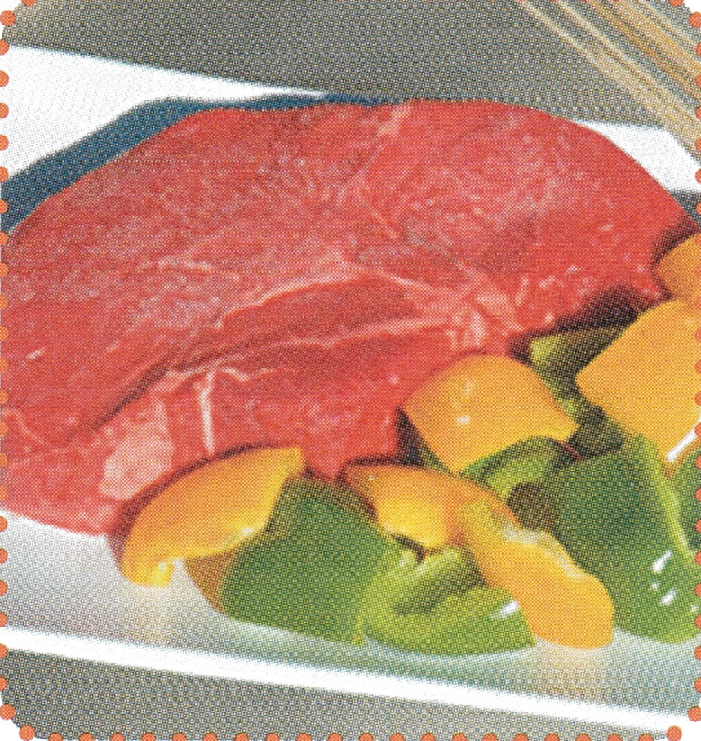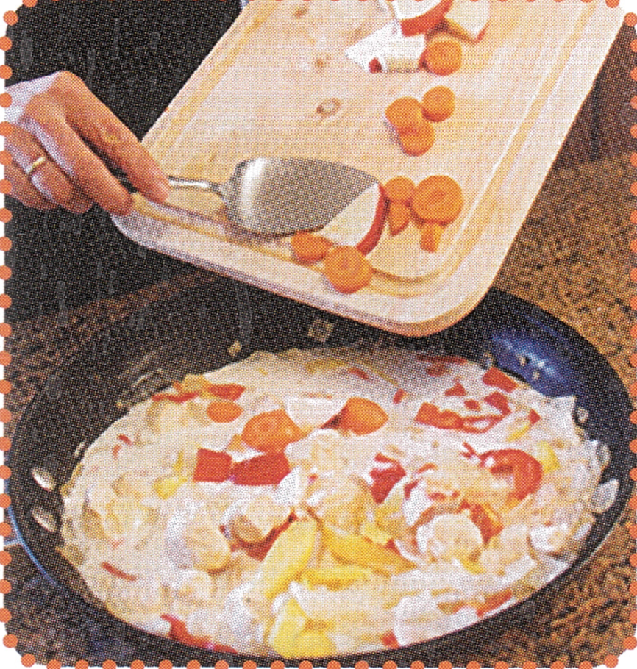

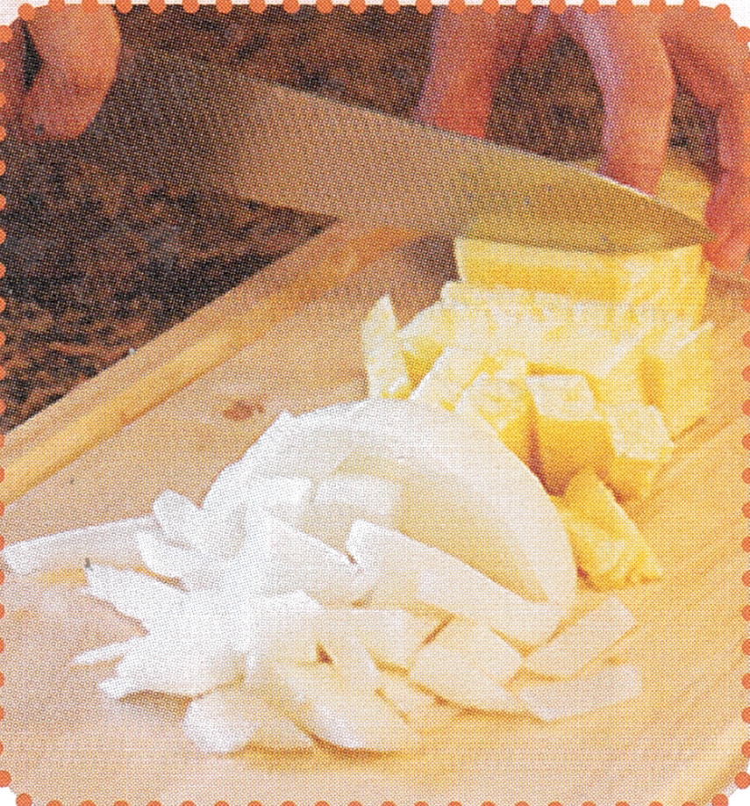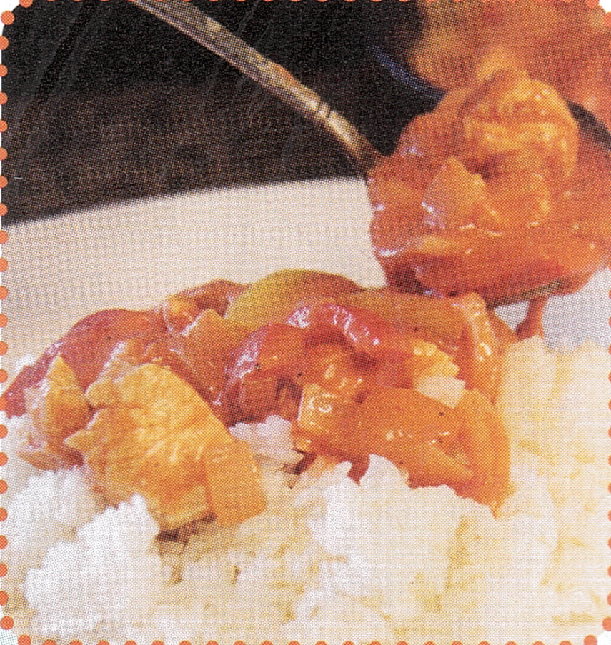

- A Snack Foods: SonPyeon

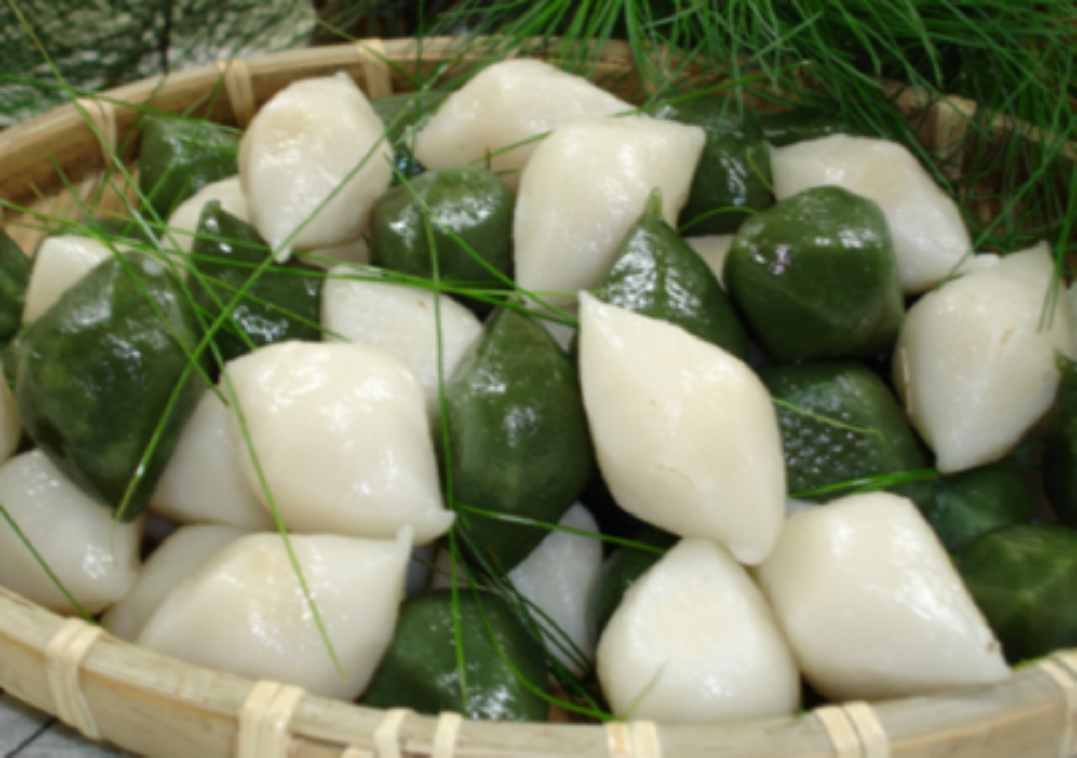

- Ingredients List with Pictures

Frozen rice flour  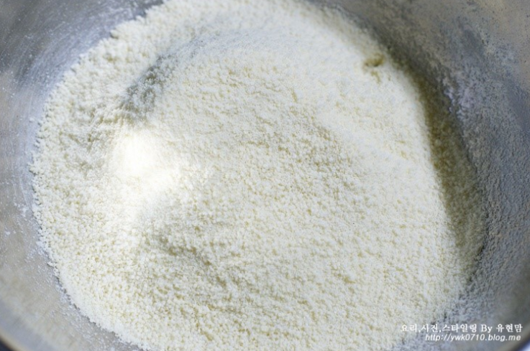 | salt  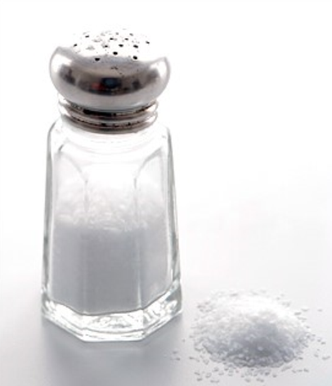
sesame seeds | dried and skinned mung beans
brown sugar | pine needles
mugwort (ssook in Korean)

- “How to Make the Snack?” Worksheet (=Recipe Table)

