Background Information Sheet
Name | Class | Date | Lesson Type | Plan type | Length
Daisy | TESOL | 12.Feb.2020 | Grammar | PPP | 35 min

Lesson
Topic | I always wash my hands after I go to the bathroom.
Main Aim | Students will learn the 2nd conditional.
Secondary Aim | Students will practice their speaking fluency.

Materials and References
Board and pens, worksheets.pictures.

Student Profile
Level |  | Lower Intermediate
Age |  | 8-10 years old |  | Number of Students | 7
Detail |  | Students are all native Korean
Assumptions about students’ knowledge as required for this lesson:
- Students know the vocabulary used in this lesson
- Students have learned about the ‘frequency adverbs’.
- Students understand the concept of the ‘frequency adverbs’ exactly.

What language difficulties to expect when presenting, and how to deal with it:
- Meaning: “I always wash my hands after I go to the bathroom.” Students might does not understand clearly the meaning of the words exactly. Make a clear visual context and C.C.Q.

- Form: Students might confuse a position of the frequency adverbs in a sentence and what precise meaning exactly.

- Pronunciation: Students may not know where to put natural sentence stress. Drill several times chorally, then individually. Ask, “Which words sound stressed?” Board the stress markers in red.

Anticipated Classroom Management Difficulties and their Solutions:
The quantity of new language points to be learned about the 2nd conditional is too much for students to handle in a short 25 minute lesson. This could lead to anxiety, rushing, and a lot of teacher talk. For this lesson I will manage this by selectively presenting only a few new concepts about the 2nd conditional. The remaining new language points can be presented in the next lesson.

My Personal Aim
What I hope most to demonstrate in this lesson is the ability to
- present the target language using a situational presentation
- to be an involver type teacher

Stage Name: Lead-in
Purpose of this stage: To relax both the teacher and students. To focus attention on the lesson. Create a situation for students to experience or think about, and then to elicit the target language.
Materials: Picture and board & color pens
Timings | Interactins |  | Procedure
2min | T-S |  | Hi guys! (Put on the picture on board)  What is this picture?  Tell me about the picture and make a sentence.  (Students will say)  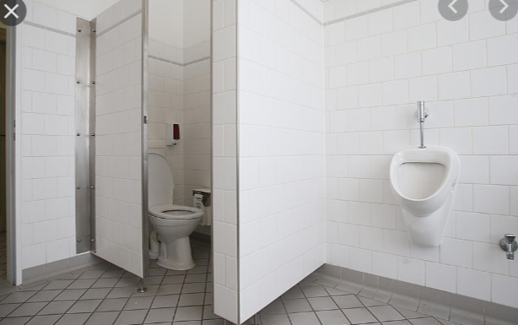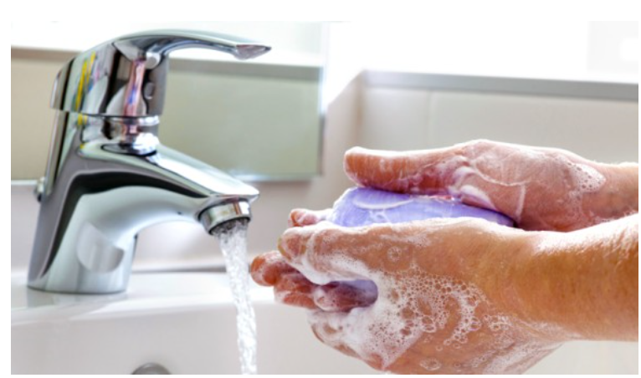
Stage Name: Presentation
Purpose of this stage: Make the students think about the situation. To clarify the meaning, form, and pronunciation features of the target language.
Materials: Board and colored pens
Timings | Interactions |  | Procedure
30 sec  30 sec  4min | T  T-S  T-S |  | Board the model sentence (if students are unable to tell you, just board it).  (Write on the board some sentences)  CCQ – ask questions, and use time lines or scales where appropriate.  - Do you wash your hands only one time in a month? - No  - Do you wash your hands after the go to the bathroom? –Yes  - Can you cook with your dirty hands? –No  Form – clarify the affirmative, negative, question form, or other special features. Substitution tables may be of use.  (Write 2 sentences on the board.)  - Can we say I wash my hands always? –No  - Can we say I don’t wash my hands often?-No  - Why?  Let students know the position of ‘frequency adverbs’ is before the main verb.  Subject + (be) + adverb + complement.  Board below the model sentence:  How do we make this into a negative sentence? Board I don’t always wash my hands.  Which word shows ‘frequency adverbs’? always/usually/often ?  How do we make this a question? Board. Did you/Didn’t you always wash your hands?  And how can we answer this question? Board.Yes or (No), I (don’t) always wash my hands.  Subject - frequency adverbs general verb  + I always/usually/often wash my hands  - I don't or didn't  ? Did or Do(n't) you your hands?  Drill – drill the spoken form, focusing on contractions, stress and intonation.  - Which words are stressed? (always, wash, hands). Mark the stress with a red marker.  - Which words are unstressed? (I, my) Mark the stress with a blue marker.  - What happens to the pronunciation of ‘Don’t you’? (it joins together and is fast.)  - Listen, and repeat 3 times “ I always wash my hands” x3  - Nominate for individual drilling.  - Gestures. Nominate for individual drilling.  - Nominate a student to ask the question ”Don’t you always wash your hands? “
Stage Name: Controlled Practice
Purpose of this stage: students practice working with the form (scrambled sentences, split sentences, select the correct form of the verb, correct incorrect sentences, and change one form into another form). Accuracy must be checked.
Materials: List all materials that will be needed in this stage.
Timings | Interactions |  | Procedure
30 sec  1min  30 sec  3min | T  S  S – S  T - S |  | Instructions. I will give you the worksheet-A. Please fill out the blank.  ICQ. Ex) I ( usually／sometimes ) get up at 7.  Hand out the work sheet.  Students do a worksheet-1.  (Worksheets should be properly designed. See examples in a course book.  Pair check.  Feedback to check accuracy. Board correct answers visually.
Stage Name: Less Controlled Practice
Purpose of this stage: students practice working with the meaning (match a timelines to sentences, choose the sentence that matches a picture, gap-fill a paragraph). Accuracy must be checked.
Materials: List all materials that will be needed in this stage.
Timings | Interactions |  | Procedure
30 sec  2 min  30 sec  2 min | T  S  S-S  T-S |  | Instructions.  Turn over your worksheet.  Exercise B says make 5 sentences use below the words with the pictures. always/often/usually/sometimes/never.  Students do the worksheet-2  Pair check.  Feedback to check accuracy.
Stage Name: Production – Freer Practice
Purpose of this stage: is to get students to practice the grammar communicatively.
Materials: List all materials that will be needed in this stage.
Timings | Interactions |  | Procedure
1min  4 min  1min | T  S-S  T-S |  | Instructions.  Talk to your partner that’s what you always do. And make sentences using the words as below.  always/often/usually/sometimes/never  For example, can you talk about “I often visit to my friend’s house.” ,“I always go to library”..  Students discuss their past using the target language naturally.  Feedback.
Stage Name: Wrap-up
Purpose of this stage: is to end the lesson on a positive note so that students feel they have achieved progress.
Materials: List all materials that will be needed in this stage.
Timings | Interactions |  | Procedure
1 min  50 sec  10 sec | T – S  T  T |  | Lesson feedback. Tell the class what they did well, and what needs to improve.  Offer delayed corrections to the previous stage.  Please review the lesson today and make 5 sentences with any ‘frequency adverbs’ at home.  Next, we will learn about the past participle.
Instructor’s Comments and Assessment
Pros
Cons
Change
Overall Comments
Grade
Above Standard 85%-100% | Standard 70%-84% | Below Standard 69%-0%
Instructor | Student Signature | Date
Taute, David

Worksheet-1
Exercise A
Choose one of two options and circle the correct answer.
Ex) We ( always／often ) go to school at 8.
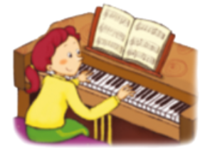 * Play piano: Every day
- I ( sometimes/always) play the piano.
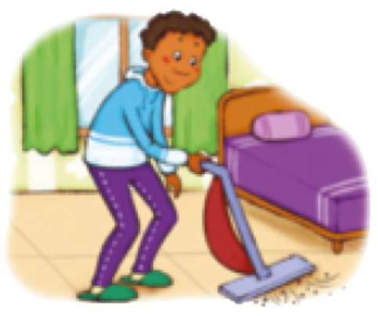 * Clean my house : 2days a week.
- He ( never/usually ) cleans his room in the morning.
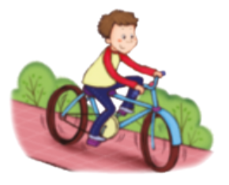 * Ride a bike: 3days a week
- Jack ( often/never ) rides his bike.
* Walk my dog: 3times a week.
- We ( always/sometimes ) walk our dog.

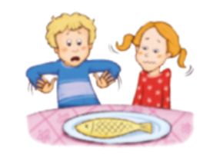 * Eat fish : Zero time a week
- They ( often/never ) eat fish.

Work shee-2
Exercise B
Please make 5 sentences using the words and the pictures below.
always/often/usually/sometimes/never
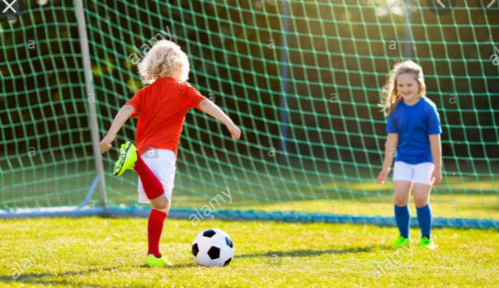 (play football/often)

(school/always)

(threather/sometimes)

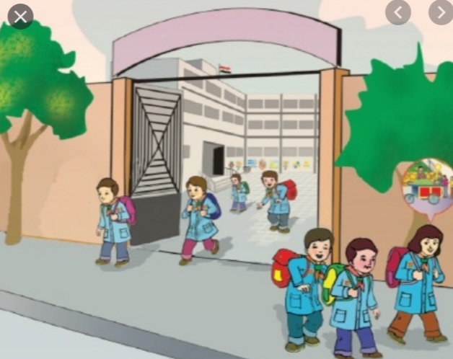 (after school/usually)

(prision/never)

Worksheet-1 (Answer)
Exercise A
Choose one of two options and circle the correct answer.
Ex) We ( always／often ) go to school at 8.
* Play piano: Every day
- I ( sometimes/always) play the piano.
* Clean my house : 2days a week.
- He ( never/usually ) cleans his room in the morning.
* Ride a bike: 3days a week
- Jack ( often/never ) rides his bike.
* Walk my dog: 3times a week.
- We ( always/sometimes ) walk our dog.

* Eat fish : Zero time a week
- They ( often/never ) eat fish.

Work shee-2 (Answer)
Exercise B
Please make 5 sentences using the words and the pictures below.
always/often/usually/sometimes/never
(play football/often)
- I often go playing football with my friend.
(school/always)
- I always go to school on time.
(movie threather/sometimes)
- I sometimes watche a movie at the movie threather.
(after school/usually)
- We usually leave school on 2 p.m.
(prision/never)
- I never go to prision.

