Exercise A
Complete the conversation with the adjectives in parentheses. Use the comparative form. Add than when necessary.
- [expensive]
A: Which city is ______________________ to live in, Tokyo or Sydney?
B: Tokyo is ______________________ Sydney.
- [hot]
A: Which city is __________________________in summer, Bankok or Seoul?
B: Bankok Summers are _______________________ summers in Seoul.
- [high]
A: Which city has a _____________________________ elevation, Bogota or Mexico city?
B: Bogota is ________________________________Mexico city.
- [long]
A: Which highway has ________________________________traffic, West Highway or East Highway?
B: West Highway. Traffic on West Highway is always _____________________________traffic on East Highway.
- [fast]
A: Which one is ______________________________, a dog or a cat?
B: A cat is ________________________________ a dog.

Answers for exercise A
- More expensive , more expensive than
- Hotter, hotter than
- Higher, higher than
- Longer, longer than
- Faster, faster than

Exercise B. Choose two things to compare, using “Than” in the sentence. Make three sentences.
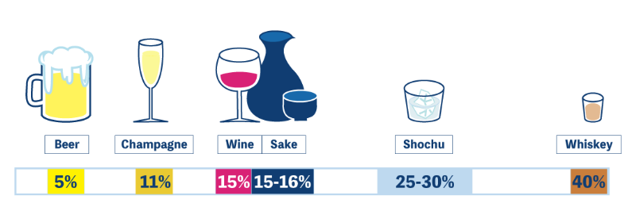
1.
2.
3.

Answers for Exercise B
- Alcohol content of champagne is higher than a beer.
- The color of Shochu is clearer than whiskey.
- Beer has more bubble than sake.
- Whiskey is stronger than wine.

