Background Information Sheet
Name | Class | Date | Lesson Type | Plan type | Length
Shabina | 203 WD | 12/02/2020 | Grammar | PPP | 25 min

Lesson
Topic | I’m going to visit my parents’ house this weekend.
Main Aim | Students will learn “be going to“ with activities.
Secondary Aim | Students will practice their speaking fluency.

Materials and References
http://en.islcollective.com ,English Grammar in Use R. Murphy, Cup, White board, colored markers, worksheet, picture.

Student Profile
Level |  | Lower Intermediate
Age |  | Adults |  | Number of Students | 7
Detail |  | Everyone is highly motivated to learn English and all native Korean.  They are interested in talking to each other about their plan this weekend.  They are accustomed to pair work but still need to be more relaxed before they will open up to communicate freely.
Assumptions about students’ knowledge as required for this lesson:
- Students are able to use the vocabulary needed when they speak their plan.
- Students have already learned about the subject and b-verb relationship and to infinitive.
- Students know how to make the present and past tense.

What language difficulties to expect when presenting, and how to deal with it:
- Form: Students may say something wrong.
ex) I’m going to visiting my parents’ house this weekend. Because they don’t know “be going to verb” phrase.
Give them examples to understand well.
- Pronunciation: Students may not know where to put natural sentences stress. Drill 5 times chorally, then individually. Ask “where is the stress?” Board the stress markers in red.

Anticipated Classroom Management Difficulties and their Solutions:
Some students don’t want to be partners who they feel uncomfortable with. -> find proper partners.
Some students may run out of time for speaking their opinion. -> let them know the left time.
Some students may be difficult to answer the work sheet. -> show them a sample.

My Personal Aim
What I hope most to demonstrate in this lesson is
the ability to make the grammar class interesting.
the ability to lead the students to find the grammar easy.

Stage Name: Lead-in
Purpose of this stage: To relax both the teacher and students. To focus attention on the lesson. Create a situation for students to experience or think about, and then to elicit the target language.
Materials: Board, colored board markers.
Timings | Interactions |  | Procedure
30 sec  30 sec  1 min | T  S-S  T-S |  | T: Hello everyone  today we talk about our plan this weekend.  Talk to your partner about it.  .  Now share your plan. Nominate 2-3 students  Board  (visit parents’ house, play soccer with my friends, go hiking, swimming, shopping, traveling..etc.)  What sentence can you use to say your plan this weekend?  Try to elicit the model sentence which contains the target language by referring to the situation. If no one can come up with the answer,  Board  “I’m going to visit my parents’ house this weekend.”
Stage Name: Presentation
Purpose of this stage: Make the students think about the situation. To clarify the meaning, form, and pronunciation features of the target language.
Materials: : Board, colored board markers, picture.
Timings | Interactions |  | Procedure
1 min  3 min  1 min | T-S  T-S  T-S |  | Ask the students to read the sentence once.  “I’m going to visit my parents’ house this weekend.”  CCQ  - Is it related to now or future? (future)  - Is it about what you decide to do? (Yes)  - Do I say about my plan? (Yes)  Form  Board  Positive: I’m going to visit my parents’ house this weekend.  Subject be-verb object when  Be going to + verb -> things decided to do.  Now  Past Going to visit Future  Does this sentence tell us the future or the past? (future)  Which word shows I’m talking about the future? Board (this weekend)  Can we say I’m going to visiting my parents’ house this weekend? (No)  What form of verb should be used after be going to? Board (Verb in the base form)  How can we make this into a negative sentence?  Board I’m not  How do we make this a question sentence?  Board Am I  And how can we answer this question?  Board Yes, you are or No, you aren’t.  How do we make a question sentence to hear your plan this weekend?  Board What are you going to do this weekend?  Let’s check another meaning “be going to”.  Look at this picture. Can you say what happens in a minute to the man?  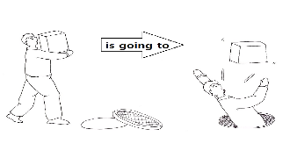  Board  ” He is going to fall into the hole.”  Also We can predict obviously “something is going to happen” using be going to.  Drill  Listen and speak 5 times together.  (They speak each sentence 5 times)  (I‘m going to visit my parents’ house this weekend.)  And nominate for individual drilling. (3 students)  Where is the stress? Board I, visit, my parents’ house, this weekend.  Mark the stress with a red marker.
Stage Name: Controlled Practice
Purpose of this stage: students practice working with the form (scrambled sentences, split sentences, select the correct form of the verb, correct incorrect sentences, and change one form into another form). Accuracy must be checked.
Materials: Worksheet, board and marker, eraser.
Timings | Interactions |  | Procedure
30 sec  3 min  30 sec  1 min | T  S – S  S – S  T – S |  | Instructions. Hold up the worksheet, point to exercise A, B.  Exercise A says to make the negative and the question sentence.  Exercise B says to make dialogues about your plan as an example..  Don’t do exercise C  ICQ  “Is it pair work or individually?” (Individually)  “Do you have to do exercise C?” (No)  Hand out.  Students do a worksheet.  Pair check.  Feedback to check accuracy. Board correct answers visually.
Stage Name: Less Controlled Practice
Purpose of this stage: students practice working with the meaning (match a timeline to sentences, choose the sentence that matches a picture, gap-fill a paragraph). Accuracy must be checked.
Materials: Worksheet, board and marker, eraser.
Timings | Interactions |  | Procedure
30 sec  3 min  30 sec  1 min |  |  | Instructions  Turn over to exercise C  Exercise C says to complete the gaps with the “be going to” future. Write(P) for predictions  Or (I) for intentions in the circles.  Students do the worksheet.  You have 3 minutes.  Pair check.  Feedback to check accuracy.
Stage Name: Production – Freer Practice
Purpose of this stage: is to get students to practice the grammar communicatively.
Materials:
Timings | Interactions |  | Procedure
1 min  4 min  1 min | T  S-S  T-S |  | Instructions.  Talk to your partner about your plan for the near future freely. No worksheet.  For example,  what are you going to do next Monday?  I’m going to buy some books for my son.  Students discuss their plan for the near future using the target language naturally.  Feedback.
Stage Name: Wrap-up
Purpose of this stage: is to end the lesson on a positive note so that students feel they have achieved progress.
Materials: work sheet
Timings | Interactions |  | Procedure
1 min | T – S |  | Offer delayed corrections to the previous stage.  “Look at the board. Here are some sentences I heard. Tell me how to correct them.”  Give some compliments about what they improve.  “You can make and speak proper sentences and your fluency has improved a lot.”  Hand out work sheet for Homework  Tell them to make 5 sentences using “different subject + be going to verb + different time”.  Inform students about the topic for the next lesson.  Next time, we are going to study the difference between Will and Be going to.  Time’s up
Instructor’s Comments and Assessment
Pros
Cons
Change
Overall Comments
Grade
Above Standard 85%-100% | Standard 70%-84% | Below Standard 69%-0%
Instructor | Student Signature | Date
Taute, David

Exercise A
Change the sentence to the negative and question form.
1. I’m going to study English tonight.
Negative
Question
2. He’s going to walk his dog tomorrow.
Negative
Question
3. She’s going to climb the mountain this weekend.
Negative
Question
Exercise B
Make dialogues about your own plan as an example.
Ex) A: What are you going to do after class?
B: I’m going to play soccer with my friends.
A: Where are you going to do that?
B: I’m going to do it in the playground near the park.

A: What are you going to do
B: I’m going to
A: Where/ how/with whom/when are you going to do that?
B: I’m going to do it
Exercise C
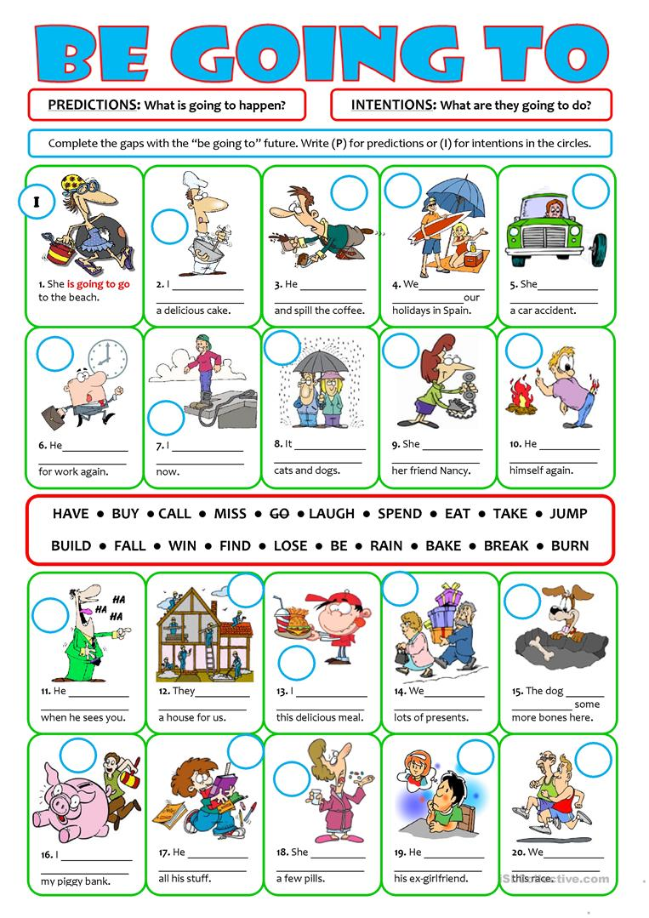

JUMP. SPEND. FALL. BURN. BAKE. RAIN. CALL. HAVE. BE
Answer sheet.
Exercise A
Change the sentence to the negative and question form.
1. I’m going to study English tonight.
Negative: I’m not going to study English tonight.
Question: Am I going to study English tonight?
2. He’s going to walk his dog tomorrow.
Negative: He’s not going to walk his dog tomorrow.
Question: Is he going to walk his dog tomorrow?
3. She’s going to climb the mountain this weekend.
Negative: She’s not going to climb the mountain this weekend.
Question: Is she going to climb the mountain this weekend?

Exercise C
2. (I), am going to bake 6. (P), is going to be late 10. (P), is going to burn
3. (P), is going to fall 7. (I), am going to jump
4. (I), are going to spend 8. (P), is going to rain
5. (P), is going to have 9. (I), is going to call

HOMEWORK

Make 5 sentences as an example
Example) subject + be going to verb + different time.

Subject | Be going to | Verb + Object | Time
I | am going to | Study Math | tonight.
You | are going to |  | Tomorrow.
He/ She | is going to |  | this weekend.
We | are going to |  | this Saturday.
They | are going to |  | after class.

Make your sentences.
Subject | Be going to | Verb + Object | Time
