Background Information Sheet
Name | Class | Date | Lesson Type | Plan type | Length
Hong Yeni | 203WD | 2/12/2020 | Grammar | PPP | 25 min

Lesson
Topic | Comparative
Main Aim | Students will learn the 2nd conditional.
Secondary Aim | Students will practice their speaking fluency.

Materials and References
Board, marker, worksheet

Student Profile
Level |  | Lower Intermediate
Age |  | Elementary |  | Number of Students | 7
Detail |  | Students are all Korean.
Assumptions about students’ knowledge as required for this lesson:
- Students know the vocabulary used in this lesson
- Students have learned about the comparative
- Students know how to make the negative form using ‘not’
What language difficulties to expect when presenting, and how to deal with it:
- Grammar: Students might ask different questions based on grammar. However, teacher have limited time. Ask the student to come after class.
- Pronunciation: Students may not know where to put natural sentence stress. Drill several times chorally, then individually. Ask, “Which words sound stressed?” Board the stress markers in red.

Anticipated Classroom Management Difficulties and their Solutions:
Students will be confused with ex) bigger adding another g for bigger. It will be too much for the students to learn within 25 minutes lesson. However, the students are able to learn naturally.
My Personal Aim
What I hope most to demonstrate in this lesson is the ability to
- present the target language using a situational topic for their age
- to be an involver type teacher to help them understand naturally

Stage Name: Lead-in
Purpose of this stage: To relax both the teacher and students. To focus attention on the lesson. Create a situation for students to experience or think about, and then to elicit the target language.
Materials: List all materials that will be needed in this stage.
Timings | Interactions |  | Procedure
1min | T-S |  | Hello everyone. Look at this picture. Tell me about these people in sentences.  (Sam is taller than Eric.)
Stage Name: Presentation
Purpose of this stage: Make the students think about the situation. To clarify the meaning, form, and pronunciation features of the target language.
Materials: List all materials that will be needed in this stage.
Timings | Interactions |  | Procedure
10 sec  30 sec  30 sec  2min  2min | T-S  T-S  T-S  T-S |  | Board the model sentence (Sam is taller than Eric.)  CCQ  - Is Eric shorter than Sam? (Yes)  - Can I say Sam is taller than Eric? (Yes)  - What did I just do with Sam and Eric? (Compare)  Form – Look at this sentence again. (point the board)  - Can I say Sam is big than Eric? (No)  - How about Sam taller Eric? (No)  - Why? (Adj+ er + than)  - How do we change this to a negative form? (Sam is not taller than Eric.)  Examples of what might the students say  Sam is / is not taller than Eric  shorter than  smarter than  Drill – drill the spoken form, focusing on contractions, stress and intonation.  Guys, listen carefully. “Sam is taller than Eric”.  Which words are stressed? (Sam, taller) Mark the stress with a red pen.  Listen and repeat 3 times.  Conduct the drill chorally 3 times with gestures.  Nominate for individual drilling.  (Any sentences that student made in the substitution table.)  Conduct the drill chorally 3 times with gestures.  Nominate for individual drilling.
Stage Name: Controlled Practice
Purpose of this stage: students practice working with the form (scrambled sentences, split sentences, select the correct form of the verb, correct incorrect sentences, and change one form into another form). Accuracy must be checked.
Materials: List all materials that will be needed in this stage.
Timings | Interactions |  | Procedure
30 sec  10 sec  1min  1min  1min | T  T-S  S  S – S  T - S |  | Instructions.  Hold the worksheet and point exercise A.  “We are now going to do a worksheet. Please look at exercise A.  Read the questions carefully and fill in the correct answers. “  ICQ.  - Do you flip over to exercise B? (No)  - Do you only work on exercise A? (Yes)  Hand out. Student work on it.  Pair check.  Feedback to check accuracy. Board correct answers visually. (If needed)
Stage Name: Less Controlled Practice
Purpose of this stage: students practice working with the meaning (match a timelines to sentences, choose the sentence that matches a picture, gap-fill a paragraph). Accuracy must be checked.
Materials: List all materials that will be needed in this stage.
Timings | Interactions |  | Procedure
20 sec  2min  1min  1min | T  T-S  S  S-S  T-S |  | Instructions.  “Now turn over your worksheet. Compare the zoo animals and write 5 comparative sentences.“  ICQ  - What sentences do you write? (comparative sentences)  Students do the worksheet.  Pair check  Feedback to check accuracy. (If needed)
Stage Name: Production – Freer Practice
Purpose of this stage: is to get students to practice the grammar communicatively.
Materials: List all materials that will be needed in this stage.
Timings | Interactions |  | Procedure
30 sec  6 min  2min | T  S-S  T-S |  | Instructions.  Talk to your partners about, which one is harder math or English?  Talking with their partners  Nominate one or two student and ask why.
Stage Name: Wrap-up
Purpose of this stage: is to end the lesson on a positive note so that students feel they have achieved progress.
Materials: List all materials that will be needed in this stage.
Timings | Interactions |  | Procedure
1 min | T |  | (Offer delayed corrections if found.)  Class you did a very good job.  Grammar can be a bit boring but you guys came through it.  After this lesson you will know how to use comparative grammar.  Next class you will learn about superlatives.  END.

Exercise A
Read the questions carefully and fill in the correct answers.

softer than | faster than | bigger than | older than | colder than

Example:
(John ) (Joseph)
John is older than Joseph.
- 2.
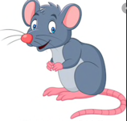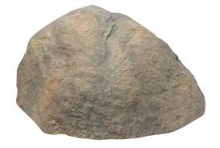

Elephant is ___________________ the mouse. The pillow is __________________ the stone.

3 . 4.
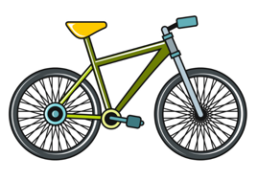

Car is __________________________ bike. Winter is ____________________ summer.

Exercise B
Compare the zoo animals and write 5 comparative sentences.

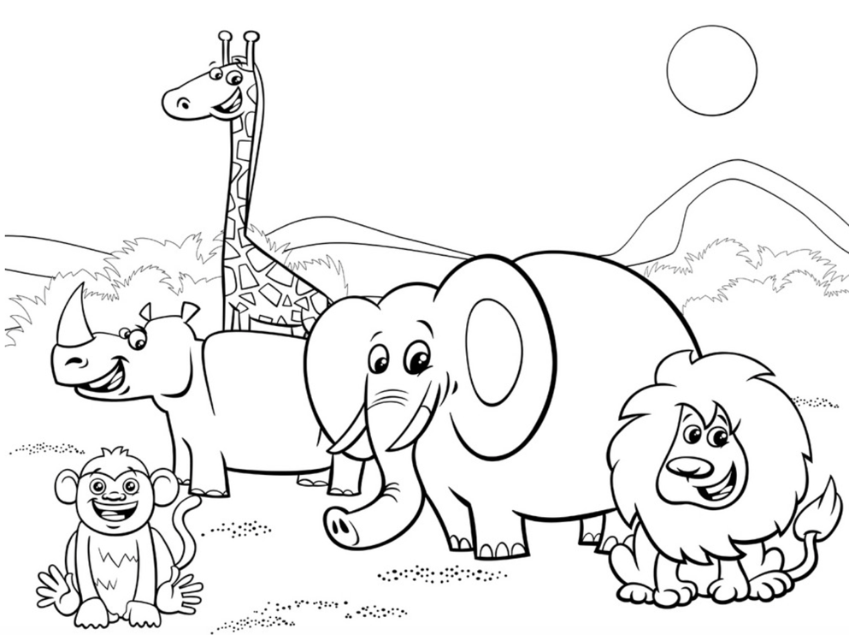

Instructor’s Comments and Assessment
Pros
Cons
Change
Overall Comments
Grade
Above Standard 85%-100% | Standard 70%-84% | Below Standard 69%-0%
Instructor | Student Signature | Date
Taute, David

