Name | Class | Date | Lesson Type | Plan type | Length
Jinny - Ko, Jinsun | TESOL | 19/Feb/2020 | Reading | PPP | 25 min

Lesson
Topic | Soybean products may help you live longer.
Main Aim | Students will practice their reading comprehension.
Secondary Aim | Students will practice their speaking fluency.

Materials and References
http://breakingnewsenglish.com/2002/200205-soybeans.html, worksheets, photos
board and board markers(black, blue and red colored)

Student Profile
Level | Upper Intermediate
Age | Adults | Number of Students | 7
Detail | This is general English class and students are highly motivated Korean learners. A few of them are working as an English instructors focused on Speaking lesson, most of them are looking for jobs related to English. They could speak English fluently but many are still afraid of making a mistake. They are quite accustomed to pair and group work.

Anticipated Difficulties and their Solutions:
- A few students may not know some vocaburary. --> Encourage them that they could elicit the meaning from the whole sentences or phragrph.
- Every students have different speed of reading. It may give some nervousness to those slow readers. So they may feel anxiety to take reading task. --> Let them know how to be relaxed with their article.
- The failure of time management. --> In order not to uncontrol time, I will check the clock in every single stage.

My Personal Aim
What I aim to demonstrate is the ability to write out a complete, detailed reading lesson plan.

Stage Name: Lead-in
Purpose of this stage: To relax both the teacher and students. To focus attention on the lesson. To lead in to the topic, activating background knowledge – this will help to contextualize the text.
Materials: List all materials that will be needed in this stage.
Timing | Interaction | Procedure
30 sec  1 min  30 sec | T  T-S  S-S  T-S | Hello, everyone.  Please, take a look this photos.  What do you see? Yes, these are healthy foods. We call them Superfoods, too.  How healthy is the food you eat?  Talk to your partner about your own superfoods.  You have 1 minute.  Gesture for students to begin talking to their partners.  Students talk to their partners. Monitor for any use of key words.  OK. Times up. Could you tell us about your superfoods? Nominate 2 students.  Feedback.

Stage Name: Presentation
Purpose of this stage: To pre-teach keywords if necessary, and answer a guiding questions (such as a predicting task, or a specific question). These steps provide extra help for students to comprehend the text.
Materials: List all materials that will be needed in this stage.
Timing | Interaction | Procedure
2 min  2 min  10 sec  1 min  1 min | T-S  T  T-S  S-S  T-S | Pre-teach keywords (fermented, be associated with)  1. fermented  Elicit  Do you know 'Kimchi' ? (Show students the same photo with Kimchi.)  Could you feel the different taste of Kimchi when time goes by? Becoming sour.. you know why?  Yes, because it is fermented. Do you know other foods processed this? (Yogurt, Soybean paste etc)  CCQs  1. Is this food changed chemically? (Yes.)  2. Does this food take some times to be changed chemically? (Yes.)  3. Does this food sound like healthy? (Yes.)  Drill  Listen and chorally repeat 3 times. (Gesture.)  Nominate 3 individually.  If needed, correct students’ pronunciation.  Board ●  Write with a black board pen 'fer|ment|ed' on the right of the board.  How many syllables? (3) Mark with a blue pen.  Where is the stress? (1st) Mark with a red pen.  What type of word is it? (Adjective.)  2. be associated with  Elicit  Show students 2 photos to compare. (healty foods with healty person vs junk foods with fat person)  What do you see? Do you think there is something between foods and the health? Yes, there is.  How could you make sentence to indicate the relation of foods and the health using certain phrase?  Yes, the foods are associated with the health.  CCQs  1. Can we use this expression for the relation of car emmisions and pollution? (Yes.)  2. Can we use this expression for the relation of hobby and snoring? (No.)  Drill  Listen and chorally repeat 3 times. (Gesture.)  Nominate 3 individually.  If needed, correct students’ pronunciation.  Board ●  Write with a black board pen 'be as|so|ci|at|ed with' on the right of the board.  How many syllables of assiciated? (5) Mark with a blue pen.  Where is the stress? (2nd) Mark with a red pen.  Guiding Question  What do you know about soybeans?  Talk to your partner. You have 1 minute.  Students discuss the question with a partner.  Feedback. Nominate a few students to share their ideas.

Stage Name: Practice – Literal Comprehension
Purpose of this stage: is to get students to practice reading for literal detail. They will also practice fast reading (skimming and scanning)
Materials: List all materials that will be needed in this stage.
Timing | Interaction | Procedure
30 sec  2 min  30 sec  1 min | T  S  S-S  T-S | Instructions. Hand out worksheets.  Now, we are going to read an article related to soybean and soybean products.  After then, you need to do Exercise A to check your comprehesion.  Just do it individually. You have 2 minutes.  ICQs.  1. Do we work with partner? (No.)  2. Do we work all exercises? (No.)  Okay. Just do it. now.  Students read the whole text for the 1st time, and write answers on the worksheet.  Okay. Times up. Pair check. Please, check your answers with your parter.  Nominate 4 students to share their ideas.  Do you guys all agree with the answer? OK.  Feedback to check accuracy.

Stage Name: Practice – Interpretive Comprehension
Purpose of this stage: is to get students to get students to practice interpreting a text correctly This will require more detailed, careful reading, and thinking time to arrive at the correct answer.
Materials: List all materials that will be needed in this stage.
Timing | Interaction | Procedure
30 sec  2 min  30 sec  2 min | T  S  S-S  T-S | Instructions. Hand out worksheets.  Now, it's time to do exercise B individually again. If you find new words, you can assume through the whole paragragh. You have another 2 minutes.  Okay. Do it now.  Students read for the 2nd time. Students write their answers down.  Pair check. Check your answers with your partner first.  Okay. Times up.  Nominate 2 to 3 students who spoke appropriate ansewers while pair talking to share their ideas.  Are there any different ideas here?  Do you guys all agree with the answer? Good.  Feedback to check accuracy.

Stage Name: Production - Applied Comprehension
Purpose of this stage: is for students to practice their speaking fluency on a topic related to the lesson.
Materials: List all materials that will be needed in this stage.
Timing | Interaction | Procedure
30 sec  5 min  1 min | T  S-S  T-S | Instructions.  Take a look 'exercise C'.  Nominate 2 students to read questions of Exercise C. (if needed time management)  Now, it's time to share your personal oppinions for exercise C. Discuss with your parter now.  You have 5 minutes.  Students discuss.  Monitor them from the distance.  If some errors which related to the key-words occur from students, board them.  Thank you all. Any volunteers in here to share your oppinion on number 1 or 2?  Time management if needed. (Just in case of lack of time or much remaining time.)  Feedback. Students share their ideas with the class.

Stage Name: Wrap-up
Purpose of this stage: is to end the lesson on a positive note so that students feel they have achieved progress.
Materials: List all materials that will be needed in this stage.
Timing | Interaction | Procedure
30 sec  1 min  30 sec | T-S  T-S  T | Lesson feedback.  I'm happy to see you guys talking freely and a little seriously.  Offer delayed corrections to the previous stage. (if needed.)  Did you like reading this article? Why/not?  If some students wants to speak. Listen and feedback.  Set homework.  Good.  Homework, make a 'DO LIST' for your health. You will speak out your homework on next lesson.  Inform next lesson  And next lesson will be a writing lesson for your health.  Thanks everyone.  Let's call it a day.  Students dismissed.

Soybean products may help you live longer
5th February, 2020

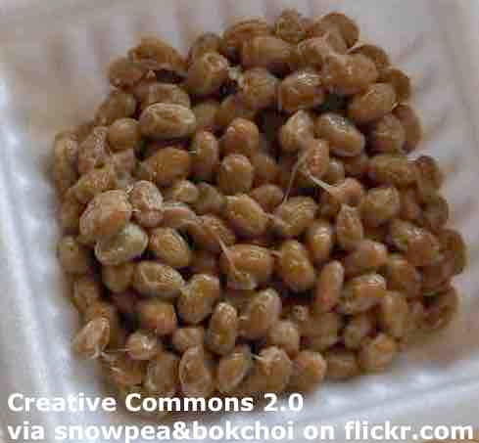 | There are many reasons why Japanese people live longer than the rest of us. One reason might be soybean products like tofu, natto and miso.
Scientists from the National Institute of Health and Nutrition in Tokyo conducted a study into the health benefits of soybeans and their products. They found that people who regularly ate tofu, natto and miso were 10 per cent less likely to die from common killers than people who ate no soybean products. Researchers said eating soybean-based food lowered the risk of death from heart attacks, stroke and other cardiovascular problems.
They said: "A higher intake of fermented soy products was associated with a lower risk of mortality."

Work Sheet

Exercise A) Individual work
1. Who did the aricle say lives longer than the rest of us?
2. Where is the National Institute of Health and Nutrition?
3. What are people who eat soybean products 10% less likely to do?
4. What do soybeans lower the risk of besides heart attacks and strokes?

Exercise B) Individual work
1. Are scientists from National Institute of Health and Nutrition all Japanese?
2. Do many people usually die from heart attacks, stroke and other cardiovascular problems?

Exercise C) Pair discussing
1. Will you eat more soybean products from now?
2. What other superfoods do you know about?

Answer Sheet

Exercise A) Individual work
1. Who did the aricle say lives longer than the rest of us?
Japanese people
2. Where is the National Institute of Health and Nutrition?
Tokyo
3. What are people who eat soybean products 10% less likely to do?
Die from killer diseases
4. What do soybeans lower the risk of besides heart attacks and strokes?
Cardiovascular problems

Exercise B) Individual work
1. Are scientists from National Institute of Health and Nutrition all Japanese?
No, because the first sentence of the article says, 'why Japanese people live longer than the rest of us'. Refering to 'us' means not Japanese.
2. Do many people usually die from heart attacks, stroke and other cardiovascular problems?
Yes, the writer says those are common killers at the fourth sentence of this article.

Exercise C) Pair discussing
1. Will you eat more soybean products from now?
2. What other superfoods do you know about?

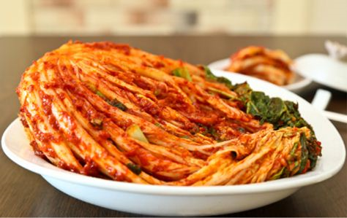



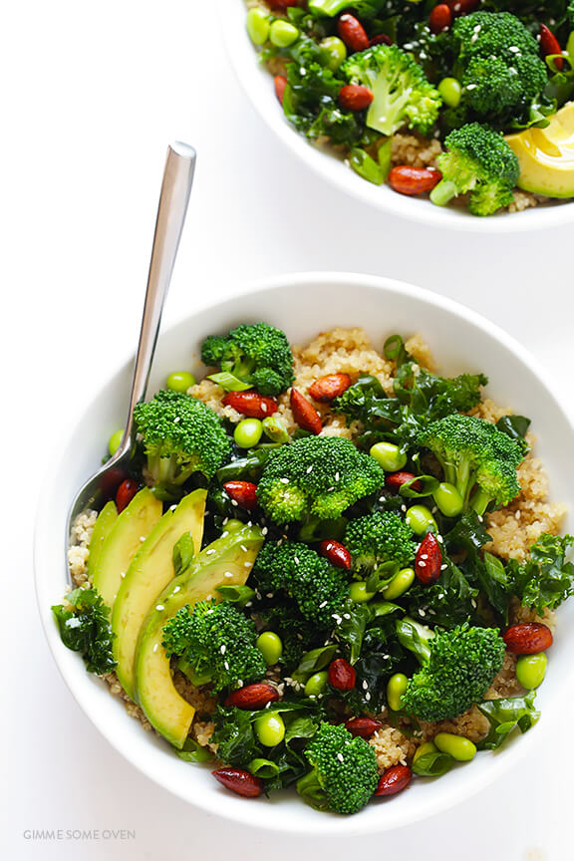




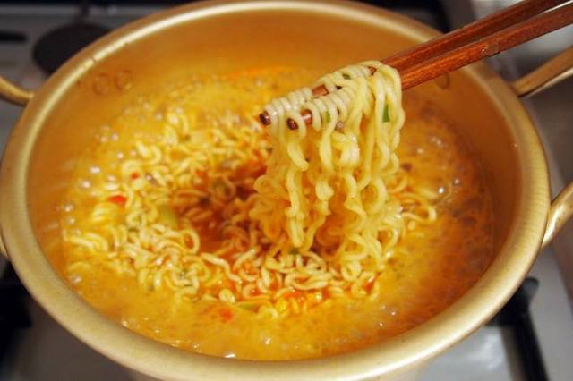

Pros
Cons
Change
Overall Comments
Grade
Above Standard 85%-100% | Standard 70%-84% | Below Standard 69%-0%
Instructor | Student Signature | Date
Taute, David

