Background Information Sheet
Name | Class | Date | Lesson Type | Plan type | Length
Sean | 203WD | 18/02/20 | Reading | PPP | 25 min

Lesson
Topic | The Promise
Main Aim | Ss practice their reading comprehension.
Secondary Aim | Ss practice their speaking fluency.

Materials and References
Reading passage
Worksheets.
Pictures

Student Profile
Level | Intermediate
Age | Teenager | Number of Students | 7
Detail | The class is consisted of Korean students who learned English in Korea. They are fluent in English considering the fact that they studied in Korea. Students have the passion to learn and be fluent in communicating in English. Two of the students came back from Australia to attend a Language exchange program.

Anticipated Difficulties and their Solutions:
Students are so passionate that many times they talk more than needed.
- Make a big clap and raise the volume of voice to get student’s attention when needed.
Students might have no idea what it is to live near the Himalayas.
- Conduct a lead-in that will help student’s understanding.

My Personal Aim
What I hope most to demonstrate in this lesson is the ability to improve student’s reading comprehension and reading speed. Students know well of the process of reading class so I aim to make students do it faster than before. Also, by reading the excerpt, I hope students be thankful for the environment they’re in and have the compassion towards those who don’t have hospitable environment.

Stage Name: Lead-in
Purpose of this stage: To relax both the teacher and students. To focus attention on the lesson. To lead in to the topic, activating background knowledge – this will help to contextualize the text.
Materials: Picture.
Timing | Interaction | Procedure
30 sec  1 min  30 sec | T  S-S  T-S | Look at this picture. Describe this picture with your partner.(show picture 1)  Students talk with their partners  Ask one student about their idea.

Stage Name: Presentation
Purpose of this stage: To pre-teach keywords if necessary, and answer a guiding questions (such as a predicting task, or a specific question). These steps provide extra help for students to comprehend the text.
Materials:
Timing | Interaction | Procedure
2 min  2min  10 sec  1 min  50 sec | T-S  T-S  T  S-S  T-S | Teach the word ‘slate’.  Elicit – What is this? (show picture 2)  What do we call this then? (show picture 3)  Show picture 2 again and elicit the word slate.  CCQ – Is it something you write on? (Yes)  Is it similar to the white board? (Yes)  Is it comfortable to use? (No)  Drill – choral and individual drilling for correct pronunciation. Repeat 3 times.  Board – Identify the part of speech and stress.  Teach the word ‘summit’.  Elicit – Draw a mountain on the board.  Point at the top of the mountain with a red marker.  What do we call this? (Summit)  CCQ – Can we call this part a summit?  Point at the bottom then middle and then the top. (No, No, Yes)  Is it the top of a mountain? (Yes)  Is it the top of a building? (No)  Drill – choral and individual drilling for correct pronunciation. Repeat 3 times.  Board – Identify the part of speech and stress.  Guiding Question  What is something kind you did to someone else this past week?  What is one thing or more thing you did to someone else that you feel good of yourself?  Students discuss the question with a partner.  Feedback. Nominate a few students to share their ideas.

Stage Name: Practice – Literal Comprehension
Purpose of this stage: is to get students to practice reading for literal detail. They will also practice fast reading (skimming and scanning)
Materials: Reading passage, worksheets.
Timing | Interaction | Procedure
1 min  2 min  1 min  1 min | T  S  S-S  T-S | Instructions.  All right guys, We are going to read this passage titled ‘The Promise.’ It’s a part of the book ‘Three cups of tea.’ Hold the worksheet and the book.  You are going to answer for Exercise 1. Point at Exercise 1 on the worksheet.  ICQ - Do you look at exercise 2? (No)  You may begin now.  Students read the whole text for the 1st time, and write answers on the worksheet.  Pair check.  Feedback to check accuracy.

Stage Name: Practice – Interpretive Comprehension
Purpose of this stage: is to get students to get students to practice interpreting a text correctly This will require more detailed, careful reading, and thinking time to arrive at the correct answer.
Materials: Reading passage, worksheets.
Timing | Interaction | Procedure
15 sec  1 min  1 min  2 min  45 sec | T  S  S-S  T-S | Instructions.  Now you are going to answer Exercise 2. Point at Exercise 2.  You may begin now.  Students read for the 2nd time. Students write their answers down.  Pair check. Monitor.  Feedback to check accuracy.

Stage Name: Production - Applied Comprehension
Purpose of this stage: is for students to practice their speaking fluency on a topic related to the lesson.
Materials: None
Timing | Interaction | Procedure
15 sec  5 min  45 sec | T  S-S  T-S | Instructions.  Now talk with your partner why it is important to help others. Support your opinion with reasons and experience if you have one.  Students discuss.  Ask one student to share his/her idea.

Stage Name: Wrap-up
Purpose of this stage: is to end the lesson on a positive note so that students feel they have achieved progress.
Materials:
Timing | Interaction | Procedure
1 min | T | Lesson feedback. Tell the class what they did well, and what needs to improve.  Offer delayed corrections to the previous stage  Inform students about the topic for the next lesson.

Picture 1

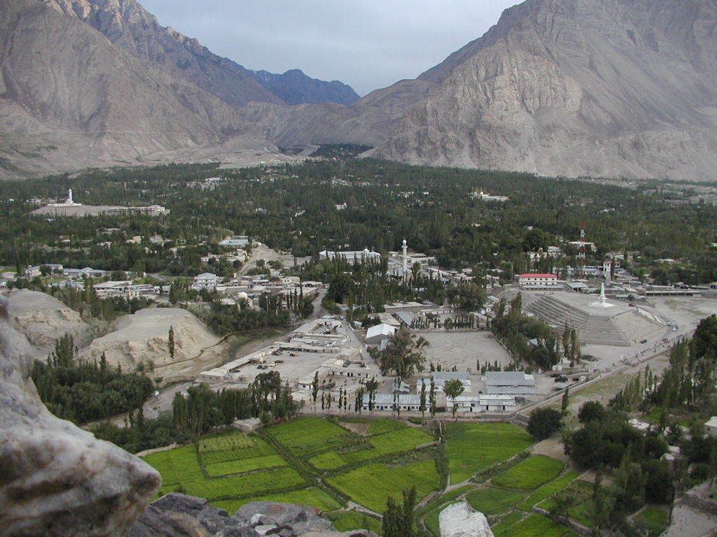

Picture 2
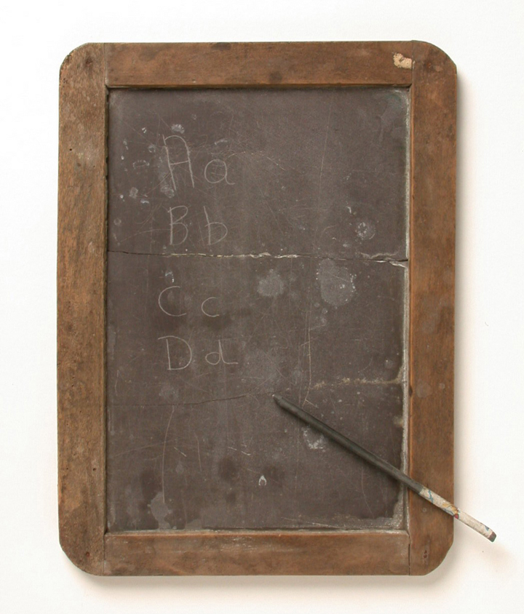

Picture 3

The Promise

Greg watched and listened as the children sang Pakistan’s national anthem to start their school day. He saw Twaha’s seven year old daughter, Jahan, standing tall and straight beneath her headscarf as she sang. When the song ended, they sat down in the dirt and began writing out their multiplication tables. A few, like Jahan, had slates on which they wrote with sticks dipped in mud. The rest scratched in the dirt with sticks. “Can you imagine a fourth-grade class in America, alone, without a teacher, sitting there quietly and working on their lessons?” Greg asked later. “I felt like my heart was being torn out….I knew I had to do something.”
But what could he do? He had barely enough money left to travel by jeep and bus to Pakistan’s capital, where he would catch an airplane to fly home. Still, there had to be something.
Standing next to Haji Ali, looking at the mountains that he’d come halfway around the world to climb, Greg suddenly felt that reaching the summit of K2 to place a necklace there wasn’t really important. He could do something much better than that to honor his sister, Christa. He put his hands on Haji Ali’s shoulders. “I will build a school,” he said, “I promise.”

Worksheet

Exercise 1
Read the passage and answer the questions below.

- Where is Greg?

- What did he see?

- What did he feel when he saw the environment the children were in?

- What did he promise to Haji Ali?

Exercise 2
Read again carefully and answer the questions below.

- Why did he feel his heart being torn out?

- Why did he promise to build a school?

- Describe what Greg would do next and how?

Worksheet (with answers)

Exercise 1
Read the passage and answer the questions below.

- Where is Greg?
Somewhere in Pakistan.
- What did he see?
He saw children in bad education environment.
- What did he feel when he saw the environment the children were in?
He felt like his heart was being torn out.
- What did he promise to Haji Ali?
He promised to Haji Ali to come back and build a school.

Exercise 2
Read again carefully and answer the questions below.
- Why did he feel his heart being torn out?
He felt bad at the environment the children were in which were bad facility and no education.
- Why did he promise to build a school?
He had compassion toward the children and wanted to help.
- Describe what Greg would do next and how?
He would go back to America and then come back with help to build a school..

Instructor’s Comments and Assessment
Pros
Cons
Change
Overall Comments
Grade
Above Standard 85%-100% | Standard 70%-84% | Below Standard 69%-0%
Instructor | Student Signature | Date
Taute, David

