Background Information Sheet
Name | Class | Date | Lesson Type | Plan type | Length
Kevin.Ku | 206th WK | 04/18/2020 | Grammar | PPP | 25 min

Lesson
Topic | Two teddy bears (comparative)
Main Aim | Students will learn the comparative.
Secondary Aim | Students will practice their speaking fluency.

Materials and References
A worksheet for grammar
https://en.islcollective.com/english-esl-worksheets/grammar/comparison-comparative-and-superlative/comparative-adjectives-worksheet-young-learners/72888

Student Profile
Level |  | Lower Intermediate
Age |  | teens |  | Number of Students | 3
Detail |  | This is a general English class and students are all Koreans. They engage actively in kinesthetic learning and favor the visual learner mode, but, auditory learning still needs developing.
Assumptions about students’ knowledge as required for this lesson:
- Students know the vocabulary used in this lesson
- Students have learned about the adjective.
- Students know how to distinguish the syllables of the word
What language difficulties to expect when presenting, and how to deal with it:
- Meaning: “Bear A is bigger than Bear B” Students may think it is talking about two bears but they can be confused about the comparing concept.’ Make a clear visual context and C.C.Q.

- Form: Students may confuse how to use the comparative form e.g. ‘Bear A is bigger than Bear B’ Identify how to use comparative form by using substitution table.

- Pronunciation: Students may not know where to put natural sentence stress. Drill several times chorally, then individually. Ask, “Which words sound stressed?” Board the stress markers in red.

Anticipated Classroom Management Difficulties and their Solutions:
The quantity of new language points to be learned about different forms of comparative is too much for students to handle in a short 25 minute lesson. This could lead to anxiety, rushing, and a lot of teacher talk. For this lesson I will manage this by selectively presenting only a few new concepts about the comparative. The remaining new language points can be presented in the next lesson.
My Personal Aim
What I hope most to demonstrate in this lesson is the ability to
- present the target language using a situational presentation
- to be an involver type teacher
Stage Name: Lead-in
Purpose of this stage: To relax both the teacher and students. To focus attention on the lesson. Create a situation for students to experience or think about, and then to elicit the target language.
Materials: White board, Markers
Timings | Interactions |  | Procedure
3 min | T-S |  | Draw two different teddy bears to create a clear and understandable situation related to target language. Try eliciting the model sentence (a sentence that contains the target language) by referring to the situation.
Stage Name: Presentation
Purpose of this stage: Make the students think about the situation. To clarify the meaning, form, and pronunciation features of the target language.
Materials: White board, Markers
Timings | Interactions |  | Procedure
30 sec  1.5 min  2.5 min  2 min | T  T-S  T-S  T-S |  | Board the model sentence (if students are unable to tell you, just board it).  Meaning CCQ – ask questions  - Is it comparing two teddy bears? (Yes)  - Does it tell the difference between two bears? (Yes)  - Does it only tell the difference of size? (No)  Form – clarify the grammar structure and other special features such as syllables.  Substitution tables may be of use.  - Identifying each sentences  - Highlight the grammar structure e.g. ‘be’ verb + comparative adj. + than  - Make substitution table  Drill – drill the spoken form, focusing on contractions, stress and intonation.  - Say and gesture “Listen and repeat: [model sentence.]”  - Drill all together and also individually using natural intonation and stress.  - Make special pronunciation features visible on the board, using color.
Stage Name: Controlled Practice
Purpose of this stage: students practice working with the form (scrambled sentences, split sentences, select the correct form of the verb, correct incorrect sentences, and change one form into another form). Accuracy must be checked.
Materials: Worksheet, pencil
Timings | Interactions |  | Procedure
30 sec  2.5 min  30 sec  1.5 min | T  S  S – S  T - S |  | Instructions  “Now, you guys will going to solve some problems related to comparative. Do it individually and do only Exercise 1.  ICQ. Do you solve Exercise 2? (No)  Hand out.  Students do a worksheet. (Exercise 1 only)  Pair checks.  Feedback to check accuracy. Board correct answers visually.
Stage Name: Less Controlled Practice
Purpose of this stage: students practice working with the meaning (match a timelines to sentences, choose the sentence that matches a picture, gap-fill a paragraph). Accuracy must be checked.
Materials: Worksheet, pencil
Timings | Interactions |  | Procedure
30 sec  2.5 min  30 sec  1.5 min | T  S  S – S  T - S |  | Instructions  “Now, you guys will going to do Exercise 2. Do it individually this time too.  ICQ.  Do you guys solve questions together? (No)  Hand out.  Students do a worksheet. (Exercise 1 only)  Pair checks.  Feedback to check accuracy. Board correct answers visually.
Stage Name: Production – Freer Practice
Purpose of this stage: is to get students to practice the grammar communicatively.
Materials: White board, markers
Timings | Interactions |  | Procedure
30 sec  5 min | T  S-S |  | Instructions.  Now, each person will choose one city where you recommend for others to go. And you guys will compare cities together by using comparative adjective. Be sure to claim better part about your city while you guys are comparing cities.  Students do a productive task which requires natural communication.  (*While they are talking, write error sentences)
Stage Name: Wrap-up
Purpose of this stage: is to end the lesson on a positive note so that students feel they have achieved progress.
Materials: White board, markers
Timings | Interactions |  | Procedure
1 min  10 sec  5 sec | T – S  T  T |  | Offer delayed corrections to the previous stage.  - “Look at the board. Here are some sentences I heard. Tell me how to correct them.” ( Let students to correct themselves )  - If they don’t know where to correct, then give them direction to correct.  Set homework. ( For homework, make 3 comparative sentences )  Inform students about the topic  - Next time, we will learn superlative form. See you next time.
Exercise 1
* Fill in the blanks
- Cats are _________________ (small) than dogs.
- A baby is ____________________ (young) than a girl.
- Strawberry cake is ____________________ (delicious) than chocolate cake.
* Unscramble
4. (Bigger, The desk, Is, The Bed, Than) -> _____________________________________________
5. (Is, Than, She, Beautiful, Her Sister, More) -> _____________________________________________

Exercise 2
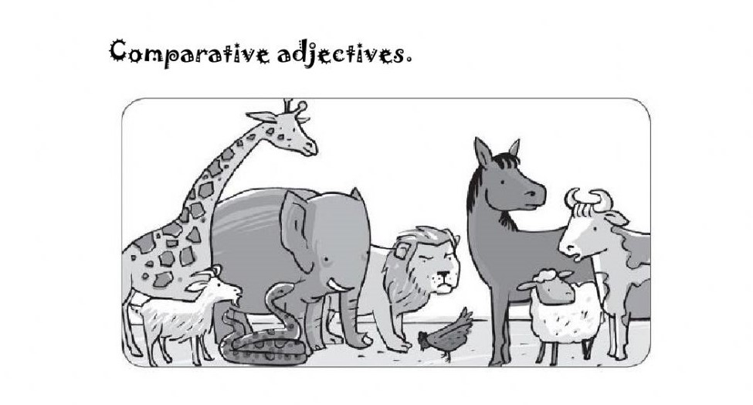
- Giraffes are ____________________ horses.
- Snakes are ____________________ lambs.
- Giraffes are ____________________ snakes.
- Cows are ____________________ lions.

Instructor’s Comments and Assessment
Pros
Cons
Change
Overall Comments
Grade
Above Standard 85%-100% | Standard 70%-84% | Below Standard 69%-0%
Instructor | Student Signature | Date
Taute, David

