Background Information Sheet
Name | Class | Date | Lesson Type | Plan type | Length
Kevin. Ku | TESOL | 04/25/2020 | Reading | PPP | 25 min

Lesson
Topic | Diary of a Wimpy Kid
Main Aim | Students practice their reading comprehension  .
Secondary Aim | Students practice their speaking fluency.

Materials and References
Reading material; worksheet ; whiteboard ; board pens ; pencil ; Computer ; Screen ; PPT

Student Profile
Level | Lower Intermediate
Age | Adults | Number of Students | 3
Detail | This is a general English class and students are all Koreans. They engage actively in kinesthetic learning and favor the visual learner mode, but, auditory learning still needs developing.

Anticipated Difficulties and their Solutions:
Not clear instructions due to nervousness -> relax by sitting down and slowly follow the planned teacher talk.
The P.C. and audio equipment could fail -> print a prepared picture of my PPT and bring a portable speakers to use.

My Personal Aim
What I hope most to demonstrate in this lesson is the ability to give clear instruction and to be an involver type teacher.

Stage Name: Lead-in
Purpose of this stage: To relax both the teacher and students. To focus attention on the lesson. To lead in to the topic, activating background knowledge – this will help to contextualize the text.
Materials: Screen, Computer, PPT
Timing | Interaction | Procedure
30 sec  2 min  30 sec | T  T-S/S-S  T-S | Organize seating arrangements so 3 students can sit close to each other, and all can easily see the screen. Show PPT 2.  Hello guys, look at this picture. “What do you think it is? Yes, Diary.” “Do you guys like to write diary? Let’s talk about good things about writing diary” Share your opinions. You have 2 minute.  Students talk in their group. Monitor for any use of key words.  Feedback Gesture to one person and ask – “Tell me about your ideas.”

Stage Name: Presentation
Purpose of this stage: To pre-teach keywords if necessary, and answer a guiding questions (such as a predicting task, or a specific question). These steps provide extra help for students to comprehend the text.
Materials: Screen, Computer, PPT
Timing | Interaction | Procedure
1 min  1 min  1 min  10 sec  2 min  50 sec | T-S  T-S  T-S  T  S-S  T-S | Pre-teach keywords: journal ; diary ; handy  Elicit – Point to PPT1. What do you see in this picture? Yes, you can see a book.  Then, what kind of book is it? (It’s a journal)  CCQ – Is it written record of daily event? ( Yes )  Does it sometimes include private feelings? ( Yes )  Drill – Listen and repeat 3 times together. ( Journal )  Nominate 2 or 3 individually.  Board – Write Journal on the right of the board.  How many syllables? (2) Mark with a blue pen.  Where is the stress? (1st) Mark with a red pen.  Elicit – Point to PPT2. What do you see in this picture now? ( Diary )  CCQ – Is it also written record of daily event? ( Yes )  Does it mostly include private feelings? ( Yes )  Can you see other’s diary without permission? ( No )  Drill – choral and individual drilling for correct pronunciation  Board – How many syllables? (3) Mark with a blue pen  Where is the stress? (1st) Mark with a red pen  Elicit – Point to PPT3. Look at this picture. How does that diary look like? ( Handy )  CCQ – Is it to become useful? ( Yes )  Is it hard to use? ( No )  Drill – choral and individual drilling for correct pronunciation  Board – How many syllables? (2) Mark with a blue pen  Where is the stree? (1st) Mark with a red pen  Guiding Question  Talk in your group. How will you feel if your mother make you write diary? And how will you react to it?  Students discuss with their partners.  Feedback. Nominate a few students to share their ideas, if necessary.

Stage Name: Practice – Literal Comprehension
Purpose of this stage: is to get students to practice reading for literal detail. They will also practice fast reading (skimming and scanning)
Materials: Worksheet, Pencil
Timing | Interaction | Procedure
30 sec  2 min  1 min  1 min | T  S  S-S  T-S | Instructions. Set the purpose for reading. Hand out worksheets.  Hold up the worksheet.  Now it’s time to read the text which is called ‘Diary of a Wimpy Kid’  As you read, you must answer these questions in exercise one only.  When you catch the answer, write it down next to the question.  But don’t do exercise 2.  I.C.Q – Do we need to do exercise 2? ( No )  Hand out the work sheet.  Students read the whole text for the 1st time, and write answers on the worksheet.  Pair check. Compare your answers with your partner. Monitor.  Feedback to check accuracy. Ask students for answer and check if others have the same or different answers. Does anyone else have a different answer? Who agrees with this answer?

Stage Name: Practice – Interpretive Comprehension
Purpose of this stage: is to get students to get students to practice interpreting a text correctly This will require more detailed, careful reading, and thinking time to arrive at the correct answer.
Materials: Worksheet, Pencil
Timing | Interaction | Procedure
30 sec  3 min  1 min  1 min | T  S  S-S  T-S | Read the text again. And this time, answer exercise 2.  These questions are more difficult, but if you read carefully and think about what you know, you can find the answers. Do it individually this time.  I.C.Q. – Do you guys answer exercise 2 together? (No)  Ok, now start exercise 2.  Students read the text for the 2nd time. And write answer for Exercise 2.  Pair check. Monitor. If students need, then replay the audio a 3rd time.  Feedback to check accuracy.

Stage Name: Production - Applied Comprehension
Purpose of this stage: is for students to practice their speaking fluency on a topic related to the lesson.
Materials: Worksheet
Timing | Interaction | Procedure
30sec  5 min  30sec | T  S-S  T-S | Instructions  Now, three of you guys will be a group and talk about the questions on Exercise 3.  You should talk freely, and remember to listen and ask questions to your partners.  You have 5 minutes.  I.C.Q – do you need to write anything? ( No )  Students discuss. Monitor from a distance.  Feedback. Nominate 1 student to share. (optional)

Stage Name: Wrap-up
Purpose of this stage: is to end the lesson on a positive note so that students feel they have achieved progress.
Materials: List all materials that will be needed in this stage.
Timing | Interaction | Procedure
1 min | T | Lesson feedback.  Ask the class what they liked about the story and difficult part from questions.  Set homework. (optional) - No homework  Inform students about the topic for the next lesson. Tomorrow we will read new reading material which will be related to vacation. That will be fun too.  Dismissed.

Worksheet 1 – Arriving late to class

Exercise One: Read and write the answer next to the question.
- Does he want to write journal or diary?
- Who make him to write journal?
- Will he write his feelings in journal?
- Why he agreed to write journal?

Exercise Two: Read carefully, think, and write your answer.
- Why doesn’t he like to write diary?

Exercise Three: Talk to your partner freely about questions below. No writing!
- When you were young, did your parents make you do something which you don’t want to? Talk about the situation
- How did you react that time?

PPT 1

PPT 2
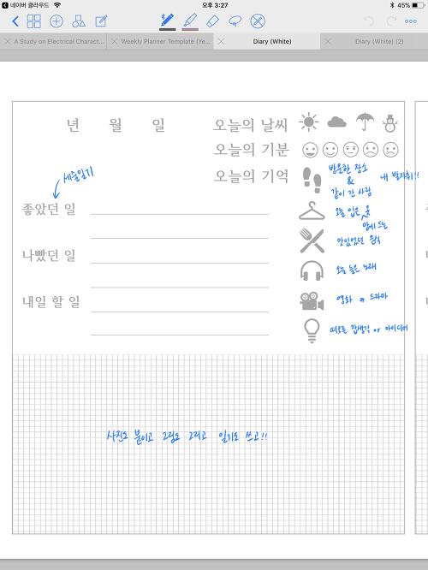
PPT 3
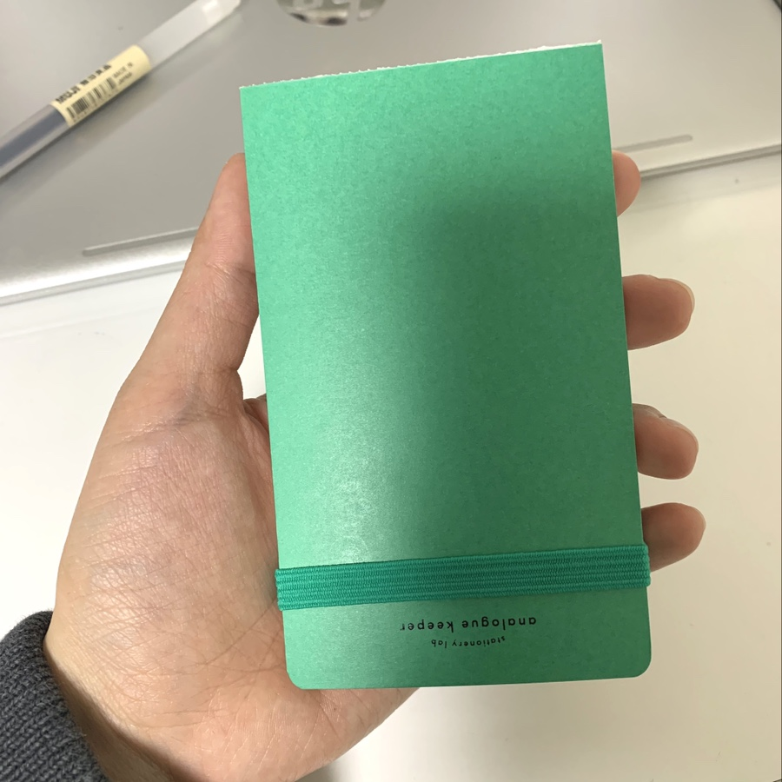

Answer Sheet – Arriving late to class

Exercise One: Read and write the answer next to the question.
- Does he want to write journal or diary? ( Journal )
- Who make him to write journal? ( His mother )
- Will he write his feelings in journal? ( No )
- Why he agreed to write journal? ( Because it will come in handy in future )

Exercise Two: Read carefully, think, and write your answer.
- Why doesn’t he like to write diary?
(Because he cares about other’s perspective about diary and he also doesn’t like to write his feelings in journal. )

Instructor’s Comments and Assessment
Pros
Cons
Change
Overall Comments
Grade
Above Standard 85%-100% | Standard 70%-84% | Below Standard 69%-0%
Instructor | Student Signature | Date
Taute, David

