Background Information Sheet
Name | Class | Date | Lesson Type | Plan type | Length
Bonnie | TESOL | 19.08.2020 | Grammar | PPP | 25 min

Lesson
Topic | He is older than Bonnie.
Main Aim | Students will learn the 2nd conditional.
Secondary Aim | Students will practice their speaking fluency.

Materials and References
Worksheets, Board and colour markers, Eraser.

Student Profile
Level |  | Lower Intermediate
Age |  | 10 years old |  | Number of Students | 2
Detail |  | This is a general English class and students are highly motivated learners. The students are all Koreans, and they are accustomed to pair work, however, still need to be relaxed before they will open up to communicate freely. One of my student little bit shy, but it isn’t big problem. Another student is talkative, so it makes good mood in the classroom.
Assumptions about students’ knowledge as required for this lesson:
- Students know the vocabulary used in this lesson
- Students have learned about the subject and ‘be’ verb relationship
- Students know how to make the negative form using ‘not’
What language difficulties to expect when presenting, and how to deal with it:
- Form: Students may confuse about comparative is verb or adjective. So, I inform it correctly in my lesson time.

- Pronunciation: Students may not know where to put natural sentence stress. Drill several times chorally, then individually. Ask, “Which words sound stressed?” Board the stress markers in red.
Anticipated Classroom Management Difficulties and their Solutions:
I really worry about the lesson time. I’ll teach some comparative part for my students, but my lesson time is just 25 minutes. It isn’t long time for teaching grammar, so I need to prepare my lesson plan really detailly. I also need to make a good lead-in and any other parts for teaching grammar easily.
My Personal Aim
What I hope most to demonstrate in this lesson is the ability to
- present the target language using a situational presentation
- to be an involver type teacher
Stage Name: Lead-in
Purpose of this stage: To relax both the teacher and students. To focus attention on the lesson. Create a situation for students to experience or think about, and then to elicit the target language.
Materials:
Timings | Interactions |  | Procedure
2 min | T - S |  | “Hello everyone. How are you?” (Good)  “Ok. Before starting main lesson, Manny can you help me?” (Yes)  “Please come here (Point next to me)” (Manny standing next to the teacher.)  “Ok class, can you describe he and I? (Gesture about height)” (He is taller than Bonnie.)  “yes. How about age?” (Manny is older than Bonnie.)  “Good. Please have a seat Manny.”
Stage Name: Presentation
Purpose of this stage: Make the students think about the situation. To clarify the meaning, form, and pronunciation features of the target language.
Materials: Board and colour markers, eraser.
Timings | Interactions |  | Procedure
5 sec  1 min  4 min  2 min | T  T-S  T-S  T-S |  | Board the model sentence (He is older than Bonnie).  CCQ – ask questions.  - “Is it talking about age?” (Yes)  - “Is it compare to Manny and I?” (Yes)  - “Am I younger or older than Manny?” (Younger)  Form – ask questions and make a table for students.  - Can we say “He older than Bonnie.”? (No) – Because it doesn’t have be-verb.  - Can we say “He is older Bonnie.”? (No) – Because comparatives form is ‘verb + er + than’.  (Board) He is older than Bonnie  “Where is subject?” (He) (Write) use blue pen  “Where is verb? (is) (Write) use blue pen  Make a line like this  sub. be-verb + er + than obj.  He is older than Bonnie  “Do you know negative form?” (He isn’t older than Bonnie.) Write it below the sentence. Use green pen.  sub. be-verb + er + than obj.  He is older than Bonnie  He isn’t older than Bonnie  “Do you know question form?” (Is he older than Bonnie?) Write it below the sentence. Use green pen.  sub. be-verb + er + than obj.  he is older than Bonnie  he isn’t older than Bonnie  Is he older than Bonnie ?  (Point verb) “Can we change any other word here?” (Yes)  “Can you give some example?” (Students answer)  (Point object) “Can we change any other word here?” (Yes)  “Can you give some example?” (Students answer)  Drill – drill the spoken form, focusing on contractions, stress and intonation.  “Everybody listens and repeat 5 times” (Gesture)  Ask repeating individually.  “Where is the stress?” (older, Bonnie) Dot on the top of sentence by red pen.  “Ok now, I give a question for you guys, and you must answer full sentence using comparative form”  1. (Point Yung Ju) “Are you taller than Manny?” (No, I’m not taller than Manny.)  2. (Point Manny) “Are you older than Yung Ju?” (Yes, I’m older than Yung Ju.)
Stage Name: Controlled Practice
Purpose of this stage: students practice working with the form (scrambled sentences, split sentences, select the correct form of the verb, correct incorrect sentences, and change one form into another form). Accuracy must be checked.
Materials: Worksheet 1
Timings | Interactions |  | Procedure
30 sec  1 min  30 sec  5 sec  1 min  1 min | T  S  T  S – S  T - S |  | Instructions. Hold the worksheet1 and point it.  “Ok guys, now we do this one, if you receive it, you can do the exercise 1 only. Write down your answer on the blank, but don’t turn to the next page. Number 5 and 6 is little bit difficult to you guys, but I know you can do it!”  ICQ – 1. Can you turn to the next page? (No)  2. Can you write your answer on your paper? (Yes)  “All right, let’s start.”  (Hand out.)  Students do a worksheet individually  “Time’s up. Now you can pair check.”  Pair check.  Feedback to check accuracy. Board correct answers visually.
Stage Name: Less Controlled Practice
Purpose of this stage: students practice working with the meaning (match a timelines to sentences, choose the sentence that matches a picture, gap-fill a paragraph). Accuracy must be checked.
Materials: Worksheet 2
Timings | Interactions |  | Procedure
30 sec  2 min  2 sec  1 min  1 min | T  S  T  S – S  T - S |  | Instruction. “Ok guys, turn to the next page.” (Student do)  “Now, you make 4 sentences about the picture using comparative form. First, you do it individually for 2 minutes. You can write your answer on your paper.”  I.C.Q – 1. Can you write your answer on your paper? (Yes)  2. How many sentences you make? (4 sentences)  “Let’s do it”  Students do a worksheet.  “Ok please check with your partner.”  Student pair check  Feedback and accuracy.
Stage Name: Production – Freer Practice
Purpose of this stage: is to get students to practice the grammar communicatively.
Materials:
Timings | Interactions |  | Procedure
20 sec  5 min  1 min | T  S - S  T - S |  | Instructions.  “Well done. Now talk to each other about your family. For example, my cat is smaller than me and he is very cute. And he likes…. Blah blah. Something like that.”  Students talk to each other.  Feedback.
Stage Name: Wrap-up
Purpose of this stage: is to end the lesson on a positive note so that students feel they have achieved progress.
Materials:
Timings | Interactions |  | Procedure
1 min  5 sec  5 sec | T – S  T  T |  | Offer delayed corrections to the previous stage.  “Look at the board. Here are some sentences I heard. Tell me how to correct them.”  Set homework.  “Today you don’t have homework. ”  Inform students about the topic for the next lesson.  “Next, we learn other rules about comparatives. Thank you for attending my class and good bye.”  Dismissed.
Instructor’s Comments and Assessment
Pros
Cons
Change
Overall Comments
Grade
Above Standard 85%-100% | Standard 70%-84% | Below Standard 69%-0%
Instructor | Student Signature | Date
Taute, David

Worksheet 1

1. A bus ________ ________ ________ car (small)

2. A babe ________ ________ ________ I (young)

3. My house ________ ________ ________ 63 building (low)

4. My room ________ ________ ________ the toilet (large)

5. I ________ ________ ________ you (pretty)

6. Math ________ ________ ________ science (easy)

Worksheet 2

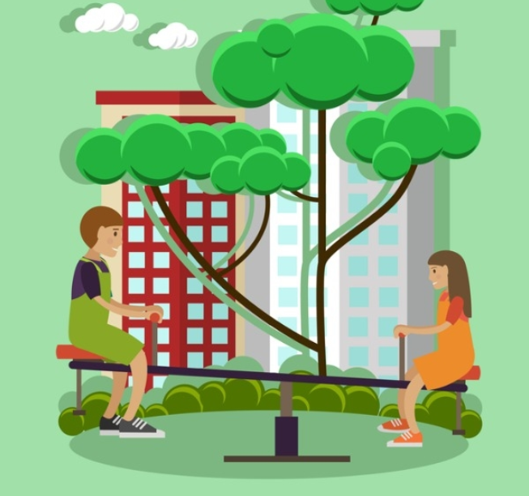

1.

2.

3.

4.
Worksheet 1 (For teacher)

1. A bus is smaller than car (small)

2. A babe is younger than I (young)

3. My house is lower than 63 building (low)

4. My room is larger than the toilet (large)

5. I am prettier than you (pretty)

6. Math is easier than science (easy)

Worksheet 2 (For teacher)

1. The girl is shorter than the boy.

2. The tree is taller than the building.

3. The cloud is higher than the building.

4. The seesaw is lower than the tree.

