Background Information Sheet
Name | Class | Date | Lesson Type | Plan type | Length
Bonnie | TESOL | 26.08.2020 | Reading | PPP | 30 min

Lesson
Topic | A dog at the well
Main Aim | Ss practice their reading comprehension.
Secondary Aim | Ss practice their speaking fluency.

Materials and References
Reference: https://www.momjunction.com/articles/moral-stories-for-kids_00369197/ https://dictionary.cambridge.org/ko/%EC%82%AC%EC%A0%84/%EC%98%81%EC%96%B4/explore
https://www.fnnews.com/news/201901271215364977
Materials: PPT, Worksheets

Student Profile
Level | Intermediate
Age | 11 - 13 | Number of Students | 2
Detail | This is a general English class and students are highly motivated learners. The students are all Koreans, and they are accustomed to pair work, however, still need to be relaxed before they will open up to communicate freely. One of my student little bit shy, but it isn’t big problem. Another student is talkative, so it makes good mood in the classroom.

Anticipated Difficulties and their Solutions:
Outside is so noisy – Close the window and door.
My USB is not working – Use back up files of my kakaotalk chat.

My Personal Aim
What I hope most to demonstrate in this lesson is the ability to write out a complete, detailed lesson plan.

Stage Name: Lead-in
Purpose of this stage: To relax both the teacher and students. To focus attention on the lesson. To lead in to the topic, activating background knowledge – this will help to contextualize the text. This is a BEFORE READINING stage.
Materials:
Timing | Interaction | Procedure
30 sec  1 min  30 sec | T  S - S  T - S | “Hello everyone. How are you?” (Good)  “Ok, before our main lesson, share your funny or good experience about trip or going to any other new place you didn’t go before. And, how was your feeling at that time. Talk to each other.”  Students talk to their partners. And teacher monitors them.  Feedback if appropriate.

Stage Name: Presentation
Purpose of this stage: To pre-teach keywords if necessary, and answer a guiding questions (such as a predicting task, or a specific question). These steps provide extra help for students to comprehend the text. This is a BEFORE READINING stage.
Materials: PPT1, PPT2
Timing | Interaction | Procedure
1 min  1 min  1 min  10 sec  1 min  50 sec | T  T  T  T  S – S  T – S | Pre-teach keywords: well, reflection, explore  Elicit – (Show PPT1) “Guys, look at this picture. What is it called?” (Well)  CCQ – “Is it a deep hole?” (Yes)  “Can you get some water from here?” (Yes)  Drill – “Everybody listen and repeat. Well.” (Gesture 3 times)  Ask individually.  Board – Board a word ‘well’  Elicit – (Point PPT1) “If there is water in here, what can you see?”  (reflection)  CCQ - “Can you see your face from the water?” (Yes)  “Is it real person or just image?” (Image)  Drill – “Everybody listen and repeat. Reflection.” (Gesture 3 times)  Ask individually.  Board – Board a word ‘reflection’  “How many syllables?” (3 syllables)  “Where is the stress?” (Second)  Elicit – (Show PPT2) “How about this. What is he doing?” (explore)  CCQ – “Is he travel some place?” (Yes)  (Point PPT2) “Did he go here before?” (No)  Student can guess the answer, because the man has a map.  Drill – “Everybody listen and repeat. Explore.” (Gesture 3 times)  Ask individually.  Board – Board a word ‘explore’  “How many syllables?” (2 syllables)  “Where is the stress?” (Second)  Guiding Question: “Why parents said No, if you make a wrong decision?”  “Talk to your partner about the reason of this question.”  Students discuss the question with a partner.  Feedback. Nominate students to share their ideas.

Stage Name: Practice – Literal Comprehension
Purpose of this stage: is to get students to practice reading for literal detail. They will also practice fast reading (skimming and scanning). This is a WHILE READINING stage.
Materials: Story, worksheet1
Timing | Interaction | Procedure
30 sec  2 min  5 sec  30 sec  1 min | T  S  T  S – S  T – S | Instructions.  (Hold story and worksheet1) “Guys, I’ll give some exercise and you can do exercise1 only. Don’t do the exercise2. This exercise is about story of the puppy. Read the story, and if you find your answer, just write it down on your worksheet. You can do your work fast if you can. You don’t need to read too deeply. You have 2 minutes.”  I.C.Q – “Can you write the answer on the paper?” (Yes)  “Do you need to read deeply?” (No)  Give the worksheet.  Students read the whole text for the 1st time, and write answers on the worksheet.  “Time’s up. Now, you can pair check with your partner by speech.”  Pair check.  Feedback to check accuracy.

Stage Name: Practice – Interpretive Comprehension
Purpose of this stage: is to get students to get students to practice interpreting a text correctly This will require more detailed, careful reading, and thinking time to arrive at the correct answer. This is a WHILE READINING stage.
Materials: Story, worksheet1
Timing | Interaction | Procedure
30 sec  4 min  5 sec  1 min  2 min | T  S  T  S – S  T – S | Instructions.  “Well done. Now, we do the exercise two. This is same as exercise1, but the question is more difficult. But, I believe you can do it. I’ll give you enough time to read the story, so read the story and write down your answer below the question.”  I.C.Q. – “Can you write down the answer on your paper?” (Yes)  “Do you need to rush?” (No)  “Ok. Let’s do it.”  Students read for the 2nd time. Students write their answers down.  “Time’s up. You can share your answer together by speech.”  Pair check. Monitor.  Feedback to check accuracy.

Stage Name: Production - Applied Comprehension
Purpose of this stage: is for students to practice their speaking fluency and is related to the lesson topic. This is an AFTER READINING stage.
Materials: Worksheet2
Timing | Interaction | Procedure
30 sec  8 min  1 min | T  S – S  T – S | Instructions.  “Now, clear your story from you and turn to your worksheet.” (Student do)  “All right. Talk together about this question. It doesn’t have answer, so you just share your thinking about it. You don’t need to write on your paper. I’ll give enough time to talk. Now, let’s begin.”  Students discuss.  Feedback. Students share their ideas with the class.  “Ok. Share your thinking to me. Manny, what is your answer about Q2?”  “Yung Ju, what is your answer about Q4?”

Stage Name: Wrap-up
Purpose of this stage: is to end the lesson on a positive note so that students feel they have achieved progress. This is an AFTER READINING stage.
Materials: List all materials that will be needed in this stage.
Timing | Interaction | Procedure
2 min | T | Lesson feedback. Tell the class what they did well, and what needs to improve.  “Well done guys. Thank you so much for sharing your ideas!”  “Which part of question is most difficult?” (Student answer)  “Yes right. It is little bit hard, but you guys did it very good. So, I really happy”  Set homework. “For homework, bring some story book and share the story in the class tomorrow.”  Inform students about the topic for the next lesson. “Tomorrow we have another reading lesson.”  “Thank you to attend this class and good bye.”  Dismissed.

PPT1
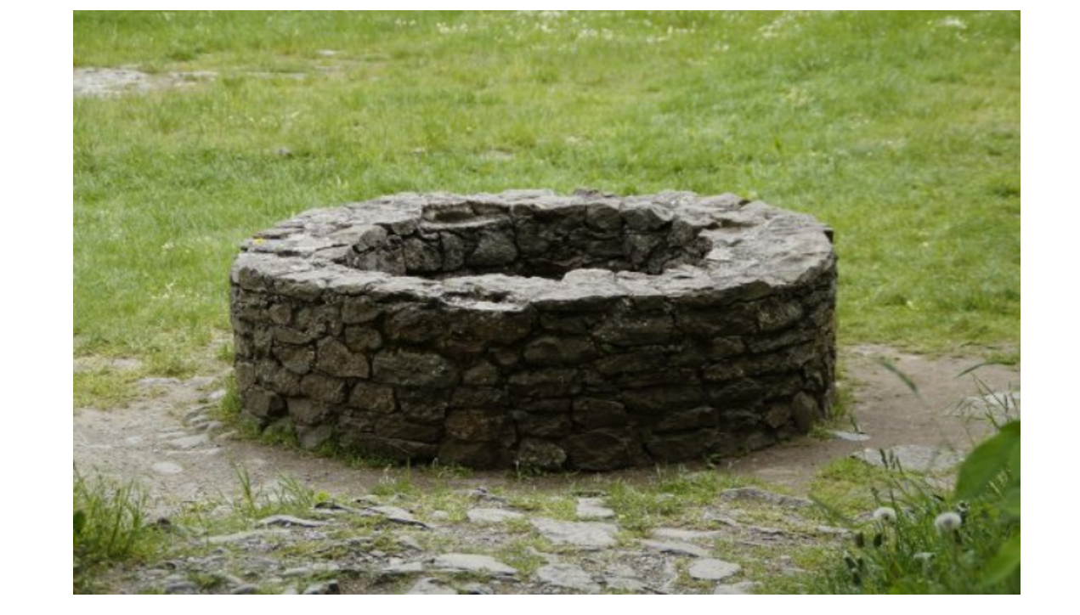
PPT2
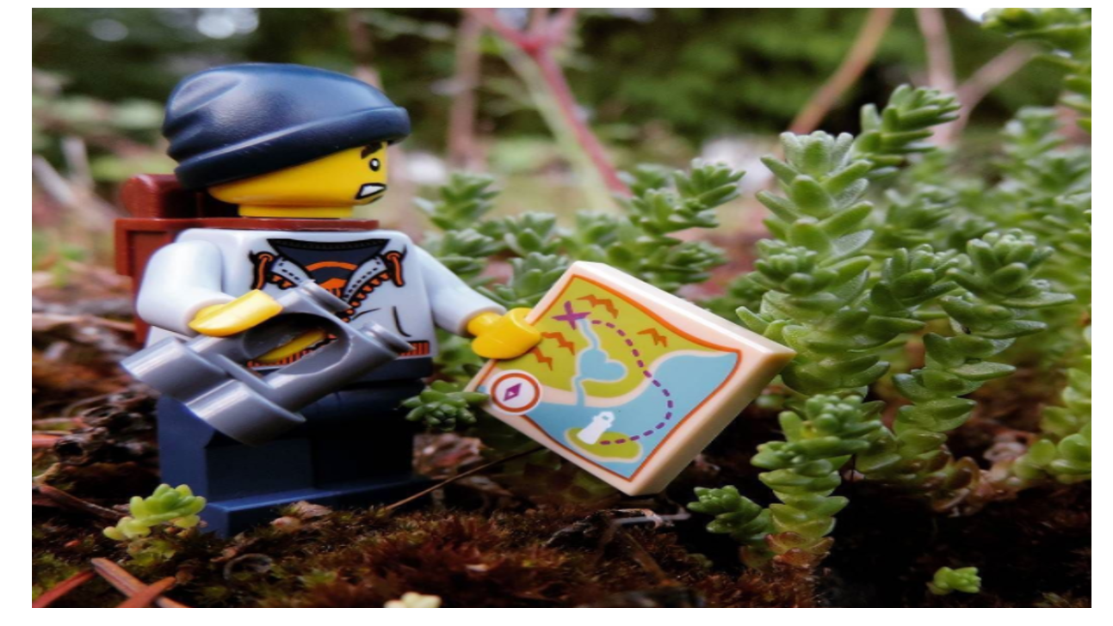

A dog at the well (Story)

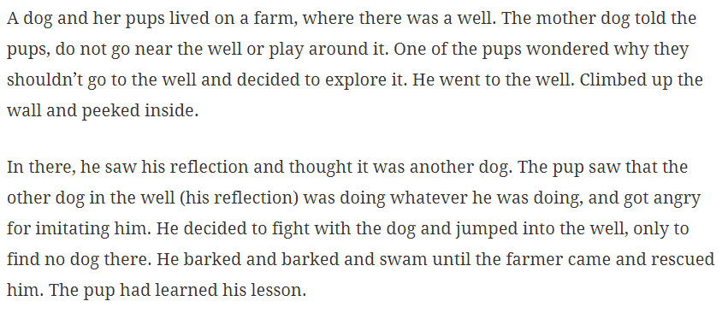
Worksheet1
Exercise 1
Q1. Where did the puppy go?

Q2. What did the puppy see?

Q3. Who did the puppy fight with?

Q4. Who did rescue the puppy?

Exercise 2
Q1. Why the mother dog told to her baby, don’t go to the well?

Q2. What did the puppy learn?

Q3. Is the puppy going to the well next time again?

Worksheet2
Exercise 3
Q1. Did you have some experience about arguing with your parents?

Q2. Do you think parents are always right?

Q3. Some elders said ‘Don’t do that. I’m right.’ to you. In this situation, do you just ignore him or try to understand him?

Q4. If your child says ‘I’ll be a singer!’ but, he can’t sing very well. In this situation, what you say to your child?

Worksheet1 (For teacher)
Exercise 1
Q1. Where did the puppy go? (Go to the well)

Q2. What did the puppy see? (His reflection)

Q3. Who did the puppy fight with? (His reflection)

Q4. Who did rescue the puppy? (The farmer)

Exercise 2
Q1. Why the mother dog told to her baby, don’t go to the well?
(Because the puppy is her baby. She knows his personality and worried about this situation.)
Q2. What did the puppy learn?
(He thinks he need to listen to what the elders say. Because he experiences bad situation due to ignore what his mother said.)
Q3. Is the puppy going to the well next time again?
(No. Because the story said ‘The pup had learned his lesson.’ It means he don’t go to the well anymore before his mom direction.

Instructor’s Comments and Assessment
Pros
Cons
Change
Overall Comments
Grade
Above Standard 85%-100% | Standard 70%-84% | Below Standard 69%-0%
Instructor | Student Signature | Date
Taute, David

